**ASSIGNMENT-1**

**1.Write a python program to test a given number is prime or not**

**Program:**

num=int(input("enter the number="))

flag = False

if num > 1:

for i in range(2, num):

if (num % i) == 0:

flag = True

break

if flag:

print(num, "is not a prime number")

else:

print(num, "is a prime number")

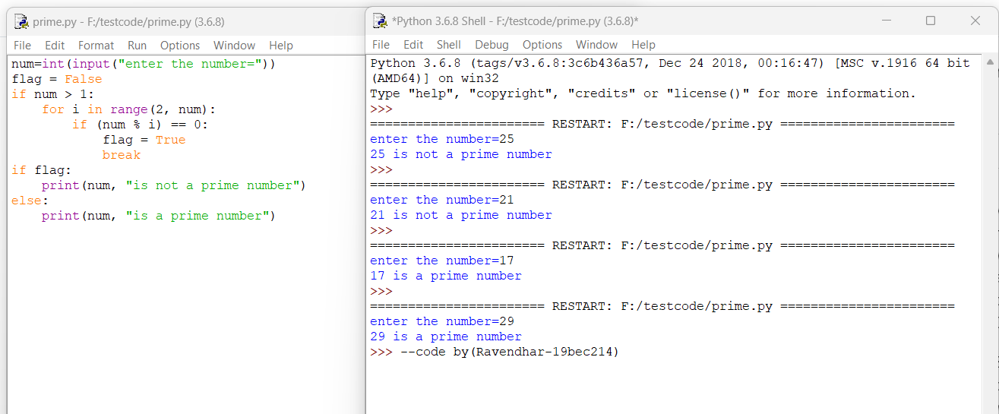**Output:**

**2.Write a program to generate odd numbers from m to n using while loop.**

**Program:**

m=int(input("enter the starting number"))

n=int(input("enter the ending number"))

while(m < n):

if m % 2 != 0:

print(m, end = " ")

m += 1

**Output:**

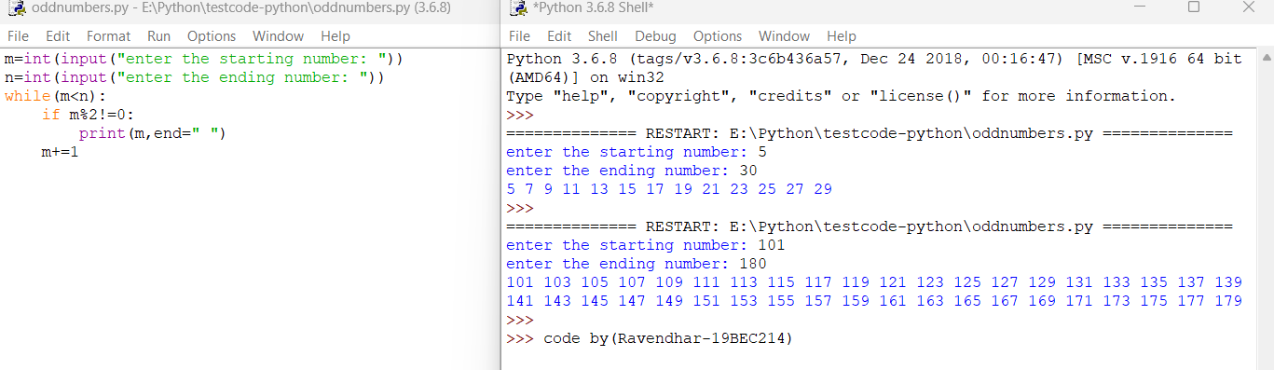

**3.Write a program to display prime numbers series up to given number.**

**Program:**

a=int(input("enter the starting number: "))

b=int(input("enter the ending number: "))

for num in range(a, b + 1):

if num > 1:

for i in range(2, num):

if (num % i) == 0:

break

else:

print(num,end=’ ‘)

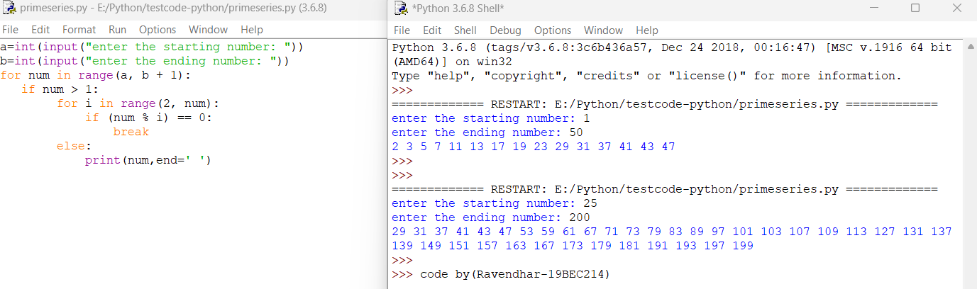**Output:**

**4. Write a program to generate Fibonacci series**

**Program:**

num=int(input("Enter the number of terms: "))

a=0;

b=1;

for i in range(1,num):

print(a,end=’ ‘)

result=a+b

a=b

b=result;

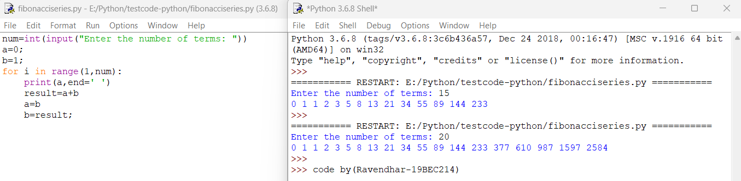**Output:**