Assignment-4

Ultrasonic Sensor detection:

Program:

#define ECHO_PIN 2

#define TRIG_PIN 3

void setup() {

Serial.begin(115200);

pinMode(LED_BUILTIN, OUTPUT);

pinMode(TRIG_PIN, OUTPUT);

pinMode(ECHO_PIN, INPUT);

}

float readDistanceCM() {

digitalWrite(TRIG_PIN, LOW);

delayMicroseconds(2);

digitalWrite(TRIG_PIN, HIGH);

delayMicroseconds(10);

digitalWrite(TRIG_PIN, LOW);

int duration = pulseIn(ECHO_PIN, HIGH);

return duration * 0.034 / 2;

}

void loop() {

float dist = readDistanceCM();

bool isNearby = dist < 100;

digitalWrite(LED_BUILTIN, isNearby);

Serial.print("Measured distance: ");

Serial.println(readDistanceCM());

delay(100);

}

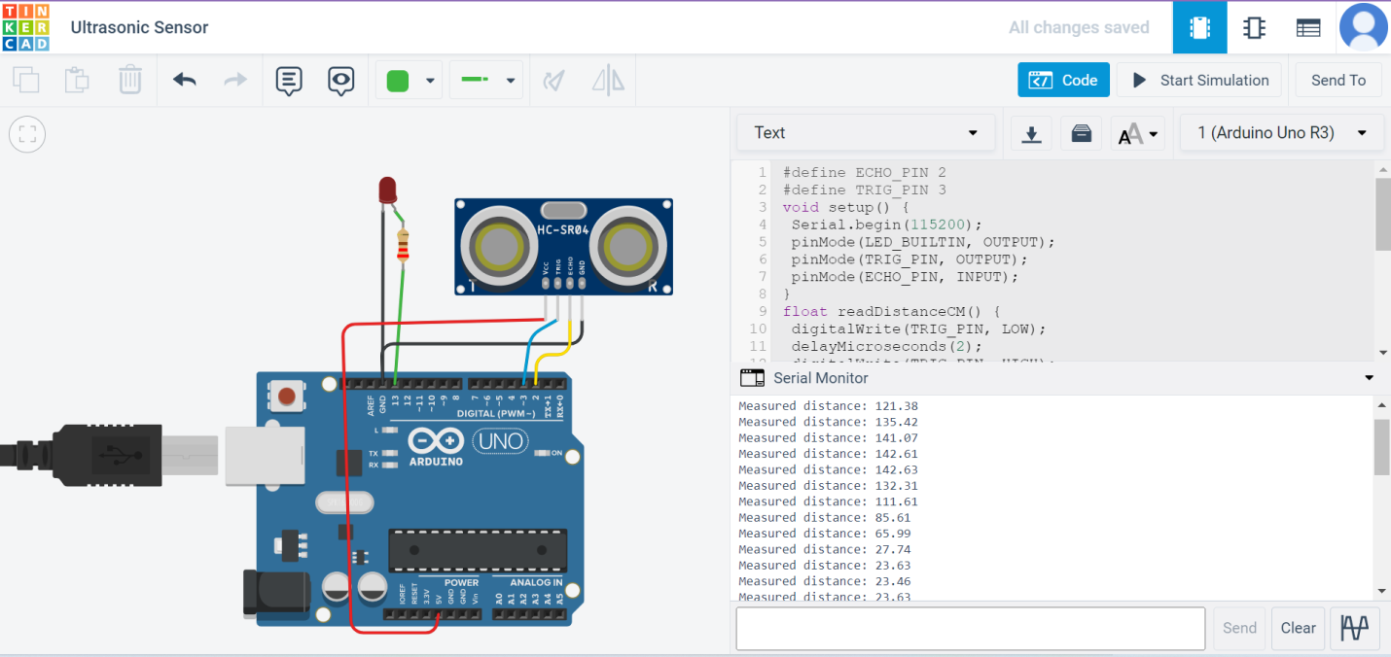

<https://www.tinkercad.com/things/1enmr2gttek?sharecode=seRi_pdQ0prs4IHeeKMqFJ7rKOJ-KciZXGs44Or1UCo>