**DATA ANALYTICS FOR HEALTH CARE**

Team id: PNT2022TMID04319

ASSIGNMENT 1:

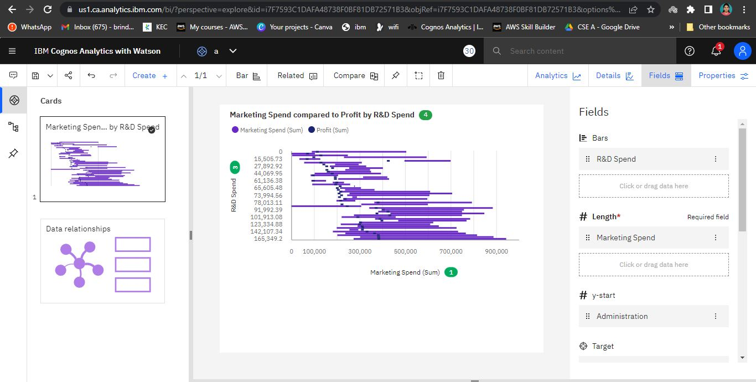

[**https://us1.ca.analytics.ibm.com/bi/?perspective=explore&pathRef=.my_folders%2Fassignment%2Fa&subView=model000001833b2be1f2_00000000**](https://us1.ca.analytics.ibm.com/bi/?perspective=explore&pathRef=.my_folders%2Fassignment%2Fa&subView=model000001833b2be1f2_00000000)

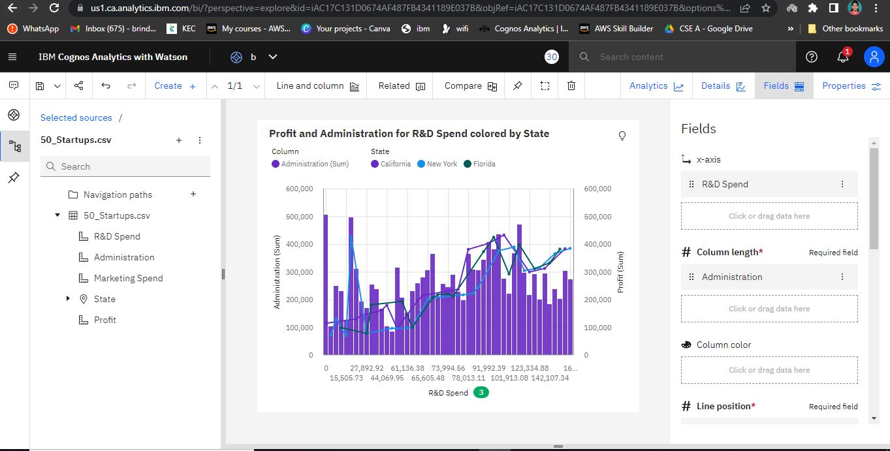

[**https://us1.ca.analytics.ibm.com/bi/?perspective=explore&pathRef=.my_folders%2Fassignment%2Fb&subView=model000001833b2e2902_00000003**](https://us1.ca.analytics.ibm.com/bi/?perspective=explore&pathRef=.my_folders%2Fassignment%2Fb&subView=model000001833b2e2902_00000003)

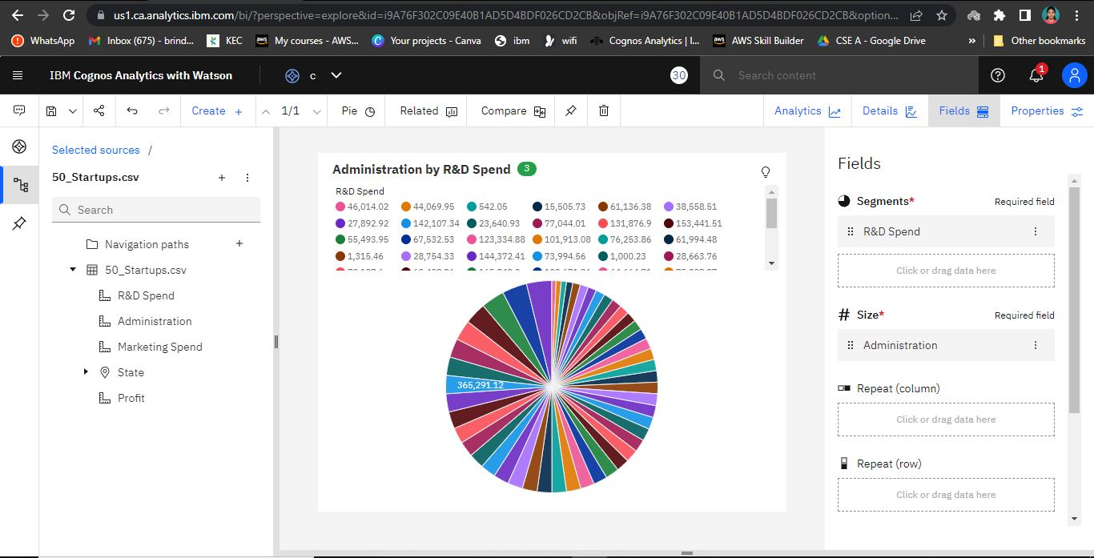

[**https://us1.ca.analytics.ibm.com/bi/?perspective=explore&pathRef=.my_folders%2Fassignment%2Fc&subView=model000001833b306b75_00000004**](https://us1.ca.analytics.ibm.com/bi/?perspective=explore&pathRef=.my_folders%2Fassignment%2Fc&subView=model000001833b306b75_00000004)

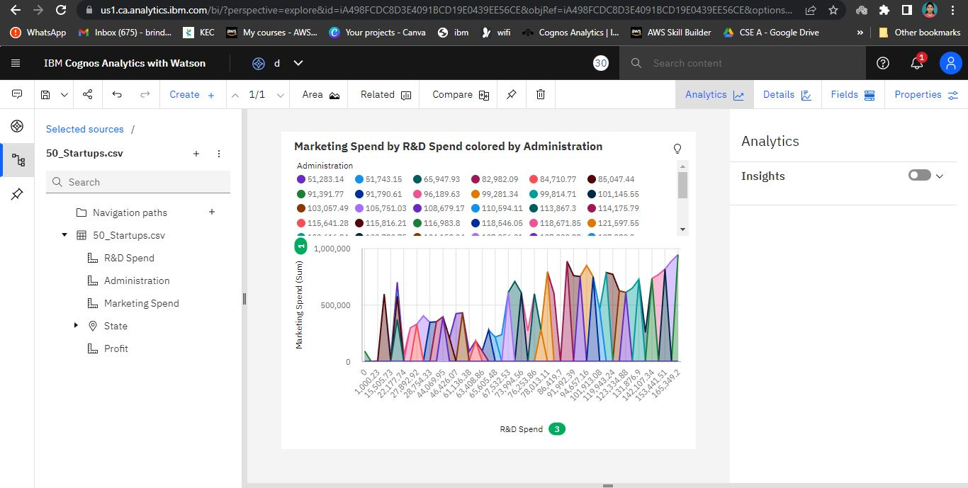

[**https://us1.ca.analytics.ibm.com/bi/?perspective=explore&pathRef=.my_folders%2Fassignment%2Fd&subView=model000001833b31beb4_00000000**](https://us1.ca.analytics.ibm.com/bi/?perspective=explore&pathRef=.my_folders%2Fassignment%2Fd&subView=model000001833b31beb4_00000000)

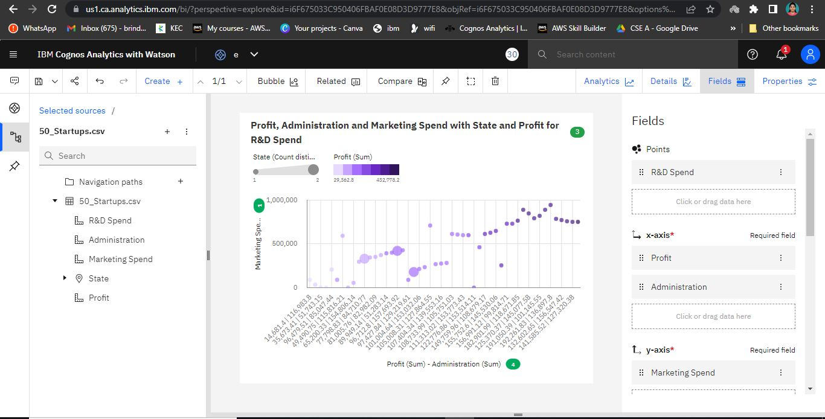

[**https://us1.ca.analytics.ibm.com/bi/?perspective=explore&pathRef=.my_folders%2Fassignment%2Fe&subView=model000001833b338d57_00000003**](https://us1.ca.analytics.ibm.com/bi/?perspective=explore&pathRef=.my_folders%2Fassignment%2Fe&subView=model000001833b338d57_00000003)

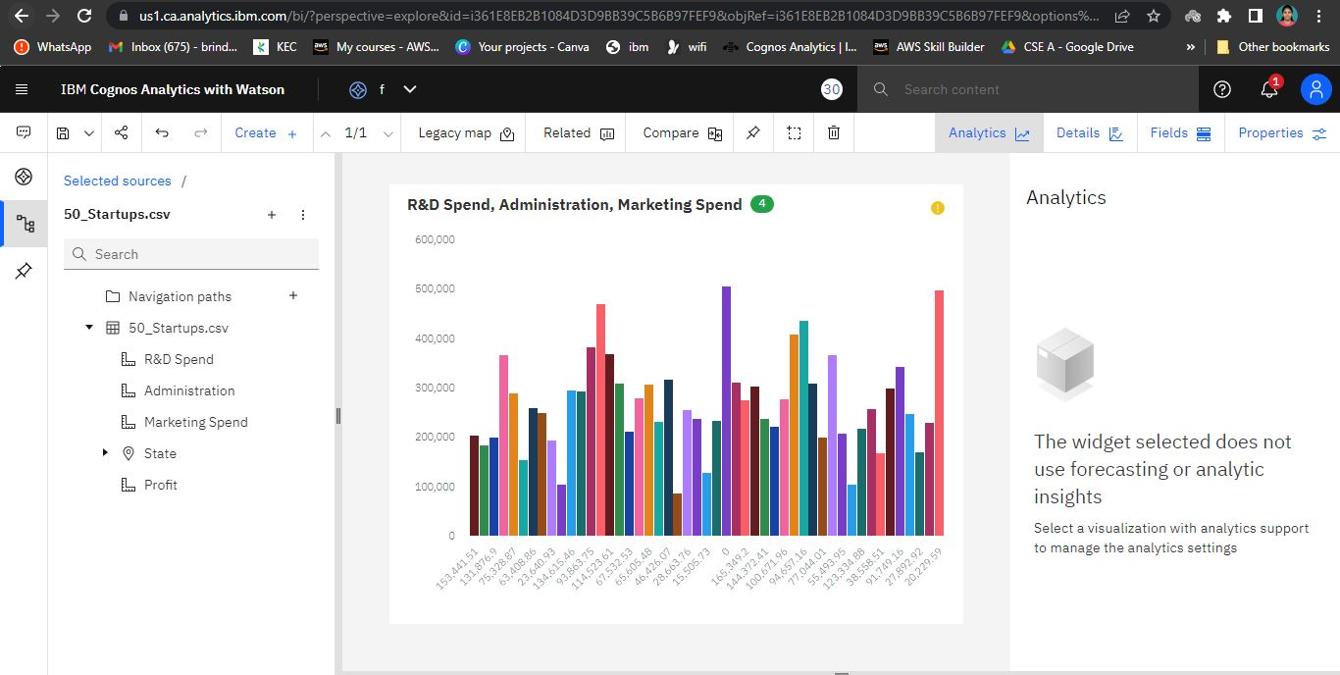

[**https://us1.ca.analytics.ibm.com/bi/?perspective=explore&pathRef=.my_folders%2Fassignment%2Ff&subView=model000001833b31beb4_00000000**](https://us1.ca.analytics.ibm.com/bi/?perspective=explore&pathRef=.my_folders%2Fassignment%2Ff&subView=model000001833b31beb4_00000000)