**DATA ANALYTICS FOR HEALTH CARE**

Team id: PNT2022TMID04319

ASSIGNMENT 2:

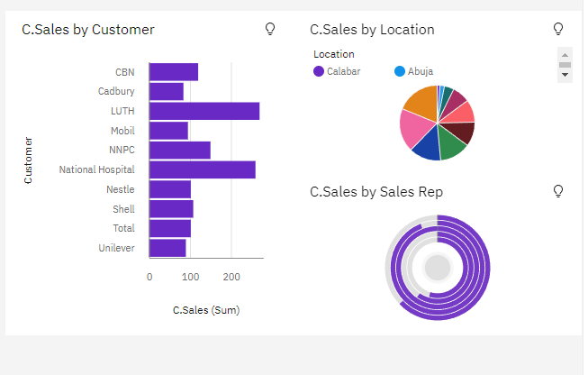

<https://us1.ca.analytics.ibm.com/bi/?perspective=dashboard&pathRef=.my_folders%2Fass2%2Fa1&action=view&mode=dashboard&subView=model000001837f4b5ba5_00000000>

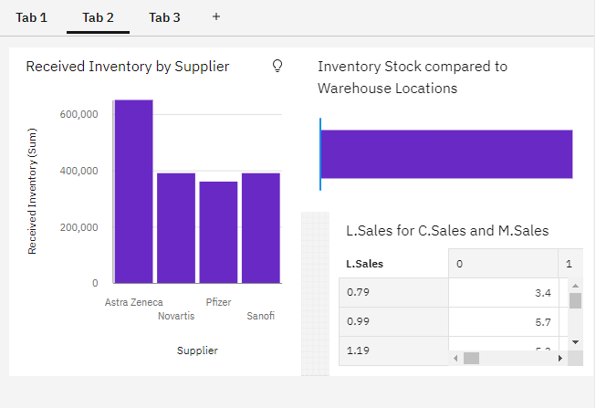

<https://us1.ca.analytics.ibm.com/bi/?perspective=dashboard&pathRef=.my_folders%2Fass2%2Fa1&action=view&mode=dashboard&subView=model000001837f5f5f07_00000000>

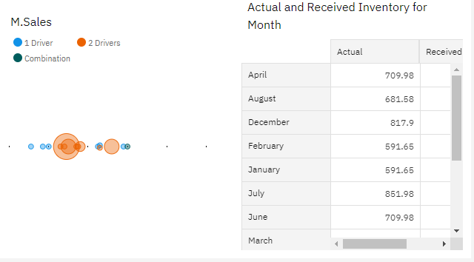

<https://us1.ca.analytics.ibm.com/bi/?perspective=dashboard&pathRef=.my_folders%2Fass2%2Fa1&action=view&mode=dashboard&subView=model000001837f6f649f_00000000>