ASSESSMENT 2

Team Id : PNT2022TMID04319

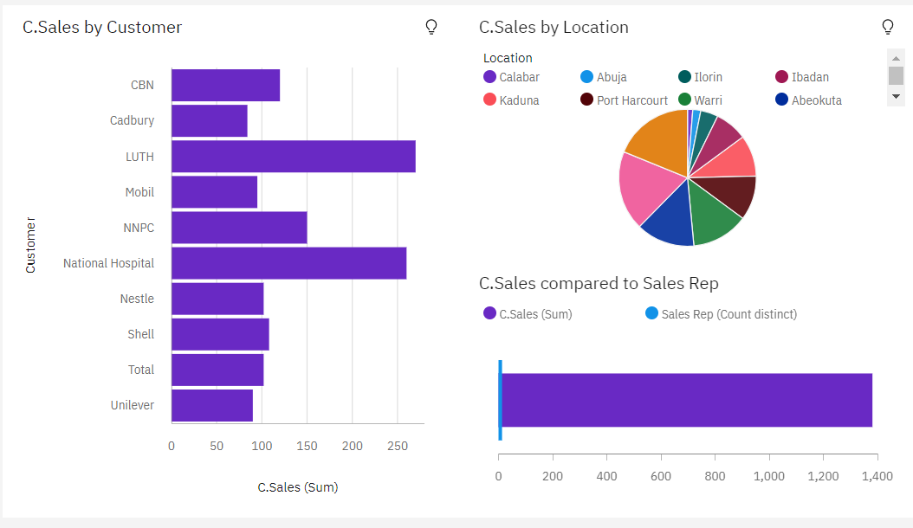

<https://us1.ca.analytics.ibm.com/bi/?perspective=dashboard&pathRef=.my_folders%2FAssessment%2B2%2F1&action=view&mode=dashboard&subView=model000001837fc08c6a_00000000>

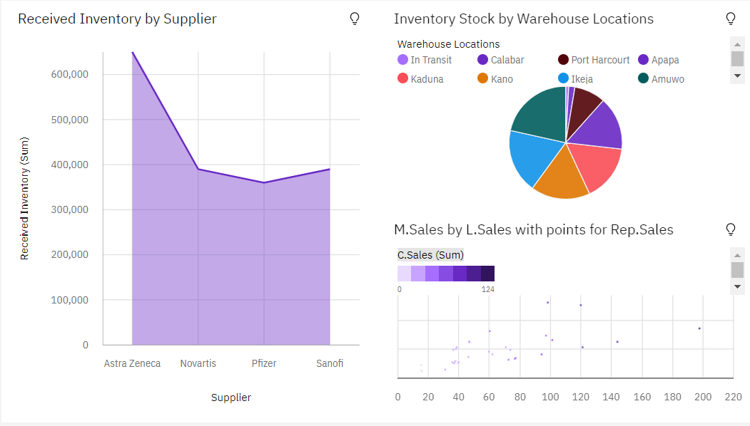

<https://us1.ca.analytics.ibm.com/bi/?perspective=dashboard&pathRef=.my_folders%2FAssessment%2B2%2F1&action=view&mode=dashboard&subView=model000001837fcbef65_00000000>

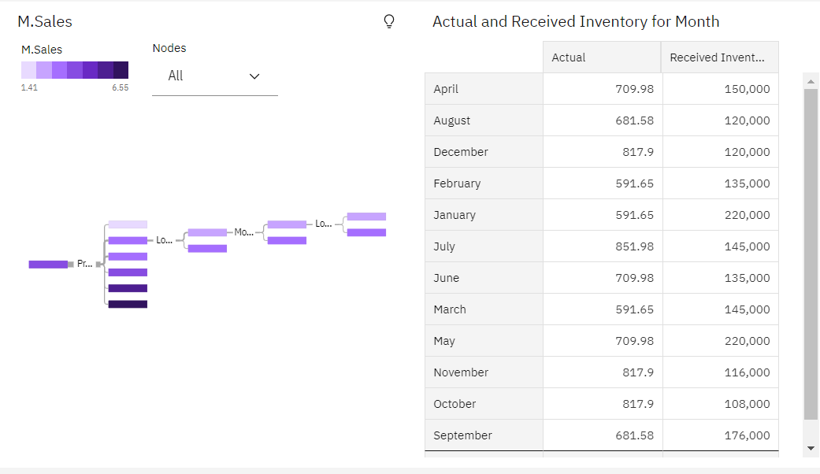

<https://us1.ca.analytics.ibm.com/bi/?perspective=dashboard&pathRef=.my_folders%2FAssessment%2B2%2F1&action=view&mode=dashboard&subView=model000001837fd367e9_00000000>