IBM ASSESSMENT

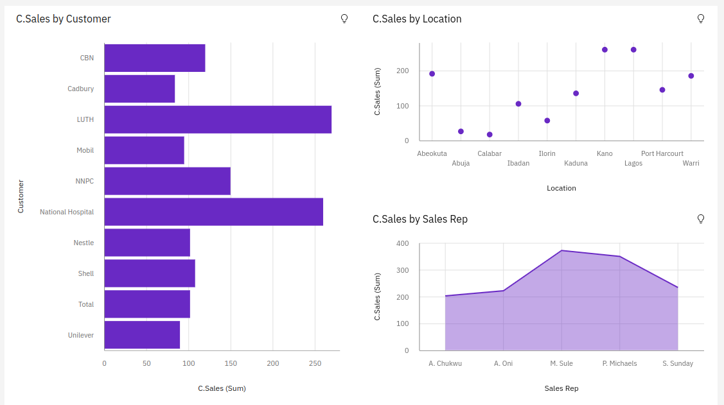

https://us3.ca.analytics.ibm.com/bi/?perspective=dashboard&pathRef=.my_folders%2FAssessment_2%2F2&action=view&mode=dashboard&subView=model000001837fc2c185_00000002

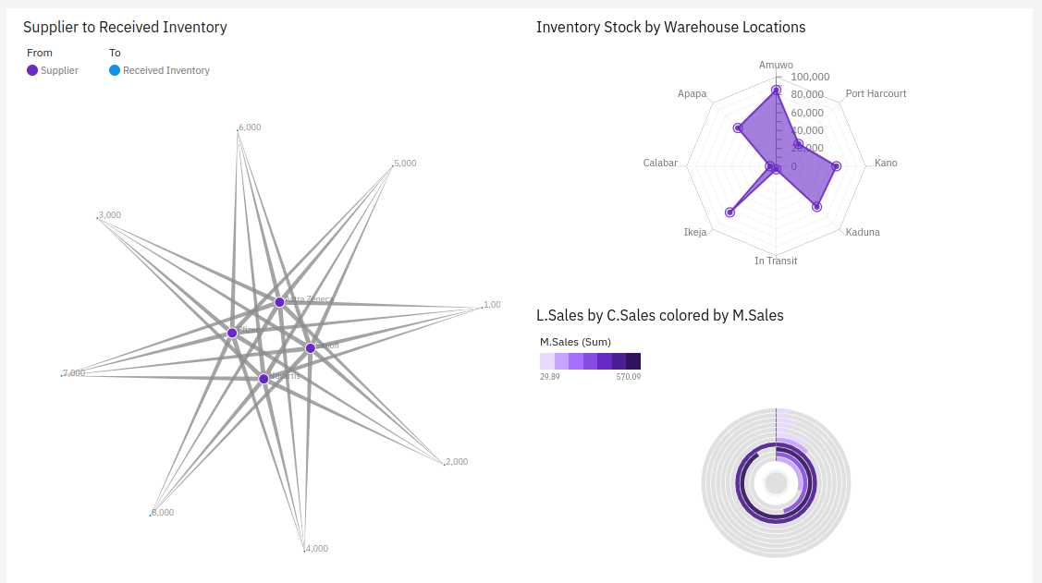
https://us3.ca.analytics.ibm.com/bi/?perspective=dashboard&pathRef=.my_folders%2FAssessment_2%2F2&action=view&mode=dashboard&subView=model000001837fd005ae_00000000

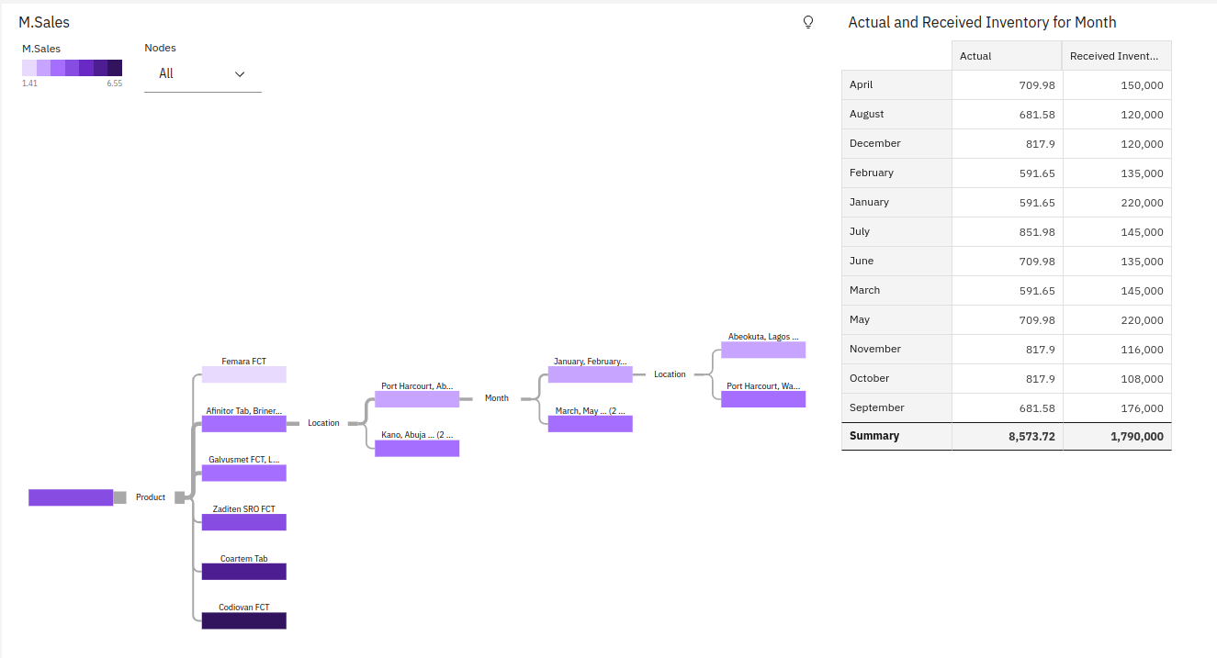
https://us3.ca.analytics.ibm.com/bi/?perspective=dashboard&pathRef=.my_folders%2FAssessment_2%2F2&action=view&mode=dashboard&subView=model000001837fd73f88_00000000

