DATA ANALYTICS FOR HEALTH CARE

TEAM : PNT2022TMID04319

1) https://us3.ca.analytics.ibm.com/bi/?perspective=explore&pathRef=.my_folders%2FIBM_Assesment%2FPiechart&subView=model000001833c8c2433_00000004
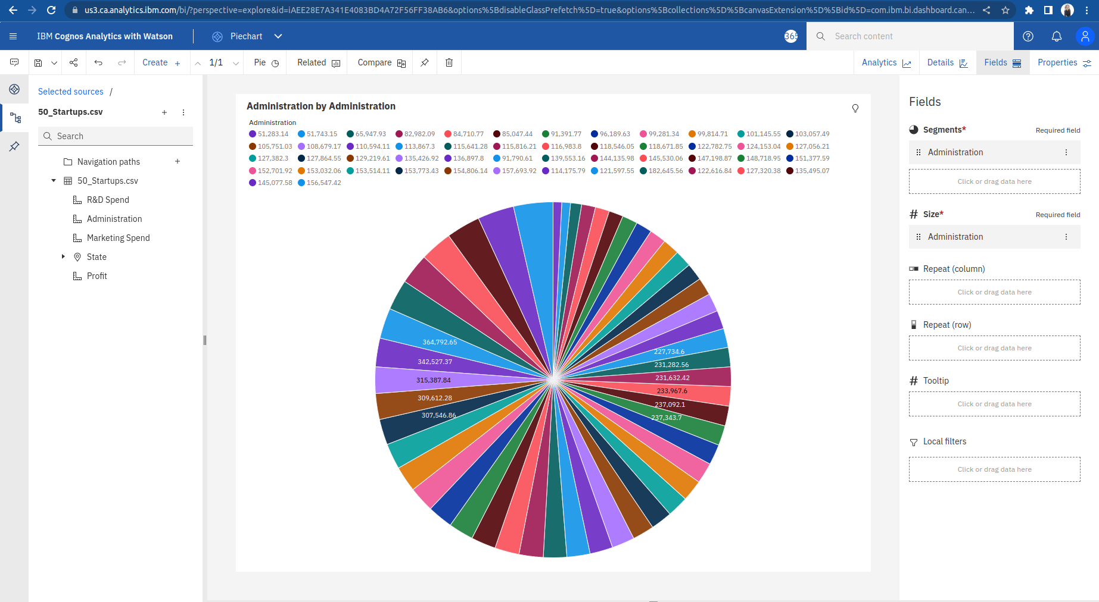

2) https://us3.ca.analytics.ibm.com/bi/?perspective=explore&pathRef=.my_folders%2FIBM_Assesment%2FNetwork&subView=model000001833ca9496f_00000004

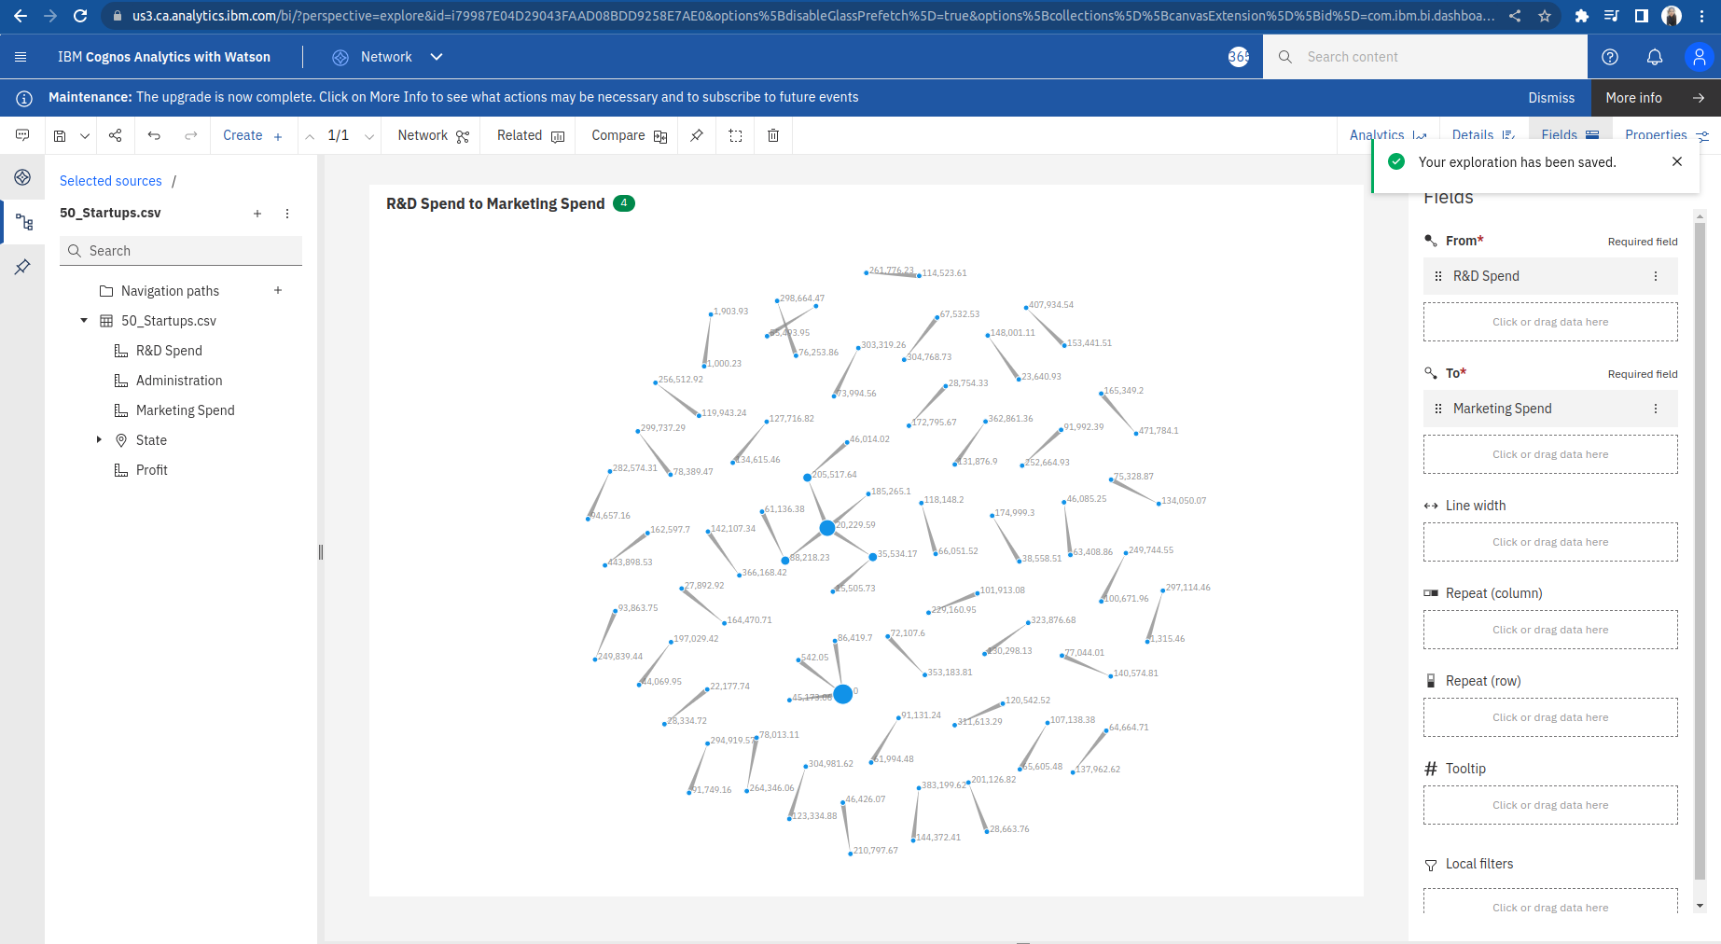

3) https://us3.ca.analytics.ibm.com/bi/?perspective=explore&pathRef=.my_folders%2FIBM_Assesment%2FLine&subView=model000001833c8c2433_00000004

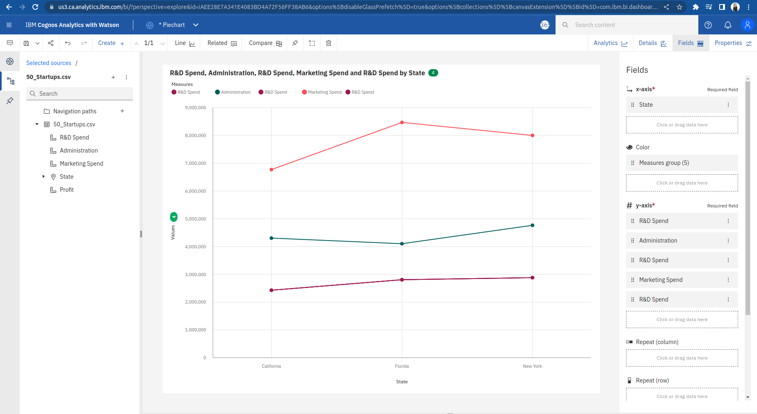

4) https://us3.ca.analytics.ibm.com/bi/?perspective=explore&pathRef=.my_folders%2FIBM_Assesment%2FRadar&subView=model000001833ca9496f_00000004

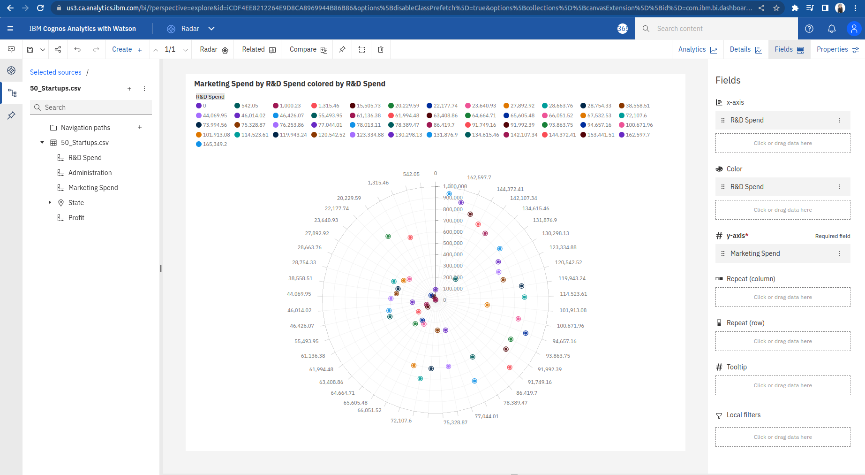

5) https://us3.ca.analytics.ibm.com/bi/?perspective=explore&pathRef=.my_folders%2FIBM_Assesment%2FRadial&subView=model000001833ca9496f_00000004

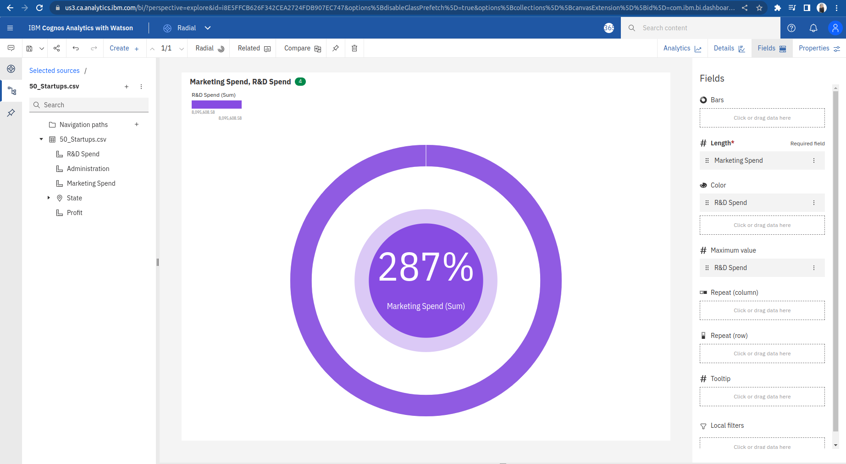

6) https://us3.ca.analytics.ibm.com/bi/?perspective=explore&pathRef=.my_folders%2FIBM_Assesment%2FDecision%2Btree&subView=model000001833ca9496f_00000004

