ANALYTICS FOR HOSPITAL’S HEALTH CARE DATA

ASSIGNMENT 1

ROLLNO : 737819CSR010

UPLOADING DATASET :-

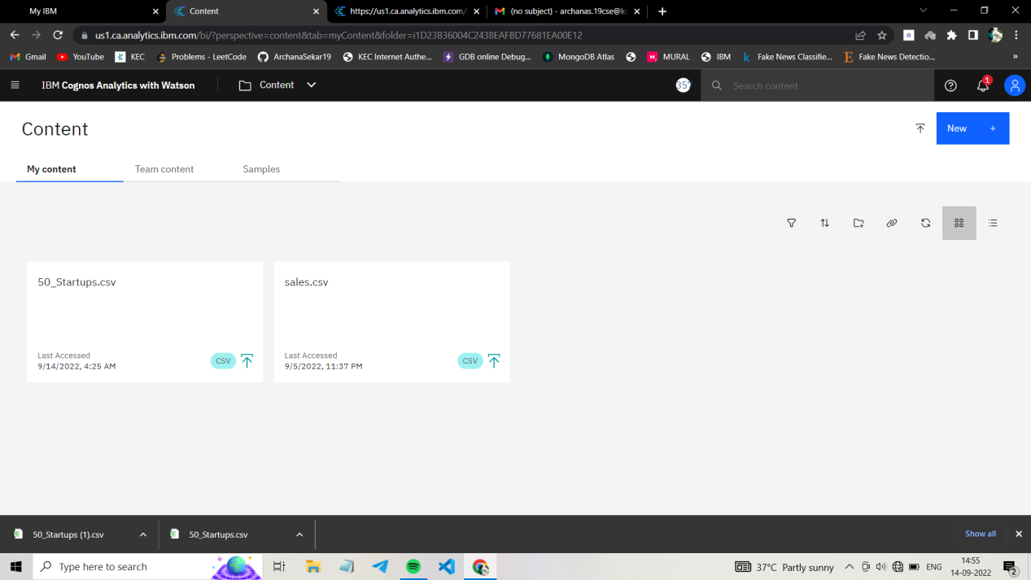

1)

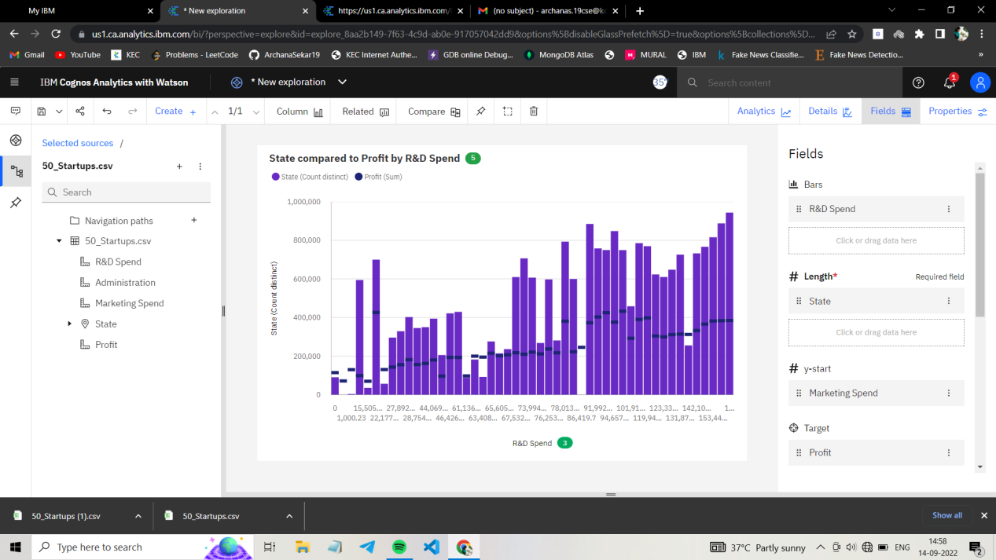

[https://us1.ca.analytics.ibm.com/bi/?perspective=explore&pathRef=.my_folders%2F1.1&subView=model000001833b522d91_00000004]("https://us1.ca.analytics.ibm.com/bi/?perspective=explore&pathRef=.my_folders%2F1.1&subView=model000001833b522d91_00000004)

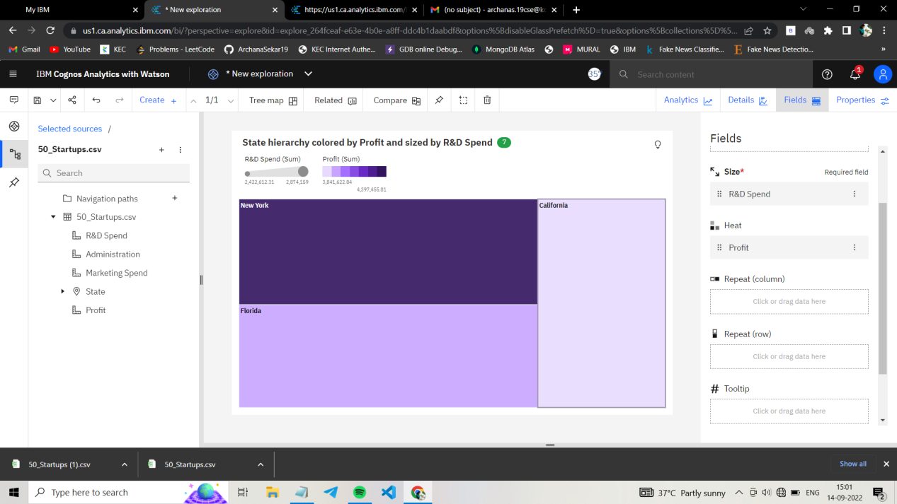2)

<https://us1.ca.analytics.ibm.com/bi/?perspective=explore&pathRef=.my_folders%2F1.2&subView=model000001833b569479_00000004>

3)

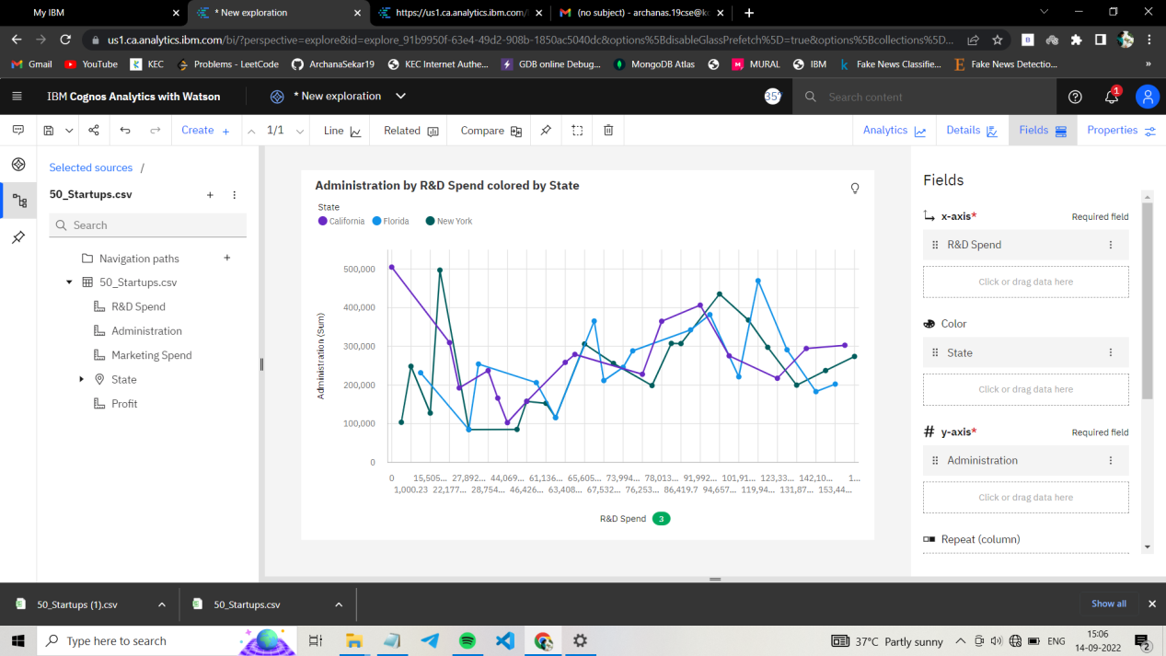

[https://us1.ca.analytics.ibm.com/bi/?perspective=explore&pathRef=.my_folders%2F1.3&subView=model000001833b59e7c5_00000004]("https://us1.ca.analytics.ibm.com/bi/?perspective=explore&pathRef=.my_folders%2F1.3&subView=model000001833b59e7c5_00000004)

4)

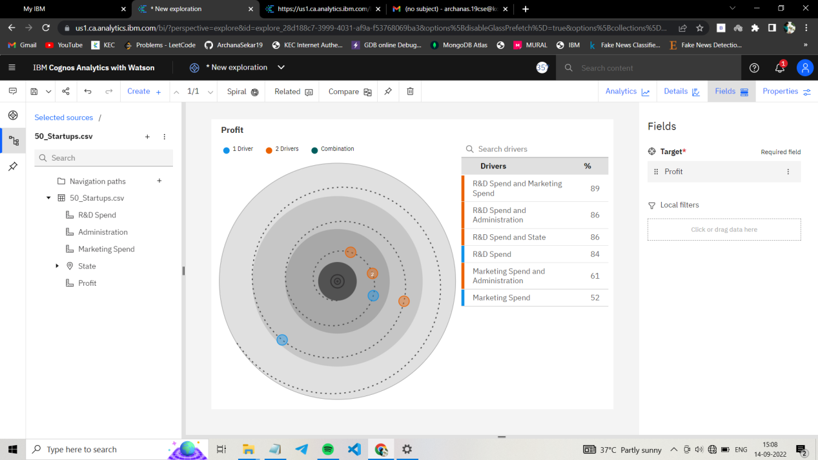

[https://us1.ca.analytics.ibm.com/bi/?perspective=explore&pathRef=.my_folders%2F1.4&subView=model000001833b5c75d7_00000004]("https://us1.ca.analytics.ibm.com/bi/?perspective=explore&pathRef=.my_folders%2F1.4&subView=model000001833b5c75d7_00000004)