|  |  |
| --- | --- |
| Date | 27 September 2022 |
| Team ID | PNT2022TMID01477 |
| Project Name | EARLY DETECTION OF CHRONIC KIDNEY DISEASE USING MACHINE LEARNING |
| Maximum Marks | 2 Marks |

PROBLEM DEFINITION:

1. CHRONIC KIDNEY DISEASE (CKD) is a disorder that disrupts the normal kidney function that is among the top 20 causes of death worldwide and it affects approximately 10% of the world’s adult population. Due to the increasing number of people with CHRONIC KIDNEY DIESEASE, effective predications measures for the early diagnosis of the CKD are required.
2. The goal is to diagnose CKD in its earliest stages using a diagnostic algorithm. The major problem that we are facing is that lack of ability to implement the huge datasets at the same time most of the algorithm will fail to give 100 percent accuracy about the prediction.

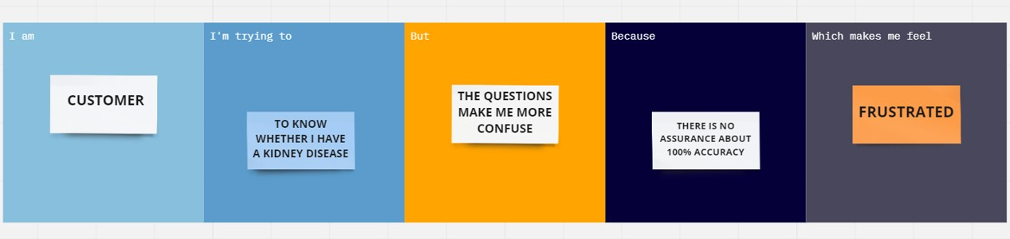

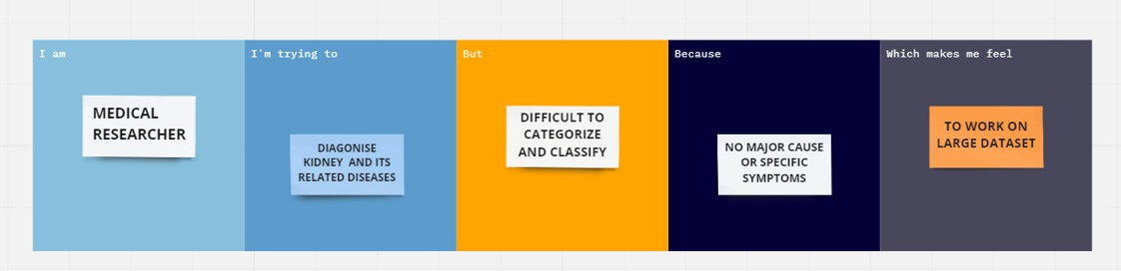

|  |  |  |  |  |  |
| --- | --- | --- | --- | --- | --- |
| **Problem Statement (PS)** | **Iam** | **I’m trying to** | **But** | **Because** | **Which makes me feel** |
| EARLY | I am A | I am Trying To Know Whether I Have A Kidney Disease | I Don’t Know What Are The Symptoms | I Have No Assurance About Whether It Will Predict Correctly | It Makes Confused |
| DETECTON OF  CHRONIC | Customer | And Ruin My Patience |
| KIDNEY |  |  |
| DISEASE |  |  |
| USING |  |  |
| MACHINE |  |  |
| LEARNING |  |  |
| EARLY | I am A | I am Trying | It Is Very | There Is No | It Makes Me To Work |
| DETECTON | Medical | To Diagnose | Difficult | Major Cause | On The Large Dataset |
| OF CHRONIC | Researcher | The Various | To | Or Specific | Earlier For The |
| KIDNEY |  | Relationship | Categorize | Symptoms | Correct Prediction To |
| DISEASE |  | With The | And | And Also | Avoid Frustrated Feel. |
| USING |  | Kindey | Classifying | Algorithm |  |
| MACHINE |  | Disease And | The Data | Can’t Able |  |
| LEARNING |  | The Related |  | To Handle |  |
|  |  | Problems |  | Large |  |
|  |  | And Their |  | Number Of |  |
|  |  | Major |  | Data Sets |  |
|  |  | Symptoms |  |  |  |