ASSIGNMENT 1

TEAM ID :PNT2022TMID04331

Diag 1:

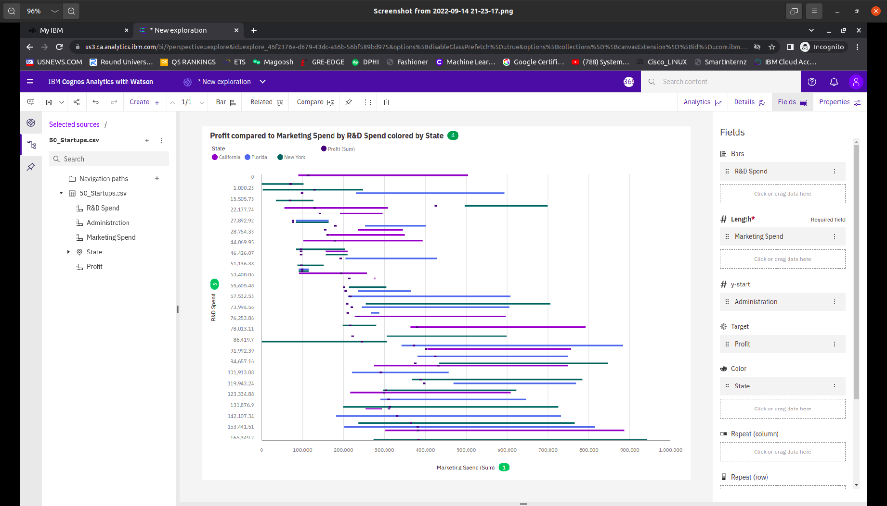

<https://us3.ca.analytics.ibm.com/bi/?perspective=explore&pathRef=.my_folders%2FAssignment1%2Fdiag1&subView=model000001833cb3159d_00000000>

Diag2:

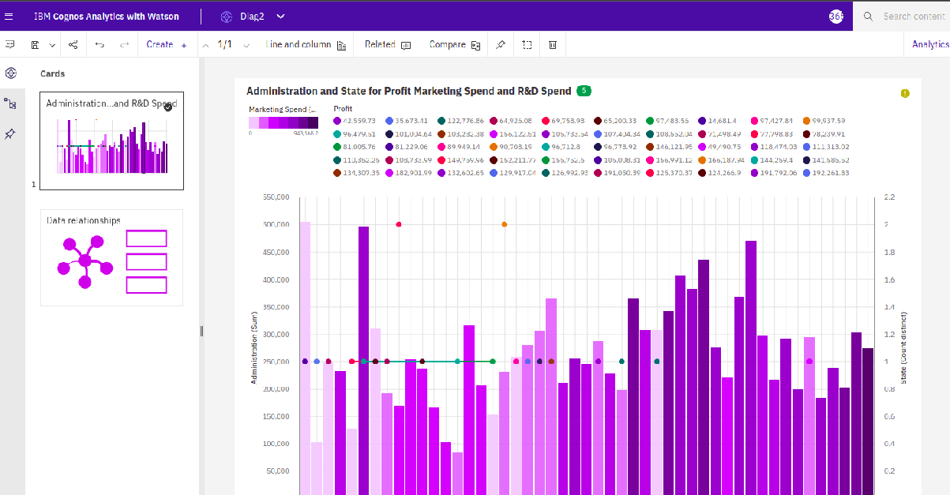

<https://us3.ca.analytics.ibm.com/bi/?perspective=explore&pathRef=.my_folders%2FAssignment1%2FDiag2&subView=model000001833cb8a53a_00000000>

Diag3:

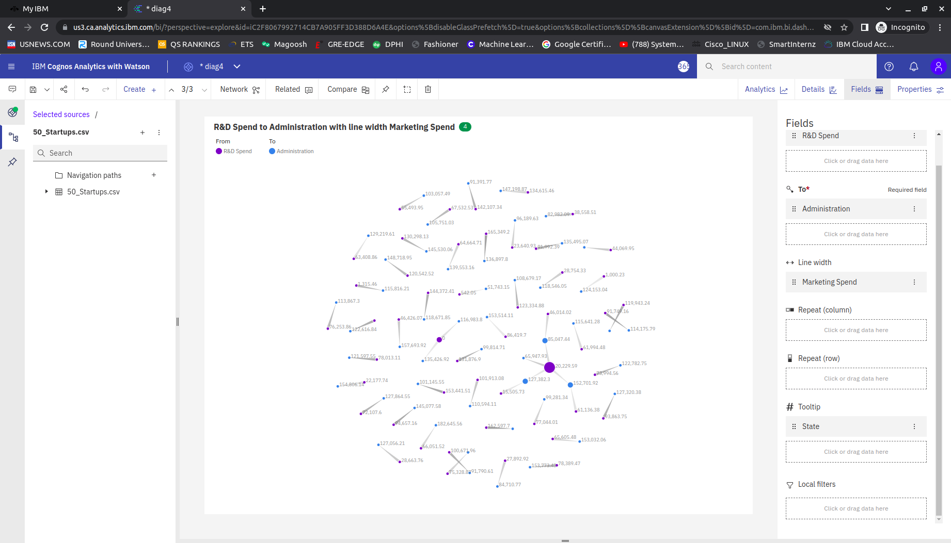

<https://us3.ca.analytics.ibm.com/bi/?perspective=explore&pathRef=.my_folders%2FAssignment1%2Fdiag3&subView=model000001833cc197c6_00000000>

Diag4:

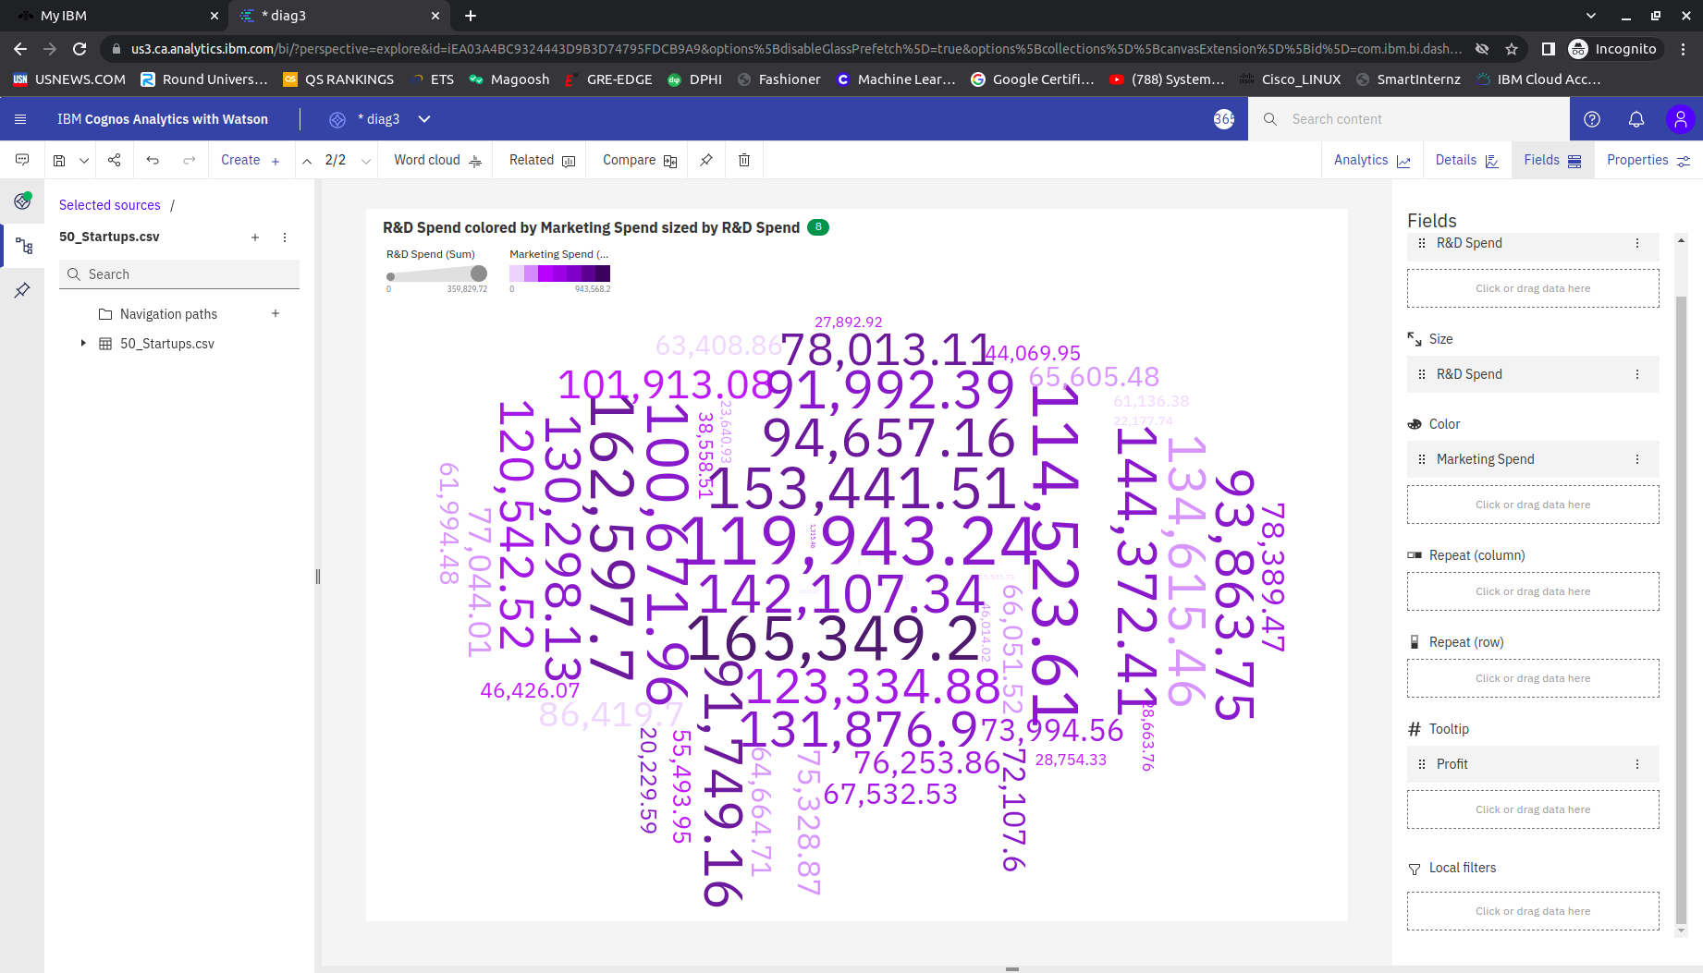

<https://us3.ca.analytics.ibm.com/bi/?perspective=explore&pathRef=.my_folders%2FAssignment1%2Fdiag4&subView=model000001833cc4c5a8_00000000>

Diag5:

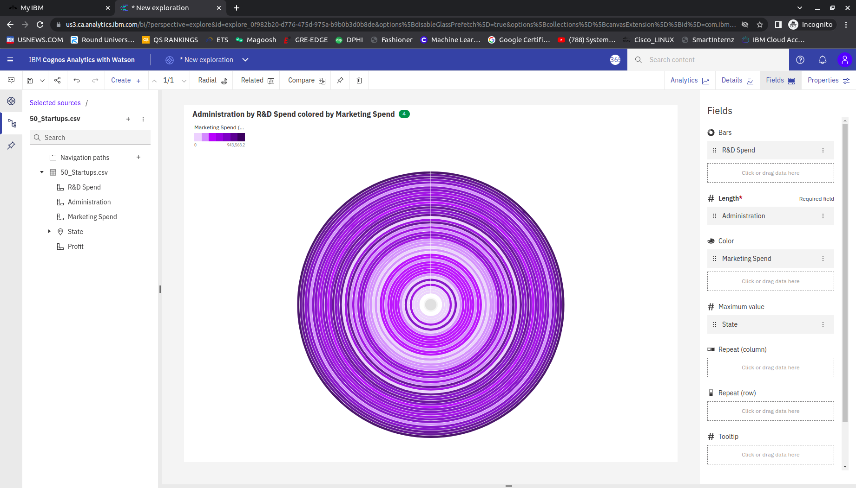

<https://us3.ca.analytics.ibm.com/bi/?perspective=explore&pathRef=.my_folders%2FAssignment1%2Fdiag5&subView=model000001833cc197c6_00000000>

Diag6:

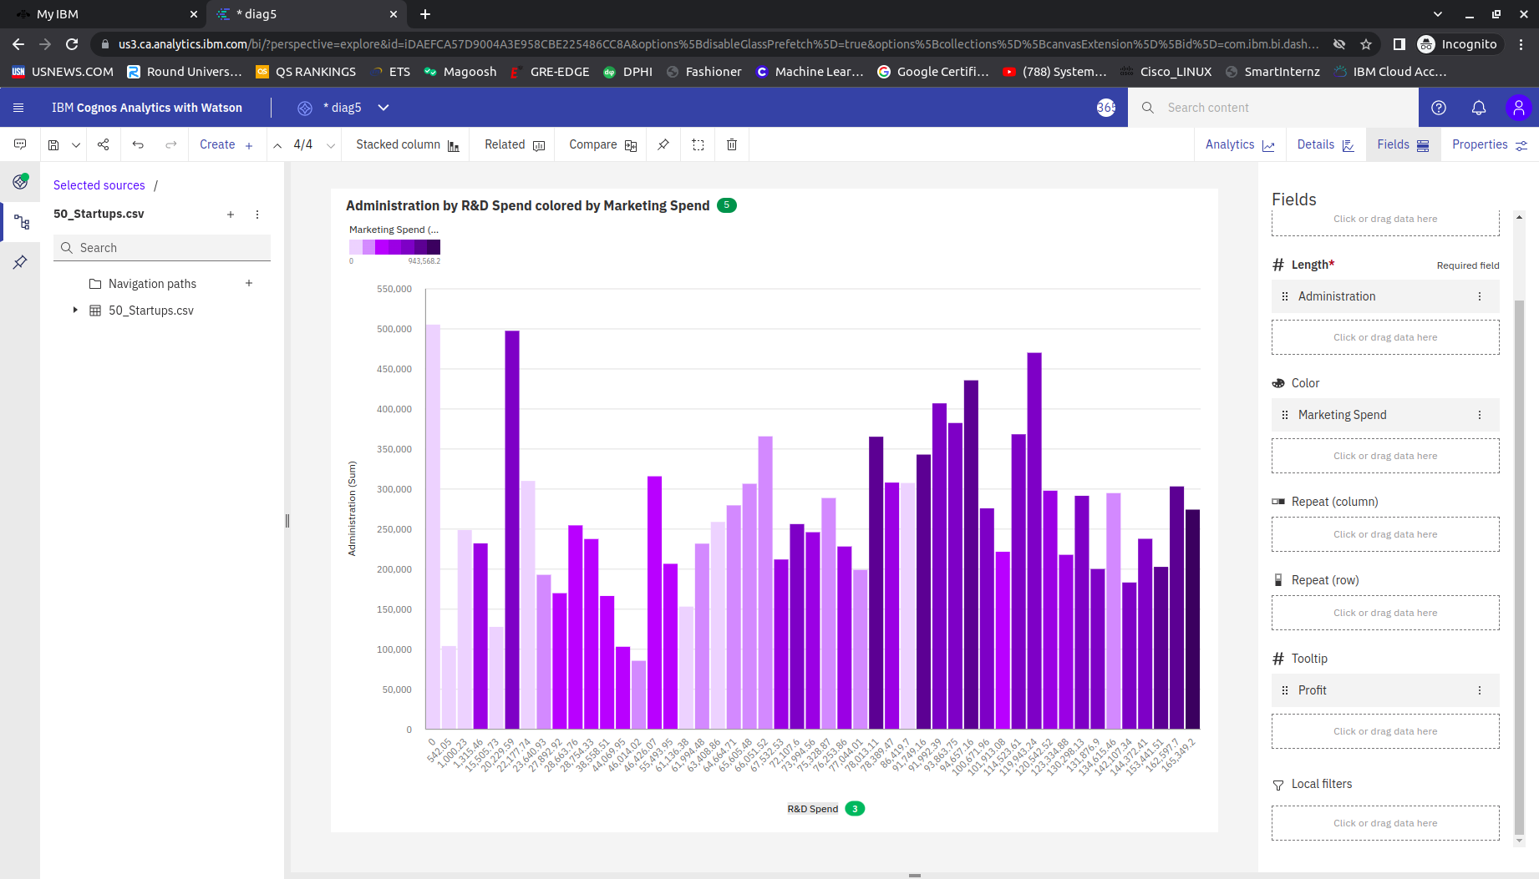

<https://us3.ca.analytics.ibm.com/bi/?perspective=explore&pathRef=.my_folders%2FAssignment1%2Fdiag6&subView=model000001833cc765bf_00000000>