|  |  |
| --- | --- |
| Team ID | PNT2022TMID00261 |
| Team Members | EVANS  BENIEL RICHARD  DHANUSH M  ANNABATHULA ROHITH |

**Machine Learning Based Vehicle Performance analyser**

Documentation

**Table of Contents**

#### INTRODUCTION 3

* 1. Project Overview 3
  2. Purpose 3

#### LITERATURE SURVEY 3

* 1. Existing Problem 3
  2. References 3

#### IDEATION & PROPOSED SOLUTION 4

* 1. Empathy Map Canvas 4

3.2) Ideation & Brainstroming 5

* 1. Proposed Solution 8
  2. Proposed Solution ﬁt 9

#### REQUIREMENT ANALYSIS 10

* 1. Functional requirement 10
  2. Non-Functional requirements 10

#### PROJECT DESIGN 11

* 1. Data Flow Diagrams 11
  2. Solution & Technical Architecture 12
  3. User Stories 12

#### PROJECT PLANNING & SCHEDULING 13

* 1. Sprint Planning & Estimation 13

6.2) Sprint Delivery Schedule 14

6.3 Reports from JIRA 15

#### CODING & SOLUTION 16

* 1. Feature 1 16
  2. Feature 2 16

#### TESTING 17

* 1. Test Cases 17
  2. User Accepting Testing 20

#### RESULTS 21

* 1. Performance Metrics 21

#### ADVANTAGES & DISADVANTAGES 21

1. CONCLUSION 22

#### FUTURE SCOPE 22

1. APPENDEX 23 Source Code 23 Github Link 25 Demo video Link: 25

# INTRODUCTION

## Project Overview

#### The automotive industry is extremely competitive. With increasing fuel prices and picky consumers. Automobile makers are constantly optimizing their processes to increase

fuel eﬃciency. So, we can help the predicting processor done easier by developing the application.

## Purpose

The purpose of this project is to give the customer a portal to predict the performance of the vehicle ( miles per gallon). Now a days fuel prices are increasing and automobile industries try to optimize the vehicle for running them using less fuel. This application helps them to predict the performance of the vehicle.

# LITERATURE SURVEY

## Existing Problem

It is hard to predict the performance of the vehicle. It takes us a lot of time and hard work to predict the performance. if the vehicle designing engineer able to predict the performance of vehicle with less amount of the time, It make the Engineer design and testing process easier for them.

## References

#### https:/[/www.researchgate.net/publication/273951090_Simulation_for_prediction_of_v](http://www.researchgate.net/publication/273951090_Simulation_for_prediction_of_ve)e hicle_eﬃciency_performance_range_and_lifetime_A_review_of_current_techniques_and

_their_applicability_to_current_and_future_testing_standards

https:/[/www.etssolution-asia.com/blog/vehicle-performance-engineering](http://www.etssolution-asia.com/blog/vehicle-performance-engineering)

# IDEATION & PROPOSED SOLUTION

## Empathy Map Canvas

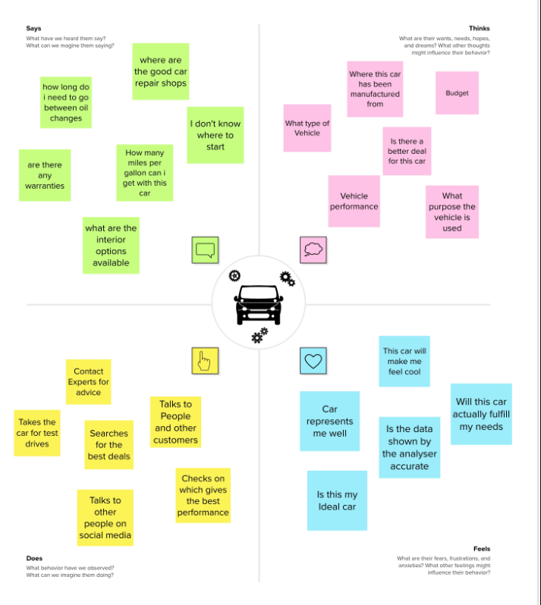

**3.2) Ideation & Brainstorming**

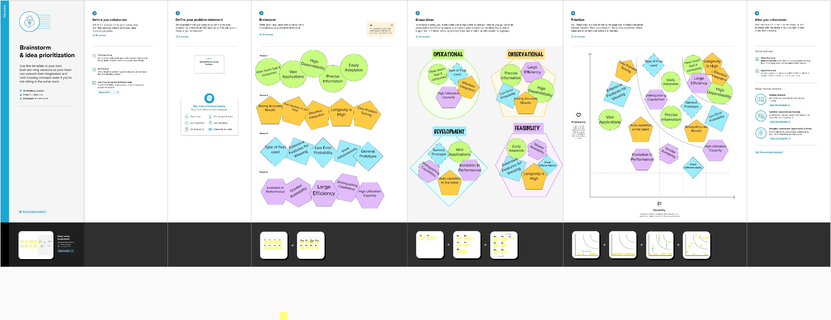

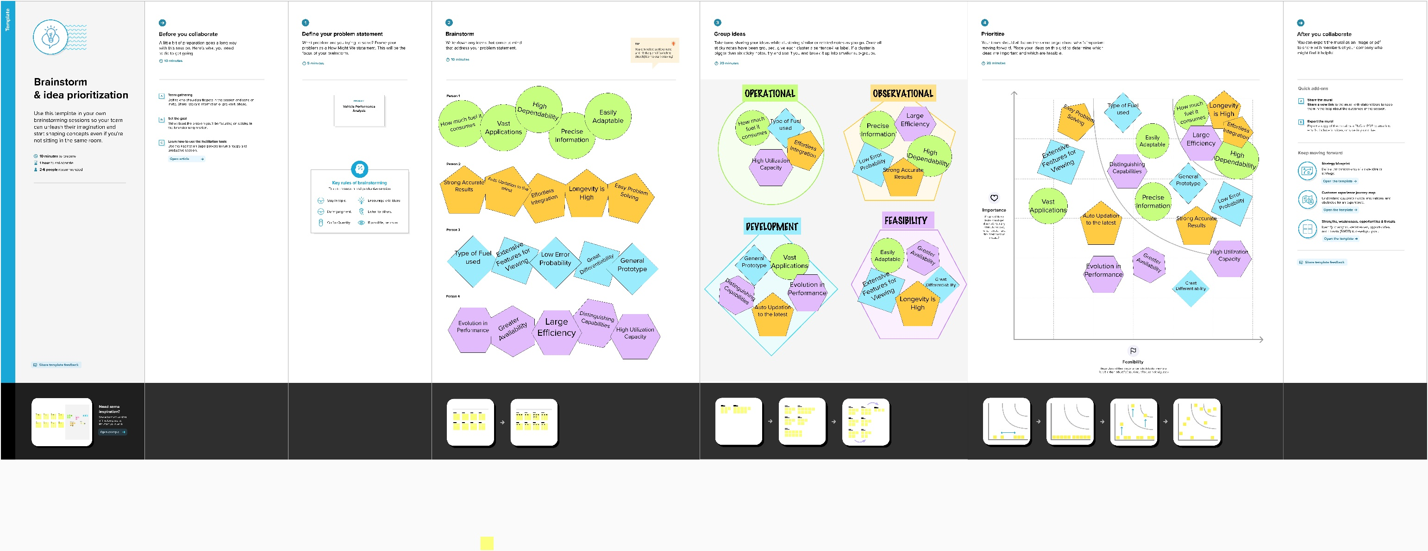

## **Proposed Solution**

|  |  |  |
| --- | --- | --- |
| **S.No.** | **Parameter** | **Description** |
| 1. | Problem Statement (Problem to be solved) | Vehicle user or manufacture trying to analyze the performance of the vehicle But, it is hard to analysis. Because it needs a knowledge of the engineering and vehicle, it takes time to do it manually, which makes users feel fear,  worried about the vehicle |
| 2. | Idea / Solution description | Dataset of the Vehicle performance need to be collected and need to analyze the data. Based on the data analysis Machine  Learning Model should be created and  need to test the accuracy of the model and the error of the model. |
| 3. | Novelty / Uniqueness | Using this Machine Learning project, we can develop the app in that app we can frequently update the dataset and train the model, So the user can get the accurate  data |
| 4. | Social Impact / Customer Satisfaction | The Social impact for this product is good,  It makes people life easier by perform analysis of the vehicle |
| 5. | Business Model (Revenue Model) | Agile Model, MVP (Minimum Viable  Product) Model |
| 6. | Scalability of the Solution | It can be further developed to provide app integration, we can further develop the  project to bring more accuracy. |

* 1. **Proposed Solution ﬁt**

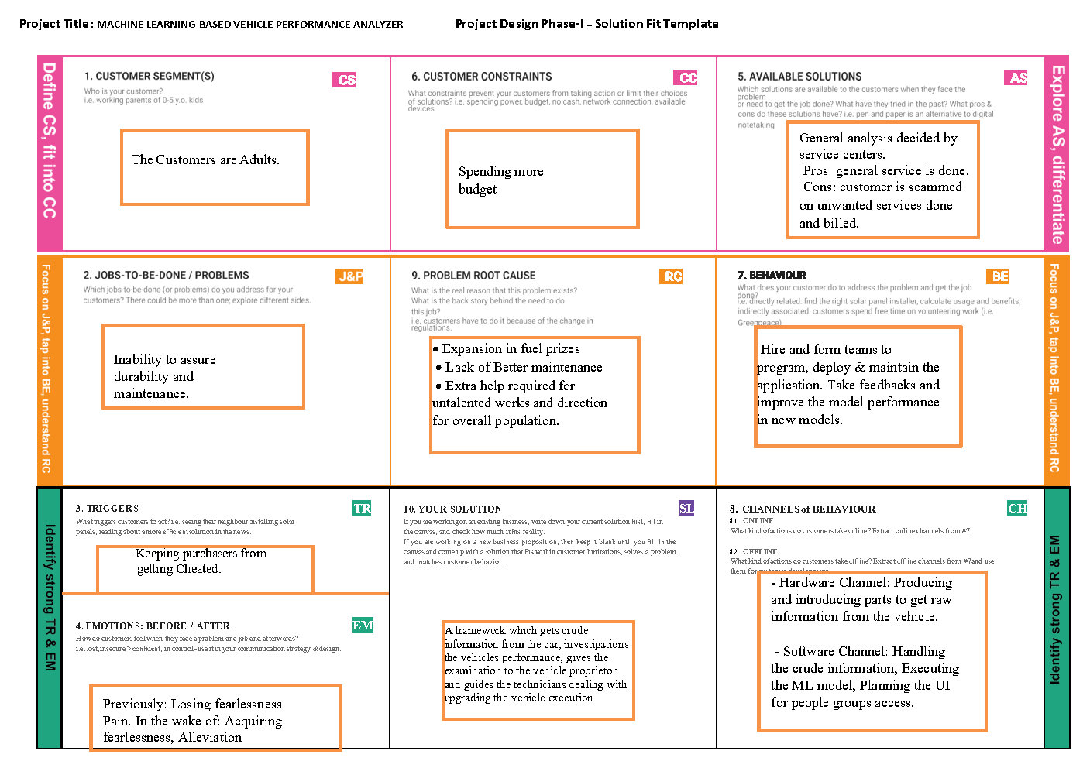

# **REQUIREMENT ANALYSIS**

## **Functional requirement**

|  |  |  |
| --- | --- | --- |
| **FR No.** | **Functional Requirement (Epic)** | **Sub Requirement (Story / Sub-Task)** |
| FR-1 | Collecting the details about the vehicle | Collecting Miles per gallon, number of cylinder, displacement, horsepower, weight, acceleration,  model_year, car name |
| FR-2 | Launch the website | launch the website in the browser and enter the  collected values and click submit |
| FR-3 | View the result | Then the user can able to view the performance score |
| FR-4 | Taking decision | By the result user can take decision to give the service to the vehicle or not based on the performance score |

* 1. **Non-Functional requirements**

|  |  |  |
| --- | --- | --- |
| **FR No.** | **Non-Functional Requirement** | **Description** |
| NFR-1 | **Usability** | It is hard for the people does not know about the terms used for the car.  It should be easy to understand the website |
| NFR-2 | **Security** | User data is completely secure. It will not get stored in the server  Https provides good encryption to the data |
| NFR-3 | **Reliability** | The website is reliable.  It has to be more accuracy |
| NFR-4 | **Performance** | The page load time, and the ML model predicting  time should be within 5sec |
| NFR-5 | **Availability** | The user can able to use the website 24hours |
| NFR-6 | **Scalability** | Can be scalable up to 2,00,000 ML product request predicting at a second  Can be scaled to used database to track the  previous previous statistics |

# PROJECT DESIGN

## **Data Flow Diagrams**

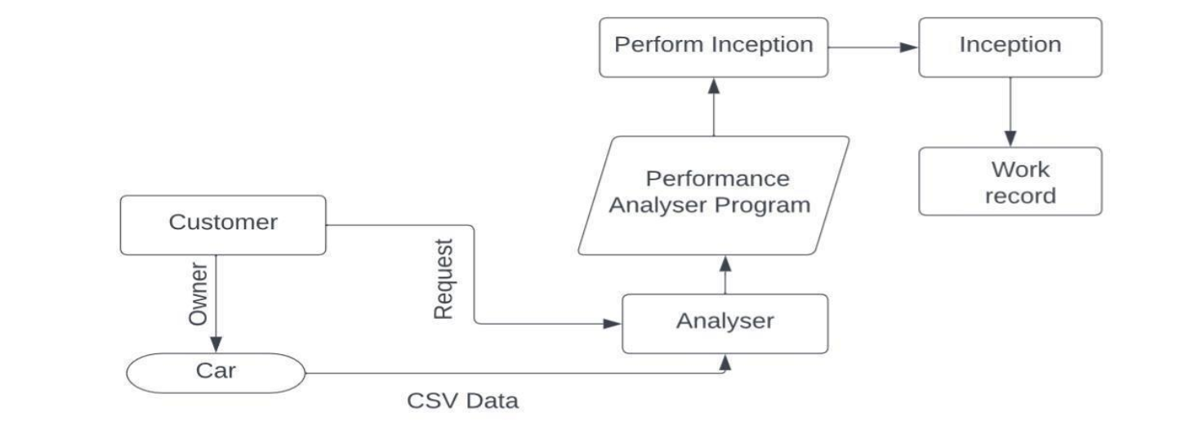

* 1. **Solution & Technical Architecture**

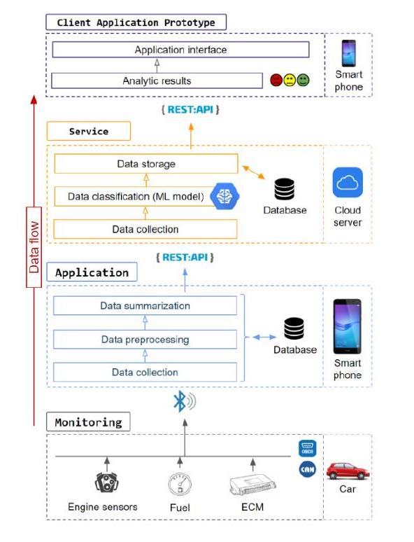

* 1. **User Stories**

|  |  |  |  |  |  |  |
| --- | --- | --- | --- | --- | --- | --- |
| **User Type** | **Functional Requirement (Epic)** | **User Story Numb**  **er** | **User Story / Task** | **Acceptance criteria** | **Priority** | **Release** |
| Customer(w eb user) | Visiting Webpage | USN-1 | As a user, I can able to view the website using the good  domain name | I can access the website | High | Sprint-4 |
|  | Design | USN-2 | As a user, I can able to Enter the data | I can submit the data to the server to predict | High | Sprint-1 |
|  |  |  | of the vehicle |  |  |  |
|  | Result | USN-3 | As a user, I can get the predicted performance of the vehicle using the  given data | I get the vehicle performance value | High | Sprint-2 |
|  | Design | USN-4 | As a user, I want the good user  experience. | I get easy understanding of website | Low | Sprint-3 |
|  | Result | USN-5 | As a user, I want the  website is fast | I get results faster | Low | Sprint-3 |
|  | Result | USN-6 | As a user, I expect the prediction is highly  accuracy. | I get most high accrued value | Medium | Sprint-4 |

# PROJECT PLANNING & SCHEDULING

## **Sprint Planning & Estimation**

|  |  |  |  |  |  |
| --- | --- | --- | --- | --- | --- |
| **Sprint** | **Functional Requirement**  **(Epic)** | **User Story**  **Number** | **User Story / Task** | **Story Points** | **Priority** |
| Sprint-4 | Visiting Webpage | USN-1 | As a user, I can able to view the website using the  good domain name | 10 | High |
| Sprint-1 | Design | USN-2 | As a user, I can able to Enter the  data of the vehicle | 20 | High |
| Sprint-2 | Result | USN-3 | As a user, I can get the predicted performance of the vehicle using the  given data | 20 | High |
| Sprint-3 | Design | USN-4 | As a user, I want the good user  experience. | 10 | Low |
| Sprint-3 | Result | USN-5 | As a user, I want  the website is fast | 10 | Low |
| Sprint-4 | Result | USN-6 | As a user, I expect the prediction is  highly accuracy. | 10 | Medium |

**6.2) Sprint Delivery Schedule**

|  |  |  |  |  |  |  |
| --- | --- | --- | --- | --- | --- | --- |
| **Sprint** | **Total Story Points** | **Duration** | **Sprint Start Date** | **Sprint End Date (Planned)** | **Story Points Completed (as on Planned End**  **Date)** | **Sprint Release Date (Actual)** |
| Sprint-1 | 20 | 6 Days | 24 Oct  2022 | 29 Oct 2022 | 20 | 29 Oct 2022 |
| Sprint-2 | 20 | 6 Days | 31 Oct  2022 | 05 Nov 2022 | 20 | 05 Nov 2022 |
| Sprint-3 | 20 | 6 Days | 09 Nov  2022 | 12 Nov 2022 | 20 | 12 Nov 2022 |
| Sprint-4 | 20 | 6 Days | 18 Nov  2022 | 19 Nov 2022 | 20 | 19 Nov 2022 |

# CODING & SOLUTION

## **Feature 1**

Created a GUI based interface for the easy integration of the user using the HTML, CSS, Python Flask. Code in Appendix

Output

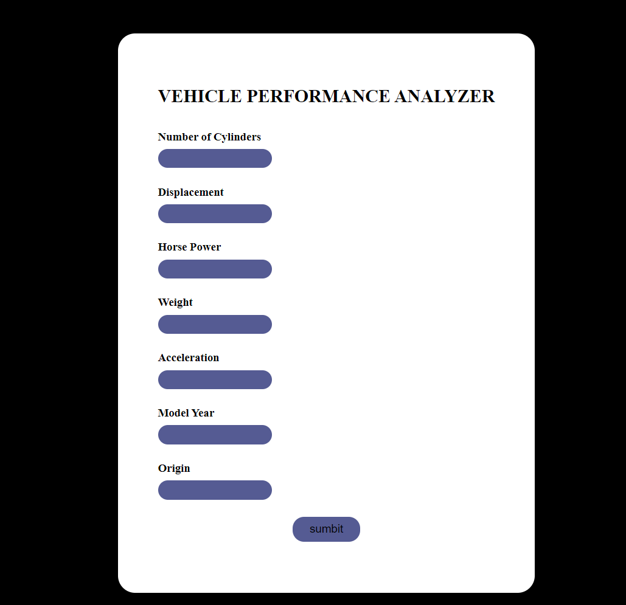

## **Feature 2**

implementation of the Model integrated with HTML and CSS in Appendix.

# **TESTING**

## **Test Cases**

**Input dataset:**

array([[-0.76894131, -0.6338073 , -0.6601792 , -0.55841396, 0.37006707,

-0.38798451, -0.75260027],

[ 1.64342359, 2.07850256, 3.38793037, 1.59935958, -2.34958594,

-0.64240058, -0.75260027],

[-0.76894131, -0.50697267, -0.55222961, -0.74265735, -1.53369004,

1.64734406, -0.75260027],

[ 0.43724114, 0.37111326, -0.25536825, 0.40177755, 0.17580614,

-0.13356844, -0.75260027],

[ 1.64342359, 1.15163409, 0.68919065, 1.08206084, -0.05730697,

0.88409585, -0.75260027],

[-0.76894131, -0.86796355, -1.06499016, -1.03791919, 0.25351051,

1.39292799, -0.75260027],

[-0.76894131, -0.87772006, -0.714154 , -0.73675211, -0.40697665,

-0.38798451, 0.47613487],

[-0.76894131, -0.99479818, -1.01101537, -1.28593914, 0.68088456,

1.13851192, 0.47613487],

[-0.76894131, -0.87772006, -1.01101537, -1.10878203, 0.33121488,

0.37526371, 1.70487001],

[ 0.43724114, 0.1272005 , -0.52524222, -0.39779152, 0.17580614,

-1.4056488 , -0.75260027],

[-0.76894131, -1.08260677, -1.41582632, -1.50561395, 0.37006707,

-0.38798451, 1.70487001],

[ 1.64342359, 1.59067705, 2.03856051, 1.71982642, -1.33942911,

0.12084763, -0.75260027],

[ 0.43724114, 0.61502602, -0.714154 , 0.76790224, 2.11841544,

0.12084763, -0.75260027],

[-0.76894131, -0.41916407, -0.22838085, -0.30566982, -0.64008976,

1.64734406, 1.70487001],

[-0.76894131, -0.64356381, 0.2304049 , -0.81470124, -1.18402036,

-1.4056488 , 0.47613487],

[ 1.64342359, 1.27846872, 1.2289386 , 0.6049177 , -1.76680315,

-1.4056488 , -0.75260027],

[-0.76894131, -0.87772006, -0.714154 , -0.86902942, 0.09810177,

1.13851192, 0.47613487],

[ 1.64342359, 1.59067705, 0.55425367, 1.15292368, 0.71973674,

0.88409585, -0.75260027],

[-0.76894131, -0.87772006, -0.44428003, -0.93753017, -0.40697665,

-1.15123272, 1.70487001],

[-0.76894131, -0.87772006, -0.714154 , -0.86666732, -0.56238539,

0.37526371, 0.47613487],

[ 1.64342359, 1.27846872, 0.82412764, 1.07025036, -0.13501135,

0.88409585, -0.75260027],

[-0.76894131, -0.72161589, -0.25536825, -0.76273515, -0.01845479,

-0.89681665, 1.70487001],

[-0.76894131, -1.13138933, -1.06499016, -1.35916408, 1.34137172,

-1.15123272, 1.70487001],

[-0.76894131, -0.83869402, -0.57921701, -0.85249475, -0.09615916,

0.12084763, 0.47613487],

[-0.76894131, -0.77039845, -0.93005317, -0.80170972, 0.52547581,

1.64734406, 1.70487001],

[-1.37203254, -1.14114584, -0.20139345, -0.70132069, -0.79549851,

-0.89681665, 1.70487001],

[-0.76894131, -0.99479818, -0.93005317, -1.15602393, 0.48662363,

0.37526371, 1.70487001],

[-0.76894131, -0.30208595, -0.33633044, -0.40015361, -0.40697665,

1.64734406, -0.75260027],

[-0.76894131, -0.45819012, -0.33633044, -0.06946035, 0.33121488,

1.64734406, -0.75260027],

[-0.76894131, -0.7313724 , -0.44428003, -0.33519601, 1.18596297,

1.64734406, -0.75260027],

[ 1.64342359, 1.91264189, 1.76868654, 0.75491072, -2.15532501,

-1.4056488 , -0.75260027],

[-0.16585009, -0.03866017, -0.74114139, 0.71593615, 1.76874576,

0.88409585, 0.47613487],

[ 1.64342359, 1.60043356, 1.28291339, 1.5249536 , -1.06746381,

0.12084763, -0.75260027],

[-0.76894131, -0.45819012, -0.49825482, -0.1580389 , 0.0203974 ,

1.64734406, -0.75260027],

[ 1.64342359, 1.27846872, 1.2289386 , 1.85919001, -0.40697665,

-0.13356844, -0.75260027],

[-0.76894131, -0.78015496, -0.49825482, -0.54306034, -0.01845479,

0.12084763, 0.47613487],

[-0.76894131, -0.64356381, 0.14944271, -0.31157506, -0.60123758,

-0.64240058, 0.47613487],

[ 0.43724114, 0.42965232, 0.14944271, 0.13604189, -0.21271572,

-0.13356844, -0.75260027],

[ 0.43724114, 0.37111326, 0.01450573, 0.60846084, -0.01845479,

-1.15123272, -0.75260027],

[-0.76894131, -0.72161589, -0.25536825, -0.6517167 , -0.21271572,

-1.4056488 , 1.70487001],

[ 1.64342359, 1.91264189, 2.03856051, 2.39892865, -1.57254222,

-1.15123272, -0.75260027],

[ 0.43724114, 0.43940883, -0.39030523, 0.33800099, 0.64203237,

0.62967978, -0.75260027],

[-0.76894131, -0.86796355, -0.98402797, -1.03791919, 1.14711079,

0.37526371, 1.70487001],

[-0.76894131, -0.6338073 , -0.49825482, -0.82414962, 0.37006707,

-0.89681665, -0.75260027],

[ 1.64342359, 2.07850256, 1.76868654, 2.15208975, -1.37828129,

-1.15123272, -0.75260027],

[-0.76894131, -0.93625912, -1.01101537, -1.26822343, -0.67894195,

1.13851192, 1.70487001],

[ 1.64342359, 1.60043356, 1.44483777, 1.69974861, -0.98975944,

-0.64240058, -0.75260027],

[-0.76894131, -0.3508685 , -0.39030523, -0.29031621, 0.37006707,

1.13851192, -0.75260027],

[-0.76894131, -0.86796355, -0.39030523, -0.77808877, -0.01845479,

-0.64240058, 0.47613487],

[ 1.64342359, 2.36144136, 2.52433366, 2.39538551, -1.57254222,

-0.64240058, -0.75260027],

[-0.76894131, -0.3508685 , -0.33633044, 0.1313177 , 1.92415451,

1.64734406, -0.75260027],

[-0.76894131, -1.05333724, -0.93005317, -1.00366882, 1.53563265,

-1.15123272, 0.47613487],

[ 0.43724114, 0.61502602, -0.17440605, 0.71003092, 1.34137172,

0.37526371, -0.75260027],

[-0.76894131, -0.45819012, -0.44428003, -0.03993416, 0.68088456,

0.88409585, -0.75260027],

[ 0.43724114, 0.42965232, 1.63374955, 0.61554713, -0.83435069,

0.62967978, -0.75260027],

[ 1.64342359, 2.61511063, 3.25299338, 1.77297355, -2.15532501,

-1.4056488 , -0.75260027],

[-0.76894131, -1.12163282, -0.95704057, -1.54813166, 0.95284986,

-1.15123272, 1.70487001],

[ 0.43724114, 0.1272005 , -0.52524222, 0.04864439, 0.09810177,

0.62967978, -0.75260027],

[-0.76894131, -0.87772006, -0.44428003, -0.76155411, 1.34137172,

-0.64240058, 1.70487001],

[-0.76894131, -0.87772006, -0.33633044, -0.75092468, 0.564328 ,

-0.89681665, 1.70487001],

[ 0.43724114, 0.37111326, -0.12043126, 0.59783142, 0.64203237,

0.62967978, -0.75260027],

[ 0.43724114, 0.43940883, -0.12043126, -0.15921995, -0.21271572,

-0.64240058, -0.75260027],

[-0.76894131, -0.3508685 , -0.39030523, -0.22299651, 0.95284986,

1.64734406, -0.75260027],

[ 1.64342359, 1.12236455, 0.95906463, 0.62027132, -1.96106408,

-1.4056488 , -0.75260027],

[ 0.43724114, 0.61502602, -0.12043126, 0.48681296, 0.564328 ,

-0.38798451, -0.75260027],

[-0.76894131, -0.51672918, -0.39030523, -0.25134164, -0.01845479,

1.13851192, 1.70487001],

[-0.76894131, -0.65332032, -0.47126742, 0.06517905, 1.53563265,

-0.89681665, 0.47613487],

[-0.76894131, -0.78015496, -0.79511619, -0.84895161, -0.40697665,

1.64734406, 1.70487001],

[-0.76894131, -0.86796355, -0.25536825, -1.03673814, 1.34137172,

-1.15123272, -0.75260027],

[ 0.43724114, 0.6930781 , 0.14944271, 0.04510125, -0.79549851,

-1.15123272, -0.75260027],

[-0.76894131, -0.93625912, -0.93005317, -1.14421345, 1.92415451,

-1.15123272, -0.75260027],

[ 0.43724114, -0.23379038, 0.77015285, 0.57421047, 0.09810177,

0.62967978, 0.47613487],

[ 1.64342359, 0.71259112, 0.14944271, 1.34189126, 1.34137172,

0.37526371, -0.75260027],

[ 1.64342359, 1.27846872, 1.2289386 , 1.81076706, -0.79549851,

-0.38798451, -0.75260027],

[-0.76894131, -0.69234636, -0.79511619, -0.90446084, -0.01845479,

-0.64240058, 0.47613487],

[ 0.43724114, 0.1272005 , -0.39030523, -0.05764987, 0.564328 ,

-0.38798451, -0.75260027],

[-0.76894131, -0.30208595, 0.01450573, -0.14622843, -0.44582883,

1.13851192, -0.75260027],

[-0.76894131, -0.6338073 , -0.49825482, -0.62455261, 0.17580614,

-0.89681665, -0.75260027],

[-0.76894131, -0.70210287, -0.25536825, -0.27141945, -0.21271572,

-0.13356844, 0.47613487],

[ 1.64342359, 1.12236455, 0.95906463, 1.4375561 , -0.60123758,

-0.38798451, -0.75260027]])

**Predicted Output:**

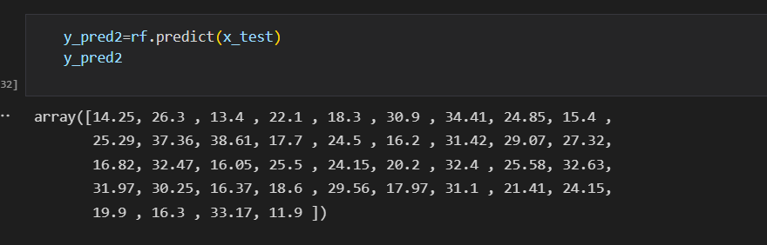

## **User Accepting Testing**

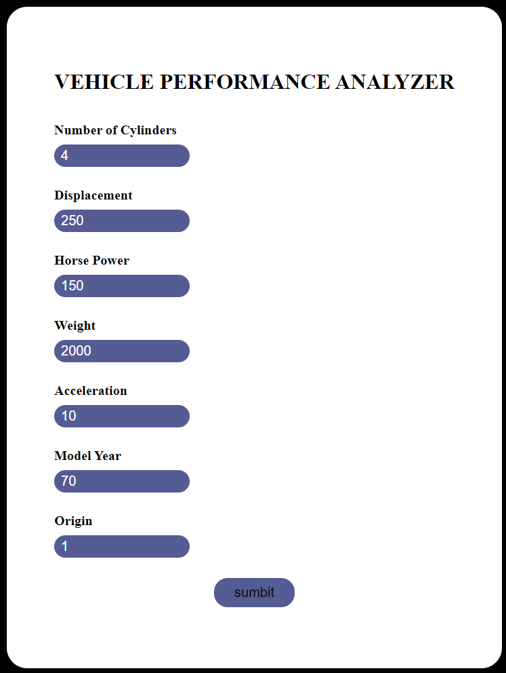**Input:**

**Output:**



# RESULTS

* 1. **Performance Metrics**

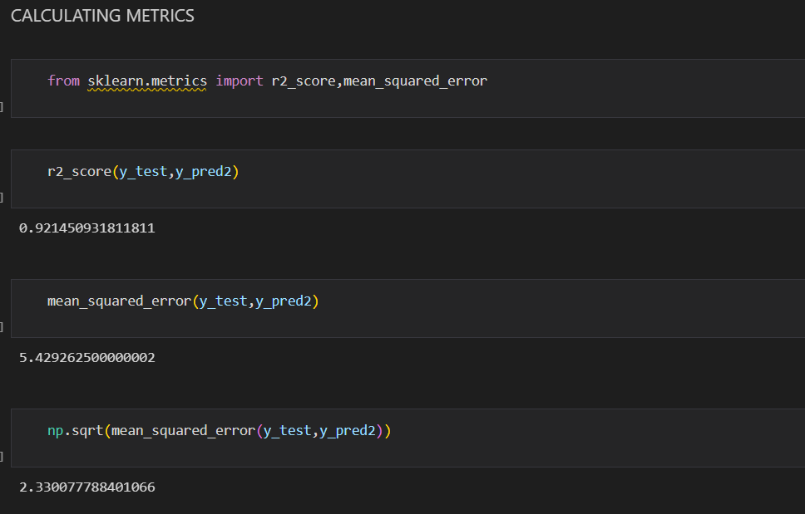

# ADVANTAGES & DISADVANTAGES

**Advantages:**

* It made easy to predict the performance of the Vehicle.
* It can we accessible everyone who want to predict the performance of the vehicle using the internet.

**Disadvantages:**

* Need to Increase the Accuracy of the Project
* Cost for deploying in IBM CLOUD for permanent usage.
* In Program API Key is Publicly available, it may give rise to the security risk.

# CONCLUSION

#### The automotive industry is extremely competitive. With increasing fuel prices and picky consumers. Automobile makers are constantly optimizing their processes to increase

fuel eﬃciency. The performance analysis of the car is based on the various parameters. These are the factors on which the health of the car is analyzed, improved to gain the competitive advantage. This application will solve the problems in evaluation of the

vehicle performance and helps us decide the vehicle based on the needs.

# FUTURE SCOPE

* Developing the CSS and Animation of the Website
* Developing the High Accuracy Model
* Developing the Code to make API key highly secure

# APPENDEX

## Source Code

### Code:

**index.html**

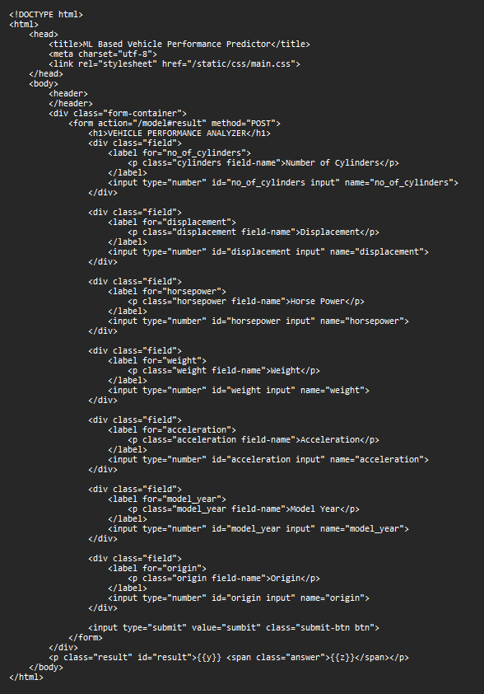

### main.css

### 

**App.py**

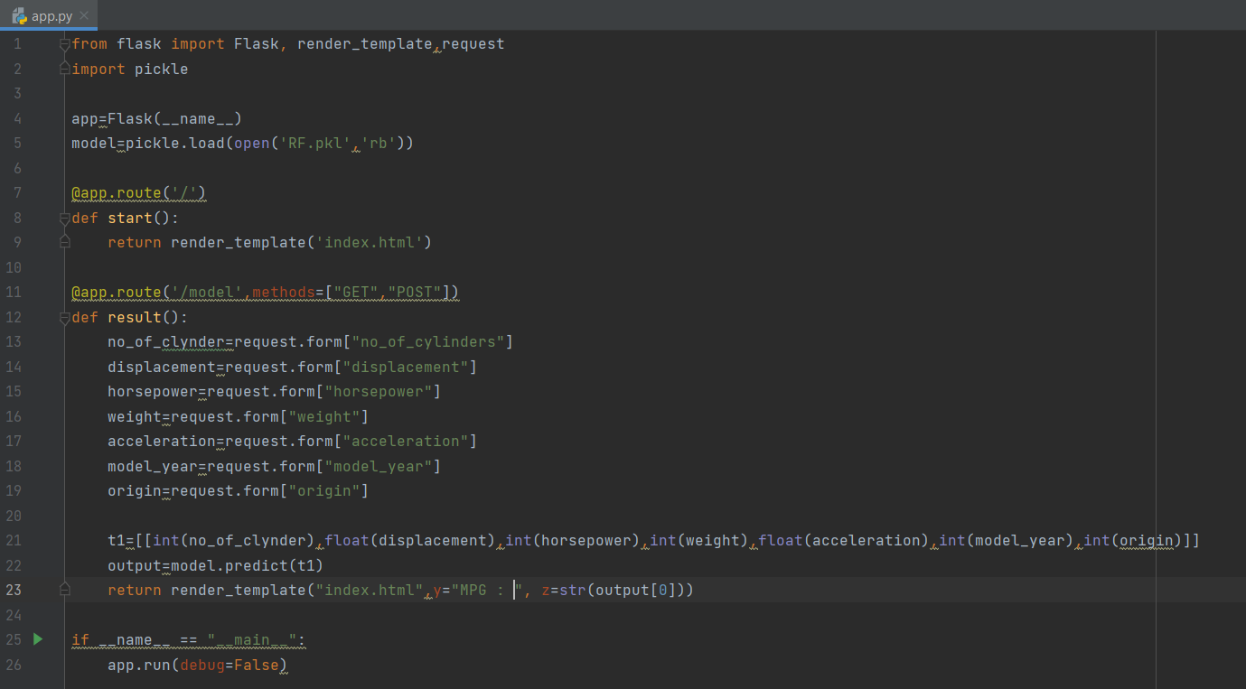

## Github Link

<https://github.com/IBM-EPBL/IBM-Project-10960-1659248136>

Demo Video Link:

<https://drive.google.com/file/d/1HISiX0aKiVy5Na0IuJJZOLx2m61FLCnC/view?usp=sharing>