**SMARTFARMER - IOT ENABLED SMART FARMING APPLICATION**

**CIRCUIT DIAGRAM:**

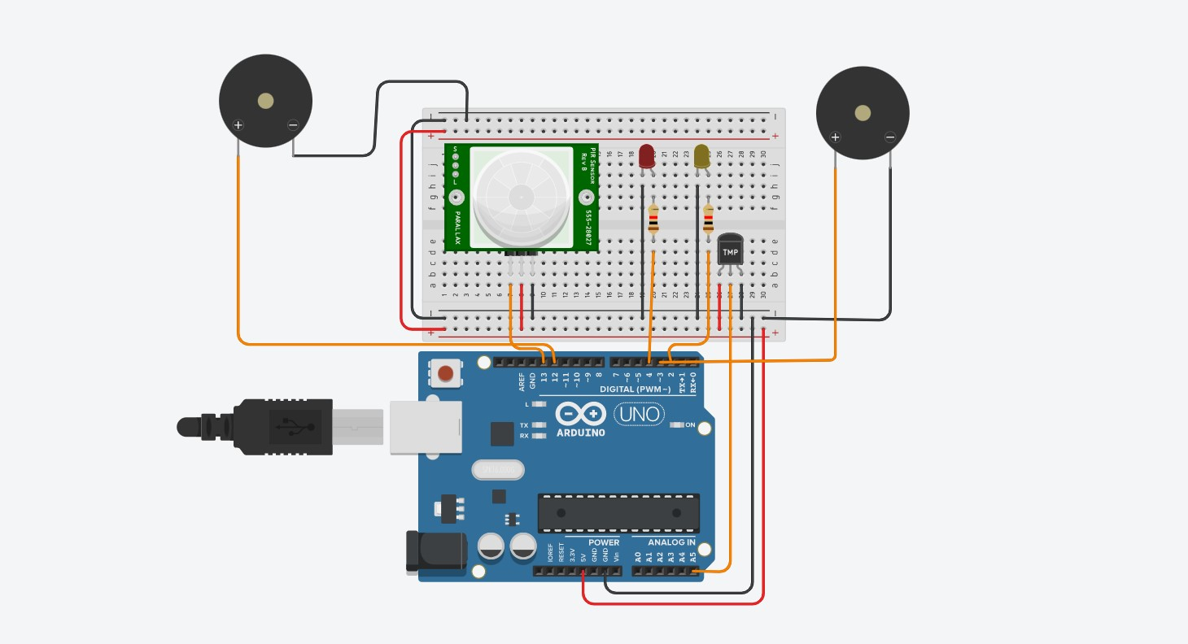

**CODE:**

int pirsensor=13;

int tempsensor=A5;

int ledpir=4;

int ledtmp=2;

int buzzpir=12;

int buzztmp=3;

void setup()

{

pinMode(pirsensor,INPUT);

pinMode(tempsensor,INPUT);

pinMode(ledpir,OUTPUT);

pinMode(ledtmp,OUTPUT);

pinMode(buzzpir,OUTPUT);

pinMode(buzztmp,OUTPUT);

Serial.begin(9600);

}

void loop()

{

int pirread=digitalRead(pirsensor);

Serial.println(pirread);

int tempread= map(((analogRead(tempsensor) - 20) * 3.04), 0, 1023, -40, 125);

Serial.println(tempread);

if(pirread==1)

{

digitalWrite(ledpir,HIGH);

digitalWrite(buzzpir,HIGH);

}

else

{

digitalWrite(ledpir,LOW);

digitalWrite(buzzpir,LOW);

}

if(tempread>42)

{

digitalWrite(ledtmp,HIGH);

digitalWrite(buzztmp,HIGH);

}

else

{

digitalWrite(ledtmp,LOW);

digitalWrite(buzztmp,LOW);

}

}