### Before you collaborate

A little bit of preparation goes a long way with this session. Here’s what you need to do to get going.

**10 minutes**

### 1

**Define your problem statement**

What problem are you trying to solve? Frame your problem as a How Might We statement. This will be the focus of your brainstorm.

**5 minutes**

Feature extraction from processed image

**2**

### Brainstorm

Write down any ideas that come to mind that address your problem statement.

**10 minutes**

### 3

**Group ideas**

**TIP**

You can select a sticky note and hit the pencil [switch to sketch] icon to start drawing!

Take turns sharing your ideas while clustering similar or related notes as you go. In the last 10 minutes, give each cluster a sentence-like label. If a cluster is bigger than six sticky notes, try and see if you and break it up into smaller sub-groups.

**20 minutes**

### 4

**Prioritize**

Your team should all be on the same page about what's important moving forward. Place your ideas on this grid to determine which ideas are important and which are feasible.

**20 minutes**

### After you collaborate

You can export the mural as an image or pdf to share with members of your company who might find it helpful.

# Brainstorm

**& idea prioritization**

Use this template in your own brainstorming sessions so your team can unleash their imagination and start shaping concepts even if you're not sitting in the same room.

**10 minutes** to prepare

1. **Team gathering**

Define who should participate in the session and send an invite. Share relevant information or pre-work ahead.

1. **Set the goal**

Think about the problem you'll be focusing on solving in the brainstorming session.

1. **Learn how to use the facilitation tools**

Use the Facilitation Superpowers to run a happy and productive session.

[**Open article**](https://support.mural.co/en/articles/2113740-facilitation-superpowers)

.

The handwritten digit recognition is the capability of computer application to recognize the human hand written digit.It is hard task for the machine because handwritten digits are not perfect and can be made with many different shapes and sizes.

#### VIMALA

Detects the scanned images of handwritten digits

Using CNN to predict real time hand written valu

Image segmentation

#### SARITHA

Improve response system

CNN has hidden layers that detects the digits

Plays an important role in modern world

#### SIVASAKTHI.S

Preprocessing of dataset

Import libraries and loading the dataset

Train the predictive model with the large dataset

the model takes images and classifes them in a certain category

Feature extraction from processed image

Classifcation and recognition of digits

accurate and effective

makes human job easer in banking system

#### GUNADEVI.B

**TIP**

Add customizable tags to sticky notes to make it easier to find, browse, organize, and categorize important ideas as themes within your mural.

To have

Creating and training the model

**Quick add-ons**

* 1. **Share the mural**

**Share a view link** to the mural with stakeholders to keep them in the loop about the outcomes of the session.

* 1. **Export the mural**

Export a copy of the mural as a PNG or PDF to attach to emails, include in slides, or save in your drive.

**Keep moving forward**

**1 hour** to collaborate

**2-8 people** recommended

Using CNN predict real hand

written digits

Image Classification and recognition

Convert handwritten digit into machine readable formats

Importing large dataset

Evaluating the model

Acquisition of image

accuracy in recognition train

**Strategy blueprint**

Define the components of a new idea or strategy.

### Key rules of brainstorming

to detect the digits

construct the ural network with hidden yers and train

la

ne

To run an smooth and productive session

train with many vareity of

Preprocessing the data

Applying statistical techniques for

High

Can be used in

many applications like postal mail sorting

analyse the image clearly

Classifcation and recognition of digits

use different

the digits can be identified from the

the digits can be classified from words,letters and characters

Identifes digits

## developing an AI predictive

[**Open the template**](https://app.mural.co/template/e95f612a-f72a-4772-bc48-545aaa04e0c9/984865a6-0a96-4472-a48d-47639307b3ca)

**Customer experience journey map**

the model with

large dataset

Understand customer needs, motivations, and

Stay in topic.

Defer judgment.

Encourage wild ideas.

Listen to others.

handwrittings

preprocessing and

recognizing the digits

accuracy

algorithms

given text

automatically

### Importance

If each of these

## model to predict

the handwritten digits

obstacles for an experience.

[**Open the template**](https://app.mural.co/template/b7114010-3a67-4d63-a51d-6f2cedc9633f/c1b465ab-57af-4624-8faf-ebb312edc0eb)

Go for volume. If possible, be visual.

tasks could get

done without any difficulty or cost, which would have the most positive impact?

**Strengths, weaknesses, opportunities & threats**

Identify strengths, weaknesses, opportunities, and threats (SWOT) to develop a plan.

|  |  |
| --- | --- |
|  |  |
|  |  |

[**Open the template**](https://app.mural.co/template/6a062671-89ee-4b76-9409-2603d8b098be/ca270343-1d54-4952-9d8c-fbc303ffd0f2)

**TIP**

Participants can use their cursors to point at where sticky notes should go on the grid. The facilitator can confirm the spot by using the laser pointer holding the **H key** on the keyboard.

[**Share template feedback**](https://muralco.typeform.com/to/CiqaHVat?typeform-source=app.mural.co)

[**Share template feedback**](https://muralco.typeform.com/to/CiqaHVat?typeform-source=app.mural.co)

### Feasibility

Regardless of their importance, which tasks are more feasible than others? (Cost, time, effort, complexity, etc.)

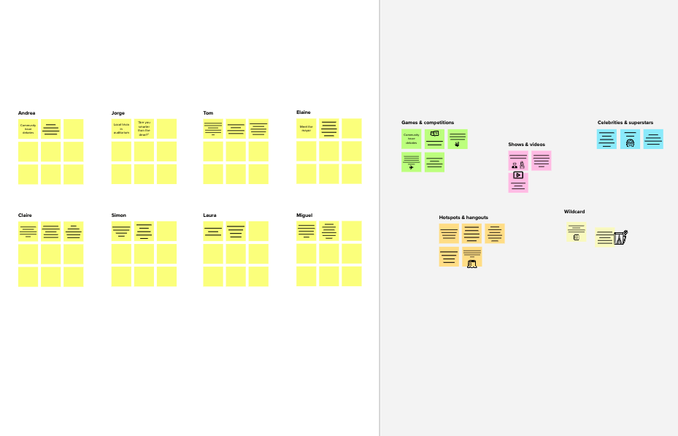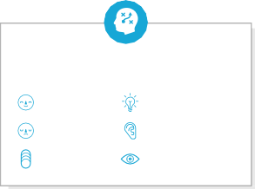

**Template**

**Need some inspiration?**

See a finished version of this template to kickstart your work.

[**Open example**](https://app.mural.co/template/e5a93b7b-49f2-48c9-afd7-a635d860eba6/93f1b98d-b2d2-4695-8e85-7e9c0d2fd9b9)