# Assignment-4

|  |  |
| --- | --- |
| StudentName | **JEYA P** |
| StudentRollNumber | **950919106009** |
| Project Name | **SmartFarmer - IoT Enabled Smart Farming Application** |

# Question-1:

**Writecodeandconnections inwokwifortheultrasonicsensor.Wheneverthedistanceis less than 100 cms send an "alert" to the IBM cloud and display in the device recentevents.Uploaddocumentwith wokwishare linkandimages ofIBMcloud**

# CODE1:

#include<WiFi.h>#include<PubSubClient.h>

void callback(char* subscribetopic, byte* payload, unsigned int payloadLength);#defineORG"92zbfc"

#defineDEVICE_TYPE"esp32"

#defineDEVICE_ID "12345"

#defineTOKEN"12345678"

Stringdata3;

char server[] = ORG ".messaging.internetofthings.ibmcloud.com";charpublishTopic[]="iot-2/evt/Data/fmt/json";

char subscribetopic[] = "iot-2/cmd/test/fmt/String";charauthMethod[]="use-token-auth";

char token[]=TOKEN;

charclientId[]="d:"ORG":"DEVICE_TYPE":"DEVICE_ID;

WiFiClientwifiClient;

PubSubClientclient(server, 1883, callback ,wifiClient);constinttrigPin=5;

const int echoPin = 18;#define SOUND_SPEED 0.034longduration;

float distance;voidsetup(){

**Serial**.begin(115200);pinMode(trigPin, OUTPUT);pinMode(echoPin, INPUT);wificonnect();mqttconnect();

}

voidloop()

{

digitalWrite(trigPin, LOW);delayMicroseconds(2);digitalWrite(trigPin, HIGH);delayMicroseconds(10);digitalWrite(trigPin,LOW);duration = pulseIn(echoPin, HIGH);distance = duration * SOUND_SPEED/2;**Serial**.print("Distance (cm): ");**Serial**.println(distance);if(distance<100)

{

**Serial**.println("ALERT!!");delay(1000);PublishData(distance);

delay(1000);

if (!client.loop()) {mqttconnect();

}

}

delay(1000);

}

void PublishData(float dist) {mqttconnect();

String payload = "{\"Distance\":";payload+=dist;

payload += ",\"ALERT!!\":""\"Distance less than 100cms\"";payload+="}";

**Serial**.print("Sendingpayload:");

**Serial**.println(payload);

if(client.publish(publishTopic,(char*)payload.c_str())){

**Serial**.println("Publishok");

}else{

**Serial**.println("Publishfailed");

}

}

voidmqttconnect(){

if (!client.connected()) {**Serial**.print("Reconnecting client to ");**Serial**.println(server);

while(!!!client.connect(clientId,authMethod,token)){

**Serial**.print(".");delay(500);

}

initManagedDevice();

**Serial**.println();

}

}

voidwificonnect()

{

**Serial**.println();**Serial**.print("Connecting to ");WiFi.begin("Wokwi-GUEST","",6);while (WiFi.status() != WL_CONNECTED) {delay(500);

**Serial**.print(".");

}

**Serial**.println("");**Serial**.println("WiFi connected");**Serial**.println("IP address: ");**Serial**.println(WiFi.localIP());

}

voidinitManagedDevice(){

if (client.subscribe(subscribetopic)) {**Serial**.println((subscribetopic));**Serial**.println("subscribetocmdOK");

}else{

**Serial**.println("subscribetocmdFAILED");

}

}

voidcallback(char*subscribetopic,byte*payload,unsignedintpayloadLength)

{

**Serial**.print("callbackinvokedfortopic:");

**Serial**.println(subscribetopic);

for(inti=0;i<payloadLength;i++)

{

data3+=(char)payload[i];

}

**Serial**.println("data: "+ data3);data3="";

}

WokwiLink :

OutputandSimulation:

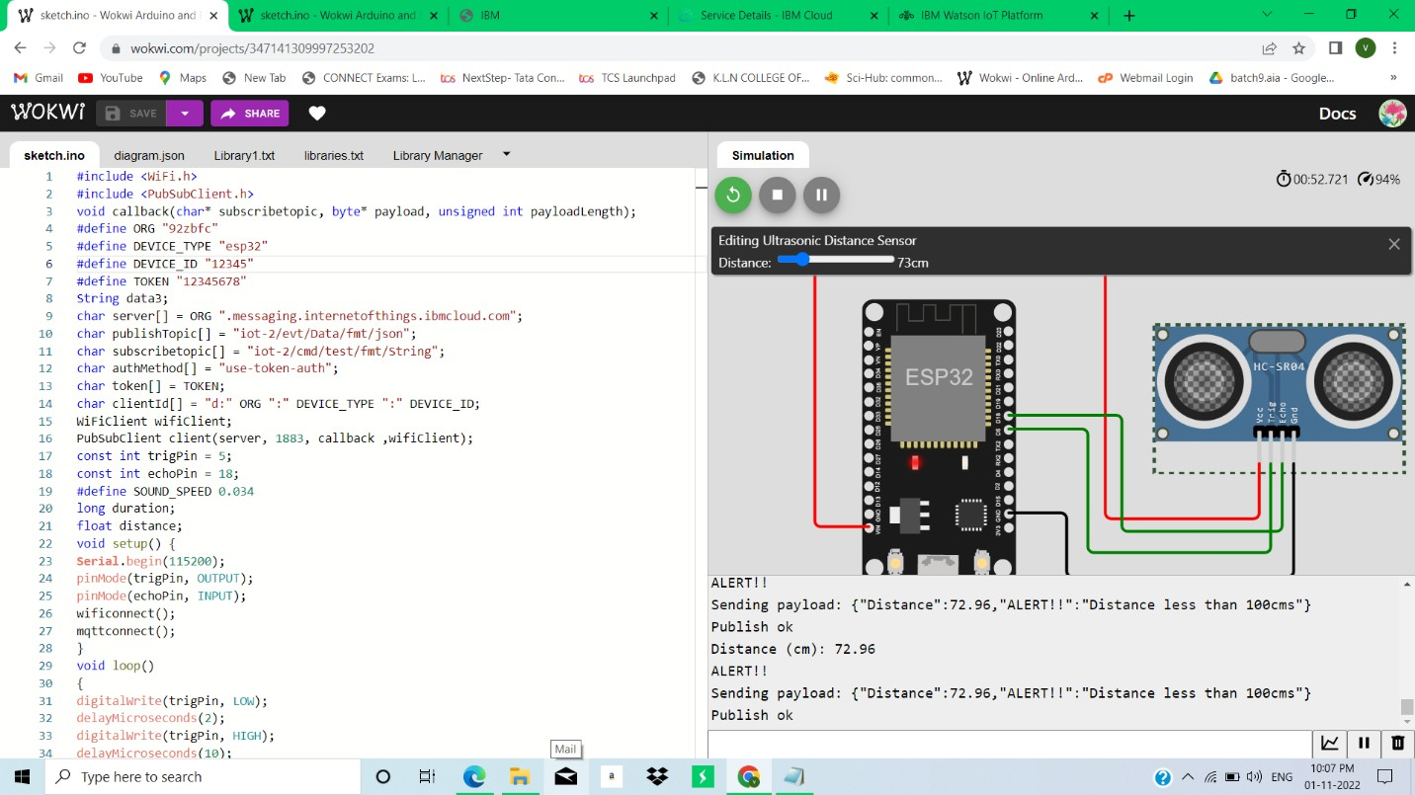

Whenever thedistanceislessthan100cmssendan"alert"totheIBMcloudanddisplayinthedevicerecentevents.

