[**PREREQUISITES**](https://careereducation.smartinternz.com/Student/guided_project_workspace/10888)

|  |  |
| --- | --- |
| Date | 17 November 2022 |
| Team ID | PNT2022TMID53558 |
| Project Name | RIVER AWTER QUALITY MONITORING SYSTEM |

IBM CLOUD SERVICES:

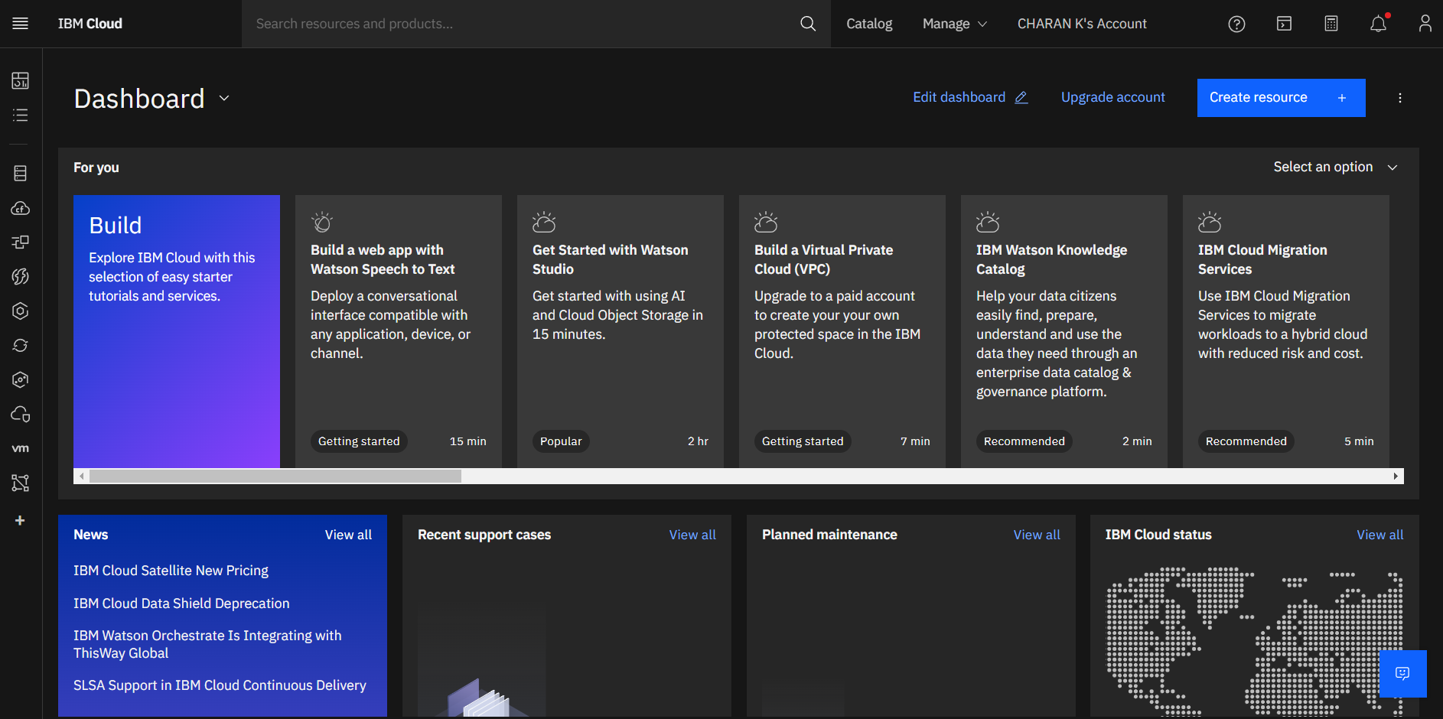

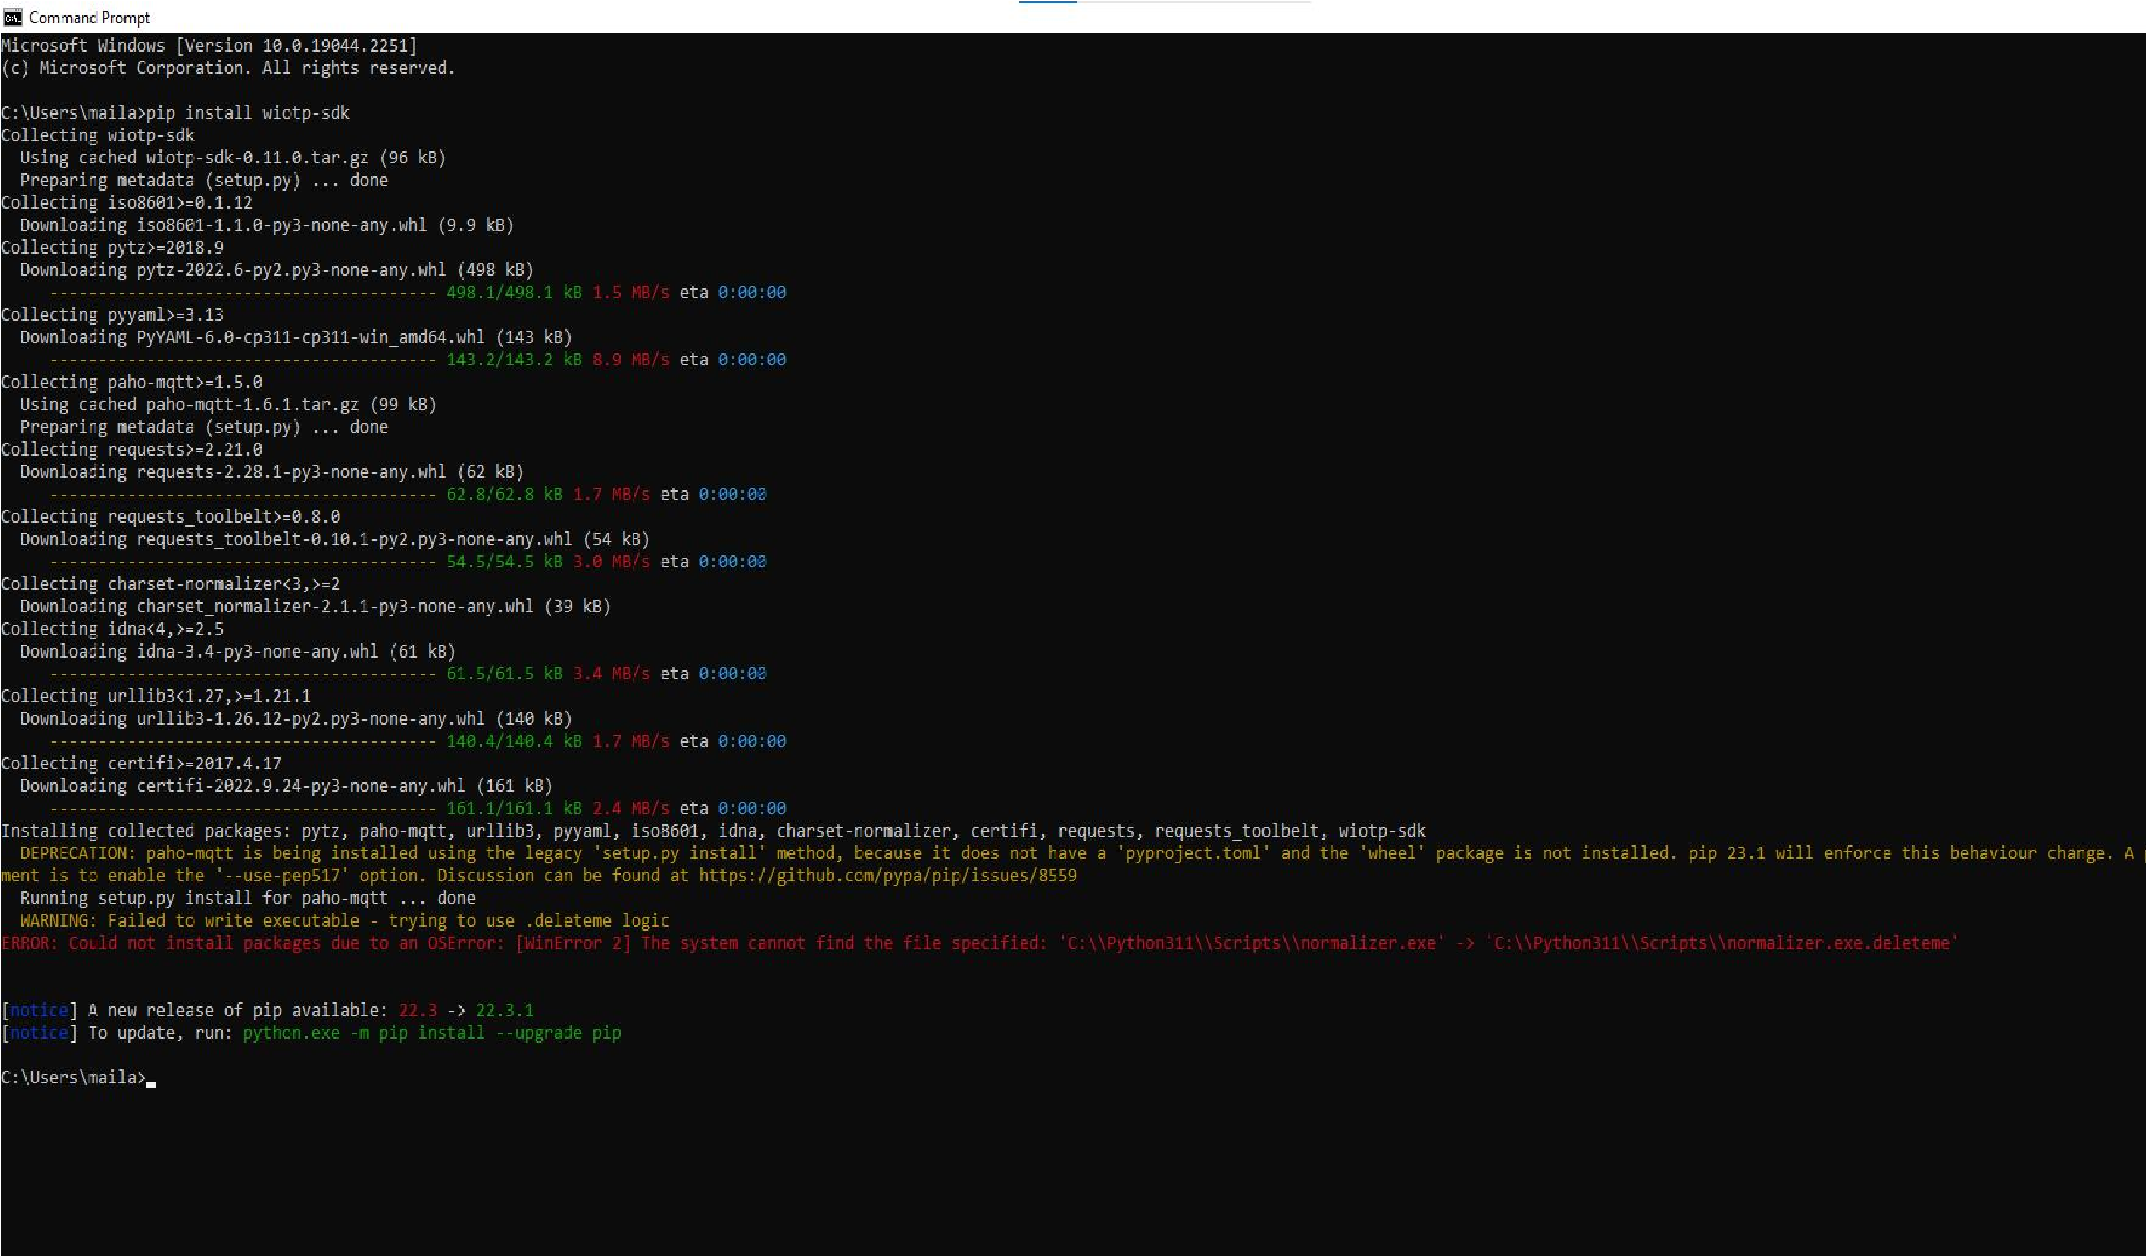PYTHON SOFTWATE: