**SOFTWARE**

**Python installation:**

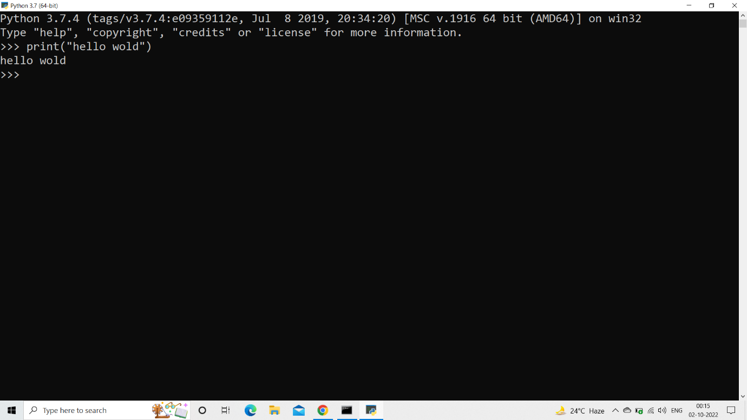

**Implementing python in command prompt:**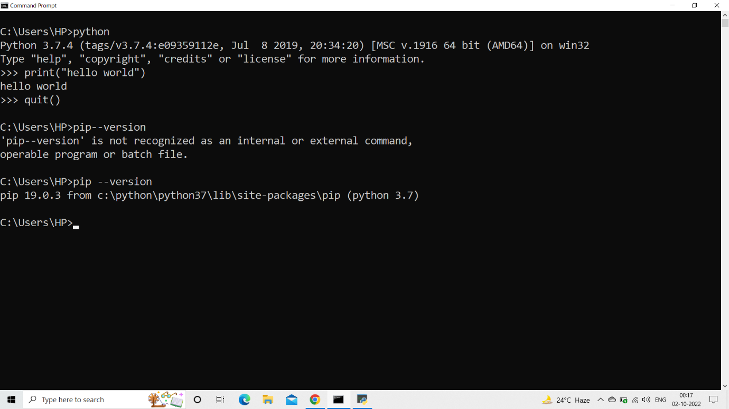

**command prompt: pip install --upgrade "ibm-watson>=5.0.0**

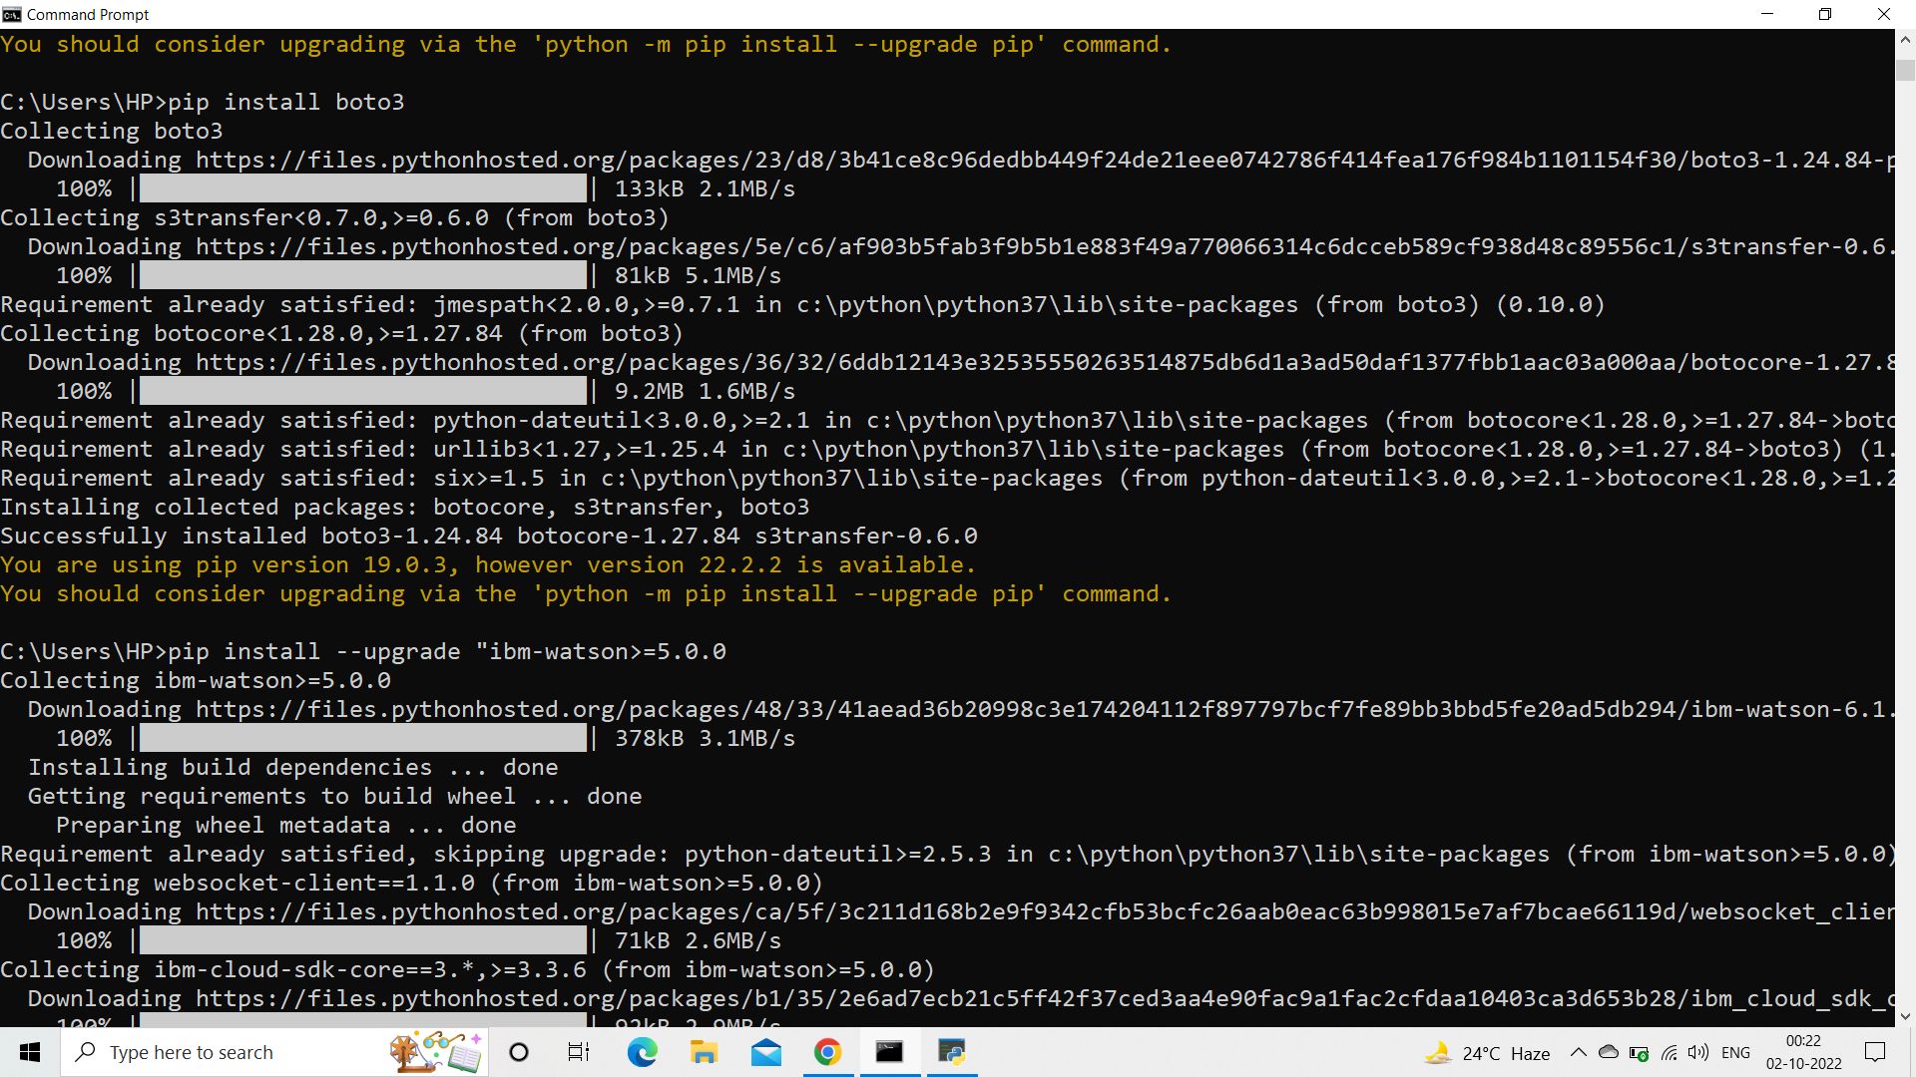

* **pip install ibm-cos-sdk**

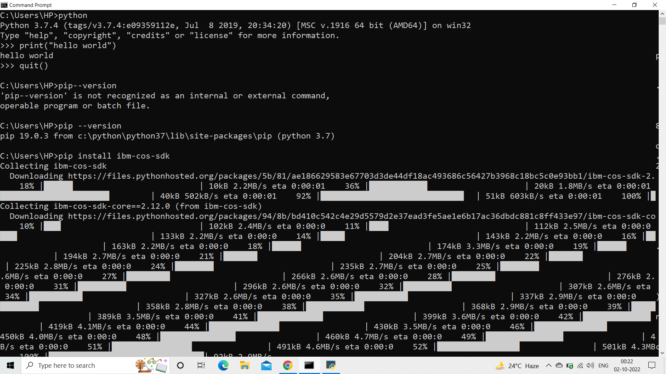

**pip install -U ibm-cos-sdk**

**pip install boto3**

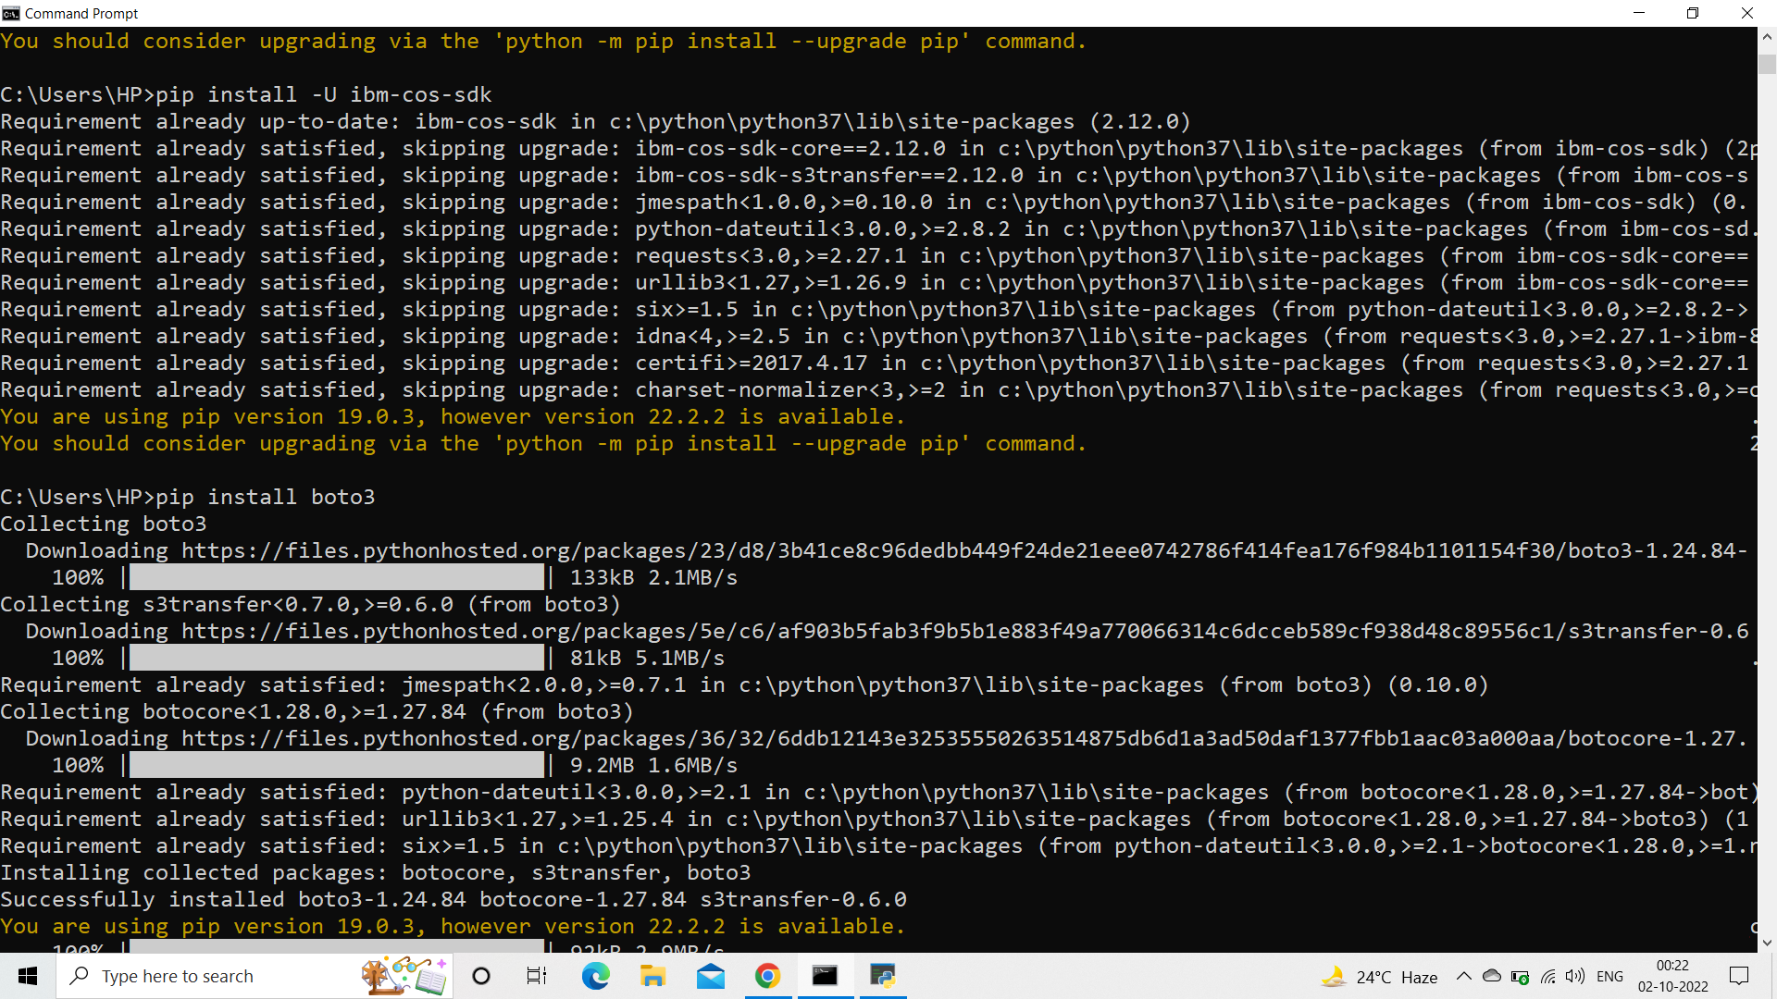

* **pip install resources**
* **pip install cloudant**

