DATA EXPLORATION ASSIGNMENT USING COGNOS ANALYTICS FOR 50 STARTUPS DATASET LINK :- <https://us1.ca.analytics.ibm.com/bi/?perspective=explore&pathRef=.my_folders%2F50_startups_exploration2&subView=model00000183278d1332_00000000>

**R&D Spend by State**

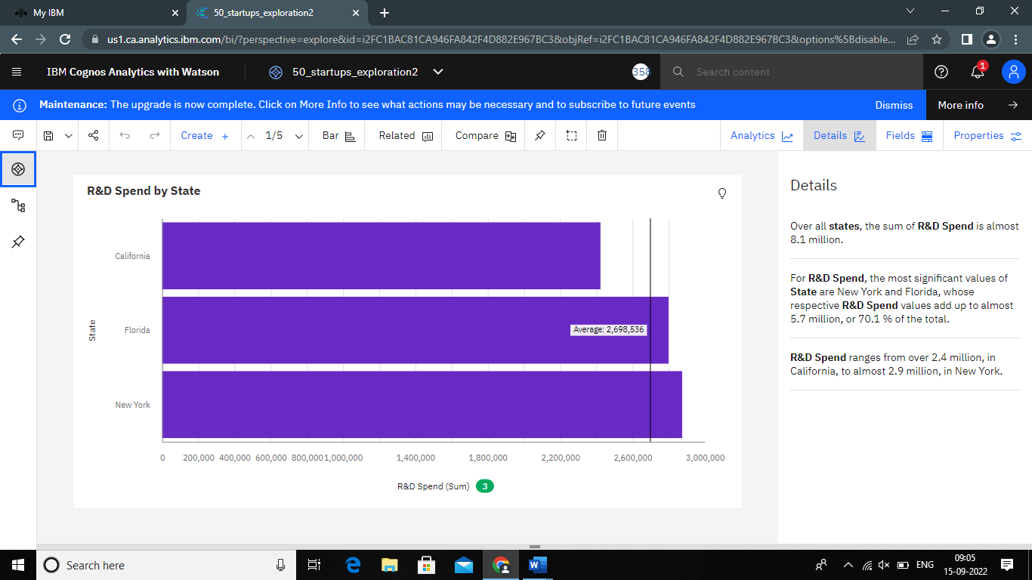

**Administration by State**

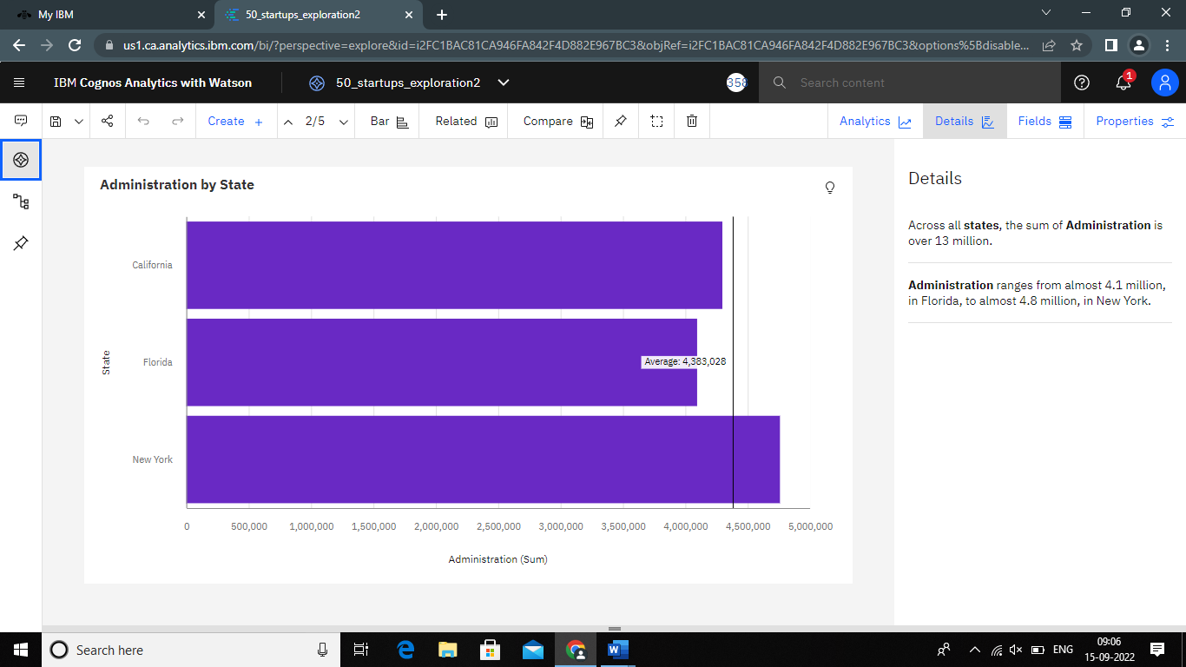

**Marketing Spend by State**

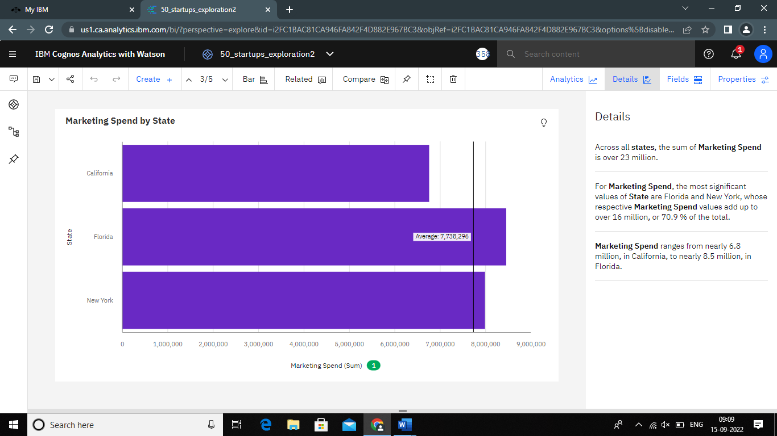

**Profit by State**

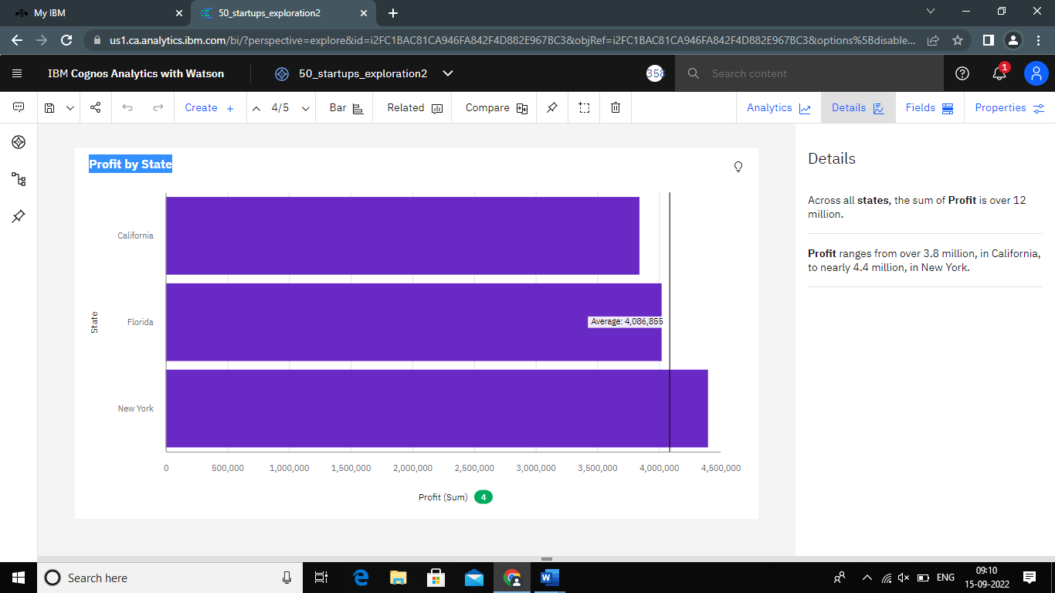

**State, Profit map view**

