ASSIGNMENT-2

GLOBAL SALES DATA ANALYTICS

Data Cleaning:(Before)

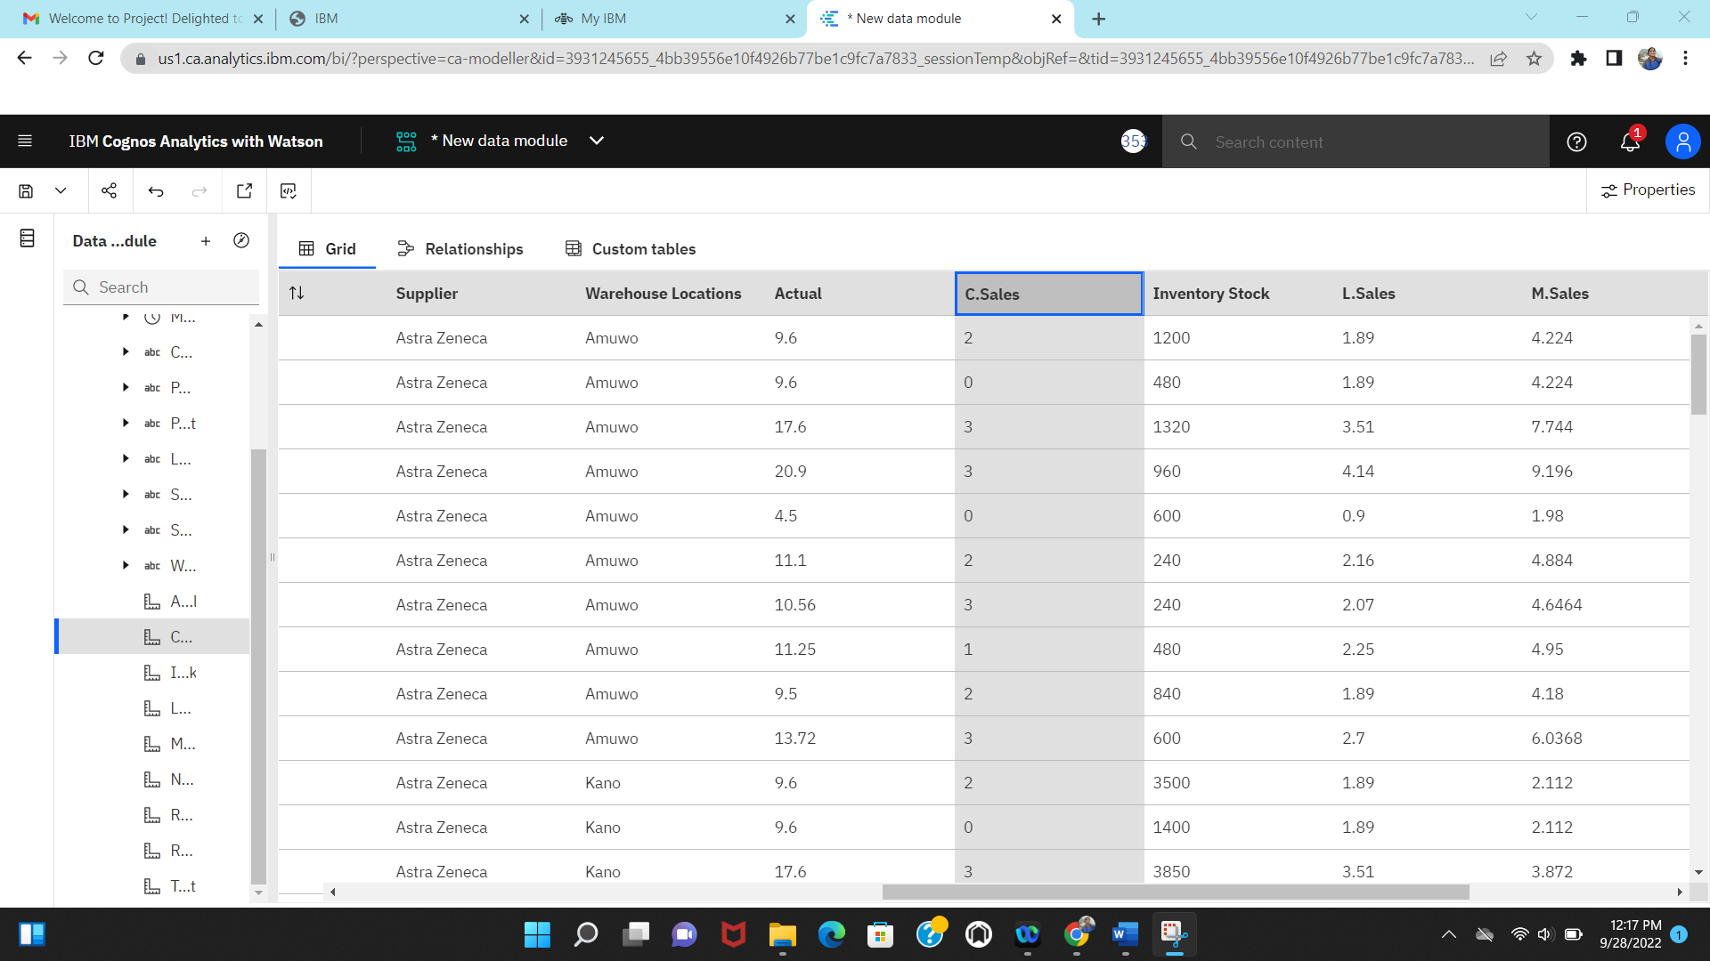Data Cleaning:(Expression)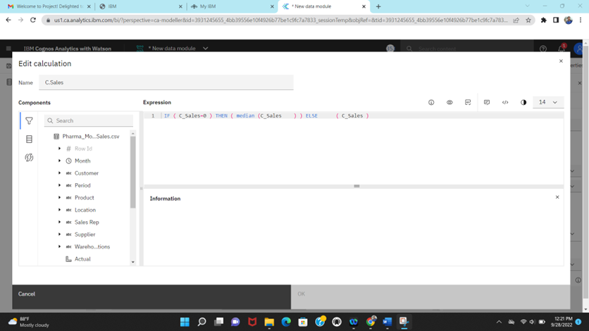

Data Cleaning:(After)

Data cleaning link:

<https://us1.ca.analytics.ibm.com/bi/?perspective=ca-modeller&pathRef=.my_folders%2FPharma_monthly_sales_data_cleaning_suchita>

Data Visualization:Sales by location

Data Visualization:

Sales By Sales Representative.

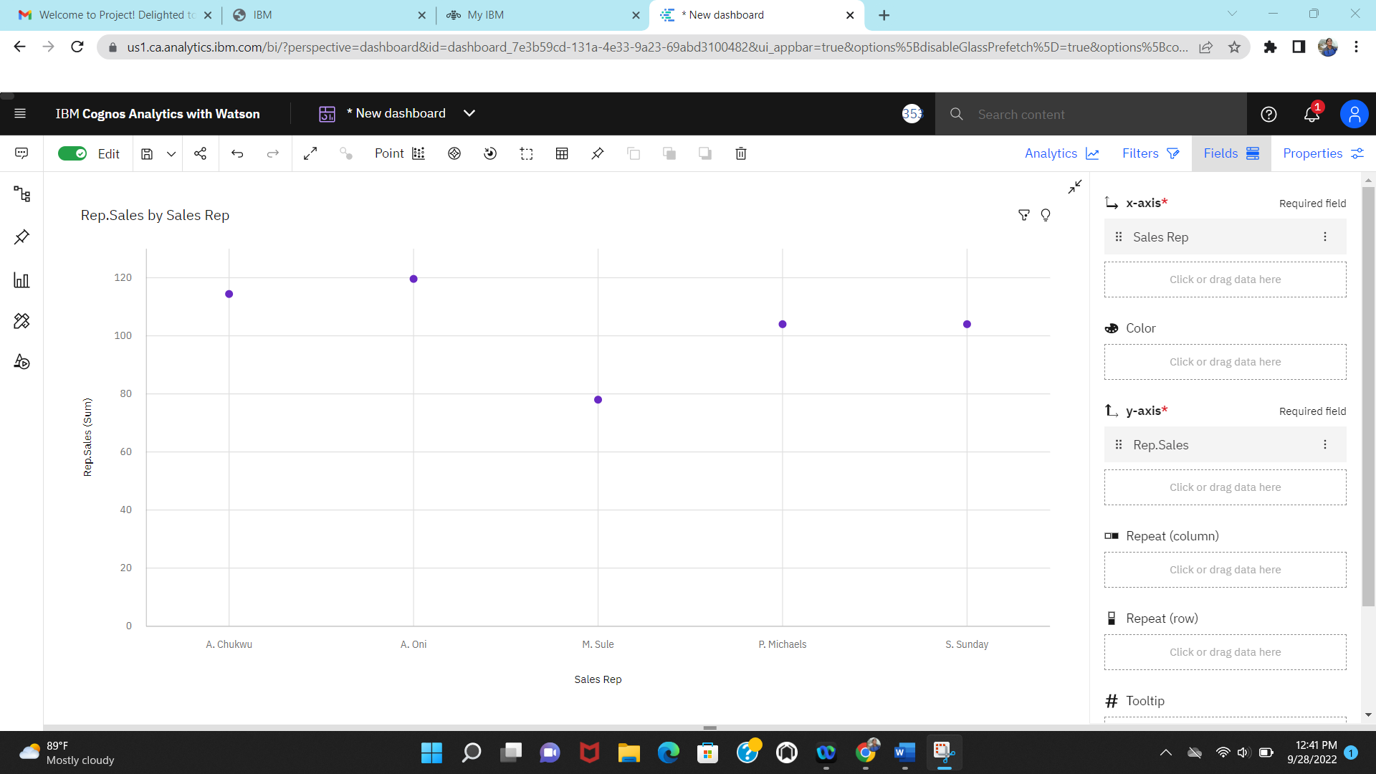

Data Visualization

Received Inventory from supplier

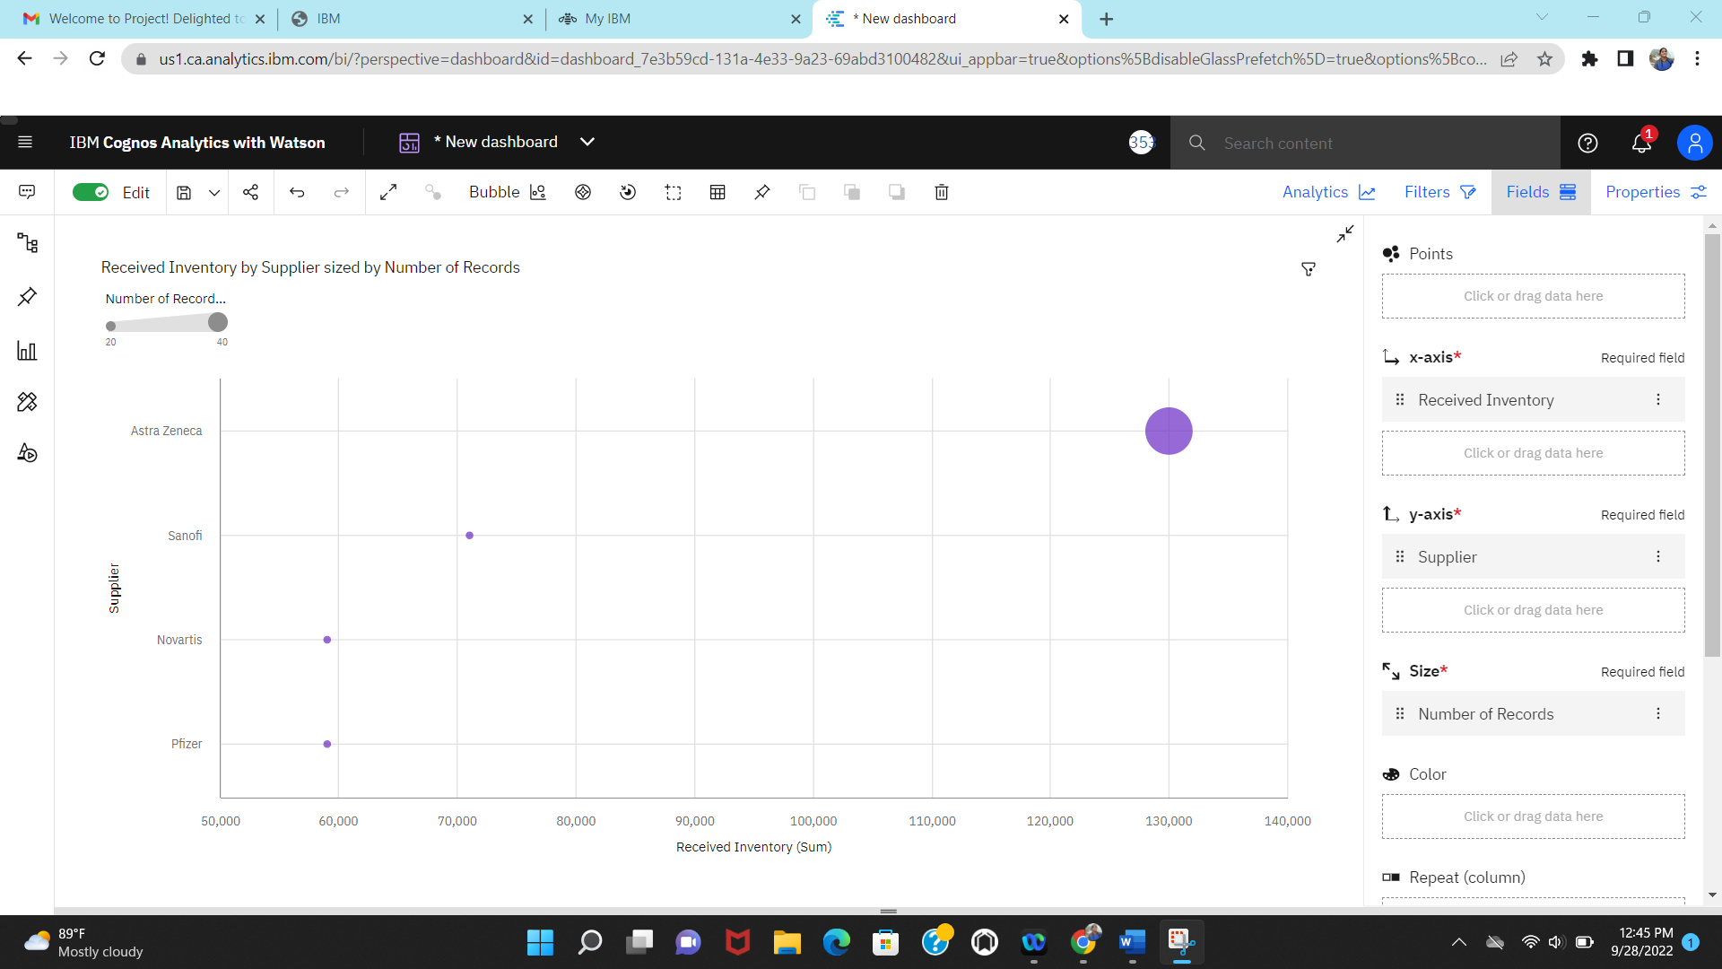

Inventory Stock for Warehouse Locations

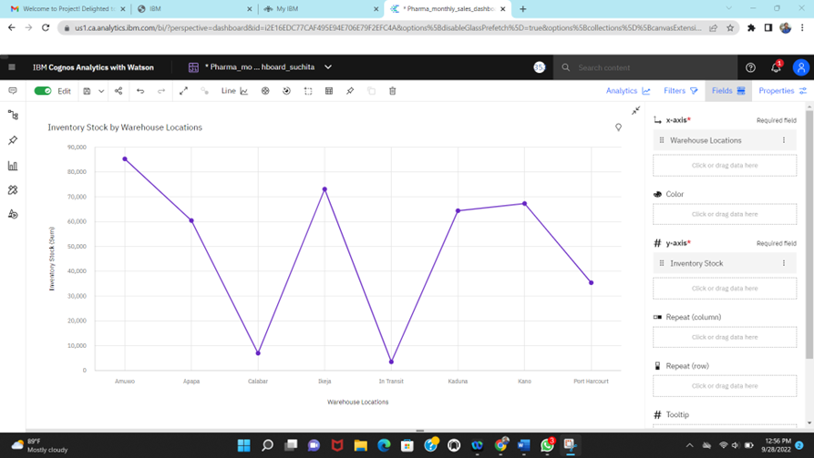

Data Visualization:

Sale by Customer

Sales trend

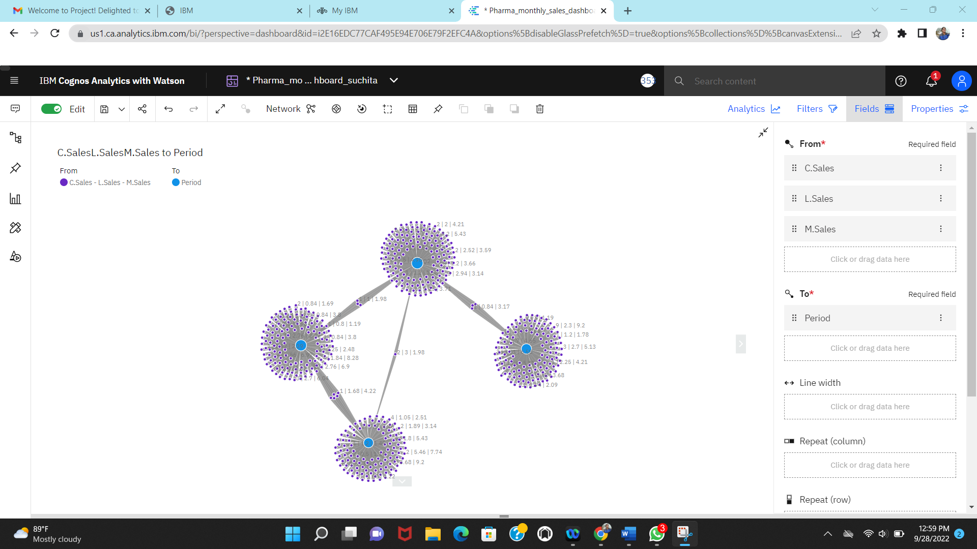

Data Visualization:

Monthly Sales

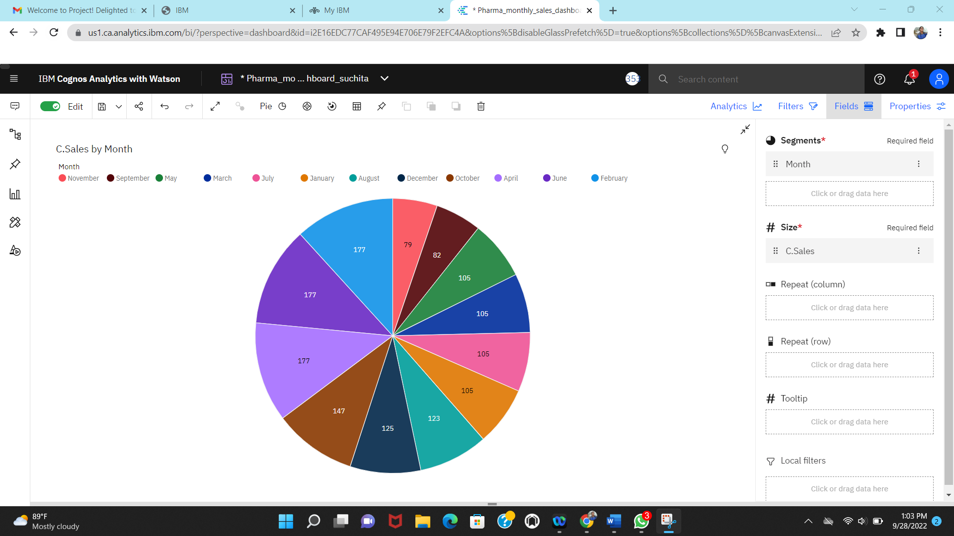

Actual and Received inventory by month

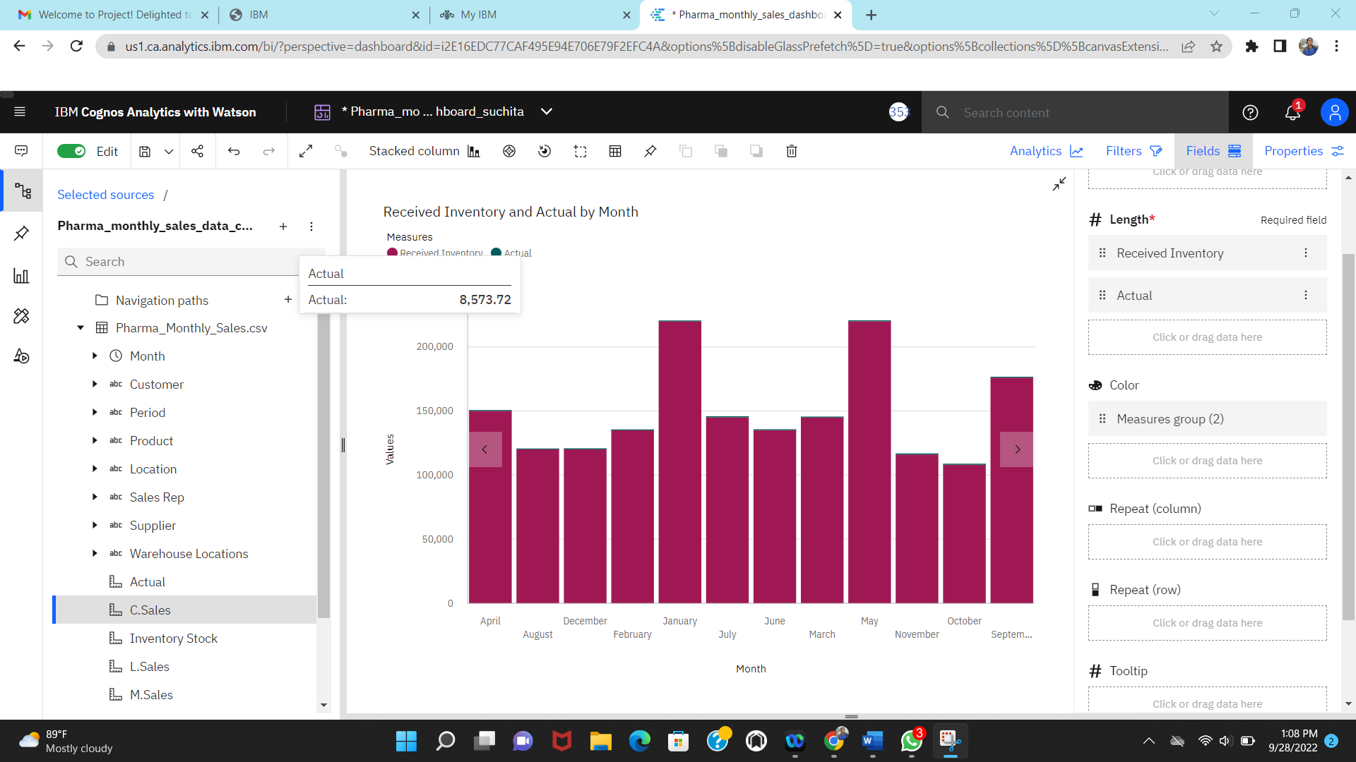

Interactive Dashboard:TAB1

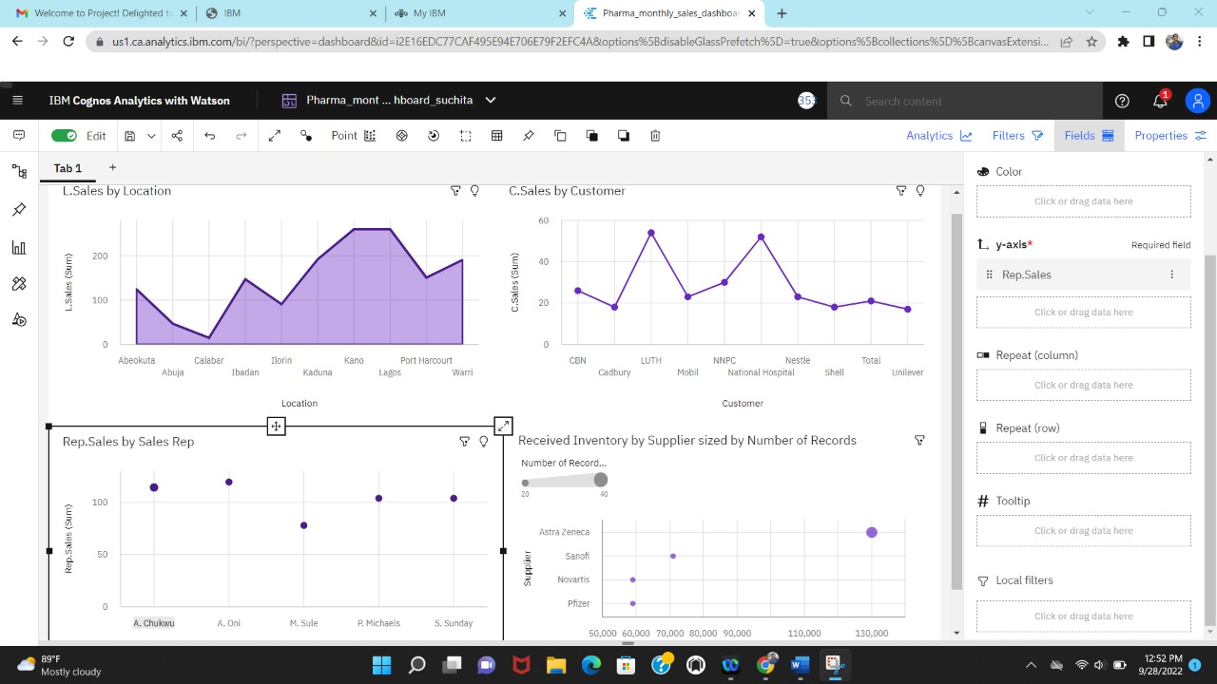

Interactive Dashboard:TAB2

Interactive Dashboard link:TAB1

https://us1.ca.analytics.ibm.com/bi/?perspective=dashboard&pathRef=.my_folders%2FPharma_monthly_sales_dashboard_suchita&action=view&mode=dashboard&subView=model0000018382e20026_00000000

Interactive Dashboard link:TAB2

https://us1.ca.analytics.ibm.com/bi/?perspective=dashboard&pathRef=.my_folders%2FPharma_monthly_sales_dashboard_suchita&action=view&mode=dashboard&subView=model0000018382fbf828_000000