INSTALLATION OF PYTHON 3.7.4

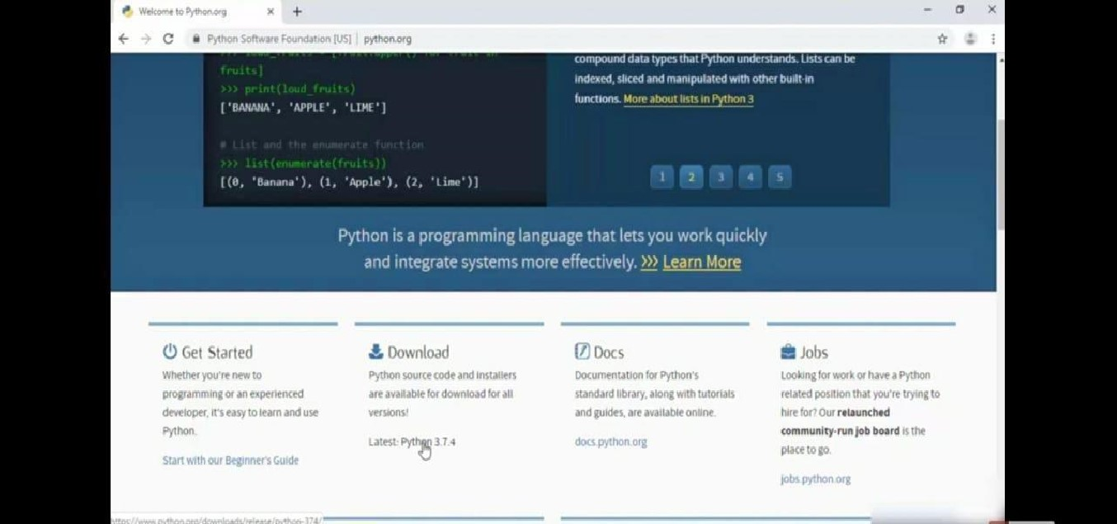STEP 1: Type python in google and click on the first link.

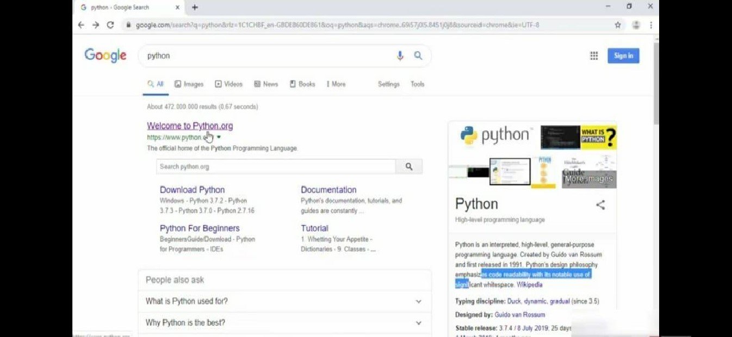

STEP 2.• Click the python 3.7.4

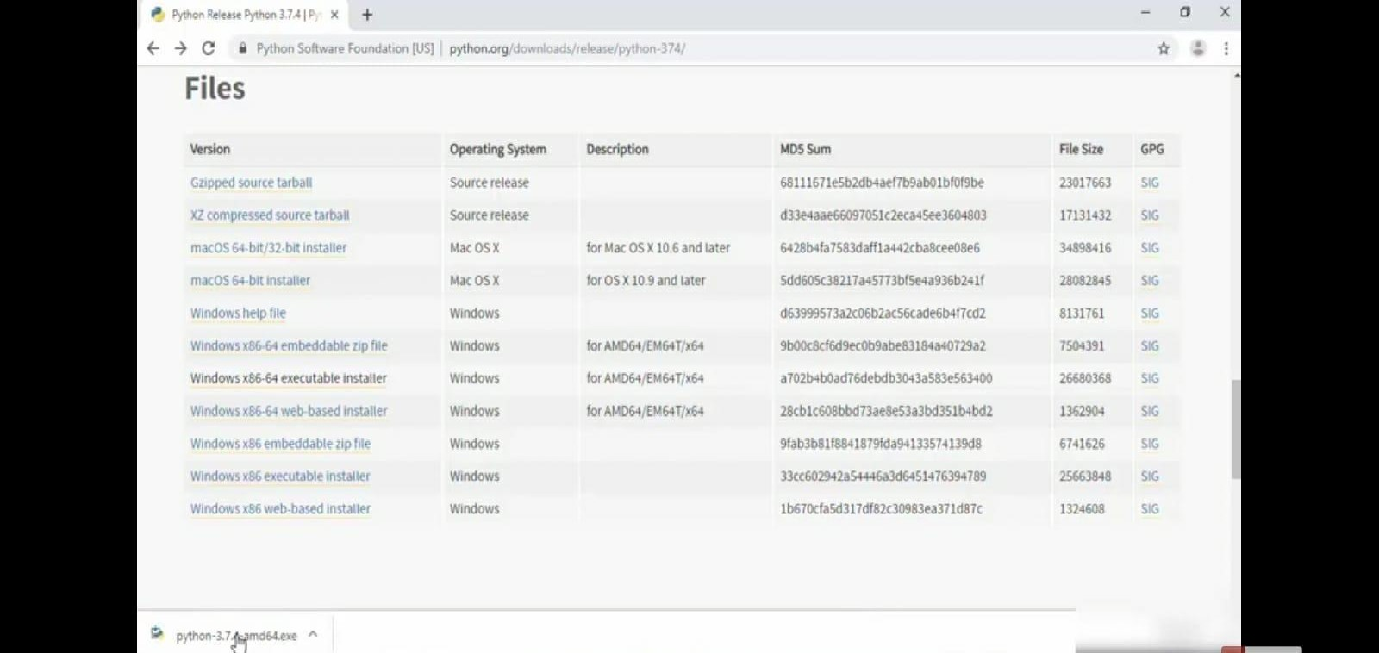 STEP 3: Scroll down to reach the Files and click windows x86-64 executable installer.

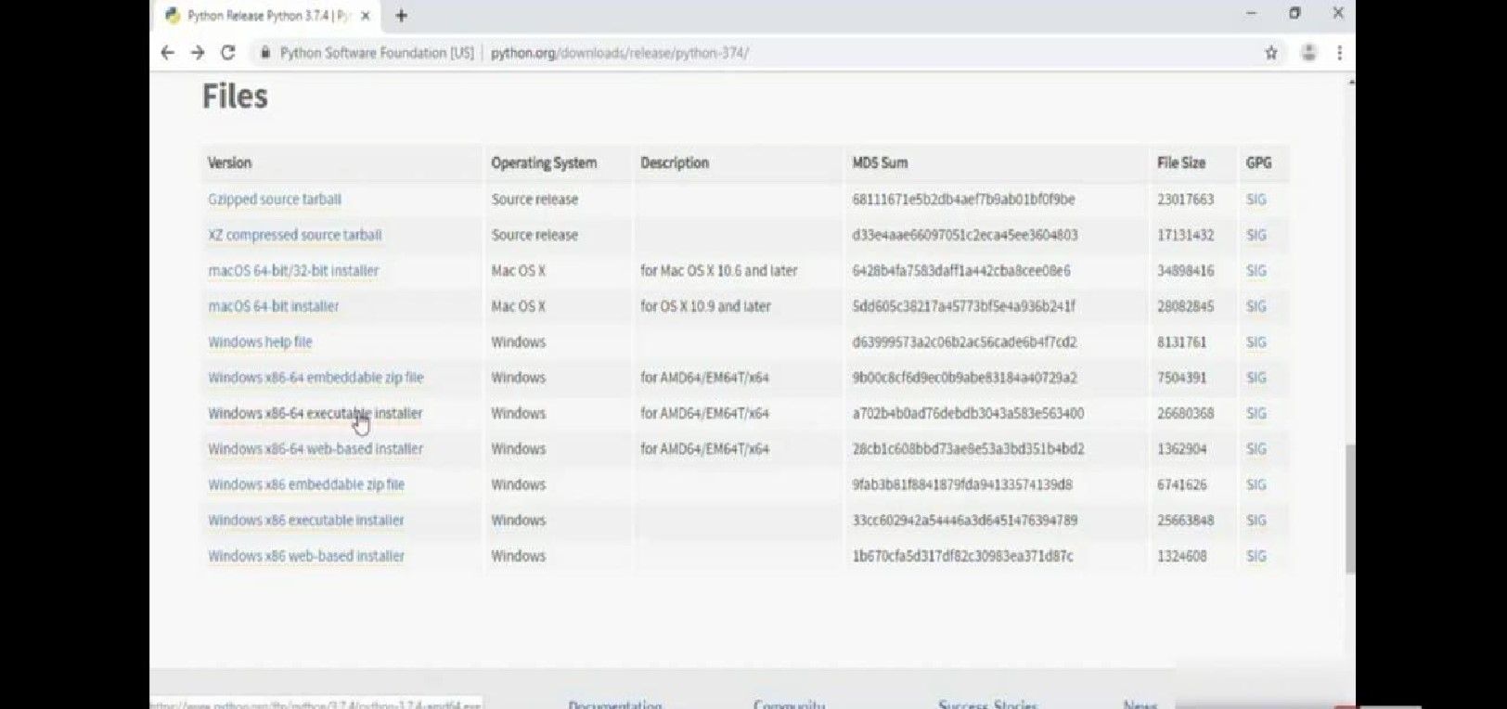i

STEP 4: Click on the executable file.

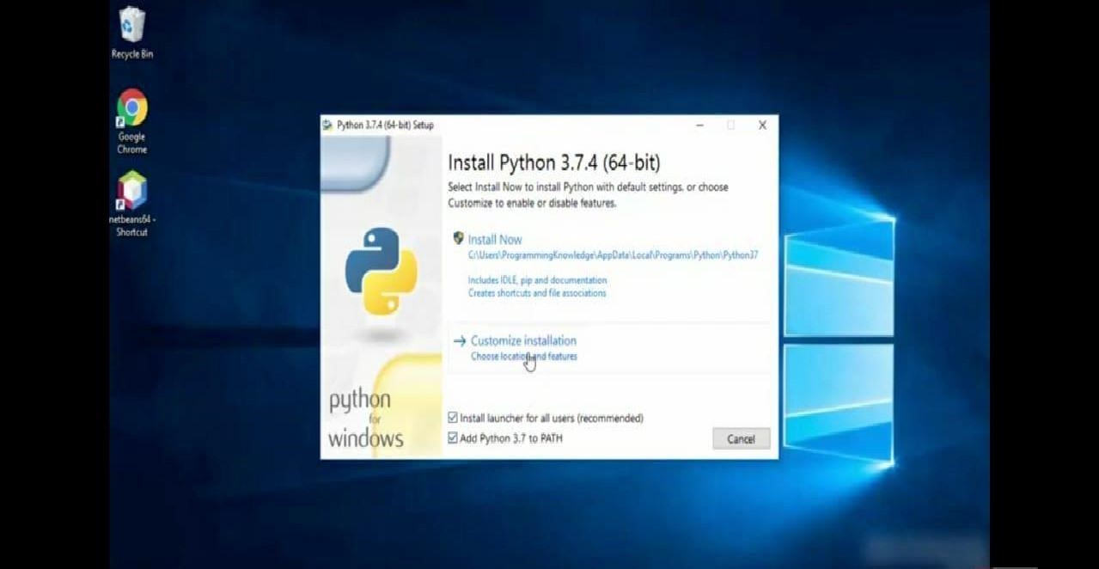STEP 5: Click on the Run button.

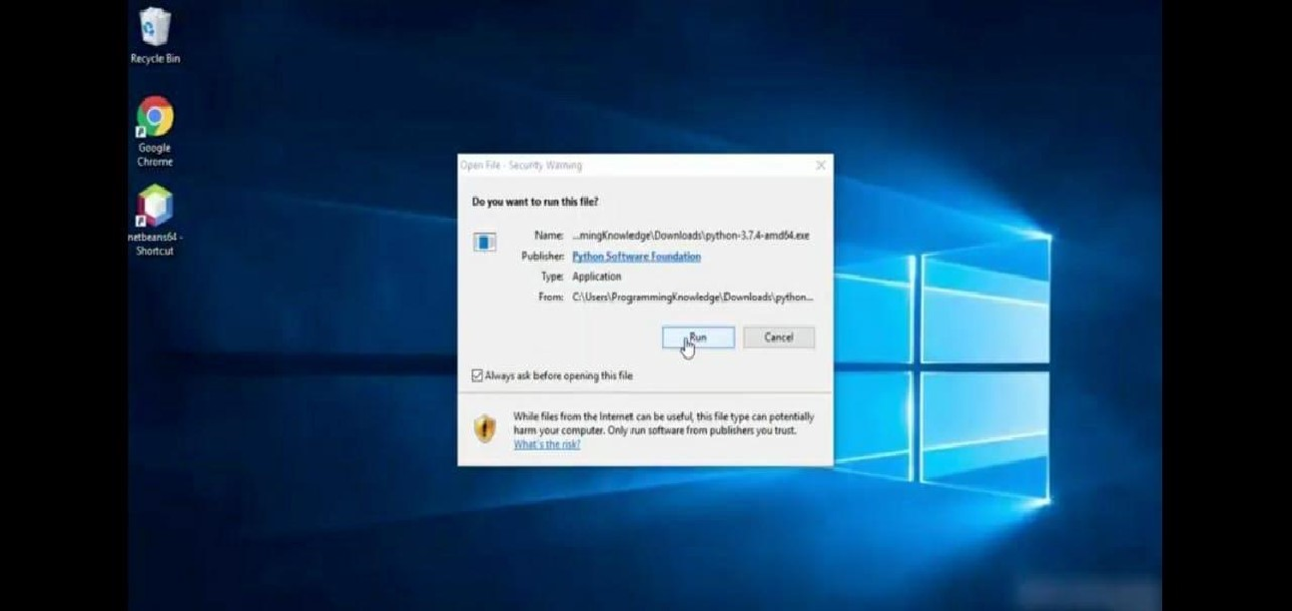

STEP 6: To change the path click on the second check box Add python 3.7 to PATH and then click the customize installation.

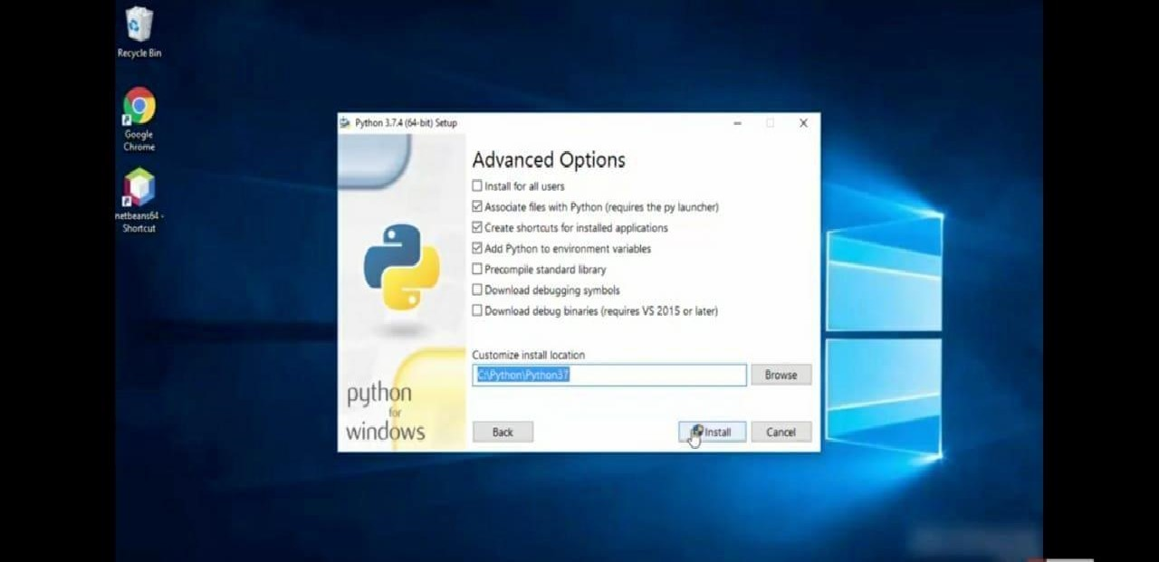 STEP 7: Click the Next button.

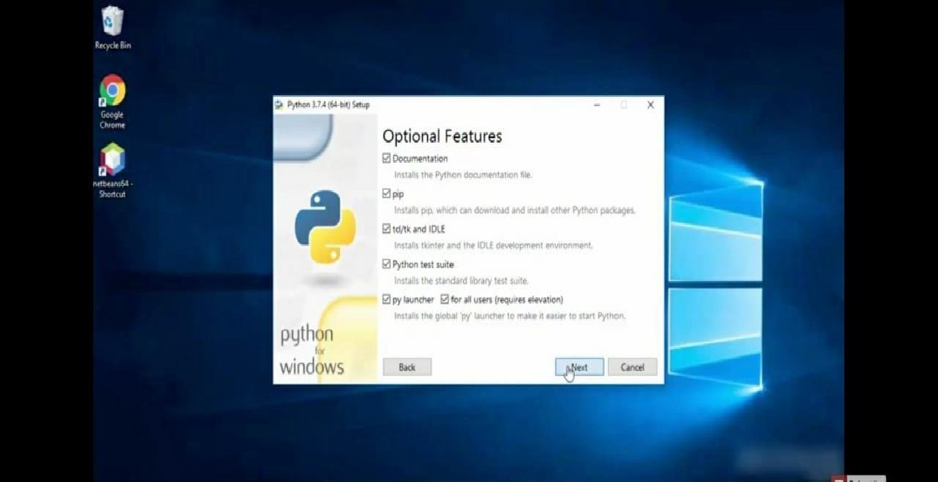

STEP 8: You can change the path here and click on the install button.

STEP 9: Installation process

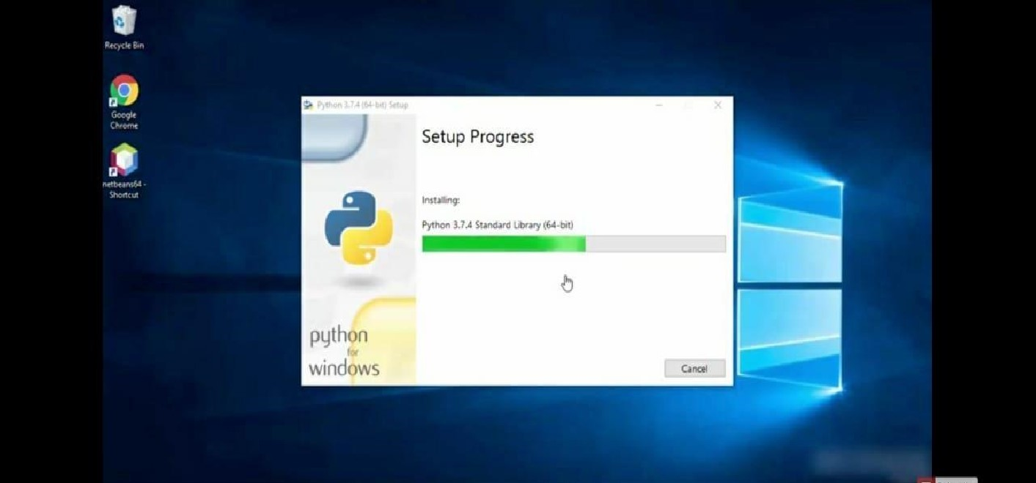

STEP 10: Click Yes button.

|  |  |
| --- | --- |
|  | 790/00 |
|  |

STEP 11: Click the close button.

