**ASSIGNMENT NO-1**

### **Project Name:** IOT BASED SAFETY GADGET FOR CHILD SAFETY

### MONITORING & NOTIFICATION

### 

**Batch Number:** B7-1A3E

**Assignment Topic**: smart home automation using sensor leds and buzzer

**Team Lead :**Pachipulusu.Nagasri

**Team Member-1:**Swarna.Yaswitha

**Team Member-2:**Vandasai.Sai Venkata Lakshmi Srujana

**Team Member-3:**Chintamreddy.Varalakshmi

Before Simulation

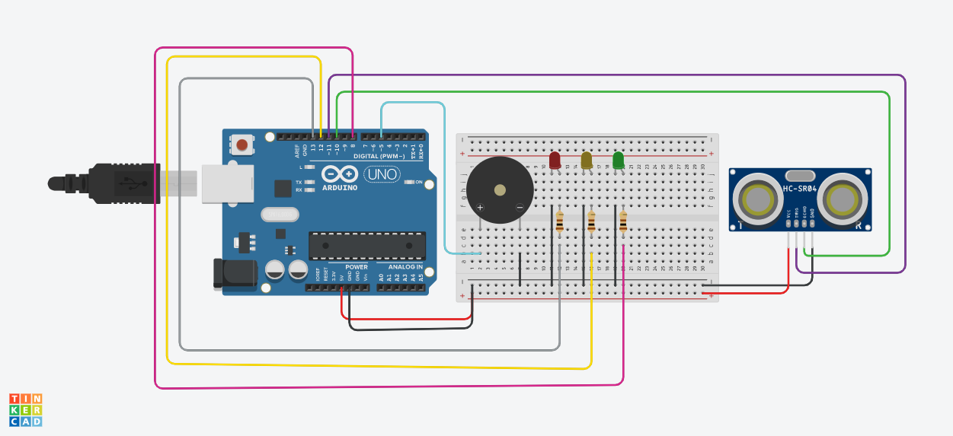

After Simulation

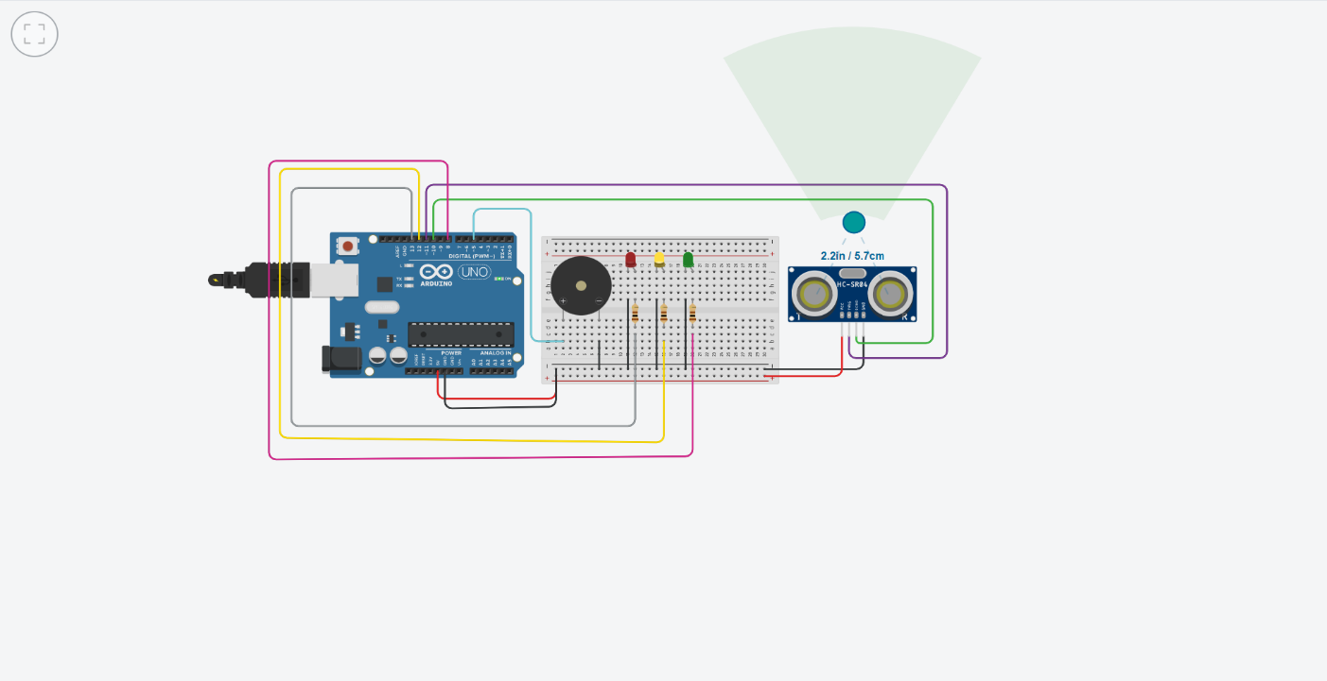

**Code:**

