**Assignment -1**

|  |  |
| --- | --- |
| Assignment Date | 08 October 2022 |
| Student Name | Rishekesh.B |
| Student Roll Number | 7179KCTKCTKCTKCTKCTKCTKCT19BCS001 |

**Question:**

Build a smart home in Thinkercad with 2 sensors, an Led, buzzer and submit it.

**Solution:**

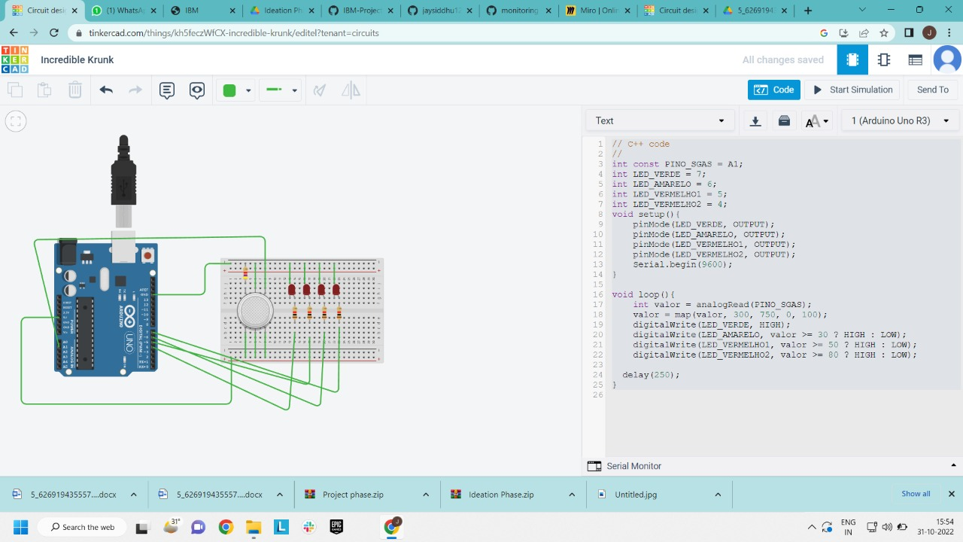

// C++ code

//

int const PINO_SGAS = A1;

int LED_VERDE = 7;

int LED_AMARELO = 6;

int LED_VERMELHO1 = 5;

int LED_VERMELHO2 = 4;

void setup(){

pinMode(LED_VERDE, OUTPUT);

pinMode(LED_AMARELO, OUTPUT);

pinMode(LED_VERMELHO1, OUTPUT);

pinMode(LED_VERMELHO2, OUTPUT);

Serial.begin(9600);

}

void loop(){

int valor = analogRead(PINO_SGAS);

valor = map(valor, 300, 750, 0, 100);

digitalWrite(LED_VERDE, HIGH);

digitalWrite(LED_AMARELO, valor >= 30 ? HIGH : LOW);

digitalWrite(LED_VERMELHO1, valor >= 50 ? HIGH : LOW);

digitalWrite(LED_VERMELHO2, valor >= 80 ? HIGH : LOW);

delay(250);

}