**PRE-REQUISITES**

**Software**

|  |  |
| --- | --- |
| DATE | 30 October 2022 |
| TEAM ID | PNT2022TMID48076 |
| PROJECT NAME | Project-Real Time River Water  Quality Monitor And Control  System |
| MAXIMUM MARKS | 2 Marks |

**Software:**

Software is a set of instructions, data or programs used to operate computers and execute specific tasks. It is the opposite of hardware, which describes the physical aspects of a computer. Software is a generic term used to refer to applications, scripts and programs that run on a device.

**Software:**

**Python 3.7 and Python 3.7.0 shell has been created**

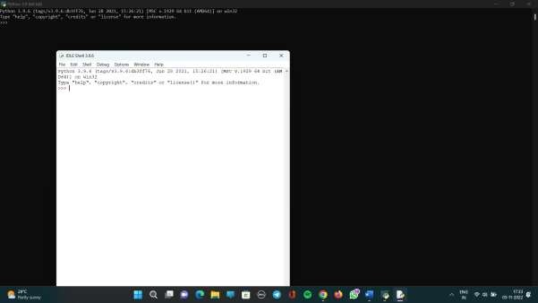

**Arduino IDE with AdafruitADS_1X15 LIBRARY**

