# Pre-reqesitue

**3.IBM Cloudant and Database**

|  |  |
| --- | --- |
| DATE | 31 October 2022 |
| STUDENT NAME | S.Sangeetha |
| ROLL NO | 912419104026 |
| MAXIMUM MARKS | 2 Marks |

# IBM cloudant:

Cloudant is an IBM software product, which is primarily delivered as a cloud-based service. Cloudant is a non-relational, distributed database service of the same name. Cloudant is based on the Apache-backed CouchDB project and the open source BigCouch project.

IBM Cloudant account and database:

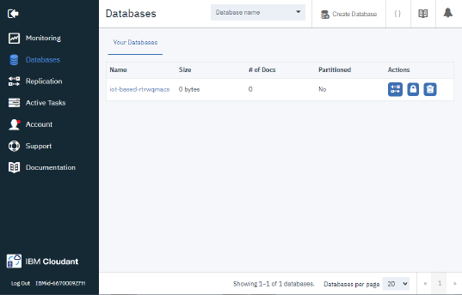

Database created……..

