Develop the Python Script

# (Develop a Python script)

**Team ID** : PNT2022TMID42730

Industry-specific intelligent fire management system

**Create a code snippet using python to**

1. Extract weather data from OpenWeatherMap using APIs
2. Send the extracted data to the cloud
3. Receive data from the cloud and view it in the python compiler

# 1*Team Member Weather accout ID

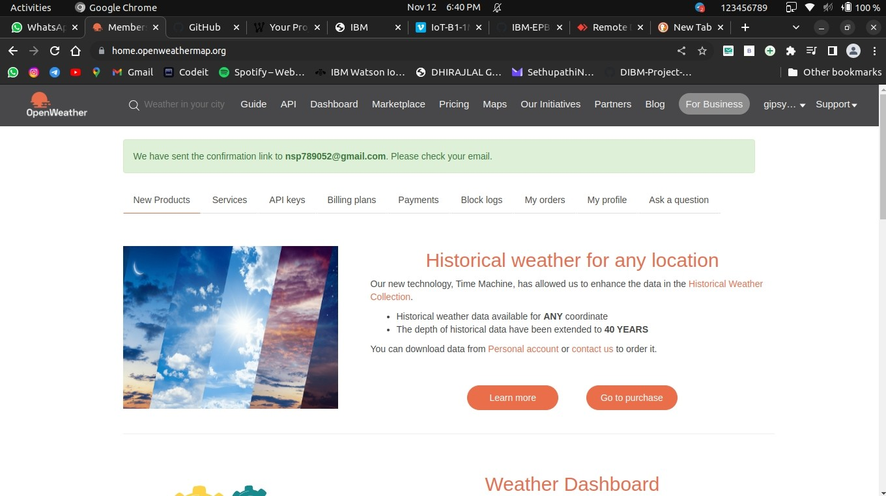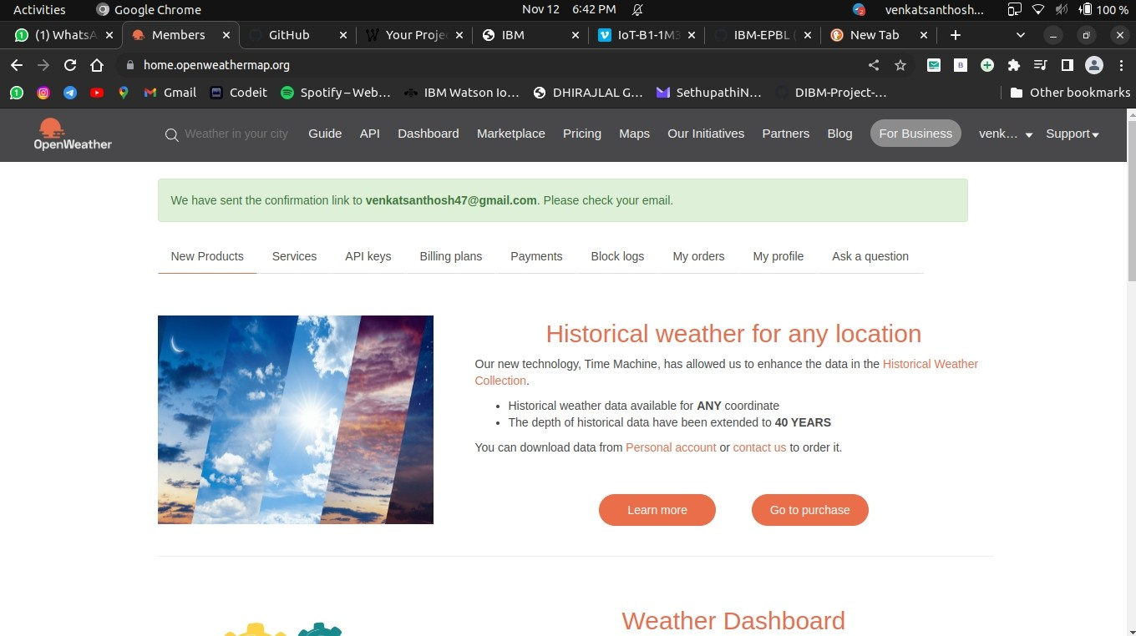

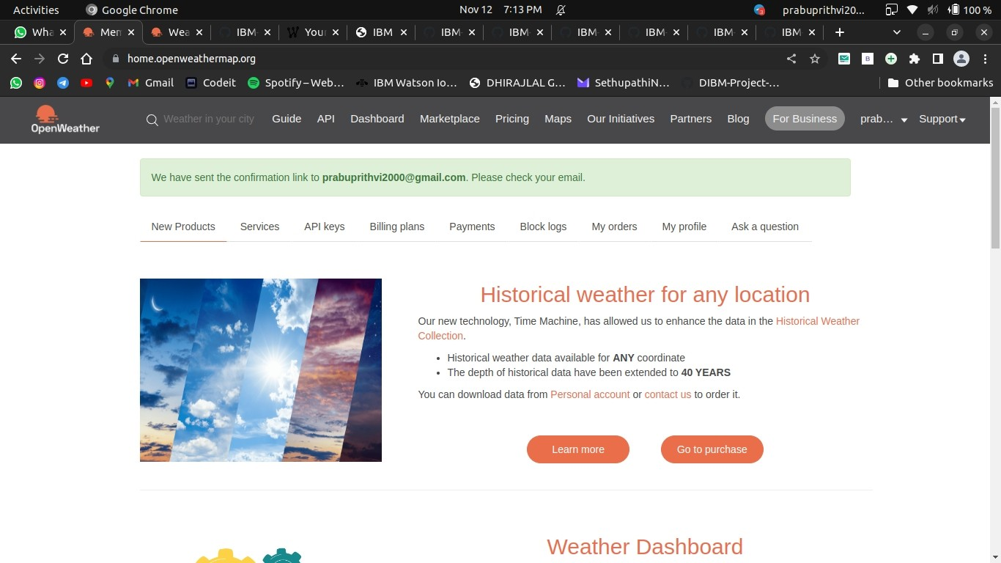

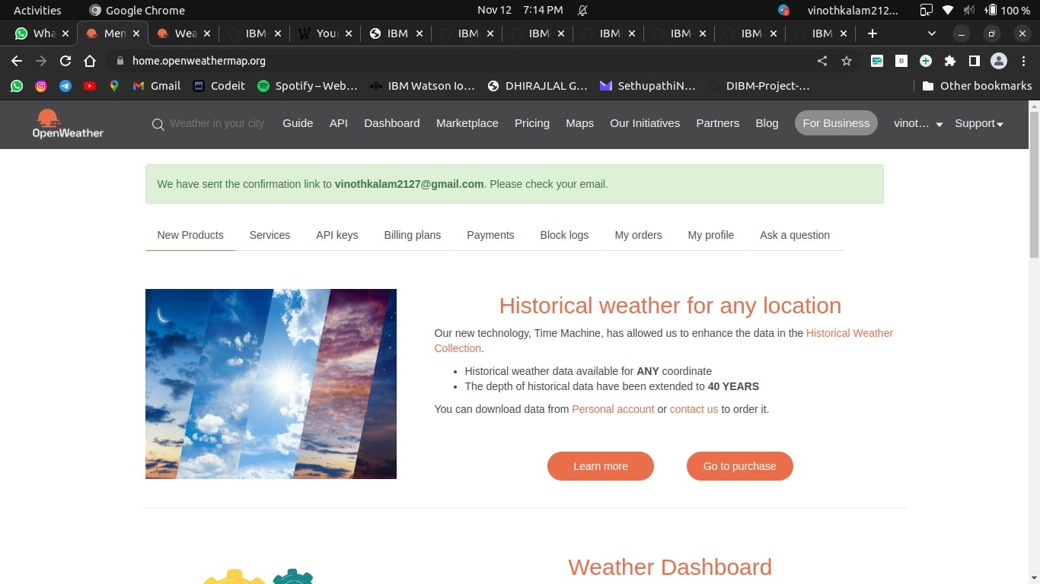

3* python compiler

