## Project Design Phase-II

**Data Flow Diagram & User Stories**

|  |  |
| --- | --- |
| Date | 1 October 2022 |
| Team ID | PNT2022TMID13167 |
| Project Name | Real-Time River Water Quality Monitoring And Control System |
| Maximum Marks | 4 Marks |

### Data Flow Diagrams:

A Data Flow Diagram (DFD) is a traditional visual representation of the information flows within a system. A neat and clear DFD can depict the rightamount of the system requirement graphically. It shows how data enters and leaves the system, what changes the information, and where data is stored.



# Start

Getting value from sensor

Sensor send the values to the Arduino

Board Database

Arduino values

No

>= Threshold value

Yes

The sense data goes to the Network and the Status of the water module

Send the report to the user Send SMS to Mobile

Stop

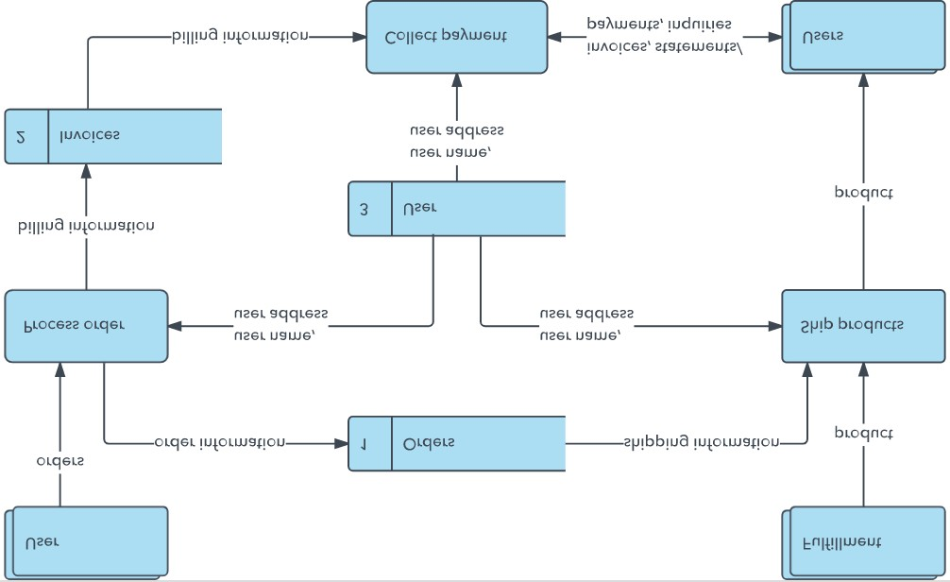

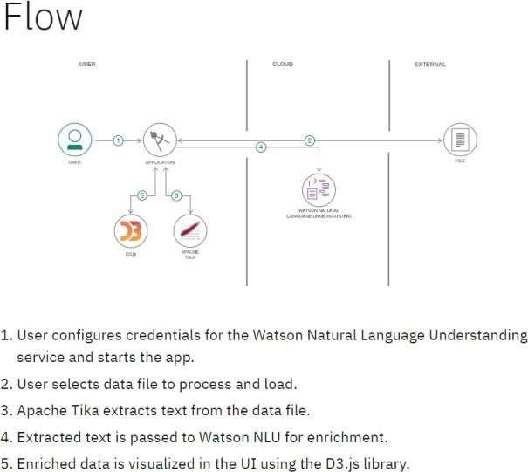Example: (Simplified)

Example : DFD Level 0(Industry Standard)

### User Stories

Use the below template to list all the user stories for the product.

|  |  |  |  |  |  |  |
| --- | --- | --- | --- | --- | --- | --- |
| **User Type** | **Functional Requirement**  **(Epic)** | **User Story Number** | **User Story / Task** | **Acceptance criteria** | **Priority** | **Release** |
| Customer (Mobile user) | Registration | USN-1 | As a user, I can register for the application by entering my email, password, and confirming my password. | I can access my account / dashboard | High | Sprint-1 |
|  |  | USN-2 | As a user, I will receive confirmation email once I have registered for the application | I can receive confirmation email & click confirm | High | Sprint-1 |
|  |  | USN-3 | As a user, I can register for the application through Facebook | I can register & access the  dashboard with Facebook Login | Low | Sprint-2 |
|  |  | USN-4 | As a user, I can register for the application through Gmail |  | Medium | Sprint-1 |
|  | Login | USN-5 | As a user, I can log into the application by entering email & password |  | High | Sprint-1 |
|  | Dashboard |  |  |  |  |  |
| Customer (Web user) |  |  |  |  |  |  |
| Customer Care  Executive |  |  |  |  |  |  |
| Administrator |  |  |  |  |  |  |
|  |  |  |  |  |  |  |
|  |  |  |  |  |  |  |
|  |  |  |  |  |  |  |