**Project Design Phase-II**

**Technology Stack (Architecture & Stack)**

|  |  |
| --- | --- |
| Date | 1 October 2022 |
| Team ID | PNT2022TMID13167 |
| Project Name | Project – Real-time River Water Quality Monitoring and Control System |
| Maximum Marks | 4 Marks |

**Technical Architecture:**

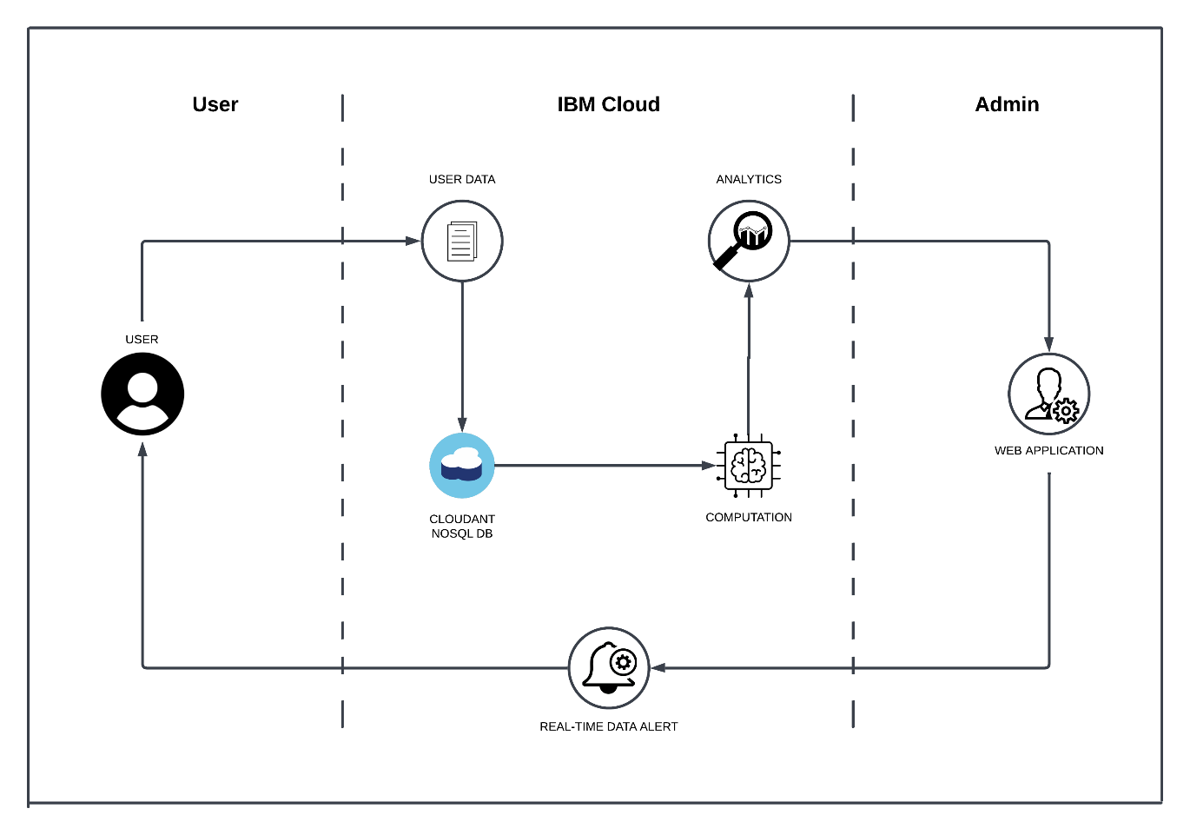

**Table-1: Components & Technologies:**

|  |  |  |  |
| --- | --- | --- | --- |
| **S.No** | **Component** | **Description** | **Technology** |
|  | User Interface | Web UI | HTML, CSS, JavaScript |
|  | Application Logic-1 | Web UI to enter the Register/Login | HTML, CSS, JavaScript |
|  | Application Logic-2 | Get the river body data from the Cloud | IBM Watson IoT API call data |
|  | Application Logic-3 | Set Some threshold values for the data set and alert the user about the abnormalities | IBM Watson Assistant |
|  | Database | Dissolved oxygen, pH, Ammonia, Chloride levels | MySQL |
|  | Cloud Database | Call the data IBM Cloudant is used and user login credentials | IBM DB2, IBM Cloudant |
|  | File Storage | Web UI code and IoT credentials are stored and API keys | IBM Block Storage |
|  | External API-1 | To get the user login credentials to find the data they require | IBM Login API |
|  | External API-2 | To get the data set of the water quality monitored by the sensor network | Monitoring API |
|  | Machine Learning Model | Convert data into analytic graph | Numeric data to graphical data |
|  | Infrastructure (Server / Cloud) | To host the server and web app | Cloud Foundry, Node Red |

**Table-2: Application Characteristics:**

| **S.No** | **Characteristics** | **Description** | **Technology** |
| --- | --- | --- | --- |
|  | Open-Source Frameworks | To develop the application interface, we use **MIT App Inventor** | MIT App Inventor |
|  | Security Implementations | To secure the login credentials and personal information | SHA-256, OWASP |
|  | Scalable Architecture | To scale the application database | IBM Auto Scaling |
|  | Availability | To make data available 24/7 | IBM cloud load balancer |
|  | Performance | To increase the performance the application in hosted in the high-performance instance | IBM Instance |