**Assignment -3**

Python Programming

|  |  |
| --- | --- |
| Assignment Date | 17 October 2022 |
| Student Name | Subhashini.R |
| Student Roll Number | 950919104026 |
| Maximum Marks | 2 Marks |

**Problem Statement :- Build CNN Model for Classification Of Flowers**

∙ Download the Dataset : Dataset

∙ Image Augmentation

∙ Create Model

∙ Add Layers (Convolution,MaxPooling,Flatten,Dense-(Hidden

∙ Layers),Output))

∙ Compile The Model

∙ Fit The Model

∙ Save The Model

∙ Test The Model

**Solution:**

# Used for manipulating directory paths

import os

import shutil

from os.path import isfile, join, abspath, exists, isdir, expanduser from os import listdir, makedirs, getcwd, remove

from pathlib import Path

# Data visualisation

import pandas as pd

import seaborn as sns

from PIL import Image

from skimage.io import imread

import cv2

from tensorflow.keras.utils import to_categorical

# Specifically for manipulating zipped images and getting numpy arrays of pixel values of images.

import matplotlib.pyplot as plt

import matplotlib.image as mimg

import numpy as np

# Plotting library

from mpl_toolkits.mplot3d import Axes3D # needed to plot 3-D surfaces # dl libraries specifically for CNN

from keras.preprocessing.image import ImageDataGenerator

from tensorflow.keras.utils import load_img

from tensorflow.keras.utils import img_to_array

from tensorflow.keras.models import Sequential

from tensorflow.keras.layers import Dense, Dropout, Flatten, Conv2D, Ma xPooling2D

from keras import optimizers

# Tells matplotlib to embed plots within the notebook

%matplotlib inline

import math

# Dataset folder

flowersPath = Path('C:/Users/sri nandhini/Downloads/Flowers Dataset/flowers')

# Each species of flower is contained in a separate folder, & this is t o get all the sub-directories

flowers = os.listdir(flowersPath)

print("Number of types of flowers: ", len(flowers))

print("Types of flowers: ", flowers)

# A list which contains tuples, the type of flower and the correspondin g image path

flowersList = []

for species in flowers:

# Get all the file names

allFlowers = os.listdir(flowersPath / species)

# Add them to the list

for flower in allFlowers:

flowersList.append((species, str(flowersPath /species) + '/' + flower))

# Build a dataframe

# load the dataset as a pandas data frame

flowersList = pd.DataFrame(data=flowersList, columns=['category', 'imag e'], index=None)

flowersList.head()

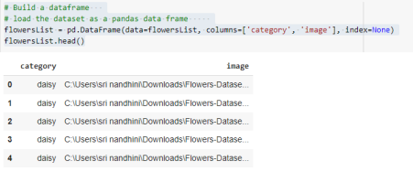# Let's check how many samples for each category are present

print("Total number of flowers in the dataset: ", len(flowersList)) flowerNum = flowersList['category'].value_counts()

print("Flowers in each category: ")

print(flowerNum)

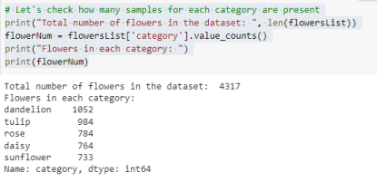

# A list for storing names of some random samples from each category RanSamples = []

# Get samples fom each category

for category in flowerNum.index:

samples = flowersList['image'][flowersList['category'] == category] .sample(4).values

for sample in samples:

RanSamples.append(sample)

# Plot the samples

f, ax = plt.subplots(5,4, figsize=(15,10))

for i,sample in enumerate(RanSamples):

ax[i//4, i%4].imshow(mimg.imread(RanSamples[i]))

ax[i//4, i%4].axis('off')

plt.show()

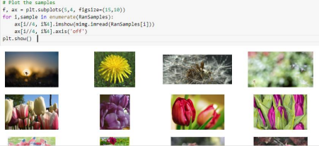

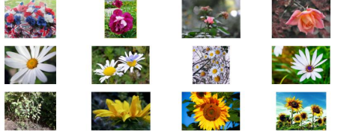# Let's do some visualization and see how many samples we have for each category

f, axe = plt.subplots(1,1,figsize=(14,6))

sns.barplot(x = flowerNum.index, y = flowerNum.values, ax = axe, palett e="rocket")

axe.set_title("Flowers count for each category", fontsize=16) axe.set_xlabel('Category', fontsize=14)

axe.set_ylabel('Count', fontsize=14)

plt.show()

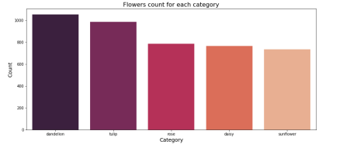# Make directory 'test', with 2 sub directories, 'trainDir', & 'validDi r'

trainDir = './test/trainDir'

valDir = './test/valDir'

# test_dir = './test/test_dir'

def create_directory(dirName):

if os.path.exists(dirName):

shutil.rmtree(dirName)

os.makedirs(dirName)

# Inside the trainDir & valDir sub-directories, sub directories for each flower is created

for flower in flowers:

os.makedirs(os.path.join(dirName, flower))

create_directory(trainDir)

create_directory(valDir)

# lists for training & validation image & label

trainImg = []

trainLabel = []

validImg = []

validLabel = []

# for copying 100 samples to the validation dir & others to the train d ir

for flower in flowerNum.index:

samples = flowersList['image'][flowersList['category'] == flower].v alues

diffPics = np.random.permutation(samples)

for i in range(100):

name = diffPics[i].split('/')[-1]

shutil.copyfile(diffPics[i],'./test/valDir/' + str(flower) + '/ '+ name)

try:

# add image to list

img = plt.imread('./test/valDir/' + str(flower) + '/'+ name )

#resize all of the image to 150*150

img = cv2.resize(img,(150,150))

validImg.append(np.array(img))

# add label to list

if (str(flower)=="dandelion"):

validLabel.append(0)

elif (str(flower)=="tulip"):

validLabel.append(1)

elif (str(flower)=="rose"):

validLabel.append(2)

elif (str(flower)=="daisy"):

validLabel.append(3)

elif (str(flower)=="sunflower"):

validLabel.append(4)

except Exception as e:

None

for i in range(101,len(diffPics)):

name = diffPics[i].split('/')[-1]

shutil.copyfile(diffPics[i],'./test/trainDir/' + str(flower) + '/' + name)

try:

# add image to list

img = plt.imread('./test/trainDir/' + str(flower) + '/' + n ame)

#resize all of the image to 150*150

img = cv2.resize(img,(150,150))

trainImg.append(np.array(img))

# add label to list

if (str(flower)=="dandelion"):

trainLabel.append(0)

elif (str(flower)=="tulip"):

trainLabel.append(1)

elif (str(flower)=="rose"):

trainLabel.append(2)

elif (str(flower)=="daisy"):

trainLabel.append(3)

elif (str(flower)=="sunflower"):

trainLabel.append(4)

except Exception as e:

None

# Let computer read the 5 category

validLabel = to_categorical(validLabel,num_classes = 5) trainLabel = to_categorical(trainLabel,num_classes = 5) print(validLabel)

print(trainLabel)

# Make new test and validation images as pixcel

validImg=np.array(validImg)

validImg=validImg/255

trainImg=np.array(trainImg)

trainImg=trainImg/255

print("\nLengths of the corresponding array dimensions: \n") print(np.shape(validImg),np.shape(validLabel),np.shape(trainImg),np.sha pe(trainLabel))

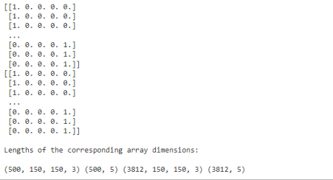def createModel():

model = Sequential()

# learn a total of 32 filters, kernel size 3x3

model.add(Conv2D(32, (3, 3), input_shape=(150,150,3), padding="Same ", activation='relu'))

model.add(MaxPooling2D((2, 2)))

# learn a total of 64 filters, kernel size 3x3

model.add(Conv2D(64, (3, 3), padding="Same", activation='relu')) model.add(MaxPooling2D((2, 2)))

# learn a total of 96 filters, kernel size 3x3

model.add(Conv2D(96, (3, 3), padding="Same", activation='relu')) model.add(MaxPooling2D((2, 2)))

# learn a total of 128 filters, kernel size 3x3

model.add(Conv2D(128, (3, 3), padding="Same", activation='relu')) model.add(MaxPooling2D((2, 2)))

# Add Dense layers on top

'''

1. flatten the 3D output to 1D

2. add dense layer to top

'''dfwsssssssssssssssssssssssssssssssss

model.add(Flatten())

model.add(Dense(256, activation='relu'))

model.add(Dense(5, activation='softmax'))

return model

# Compile

model = createModel()

batch_size = 128

epochs = 50

model.compile(loss='categorical_crossentropy',

optimizer='RMSProp',

metrics=['accuracy'])

model.summary()

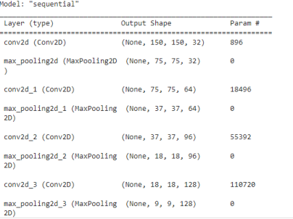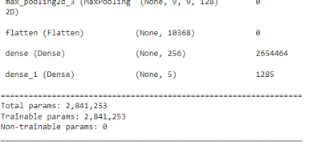# Create data argument to prevent overfitting

datagen = ImageDataGenerator(

featurewise_center=False, # set input mean to 0 over the datas et

samplewise_center=False, # set each sample mean to 0 featurewise_std_normalization=False, # divide inputs by std of the dataset

samplewise_std_normalization=False, # divide each input by its std

zca_whitening=False, # apply ZCA whitening

rotation_range=90, # randomly rotate images in the range (90, 0 to 180)

zoom_range = 0.1, # Randomly zoom image

width_shift_range=0.1, # randomly shift images horizontally (f raction of total width)

height_shift_range=0.1, # randomly shift images vertically (fr action of total height)

shear_range=0.1,

horizontal_flip=True, # randomly flip images

vertical_flip=False # randomly flip images

)

datagen.fit(trainImg)

# start training

'''

verbose -

0 shows nothing; 1 will show animated progress bar; 2 will only mentio n the number of epoch.

batch_size -

the number of samples that will be propagated through the network. epochs -

an arbitrary cutoff, use to separate training into distinct phases. '''

History = model.fit(trainImg, trainLabel, batch_size=batch_size, epochs = epochs, validation_data = (validImg, validLabel),verbose=1)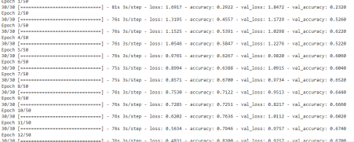

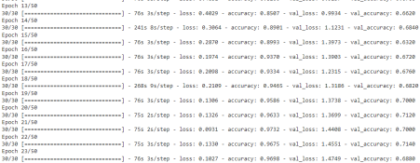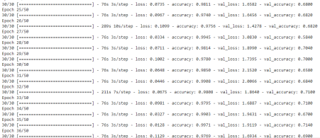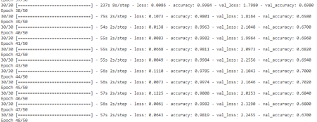# start training

'''

verbose -

0 shows nothing; 1 will show animated progress bar; 2 will only mentio n the number of epoch.

batch_size -

the number of samples that will be propagated through the network.

epochs -

an arbitrary cutoff, use to separate training into distinct phases. '''

History = model.fit(trainImg, trainLabel, batch_size=batch_size, epochs = epochs, validation_data = (validImg, validLabel),verbose=1)