**NAME:** KEERTHANA R

**REG NO:**195002063(IT)

**VISUALIZING AND PREDICTING HEART DISEASES WITH AN**

**INTERACTIVE DASHBOARD**

ASSIGNMENT-2

Overview:

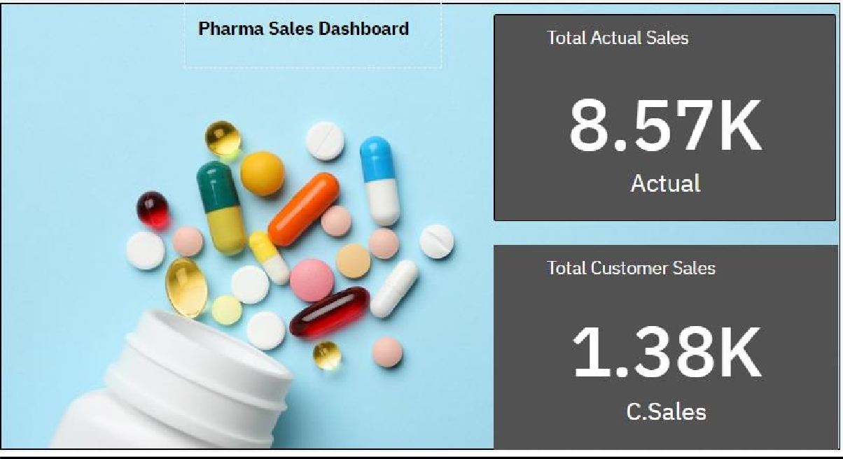

Sales By Customer:





Sales By Sales Representative:





Inventory Stock For Warehouse Location:

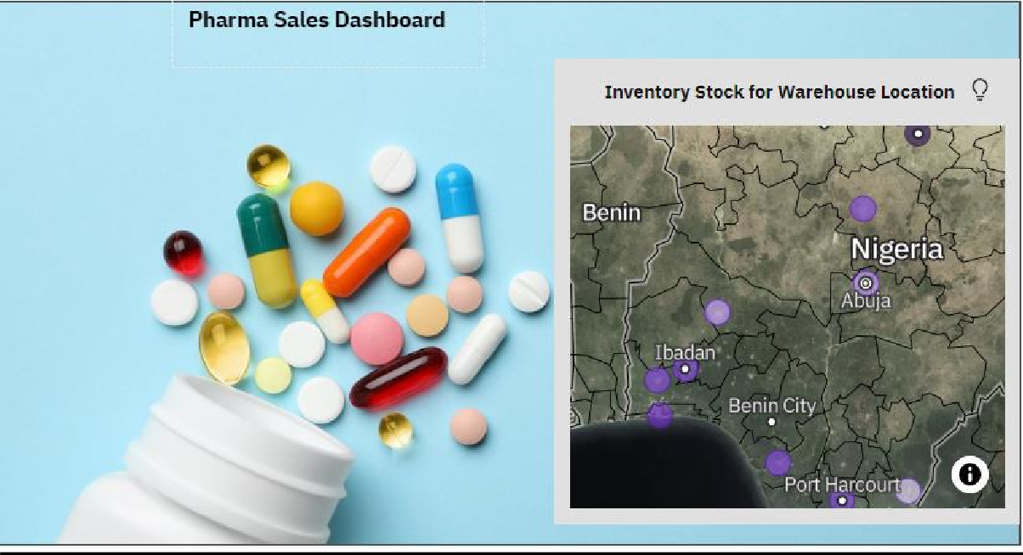

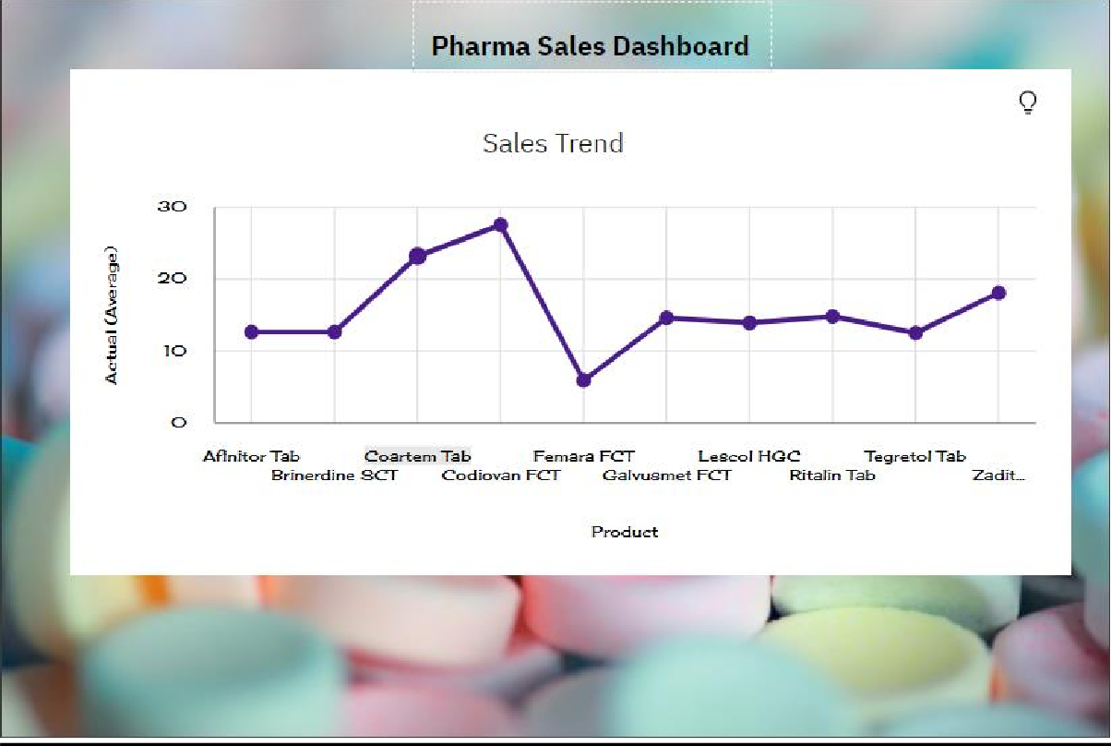

Monthly Sales:



