SRI SIVASUBRAMANIYA NADAR COLLEGE OF ENGINEERING

**NAME: MOHAMED RIYAS S.**

**REG NO.195002305**

**DEPT: INFORMATION TECHNOLOGY**

**LINE AND COLUMN:**

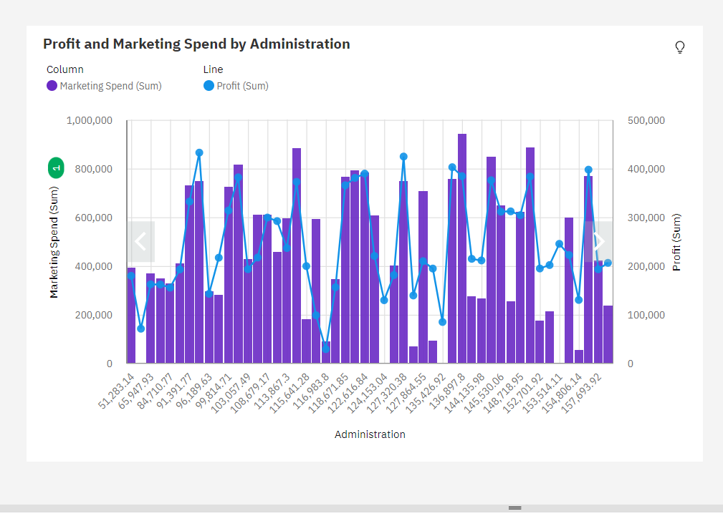

**PIE CHART:**

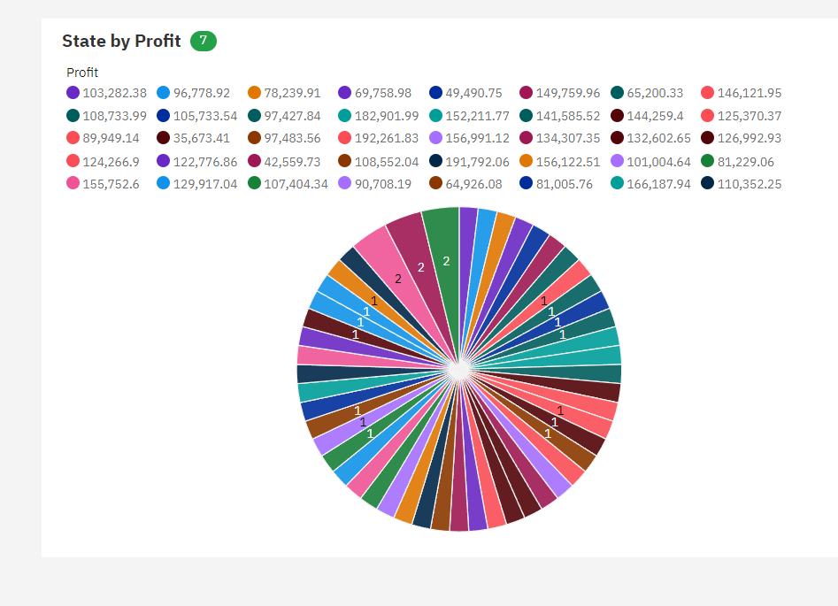

**BOX PLOT:**

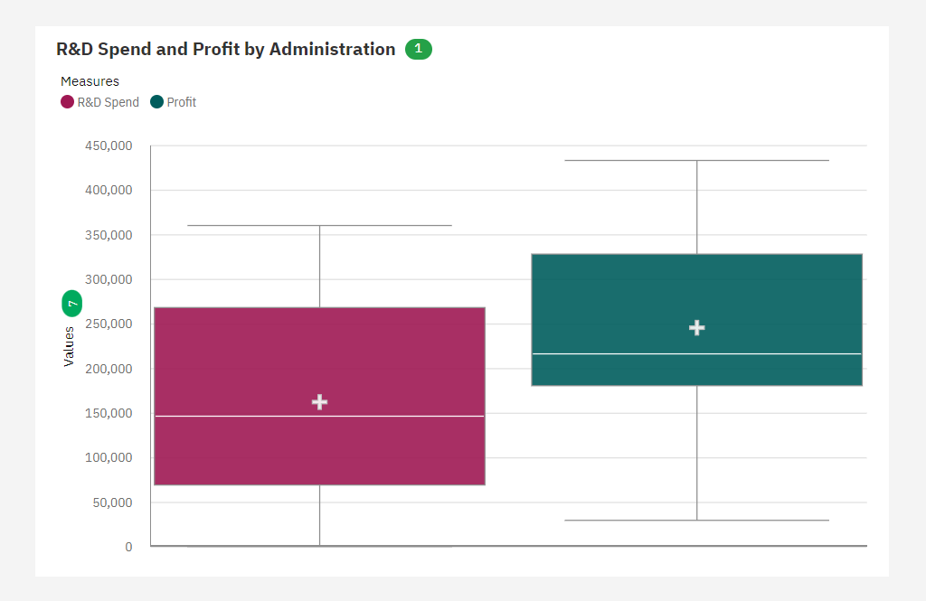

**LINE PLOT:**

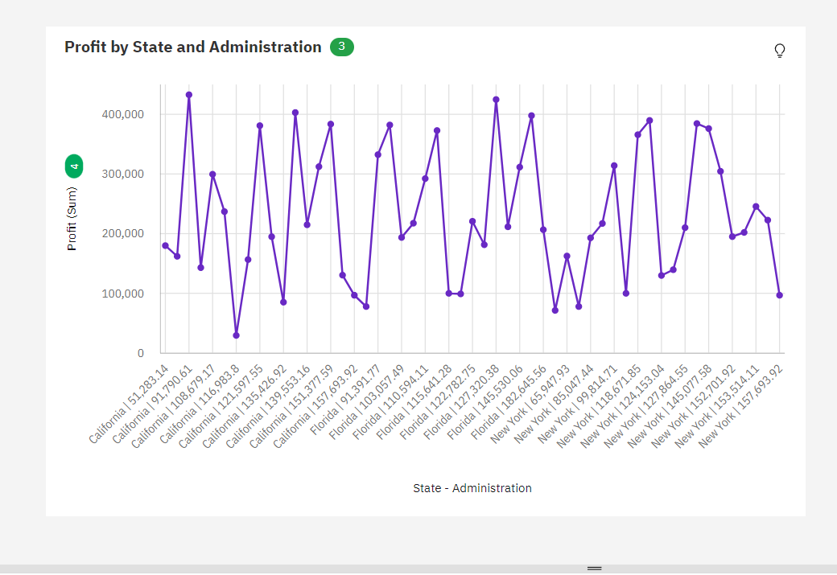

**WATER FALL PLOT:**

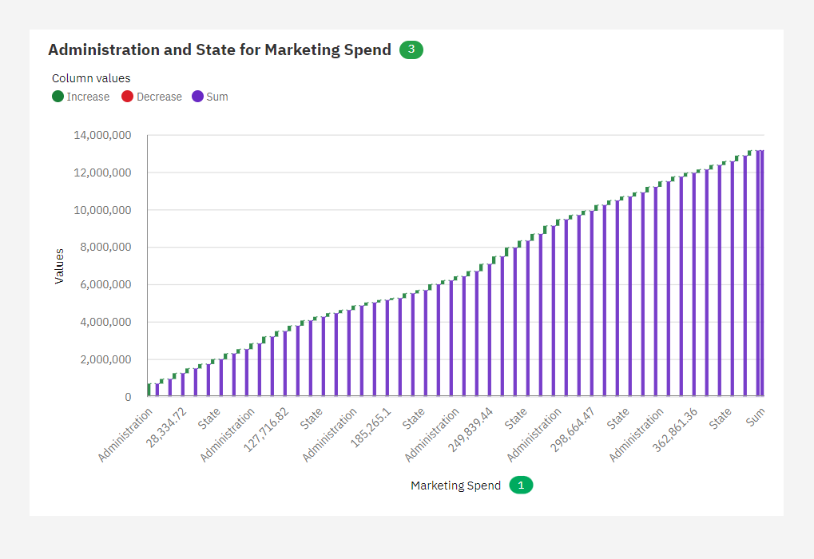

**NETWORK PLOT:**

