**ASSIGNMENT – 2**

**Team ID :** PNT2022TMID04490 **Team Member Name : Subalakshmi G**

**Roll No :** 737819CSR197

**DATASET :** Pharma - Sales - Dataset

**CHALLENGE :** Upload the dataset to Cognos Analytics, prepare the data, explore and Create Interactive Dashboard.

**EXPLORATION:**

**Task 1 : Sales By Customer**

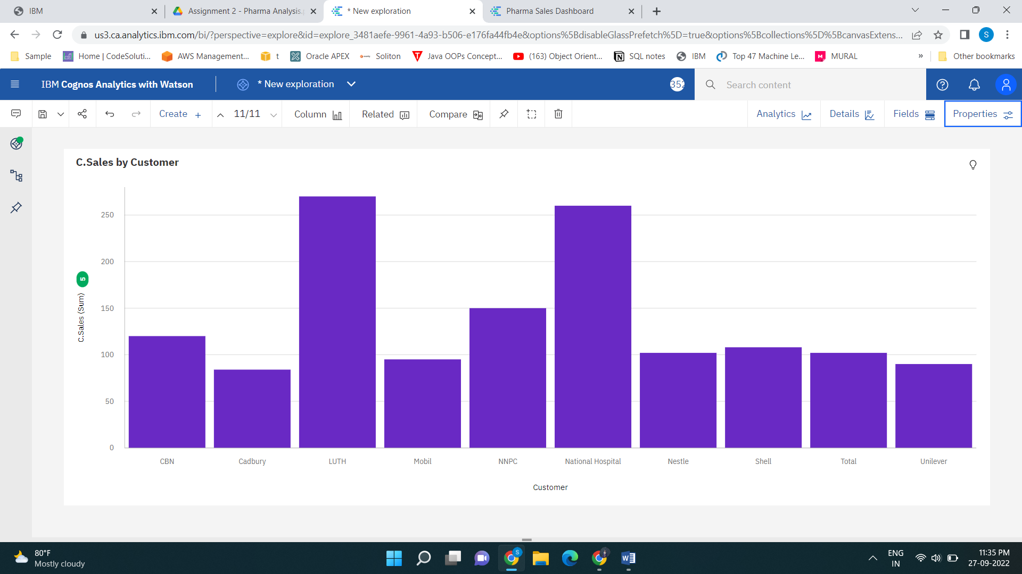

**Task 2 : Sales By Location**

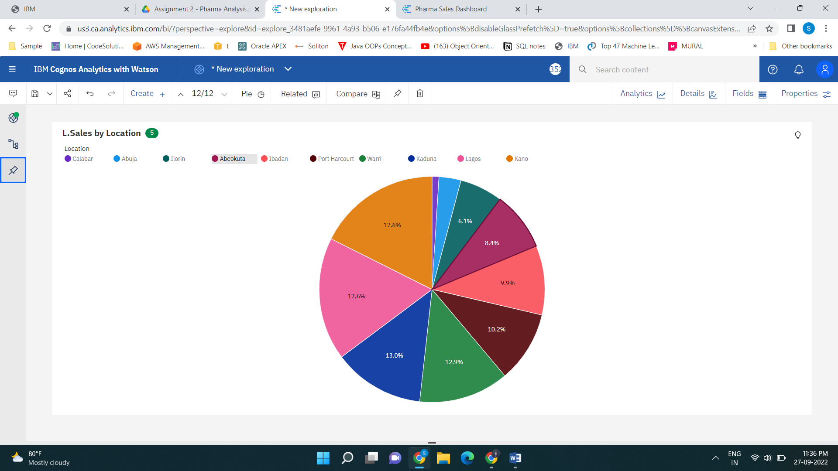

**Task 3 : Sales By Sales Representative**

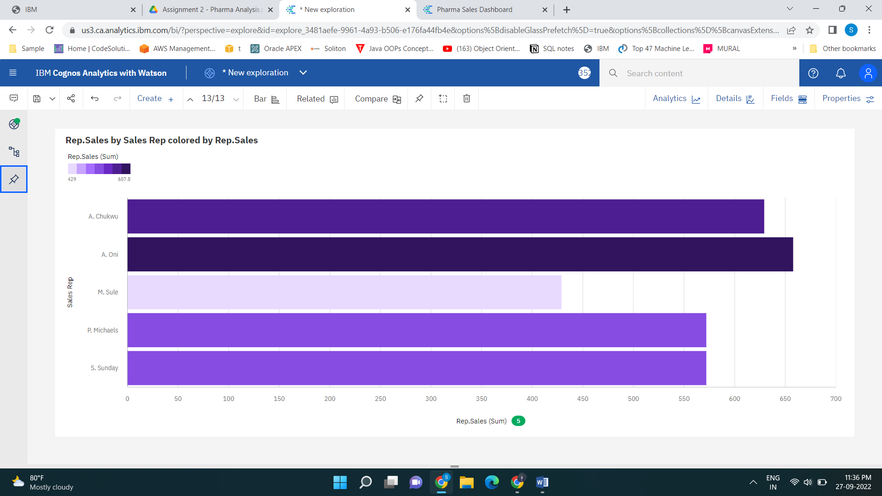

**Task 4 : Received Inventory From Supplier**

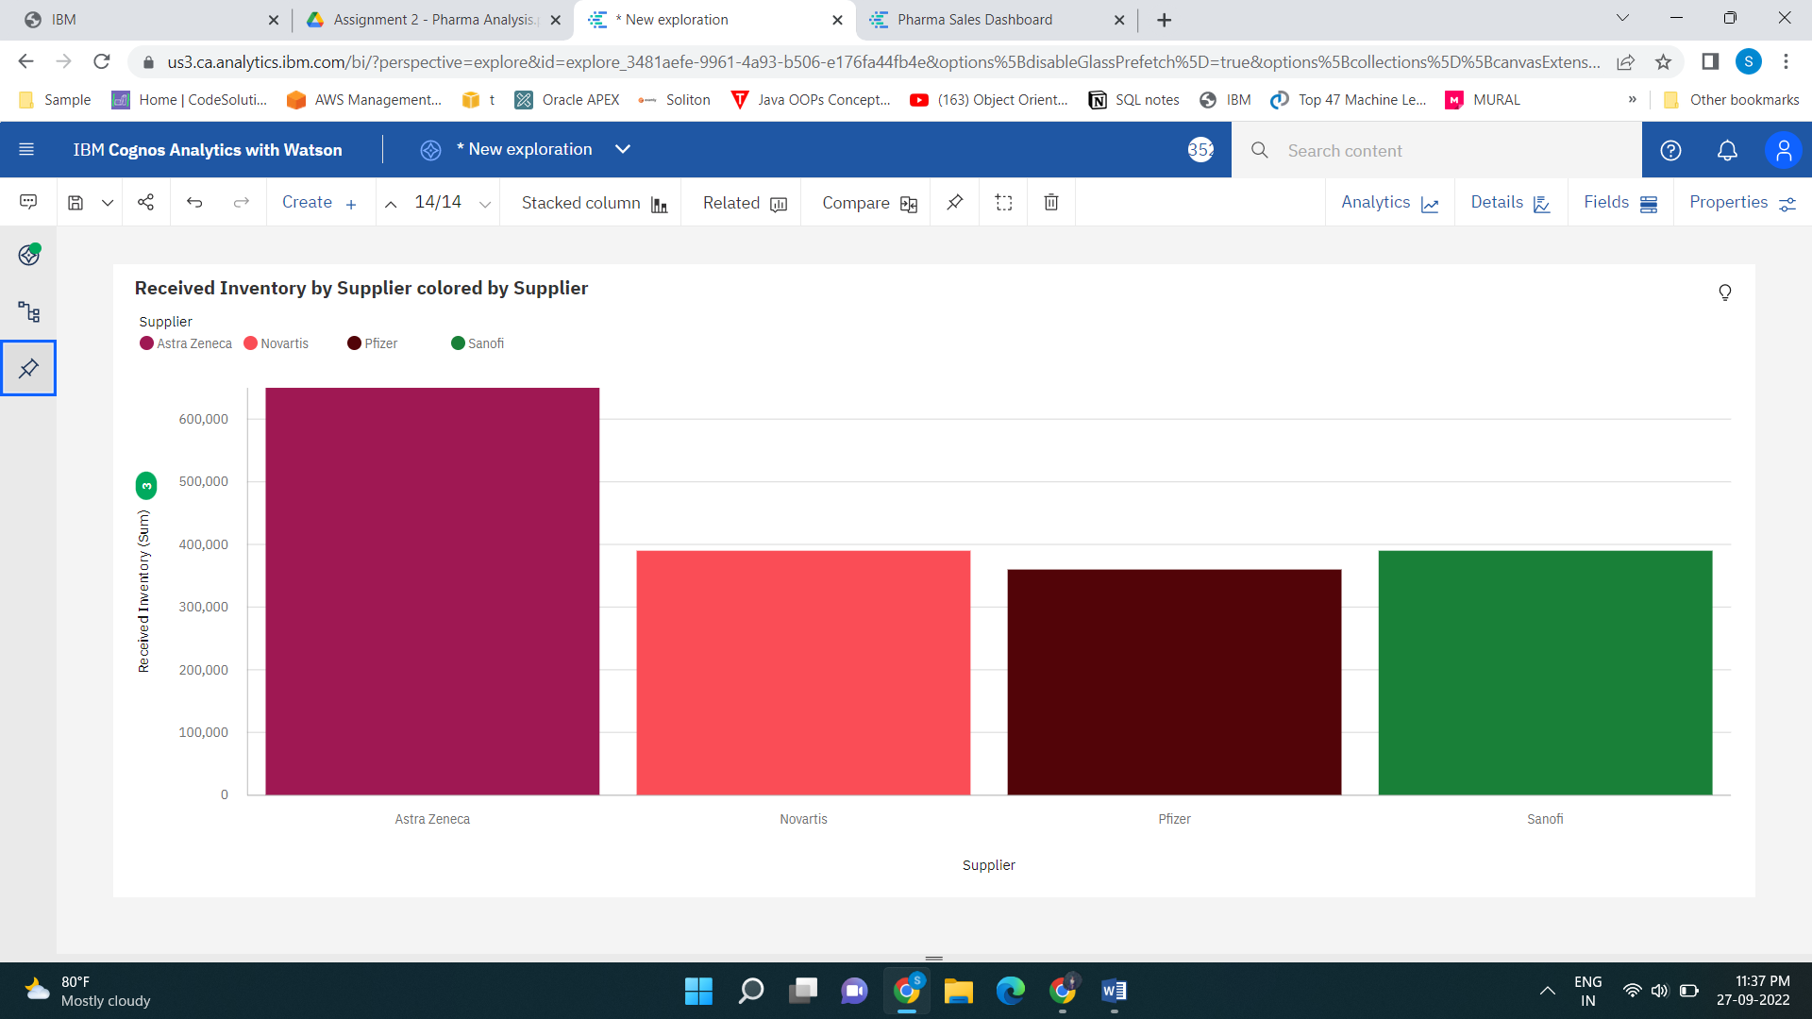

**Task 5 : Inventory Stock for Warehouse Locations**

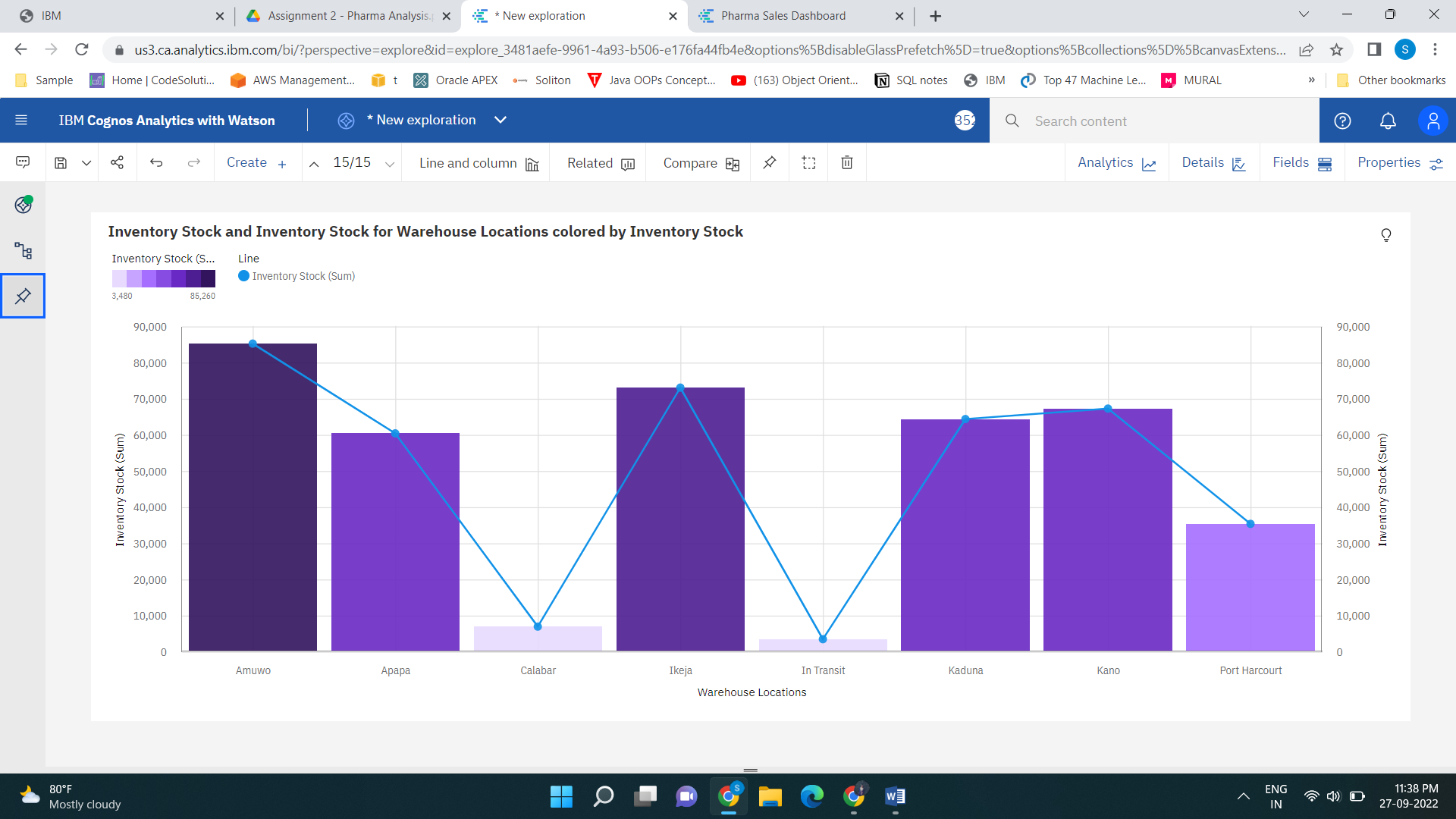

**Task 6 : Sales Trend**

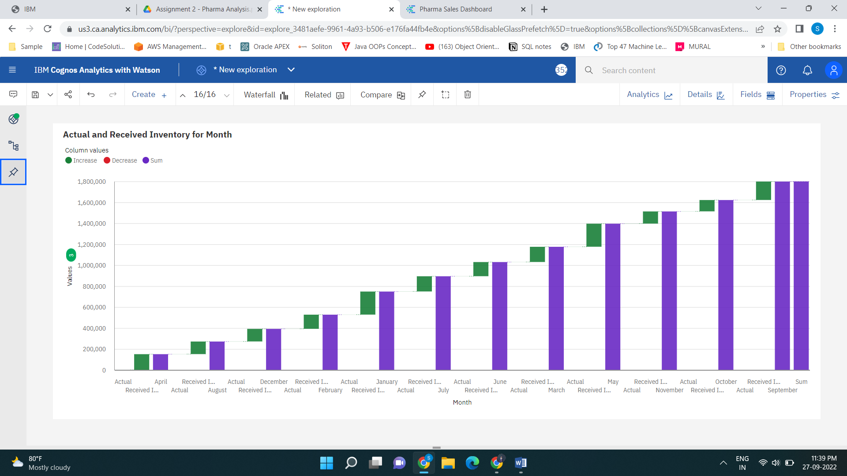

**Task 7 : Monthly Sales**

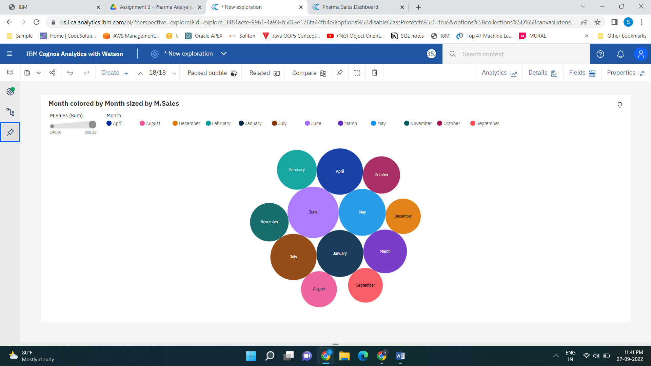

**Task 8 : Actual and Received Inventory by Month**

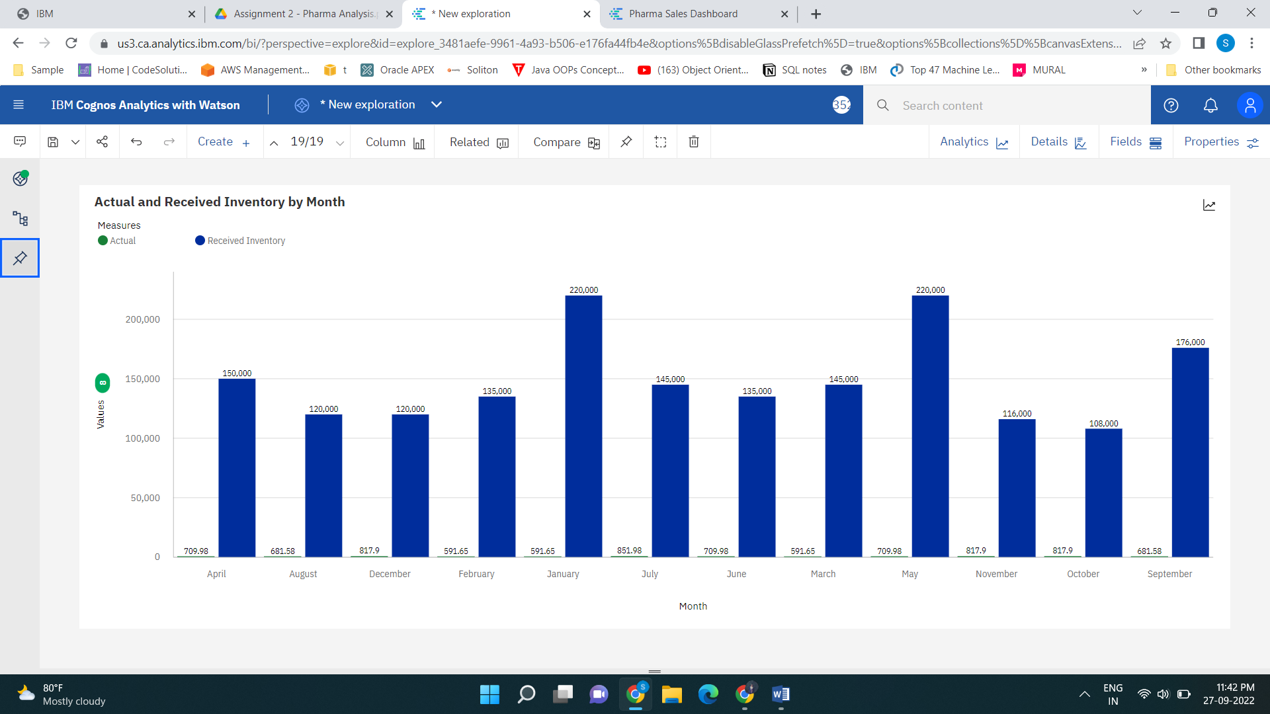

**DASHBOARD :**

