# PACKAGES INSTALLATION

|  |  |
| --- | --- |
| DATE | 16-NOVEMBER 2022 |
| TEAM ID | PNT2022TMID04163 |
| TEAM MEMBER | ASHVIN BALAJI S |
| PROJECT NAME | STATISTICAL MACHINE  LEARNING APPROACHES TO LIVER DISEASE PREDICTION |

**Packages Installation**

To build Machine learning models you must require the following packages.

## Numpy:

It is an open-source numerical Python library. It contains a multidimensional array and matrix data structures and can be used to perform mathematical operations. **Python NumPy** is a general-purpose array processing package which provides tools for handling the n-dimensional arrays. It provides various computing tools provides both the flexibility of Python and the speed of well- optimized compile C code. It’s easy to use syntax makes it highly accessible and

productive for programmers from any background. This NumPy tutorial helps you learn the fundamentals of NumPy from Basics to Advance, like operations on NumPy array, matrices using a huge dataset of NumPy – programs and projects.

Now to use numpy in the program we need to import the module.Generally,numpy package is defined as np of abbreviation for convenience.

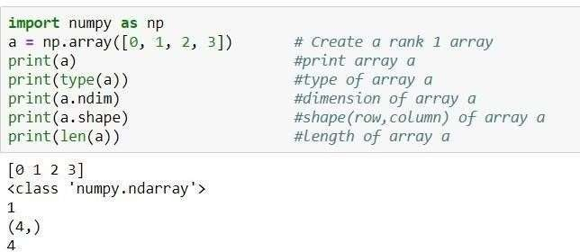

In the example figure above we can observenumpy is imported first and then a *l-*

numpy array a is defined. Then we can examine the type, dimension, shape, and

*d* length of the array using mentioned commands.

# Pandas

Panda is an open-source library built on top of *numpy* providing high performance,easy-to-use data structures and data analysis tools for the Python programming language. It allows for fast analysis and data cleaning and preparation.

It excels in performance and productivity. It can work with data from a wide variety of sources. pandasis suited for many different kinds of data: tabular data, time-series data, arbitrary matrix data with row and column labels, and Any other form of observational/statistical data sets. To install pandas in your system you can use this command pip install pandas or conda install pandas . To make series in pandaswe need to use pd.Series(data, index)format where data are input data and index are selected index for data. To understand it fully we can follow the below example.

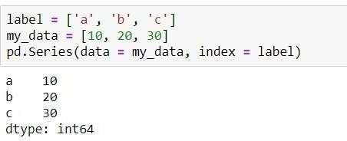

***Pandas DataFrames*** create a tabular data structure with labeled axes(rows and columns). The default format of a DataFrame would be pd.Dataframe(data, index, column) . You need to mention the data, index and columns value to generate a DataFrame. Data should be at least *two-dimensional, index* will be the row name and *columns* values for the columns.

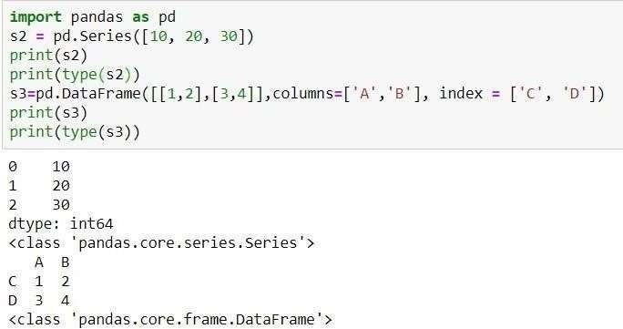

## Scikit-learn:

It is a free machine learning library for Python. It features various algorithms like support vector machine, random forests, and k-neighbours, and it also supports Python numerical and scientific libraries like NumPy and SciPy. Scikit- learn (Sklearn) is the most useful and robust library for machine learning in Python. It provides a selection of efficient tools for machine learning and statistical modeling including classification, regression, clustering and dimensionality reduction via a consistence interface in Python. This library, which is largely written in Python, is built upon NumPy, SciPy and Matplotlib.

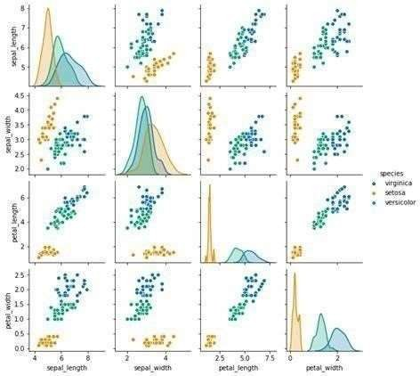

## Learning problems fall into a few categories:

**C**lassification**:**

samples belong to two or more classes and we want to learn from already labeled data how to predict the class of unlabeled data. An example of a classification problem would be handwritten digit recognition, in which the aim is to assign each input vector to one of a finite number of discrete categories. Another way to think of classification is as a discrete (as opposed to continuous) form of supervised learning where one has a limited number of categories and for each of the n samples provided, one is to try to label them with the correct category or class.

## Regression:

If the desired output consists of one or more continuous variables, then the task is called regression. An example of a regression problem would be the prediction of the length of a salmon as a function of its age and weight. **unsupervised learning**, in which the training data consists of a set of input vectors x without any corresponding target values. The goal in such problems may be to discover groups of similar examples within the data, where it is called **clustering**, or to determine the distribution of data within the input space, known as **density estimation** , or to project the data from a high-dimensional space down to two or three dimensions for the purpose of visualization.

## Matplotlib and Seaborn:

Matplotlib is mainly deployed for basic plotting. Visualization using Matplotlib generally consists of bars, pies, lines, scatter plots and so on. Seaborn: Seaborn, on the other hand, provides a variety of visualization patterns. It uses fewer syntax and has easily interesting default themes.

## Matplotlib:

Matplotlib is an amazing visualization library in Python for 2D plots of arrays.

Matplotlib is a multi-platform data visualization library built on NumPy arrays and designed to work with the broader SciPy stack. It was introduced by John Hunter in the year 2002. One of the greatest benefits of visualization is that it allows us visual access to huge amounts of data in easily digestible visuals. Matplotlib consists of several plots like line, bar, scatter, histogram etc. As per above definition, Matplotlib is used for visualizing the data. (Huge or small)

## Basic plots in Matplotlib :

Matplotlib comes with a wide variety of plots. Plots helps to understand trends, patterns, and to make correlations. They’re typically instruments for reasoning about quantitative information. Some of the sample plots are covered here.

## Line plot :



**Bar plot:**

## Histogram :

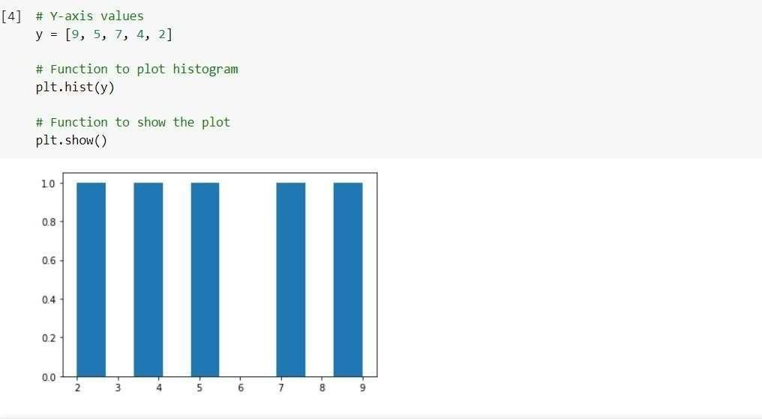

**Scatter Plot:**

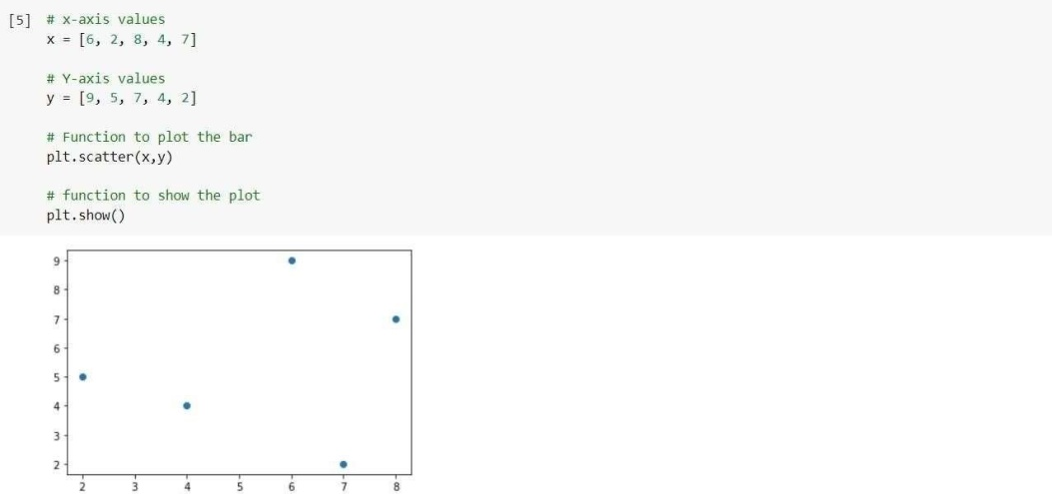

# Seaborn:

Seaborn is an amazing visualization library for statistical graphics plotting in Python. It provides beautiful default styles and color palettes to make statistical plots more attractive. It is built on the top of **matplotlib** library

and also closely integrated to the data structures from pandas. Seaborn aims to make visualization the central part of exploring and understanding data. It provides dataset-oriented APIs, so that we can switch between different visual representations for same variables for better understanding of dataset. As per definition Seaborn also aims for data visualization, the major difference is it aims for central part of exploring and understanding data.

## Some basic plots using seaborn: Dist plot:

Seaborn dist plot is used to plot a histogram, with some other variations like kdeplot and rugplot.

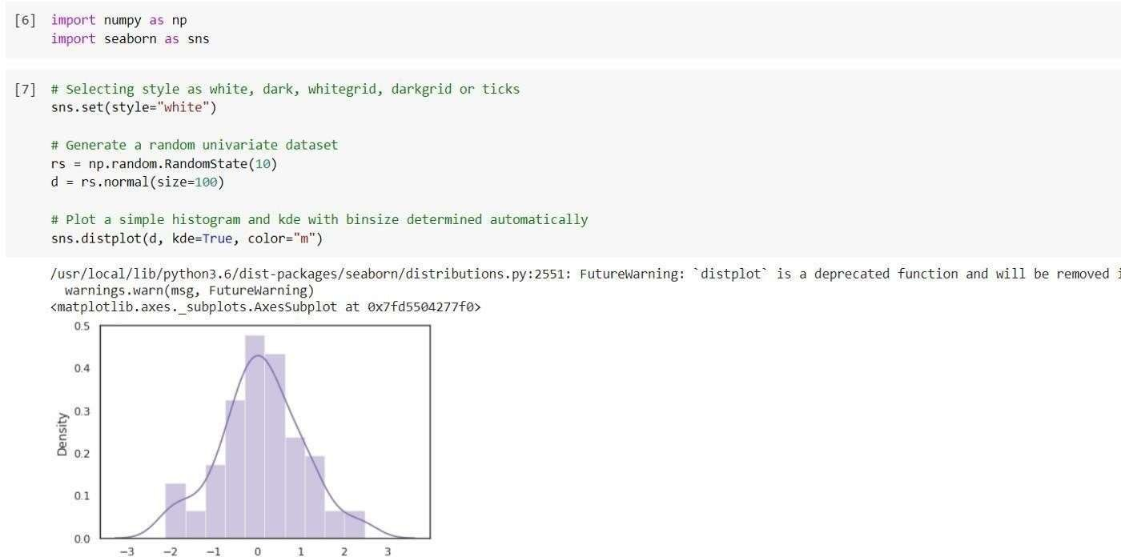

## Line plot:

The line plot is one of the most basic plots in seaborn library. This plot is mainly used to visualize the data in form of some time series, i.e., in continuous manner.

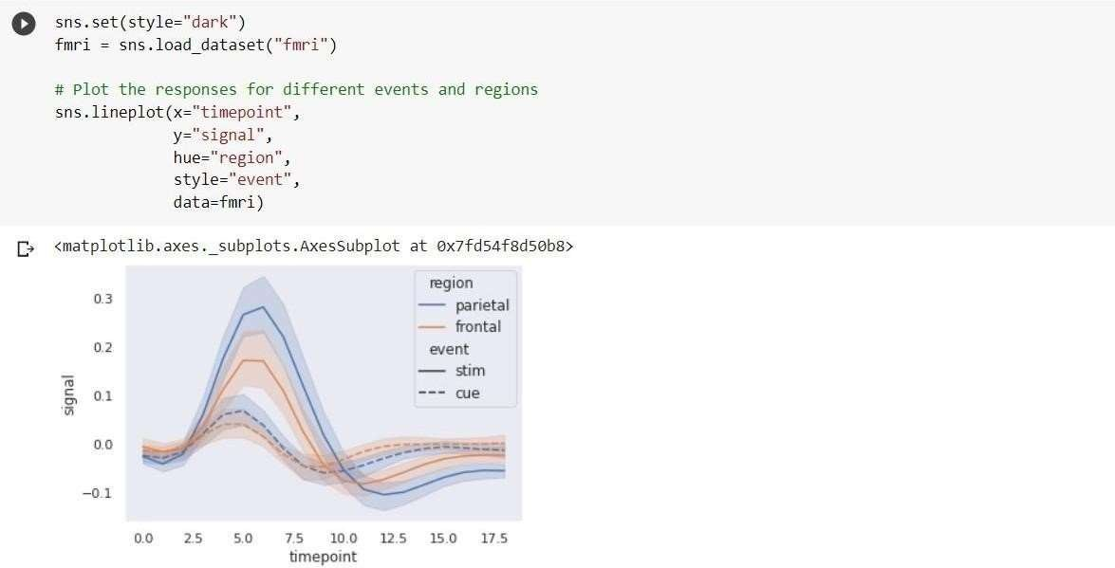

## Lmplot :

The lmplot is another most basic plot. It shows a line representing a linear regression model along with data points on the 2D-space and x and y can be set as the horizontal and vertical labels respectively.

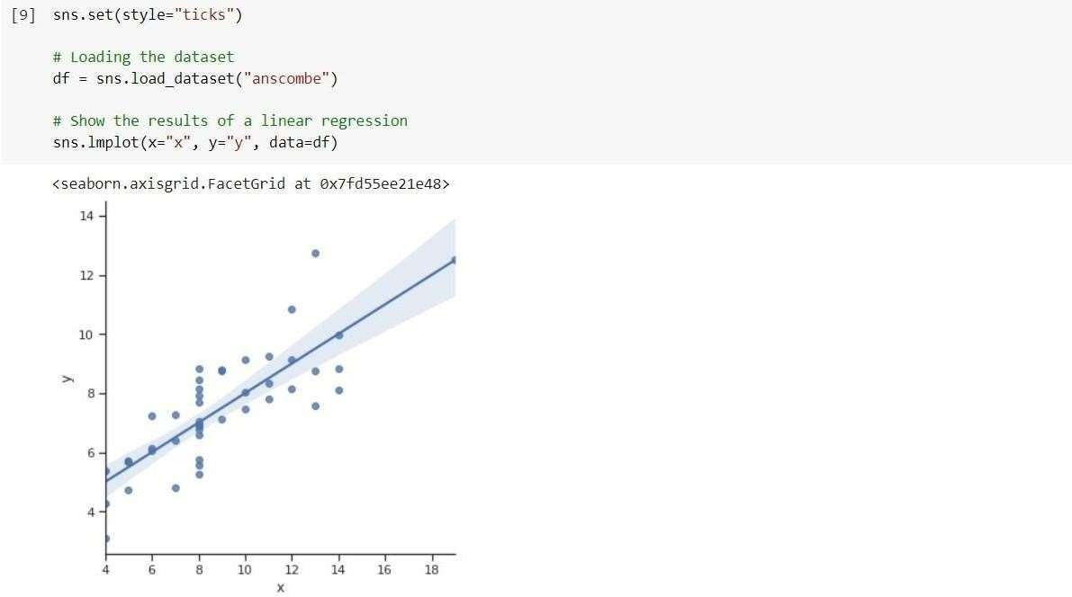

## Pickle:

The pickle module implements serialization protocol, which provides an ability to save and later load Python objects using special binary format.

If you are using **anaconda navigator**, follow below steps to download required packages:

* Open the anaconda prompt.
* Type “pip install jupyter notebook” and click enter.
* Type “pip install spyder” and click enter.
* Type “pip install numpy” and click enter. • Type “pip install pandas” and click enter.
* Type “pip install matplotlib” and click enter.
* Type “pip install seaborn” and click enter.
* Type “pip install sklearn” and click enter.
* Type “pip install Flask” and click enter.

If you are using Pycharm IDE, you can install the packages through the command prompt and follow the same syntax as above.