ASSIGNMENT 3

|  |  |
| --- | --- |
| **ROLL NUMBER** | 420419104041 |
| **NAME** | RAMYA A |
| **TEAM ID** | PNT2022TMID38576 |

# Create a Bucket in IBM Object Storage.

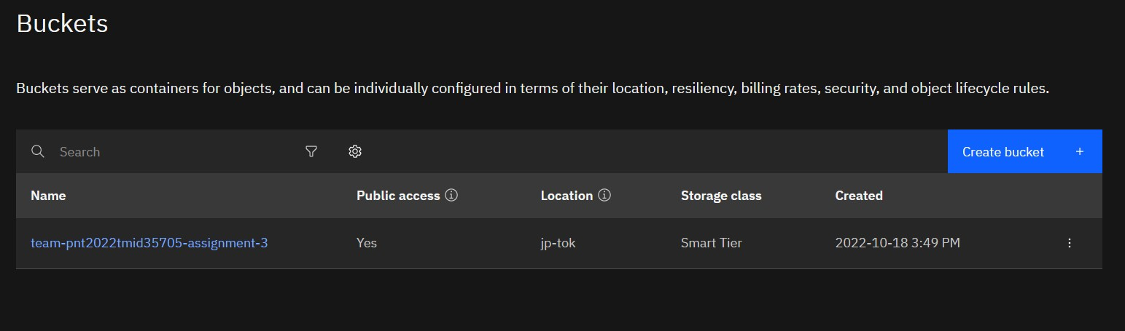

1. **Upload 5 images to IBM Object Storage Bucket and make it public. Create a HTML page and display these 5 images.**

**SOURCE CODE**

<!DOCTYPE html>

<html lang="en">

<head>

<meta charset="UTF-8">

<meta http-equiv="X-UA-Compatible" content="IE=edge">

<meta name="viewport" content="width=device-width, initial-scale=1.0">

<title>Gallary</title>

<link rel="stylesheet" href="style.css">

</head>

<body>

<div class="container">

<h1>Image Gallary</h1>

<div class="wrapper">

<img src="https://team-pnt2022tmid35705-assignment-3.s3.jp-tok.cloud- object-storage.appdomain.cloud/kratos1.jpg" alt="Image 1">

<img src="https://team-pnt2022tmid35705-assignment-3.s3.jp-tok.cloud- object-storage.appdomain.cloud/kratos2.jpg" alt="Image 2">

<img src="https://team-pnt2022tmid35705-assignment-3.s3.jp-tok.cloud- object-storage.appdomain.cloud/kratos3.jpg" alt="Image 3">

<img src="https://team-pnt2022tmid35705-assignment-3.s3.jp-tok.cloud- object-storage.appdomain.cloud/kratos4.jpg" alt="Image 4">

<img src="https://team-pnt2022tmid35705-assignment-3.s3.jp-tok.cloud- object-storage.appdomain.cloud/mustanggt.jpg" alt="Image 5>

</div>

</div>

</body>

</html>

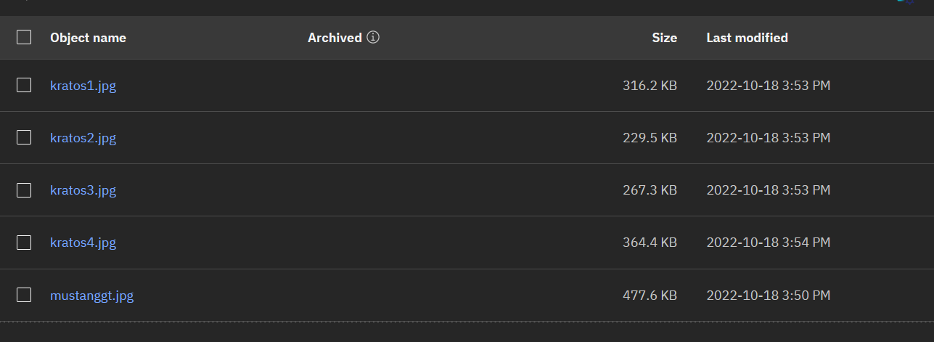**OUTPUT**

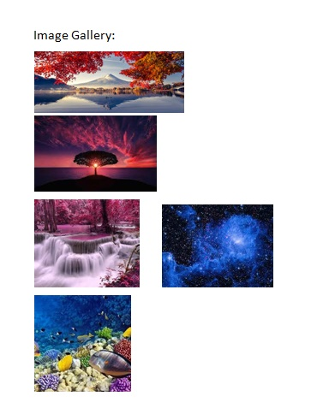

1. **Upload a CSS file to IBM Object Storage Bucket and use it on a HTML page.**

**SOURCE CODE**

**index.html**

<!DOCTYPE html>

<html lang="en">

<head>

<meta charset="UTF-8">

<meta http-equiv="X-UA-Compatible" content="IE=edge">

<meta name="viewport" content="width=device-width, initial-scale=1.0">

<title>Image Gallary</title>

<link rel="stylesheet" href="https://team-pnt2022tmid35705-assignment-3.s3.jp- tok.cloud-object-storage.appdomain.cloud/style.css">

</head>

<body>

<div class="container">

<h1>Image Gallary</h1>

<div class="wrapper">

<img src="https://team-pnt2022tmid35705-assignment-3.s3.jp-tok.cloud- object-storage.appdomain.cloud/kratos1.jpg" alt="Image 1">

<img src="https://team-pnt2022tmid35705-assignment-3.s3.jp-tok.cloud- object-storage.appdomain.cloud/kratos2.jpg" alt="Image 2">

<img src="https://team-pnt2022tmid35705-assignment-3.s3.jp-tok.cloud- object-storage.appdomain.cloud/kratos3.jpg" alt="Image 3">

<img src="https://team-pnt2022tmid35705-assignment-3.s3.jp-tok.cloud- object-storage.appdomain.cloud/kratos4.jpg" alt="Image 4">

<img src="https://team-pnt2022tmid35705-assignment-3.s3.jp-tok.cloud- object-storage.appdomain.cloud/mustanggt.jpg" alt="Image 5>

</div>

</div>

</body>

</html>

# style.css

https://team-pnt2022tmid35705-assignment-3.s3.jp-tok.cloud-object- storage.appdomain.cloud/style.css

*{

margin: 0;

padding: 0;

box-sizing: border-box;

font-family: 'Segoe UI', Tahoma, Geneva, Verdana, sans-serif;

}

.container { width: 70%;

margin: 2rem auto;

}

.container h1 {

margin-bottom: 2rem;

}

.container .wrapper { display: grid;

grid-template-columns: 1fr 1fr 1fr; gap: 2rem;

}

.container .wrapper img { width: 100%;

}

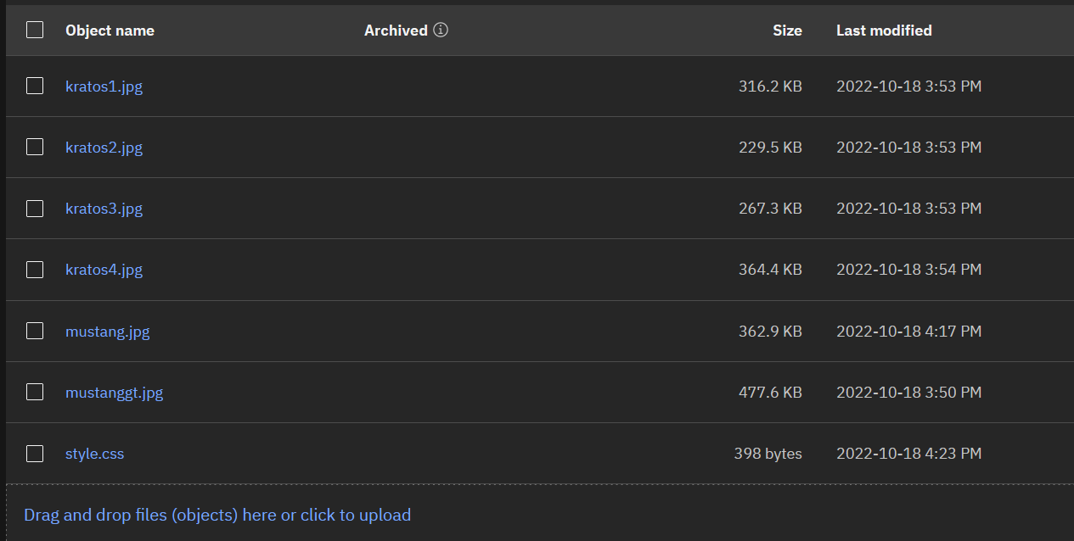**OUTPUT**



1. **Design a chat bot using IBM Watson for hospital**

https://web- chat.global.assistant.watson.appdomain.cloud/preview.html?backgroundImageURL=http s%3A%2F%2Fau-syd.assistant.watson.cloud.ibm.com%2Fpublic%2Fimages%2Fupx- d6b3d761-5481-458f-8524-5f706be94088%3A%3Abc41935c-b25c-4858-b7a5-

6e451d33bd90&integrationID=3a54966b-754b-4b5f-952d-91f3799eb0da&region=au- syd&serviceInstanceID=d6b3d761-5481-458f-8524-5f706be94088

**Output:**

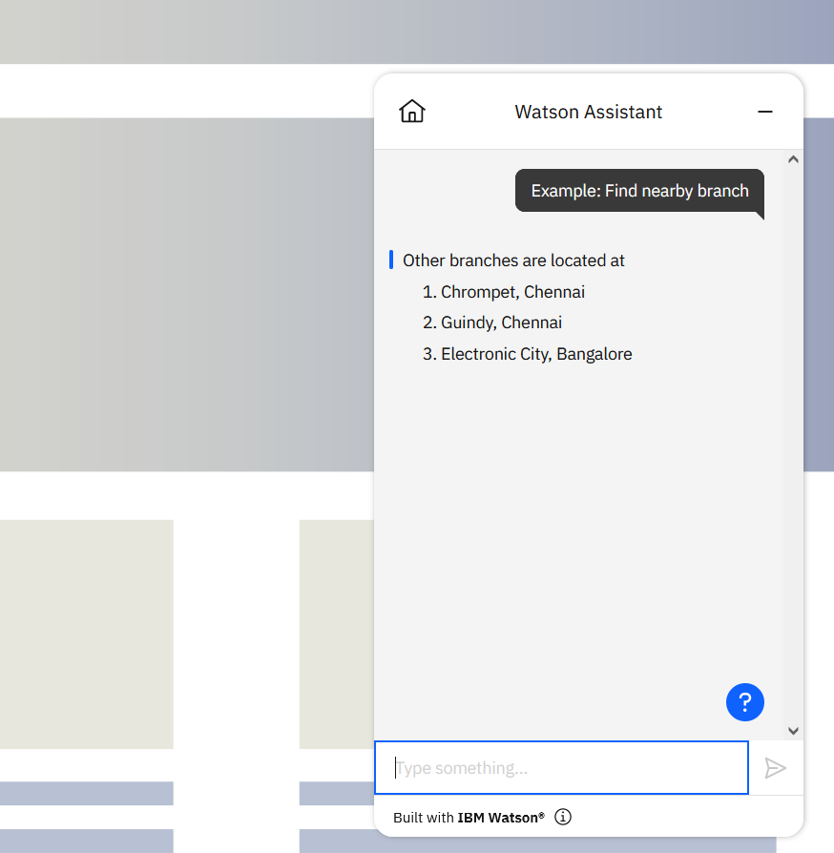

1. **Create a Watson assistant with 10 steps and 3 conditions and load that in HTML page**

**SOURCE CODE**

<!DOCTYPE html>

<html lang="en">

<head>

<meta charset="UTF-8">

<meta http-equiv="X-UA-Compatible" content="IE=edge">

<meta name="viewport" content="width=device-width, initial-scale=1.0">

<title>Hospital Bot</title>

</head>

<body>

<script>

window.watsonAssistantChatOptions = {

integrationID: "3a54966b-754b-4b5f-952d-91f3799eb0da", // The ID of this

integration.

region: "au-syd", // The region your integration is hosted in. serviceInstanceID: "d6b3d761-5481-458f-8524-5f706be94088", // The ID of

your service instance.

onLoad: function(instance) { instance.render(); }

};

setTimeout(function(){

const t=document.createElement('script');

t.src="https://web-chat.global.assistant.watson.appdomain.cloud/versions/" + (window.watsonAssistantChatOptions.clientVersion || 'latest') + "/WatsonAssistantChatEntry.js";

document.head.appendChild(t);

});

</script>

</body>

</html>

**OUTPUT**

