**SPRINT-I**

SETTING UP THE APPLICATION ENVIRONMENT

Docker CLI Installation:

For instructions on installing Docker and the CLI, IBM provided a link to the documentation. We installed the Docker Desktop application by following the directions in the documentation.

First, install the “Docker Desktop Installer.exe” file from [www.Docker.com](http://www.docker.com/)

After downloading the above file, follow the given process:

* Double-click Docker Desktop Installer.exe to run the installer.
* Follow the instructions on the installation wizard to authorize the installer and proceed with the installation.
* When the installation is successful, click Close to complete the installation process.

Here is the Screenshot for the Docker installation, given Below:

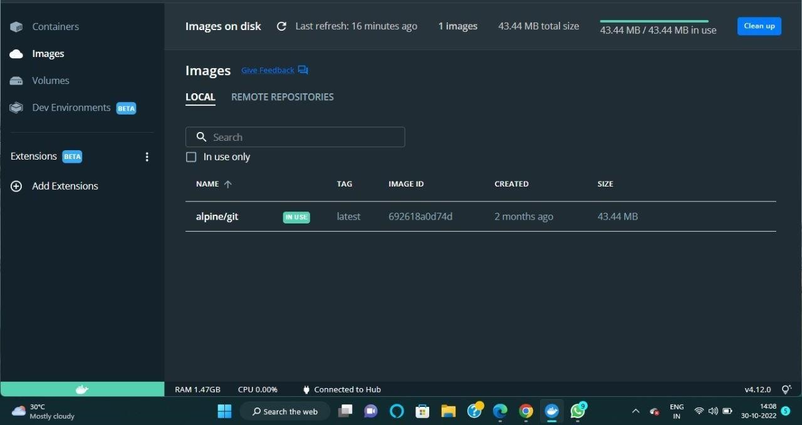

A small Green rectangle left corner shows that the engine is running.