**INSTALLATION OF PYTHON 3.9.8**

|  |  |
| --- | --- |
| Team ID | PNT2022TMID48300 |
| Project Name | Gas Leakage Alerting And Monitoring System |

**STEP 1:** Type python in the google and click on the first link.

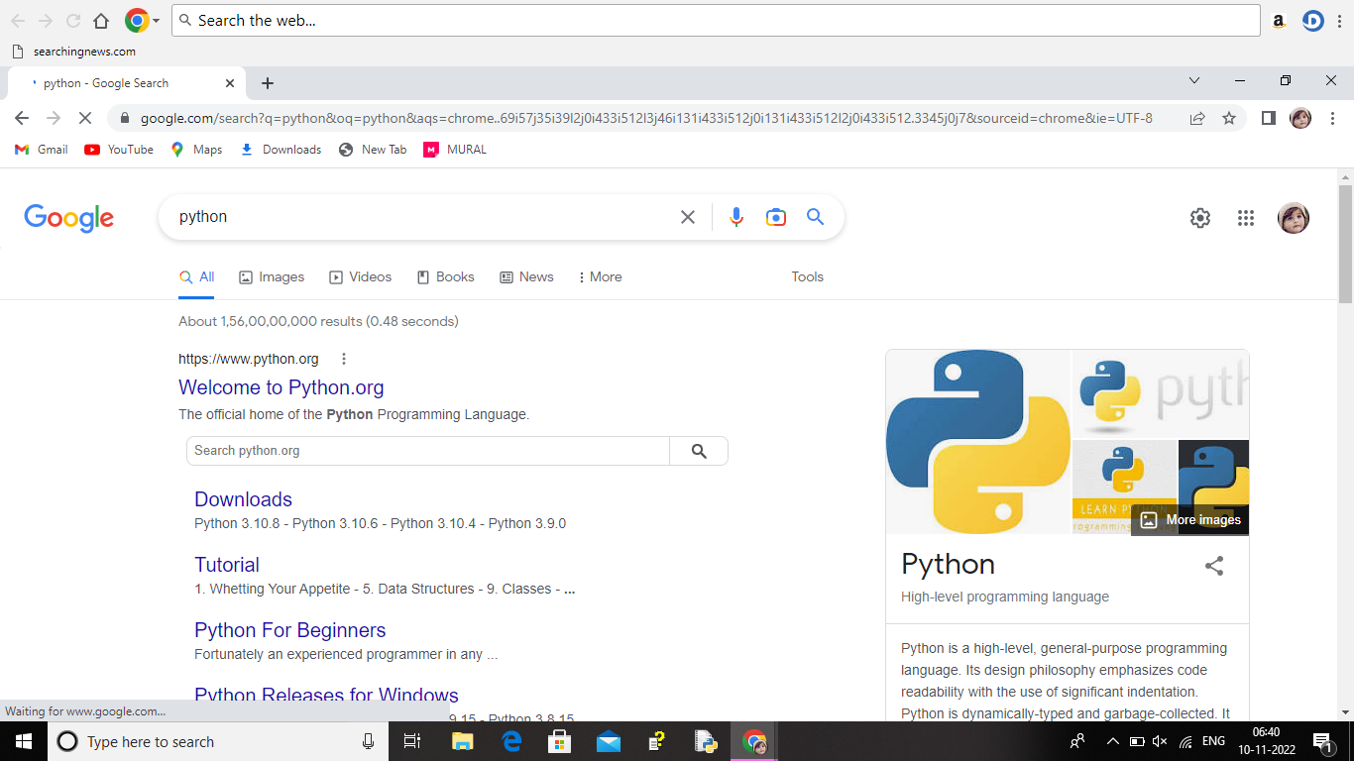

**STEP 2:** Click the python 3.9.8

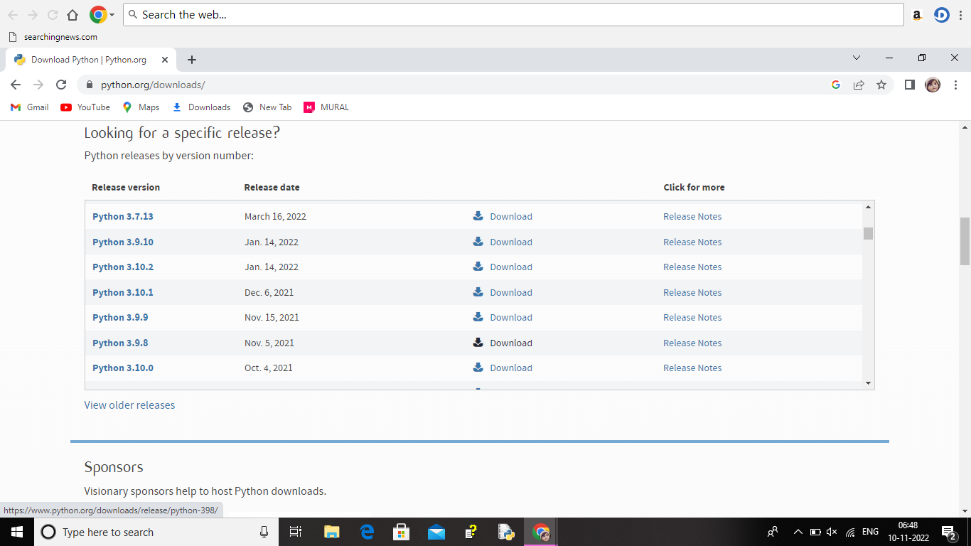

**STEP 3:** Scroll down to reach files and click on Windows Installer (64 bit)

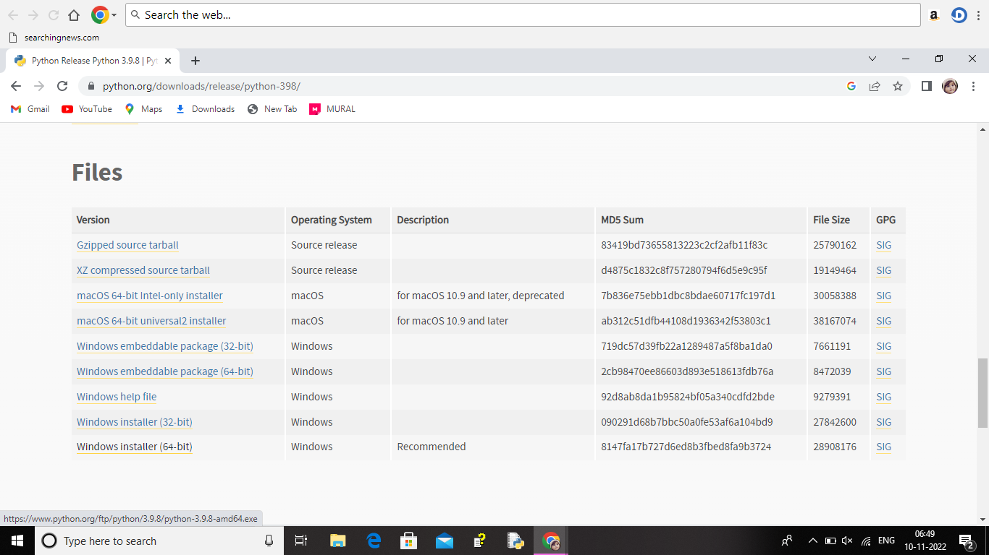

**STEP 4:** Click on the install button.

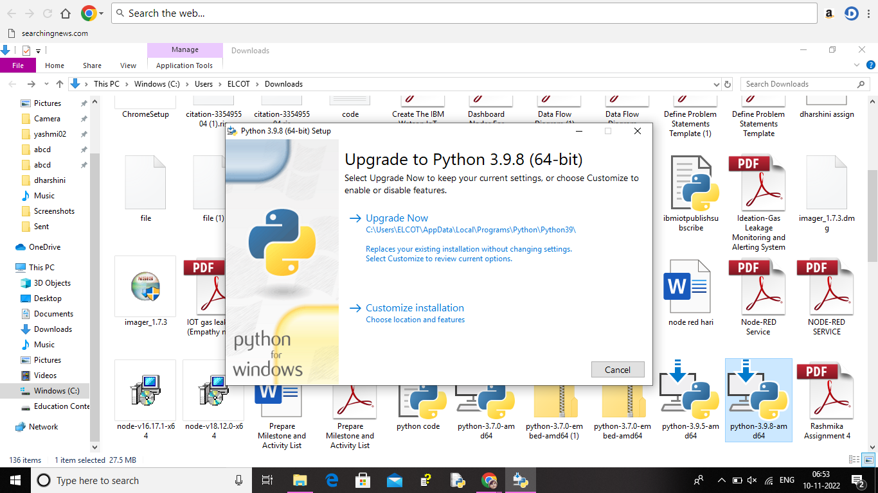

**STEP 5:** Installation on progress.

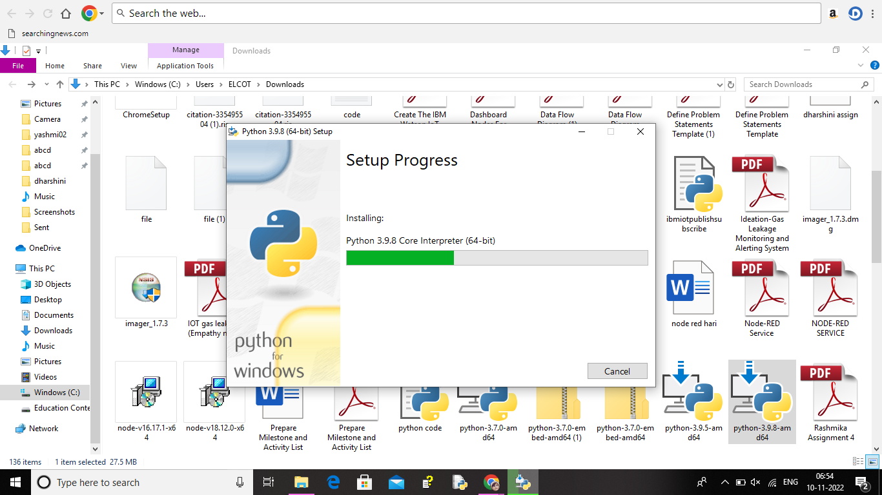

**STEP 6:** Close the button.

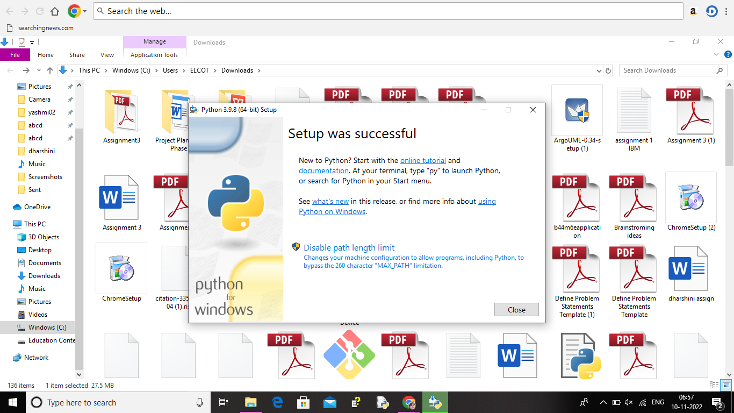

**STEP 7:** Search IDLE.

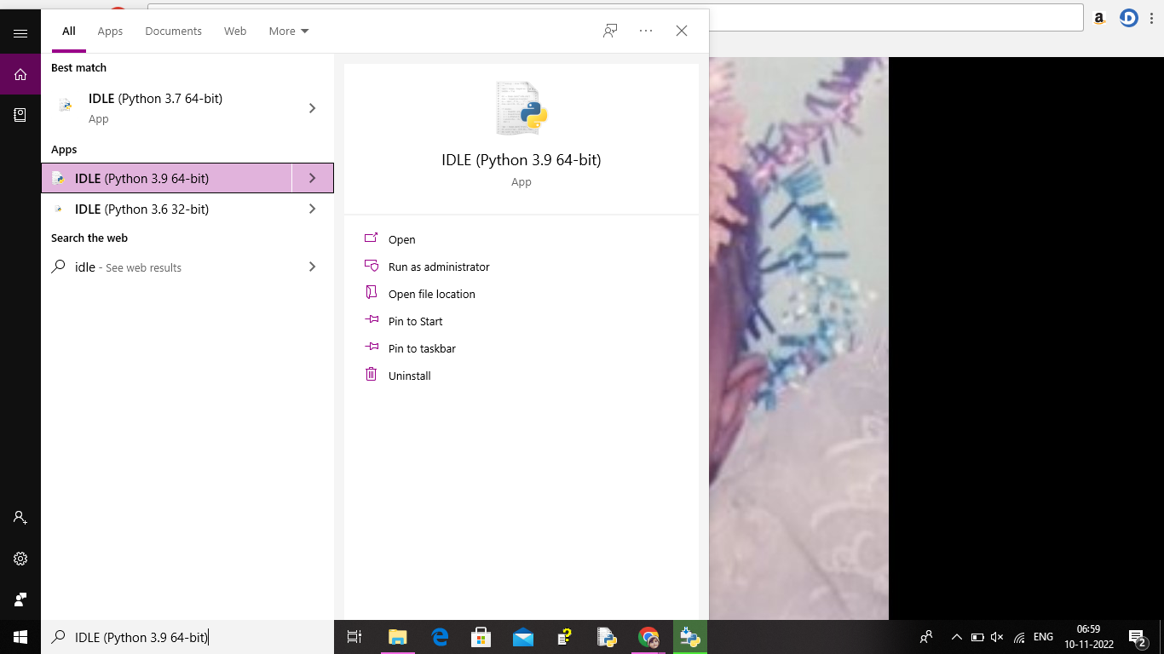

**STEP 8:** Open it.

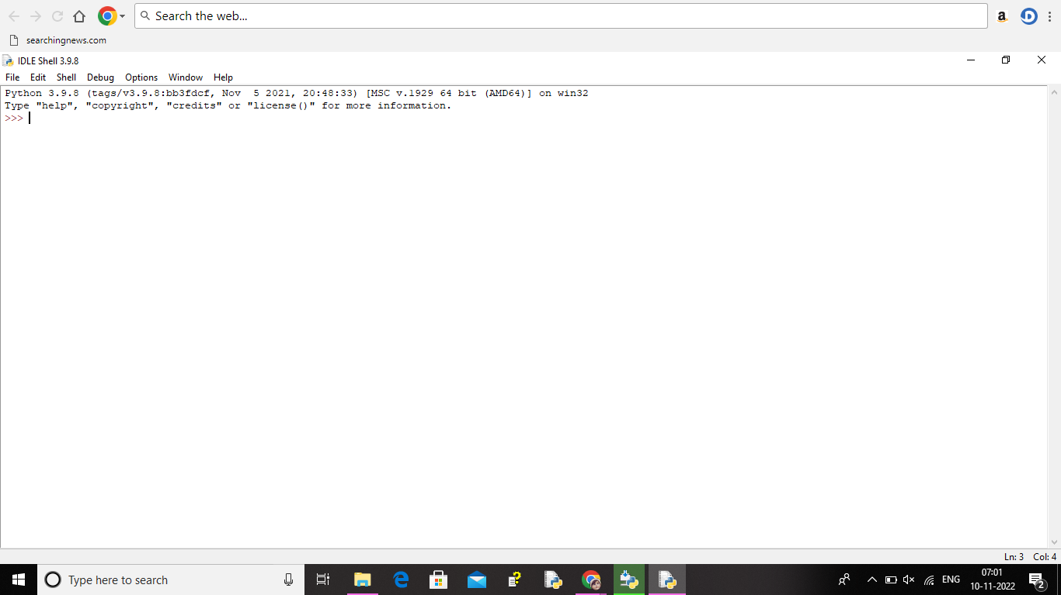

**STEP 9:** Go to file and click on new.

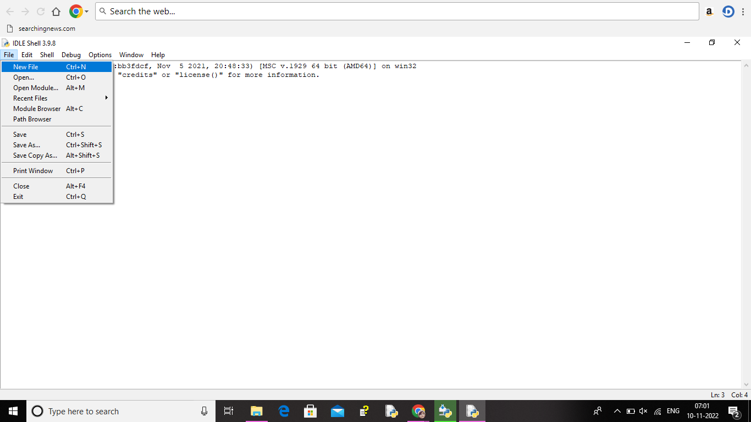

**STEP 10:** Open it.

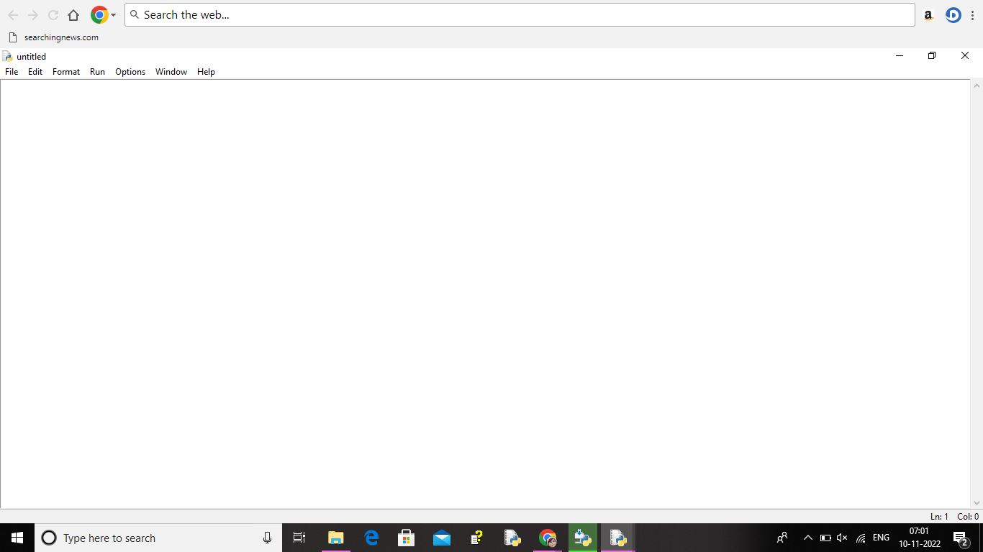

**RESULT:**

A python 3.9.8 is installed successfully.