|  |  |
| --- | --- |
| Date | 06 November 2022 |
| Team ID | PNT2022TMID25975 |
| Project Name | Project - Gas Leakage monitoring & Alerting system for Industries |
| Part | **PREREQUISITES** |

**SOFTWARE DOWNLOAD :**

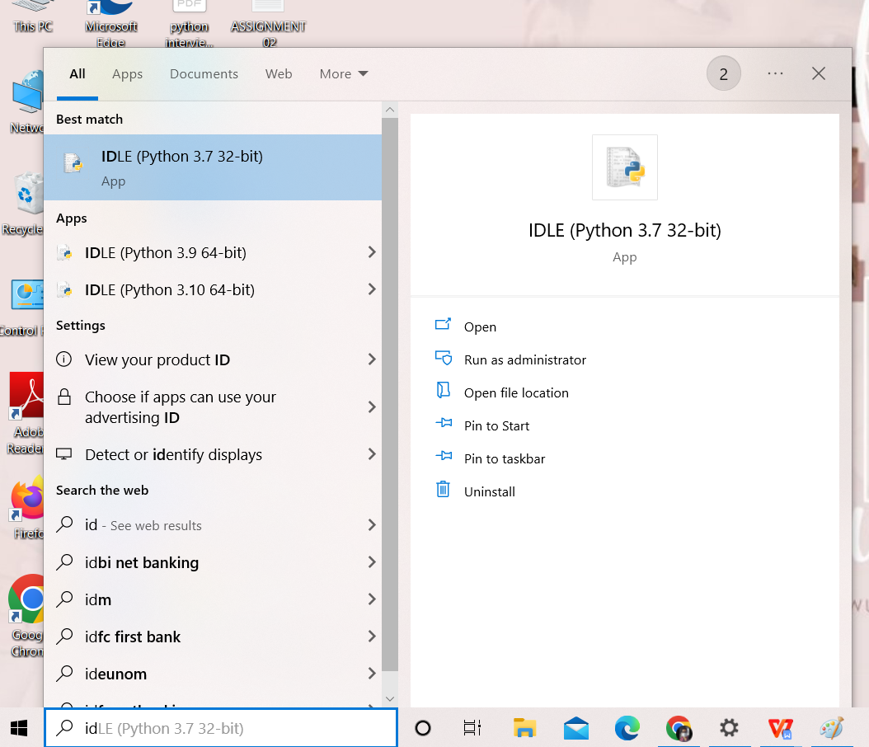

**IBM CLOUD SERVICES:**

