**Installation of Python 3.7.4 Packages**

STEP 1: Google "python 3.7.4" and select the top result.

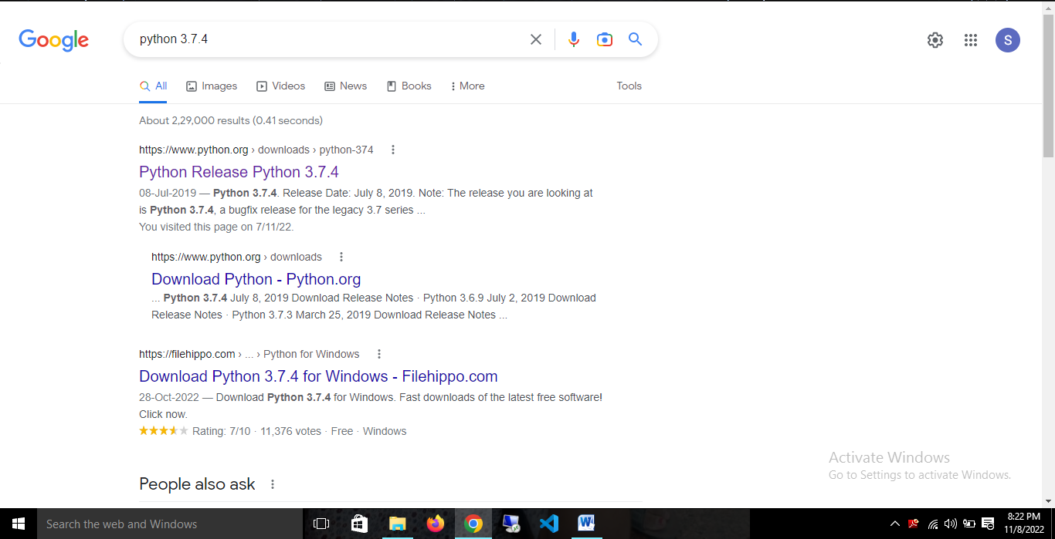

STEP 2: Go to the Python 3.7.4 link.

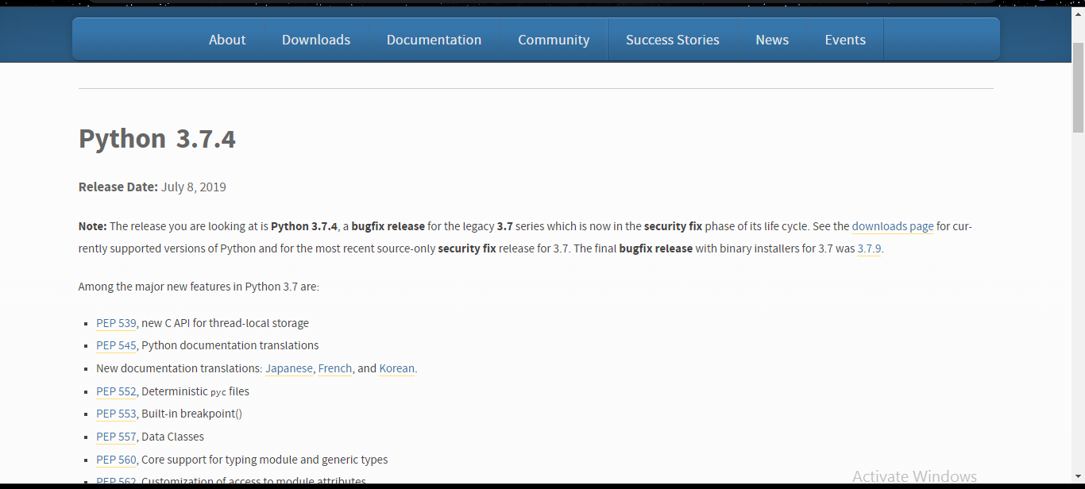

STEP 3: When you are in the Files section, scroll down and select Windows x86-64 executable installer.

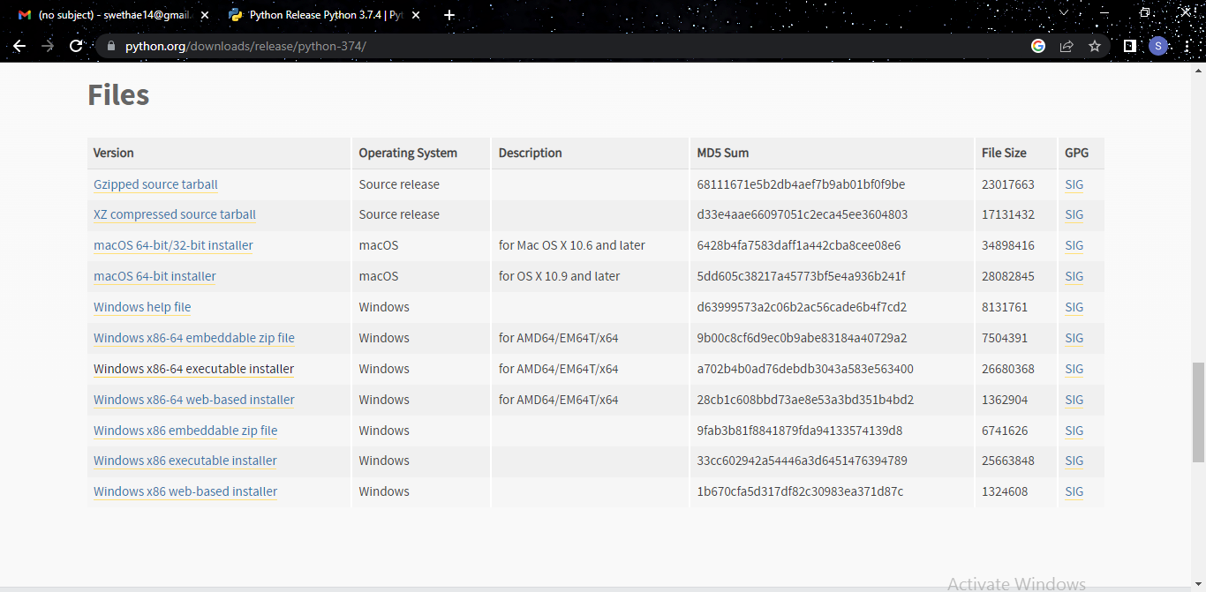

STEP 4: Click the second checkbox, Add python 3.7 to PATH, and then select Customize Installation to alter the path.

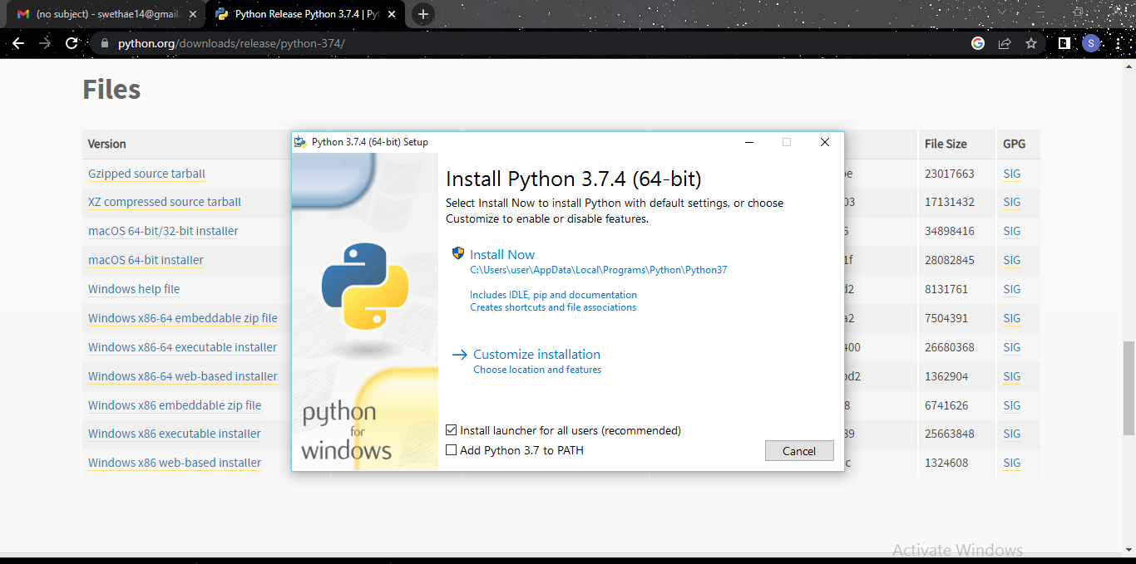

STEP 5: You can **extrade** the **route** **right here** **and click on** **at the** **set up** button.

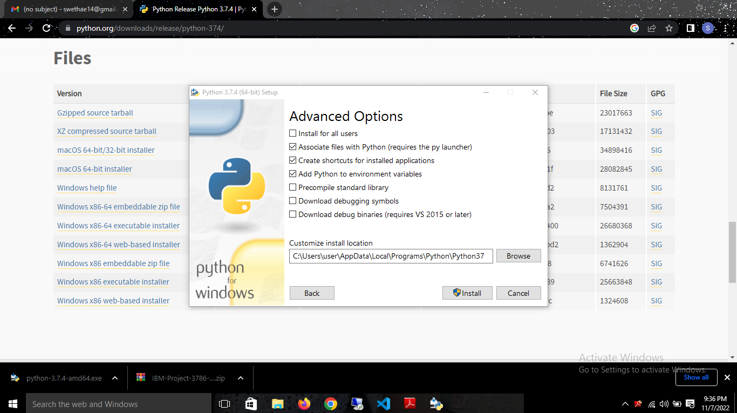

STEP 6: Click on the Install Option to install python 3.7.4

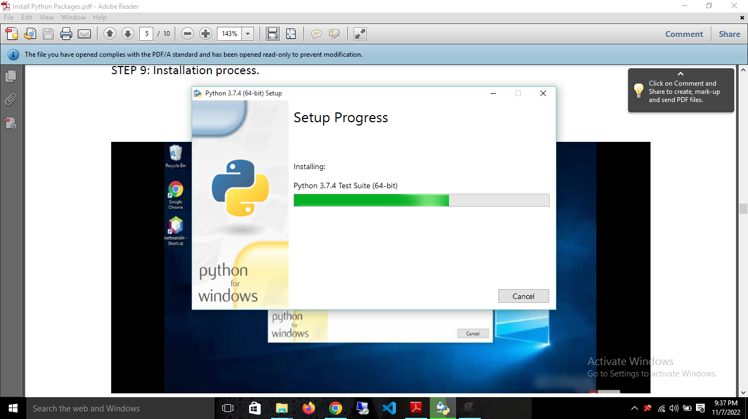

STEP 7: Once the installation is done, you get a display as below select close tab.

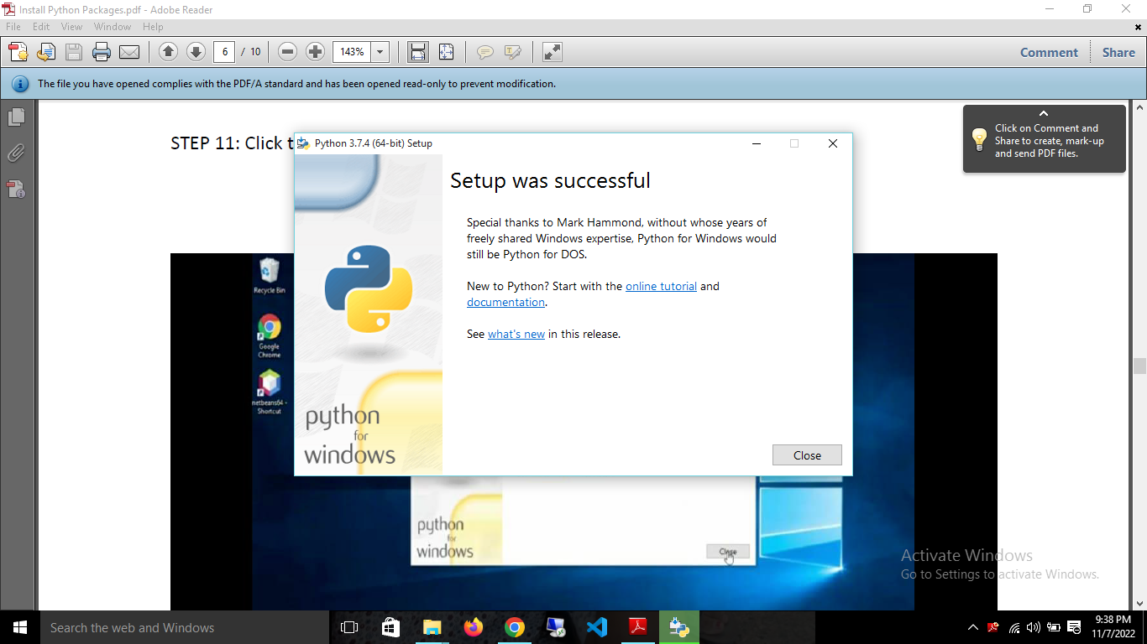

STEP 8: To check whether the installation process is successful, surf it on windows icon.

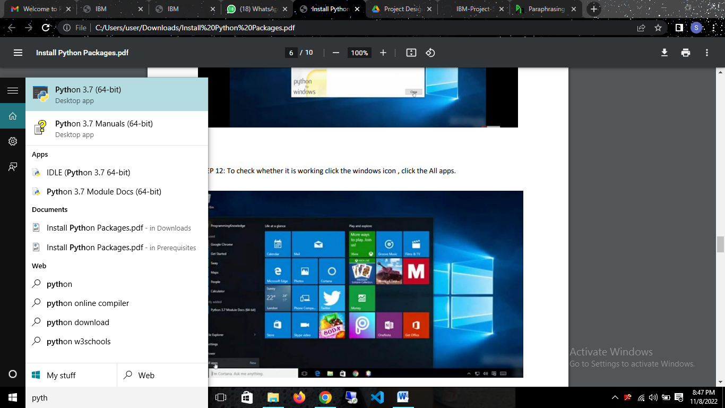

STEP 9: Select IDLE (python 3.7 (64-bit)).

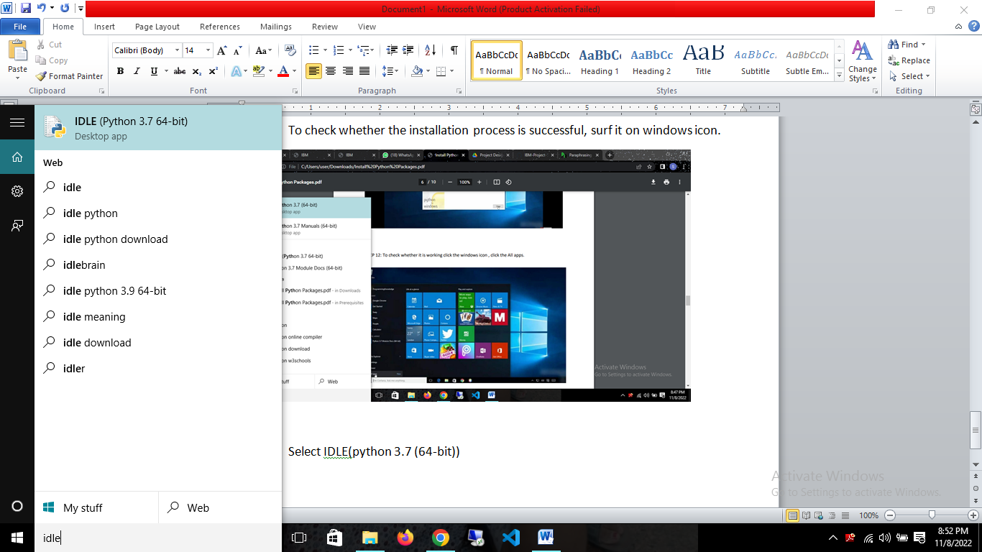

STEP 10: Python window will be like

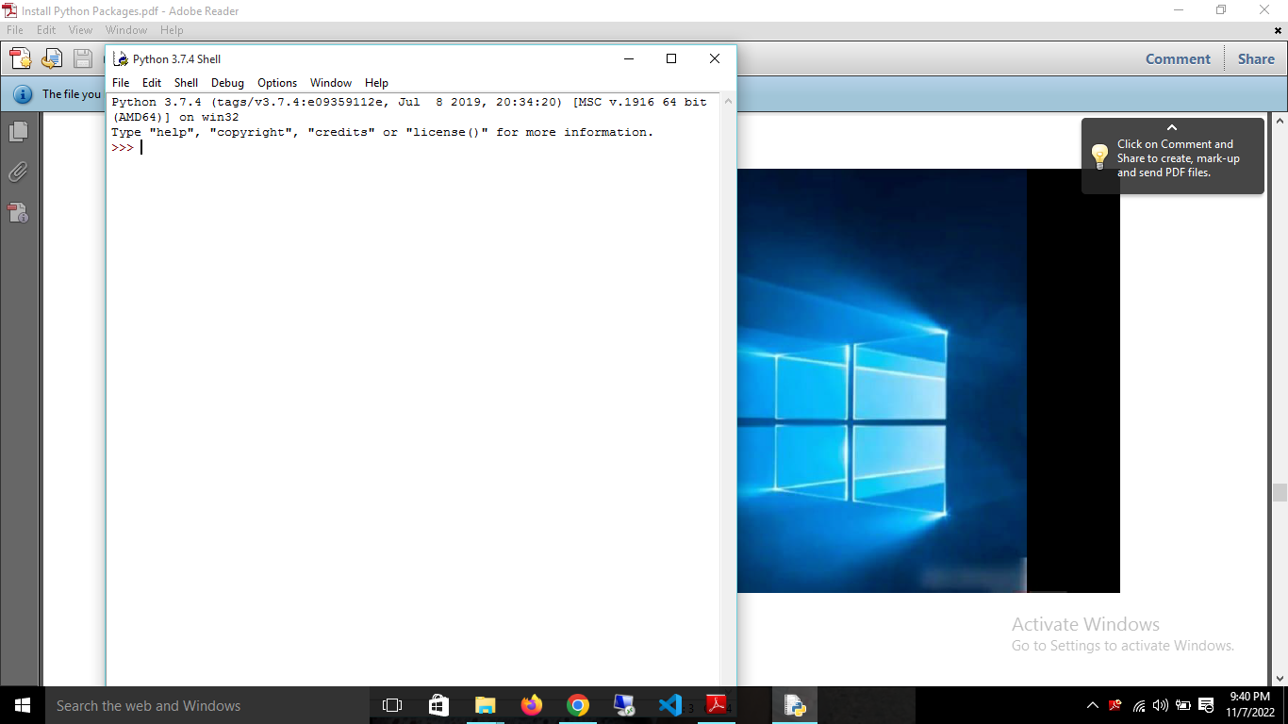

STEP 11: Select the Python 3.7 (64-bit).

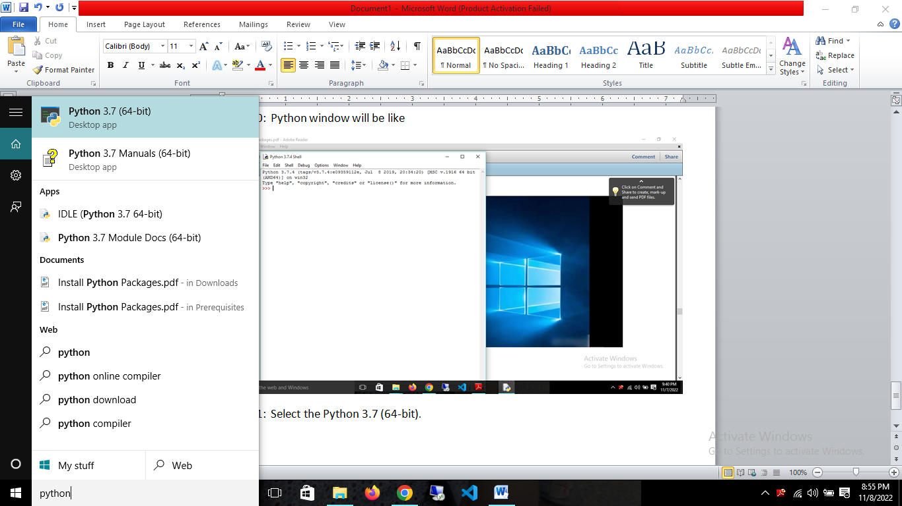

STEP 12: Python 3.7(64-bit) command prompt looks like

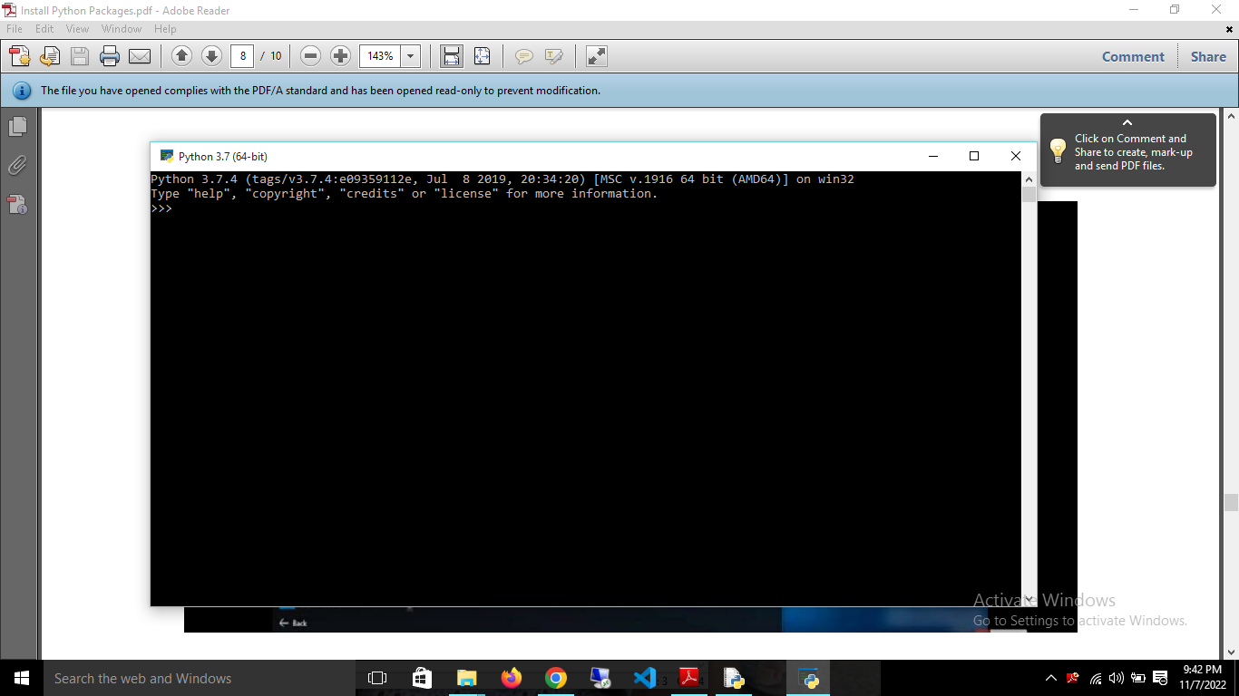

STEP 13: Check whether the python command prompt is working.

