 | Project Design Phase-I
 | Solution Architecture
Date |  | 10 October 2022
Team ID |  | PNT2022TMID37700
Project Name |  | Plasma Donor Application
Maximum Marks |  | 4 marks
Solution Architecture:

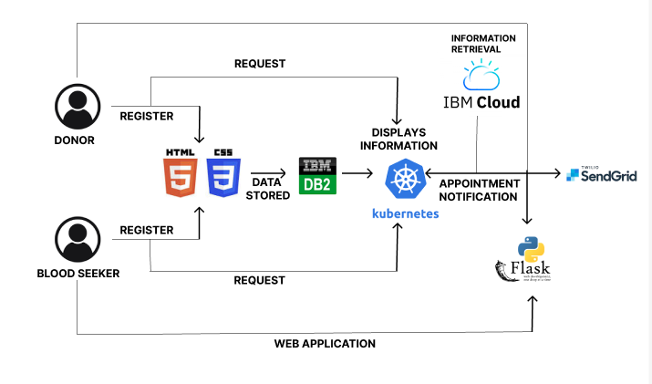

Figure 1: Architecture and data flow of the plasma donor application

