Assignment – 3

# Create a Bucket in IBM object storage.

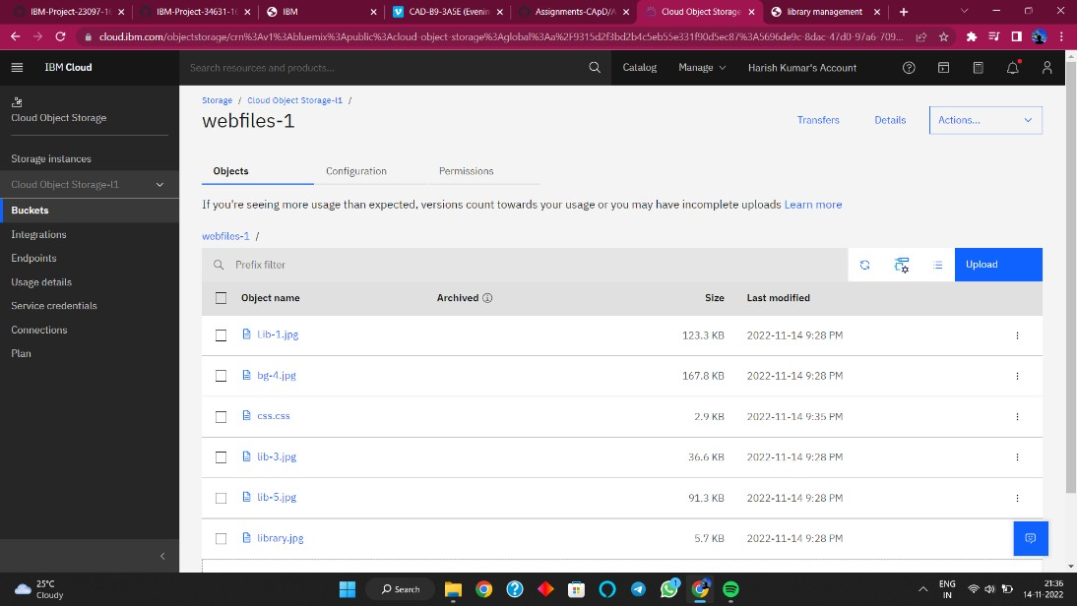

1. **Upload an 5 images to ibm object storage and make it public. write html code to displaying all the 5 images.**



# Index.html

<!DOCTYPE html>

<html lang="en">

<head>

<title>library management</title>

<link rel="stylesheet" type="text/css" href="https://s3.us-east.cloud-object- storage.appdomain.cloud/webfiles-1/css.css">

</head>

<body>

<div class="container">

<h1>LIBRARY MANAGEMENT</h1>

<nav class="navbar">

<a href="library management.htm" target="_self">HOME</a>

<a href="images/books.html">BOOKS</a>

<a href="images/comments.html">COMMENTS</a>

</nav>

</div><br><br>

<div class="container-1">

<h1 class="subcon">E-LIBRARY</h1><br><br>

<ul>

<li>It's an electronic or online library where one can have access to books,journals,novels,articles,or any other information over net.</li><br>

<li>Either general reader or a research scholar may have access to a number of e-libraries sitting at home itself.</li><br>

<li>The Electronic Library System provides the latest functions as well as allowing books to be displayed on screen as if they were printed books.</li><br>

<li>The system makes advances in retrieving books and papers.</li><br>

</ul>

</div>

<div class="container-2">

<h1 class="subcon-1">ADVANTAGES</h1>

<ul class="ul-1">

<li>Simple and easy to operate.</li><br>

<li>Increase librarian’s efficiencies.</li><br>

<li>Mobile access, anytime, anywhere</li><br>

<li>Search, add, update, and view library materials online.</li><br>

<li>Helps to manage library functions constructively.</li><br>

<li>Saves time and reduces overheads.</li><br>

<li>Reduce library’s operating cost.</li><br>

<li>Customized reports for better management.</li><br>

<li>Remove manual processes to issue books and maintain records.</li><br>

</ul>

</div>

<div class="container-3">

<h1 class="subcon-2">DISADVANTAGES</h1>

<ul class="ul-2">

<li>Online stored data is predisposed to cyber hacks. Opting for a reliable online system reduces the risk</li><br>

<li>sometimes it is complicated to operate for first-time users</li><br>

<li>Requires high-speed internet connectivity for a web-based system</li><br>

<li>Risk of computer virus</li><br>

<li>Unlike online systems that use cloud computing, Open source system stocks data on the computer’s hard drive. This raises the risk of data loss.</li><br>

</ul>

</div>

</body>

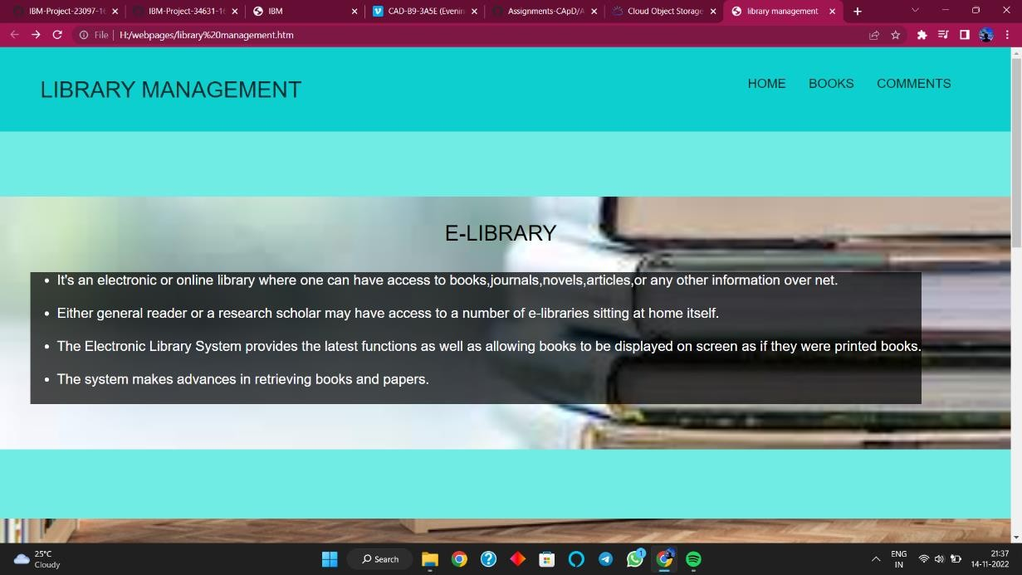</html> Output

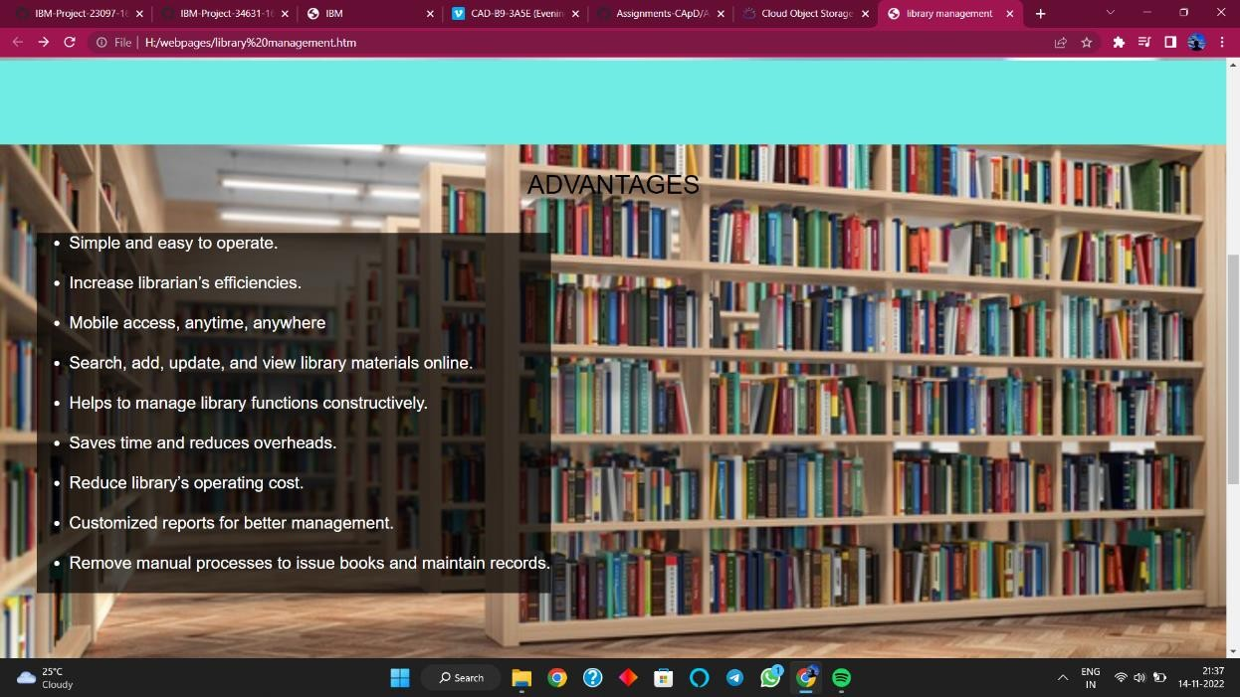

# Upload a css page to the object storage and use the same page in your HTML code.

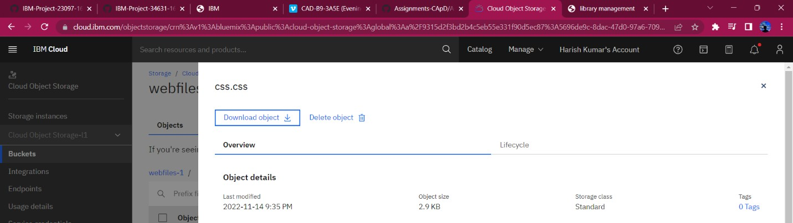Upload style.css to ibm bucket

Link the stylesheet in head

<link rel="stylesheet" type="text/css" href="https://s3.us-east.cloud-object- storage.appdomain.cloud/webfiles-1/css.css">

# Output:

1. 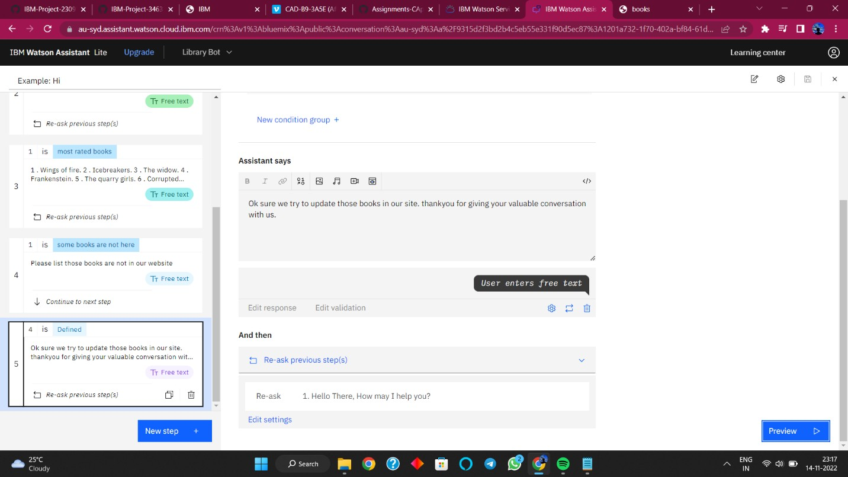**Design a chatbot using IBM Watson assistant for E-library. Ex: User comes with query to know the latest and most rated books . Submit the web URL of that chat bot as a assignment.**

URL of chat bot : https://au- syd.assistant.watson.cloud.ibm.com/crn%3Av1%3Abluemix%3Apublic%3 Aconversation%3Aau- syd%3Aa%2F9315d2f3bd2b4c5eb55e331f90d5ec87%3A1201a732-1f70- 402a-bf84-61dd81786920%3A%3A/assistants/ab725431-a5d8-4953-a72d- 3a7fedcc590b/environments/6f5300b6-f239-497a-9e86- cab01214ee44/apidetails

# Create Watson assistant service with 10 steps and use 3 conditions in it. Load that script in HTML page.

library management.html

<!DOCTYPE html>

<html lang="en">

<head>

<title>library management</title>

<link rel="stylesheet" type="text/css" href="https://s3.us-east.cloud-object- storage.appdomain.cloud/webfiles-1/css.css">

</head>

<body>

<div class="container">

<h1>LIBRARY MANAGEMENT</h1>

<nav class="navbar">

<a href="library management.htm" target="_self">HOME</a>

<a href="images/books.html">BOOKS</a>

<a href="images/comments.html">COMMENTS</a>

</nav>

</div><br><br>

<div class="container-1">

<h1 class="subcon">E-LIBRARY</h1><br><br>

<ul>

<li>It's an electronic or online library where one can have access to books,journals,novels,articles,or any other information over net.</li><br>

<li>Either general reader or a research scholar may have access to a number of e- libraries sitting at home itself.</li><br>

<li>The Electronic Library System provides the latest functions as well as allowing books to be displayed on screen as if they were printed books.</li><br>

<li>The system makes advances in retrieving books and papers.</li><br>

</ul>

</div>

<div class="container-2">

<h1 class="subcon-1">ADVANTAGES</h1>

<ul class="ul-1">

<li>Simple and easy to operate.</li><br>

<li>Increase librarian’s efficiencies.</li><br>

<li>Mobile access, anytime, anywhere</li><br>

<li>Search, add, update, and view library materials online.</li><br>

<li>Helps to manage library functions constructively.</li><br>

<li>Saves time and reduces overheads.</li><br>

<li>Reduce library’s operating cost.</li><br>

<li>Customized reports for better management.</li><br>

<li>Remove manual processes to issue books and maintain records.</li><br>

</ul>

</div>

<div class="container-3">

<h1 class="subcon-2">DISADVANTAGES</h1>

<ul class="ul-2">

<li>Online stored data is predisposed to cyber hacks. Opting for a reliable online system reduces the risk</li><br>

<li>sometimes it is complicated to operate for first-time users</li><br>

<li>Requires high-speed internet connectivity for a web-based system</li><br>

<li>Risk of computer virus</li><br>

<li>Unlike online systems that use cloud computing, Open source system stocks data on the computer’s hard drive. This raises the risk of data loss.</li><br>

</ul>

</div>

<script>

window.watsonAssistantChatOptions = {

integrationID: "f0775cf3-3958-40eb-b2f5-485eb35448c6", // The ID of this integration.

region: "au-syd", // The region your integration is hosted in.

serviceInstanceID: "1201a732-1f70-402a-bf84-61dd81786920", // The ID of your service instance.

onLoad: function(instance) { instance.render(); }

};

setTimeout(function(){

const t=document.createElement('script');

t.src="https://web-chat.global.assistant.watson.appdomain.cloud/versions/" + (window.watsonAssistantChatOptions.clientVersion || 'latest') + "/WatsonAssistantChatEntry.js";

document.head.appendChild(t);

});

</script>

</body>

</html>

# Output:

