IBM ASSESSMENT

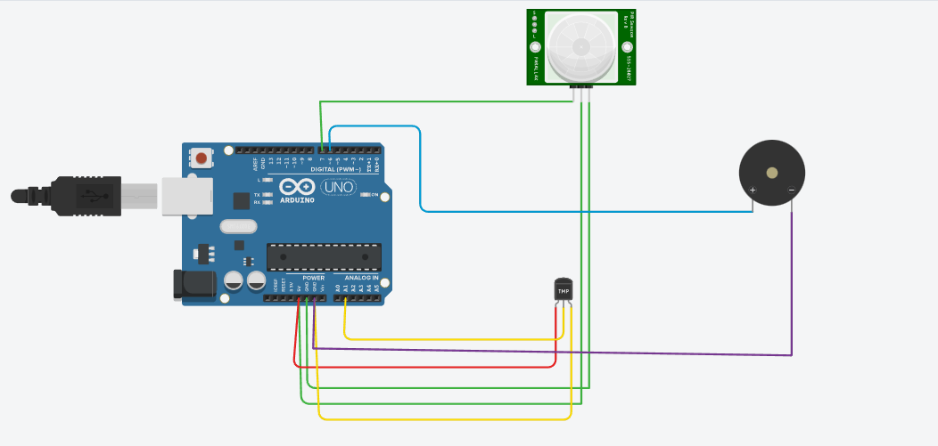

// C++ code

//

void setup()

{

Serial.begin(9600);

pinMode(7,INPUT);

pinMode(6,OUTPUT);

}

void loop()

{

int frequency1=500,frequency2=1000; //PIR SENSOR CODE

int N=digitalRead(7);

Serial.print("Motion Output");

Serial.println(N);

delay(1000);

double temp=analogRead(A1); //TEMPERATURE SENSOR CODE

double n1=temp/1024;

double vout=n1\*5;

double off=vout-0.5;

double temperature=off\*100;

Serial.println(temperature);

if(temperature>=60) //condition for temperature sensor

{

Serial.print("Temperature exceeded 60 degree celsisus");

tone(6,frequency1,1000);

}

if(N==1) //condition for PIR sensor

{

Serial.print("Motion Detected");

tone(6,frequency2,1000);

}

}

