**IBM-EPBL/IBM-Project-20074-1659711991**

**Natural Disasters Intensity Analysis and Classification using Artificial Intelligence**

**TEAM MEMBERS:**

**412419104051-KAVANA RAO Y**

**412419104012-ARCHANA K**

**412419104128-SUDHARSHINY T A**

**412419104045-JOE MARIAM.J**

**412419104107-SAUJANYA K**

**Project Flow:-**

* + The user interacts with the UI (User Interface) to open the integrated webcam.
  + The video frames are captured and analyzed by the model which is integrated with flask application.
  + Once model analyzes the video frames, the prediction is showcased on the UI and OpenCV window

To accomplish this, we have to complete all the activities and tasks listed below

* **Data Collection:**

Data collection or data gathering is the process of gathering and measuring information on targeted variables in an established system, which then enables one to answer relevant questions and evaluate outcomes

Collect the dataset or Create the dataset

Downloaded the dataset from the given link given by the ibm.

* **Data Preprocessing:**

Data preprocessing can refer to manipulation or dropping of data before it is used in order to ensure or enhance performance, and is an important step in the data mining process.

Import the ImageDataGenerator library

Configure ImageDataGenerator class

ApplyImageDataGenerator functionality to Trainset and Testset

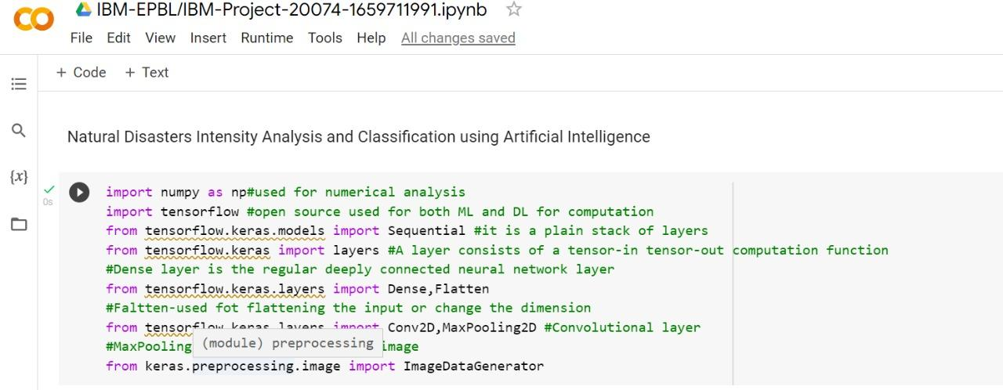

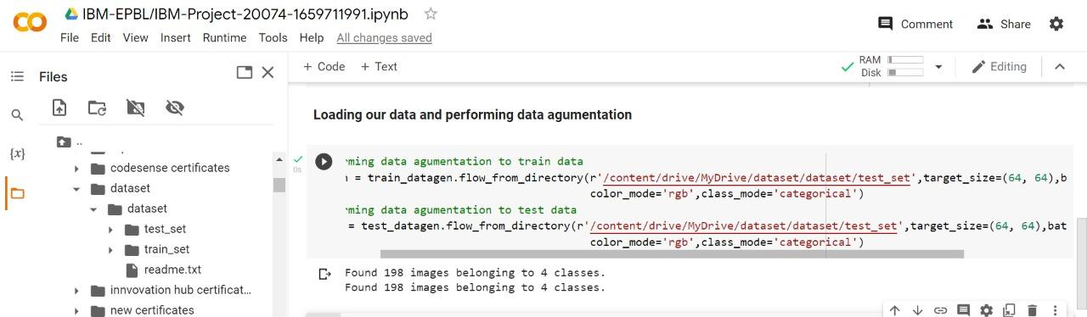

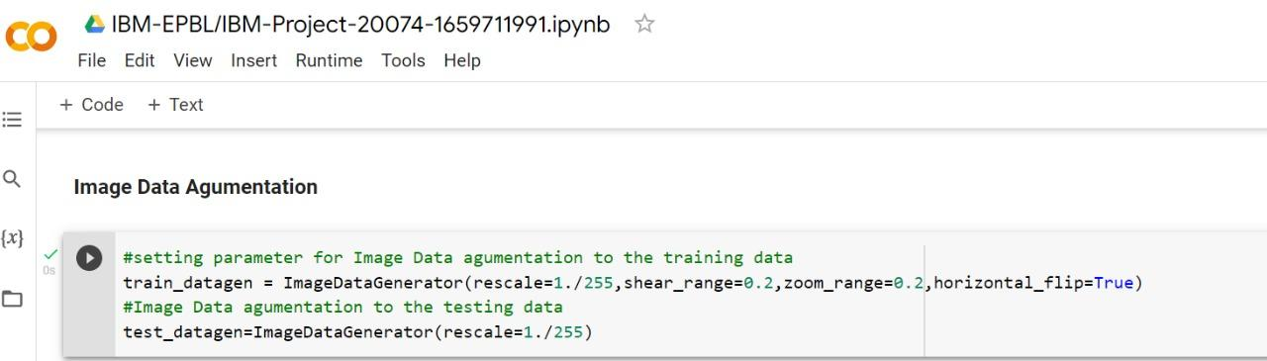

* **Model Building:**
  + The model building process involves setting up ways of collecting data, understanding and paying attention to what is important in the data to answer the questions you are asking, finding a statistical, mathematical or a simulation model to gain understanding and make predictions.
  + Import the model building Libraries