**Assignment -1**

Python Programming

|  |  |
| --- | --- |
| Assignment Date | 19 September 2022 |
| Student Name | Mr. Sailesh Baabu S |
| Student Roll Number | 2127190801068 |
| Maximum Marks | 2 Marks |

**Question-1:**

**R&D Spend by R&D Spend, Administration, State and Marketing Spend colored by Profit**

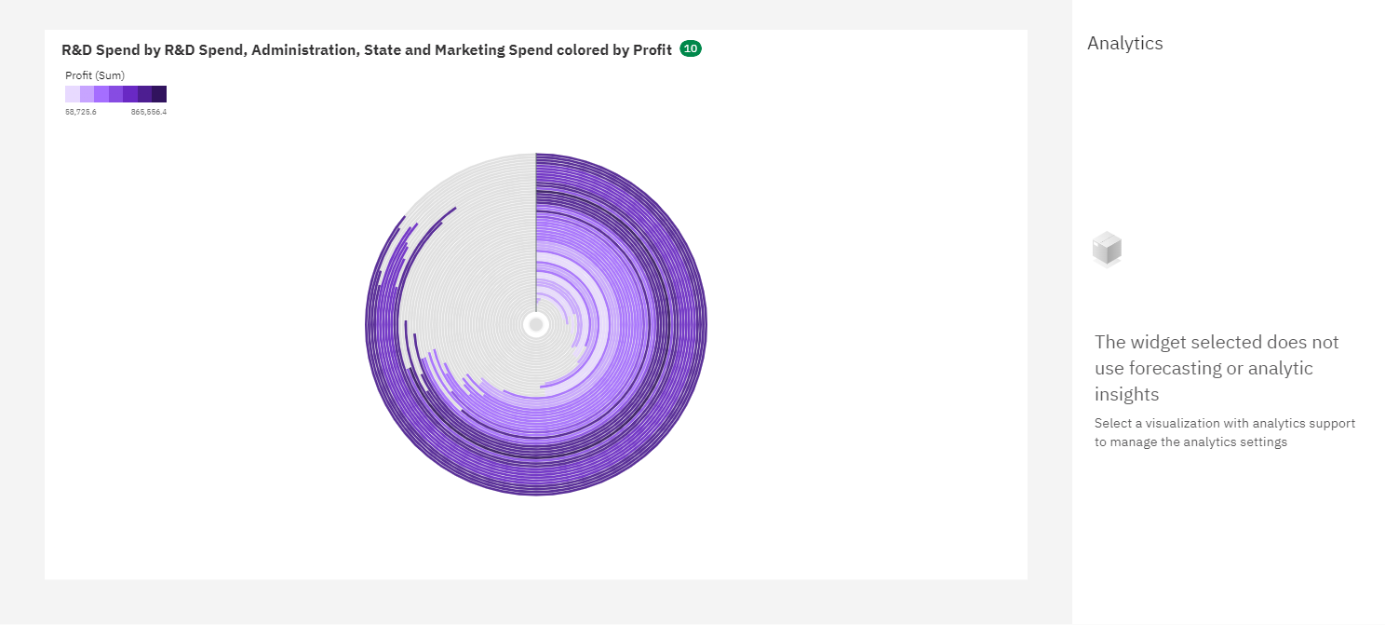

**Question-2:**

**Chart A - Administration to R&D Spend Marketing Spend State Profit**

**Chart B - R&D Spend Administration Profit Marketing Spend to Profit with line width R&D Spend**

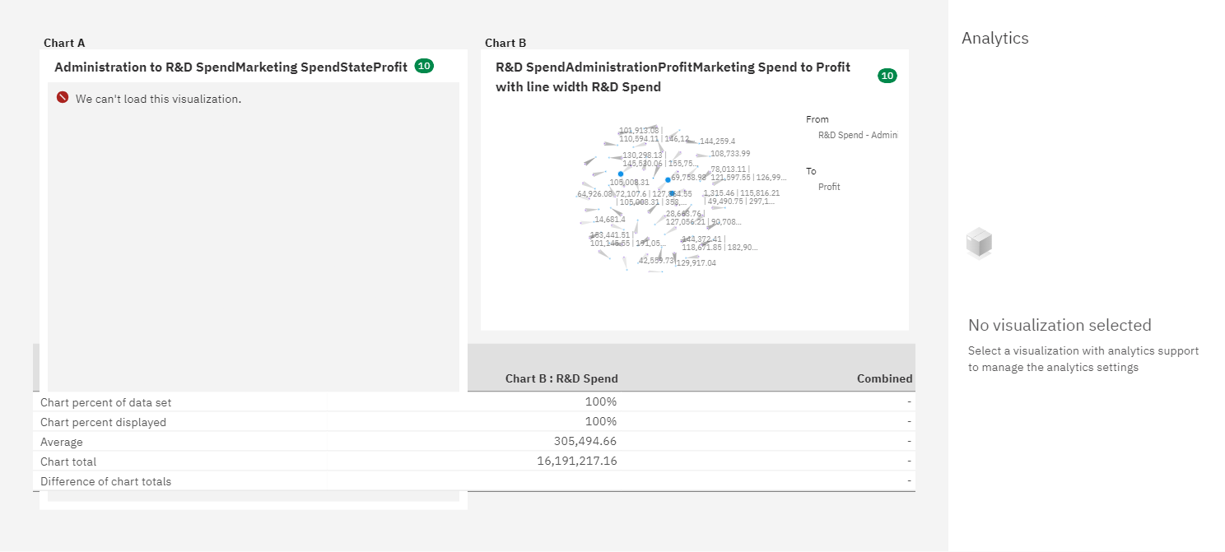

**Question-3:**

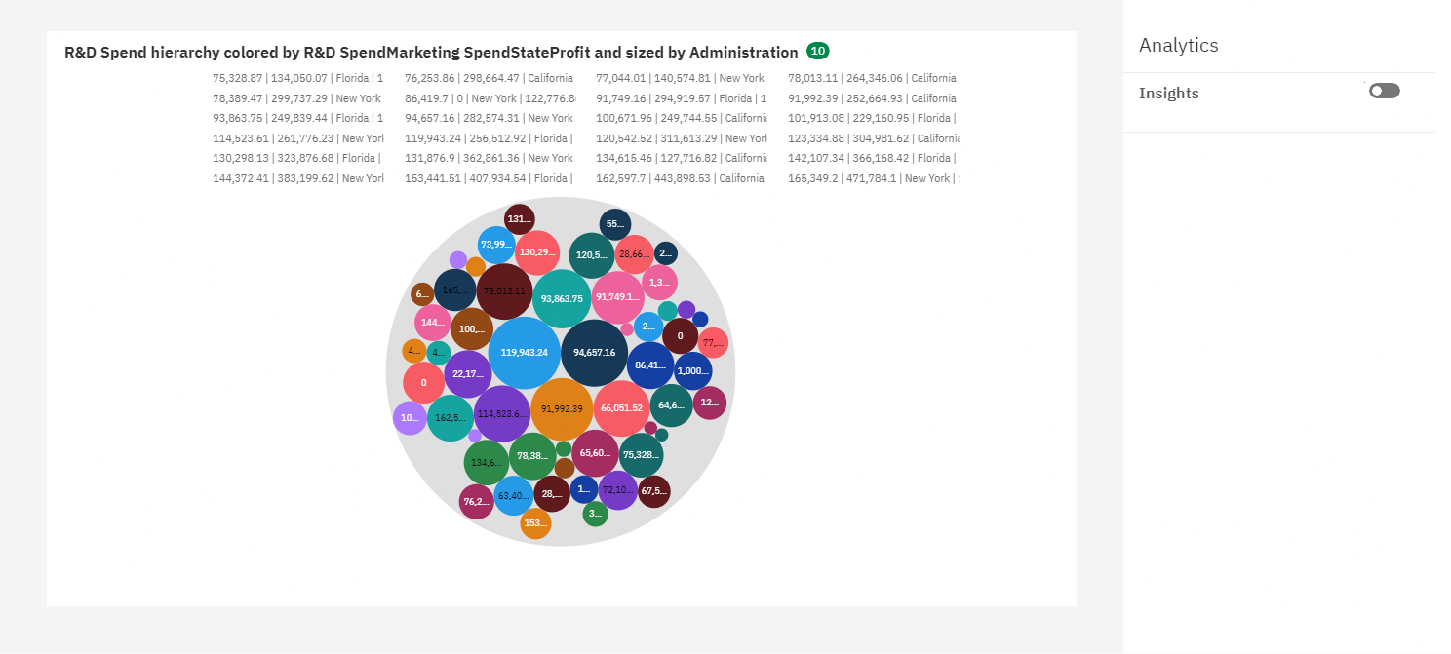**R&D Spend hierarchy colored by R&D Spend Marketing Spend State Profit and sized by Administration**

**Question 4**

**Profit**

