**Project Design Phase-I**

**Problem – Solution Fit Template**

|  |  |
| --- | --- |
| Date | 19 September 2022 |
| Team ID | PNT2022TMIDxxxxxx |
| Project Name | Project - xxx |
| Maximum Marks | 2 Marks |

C

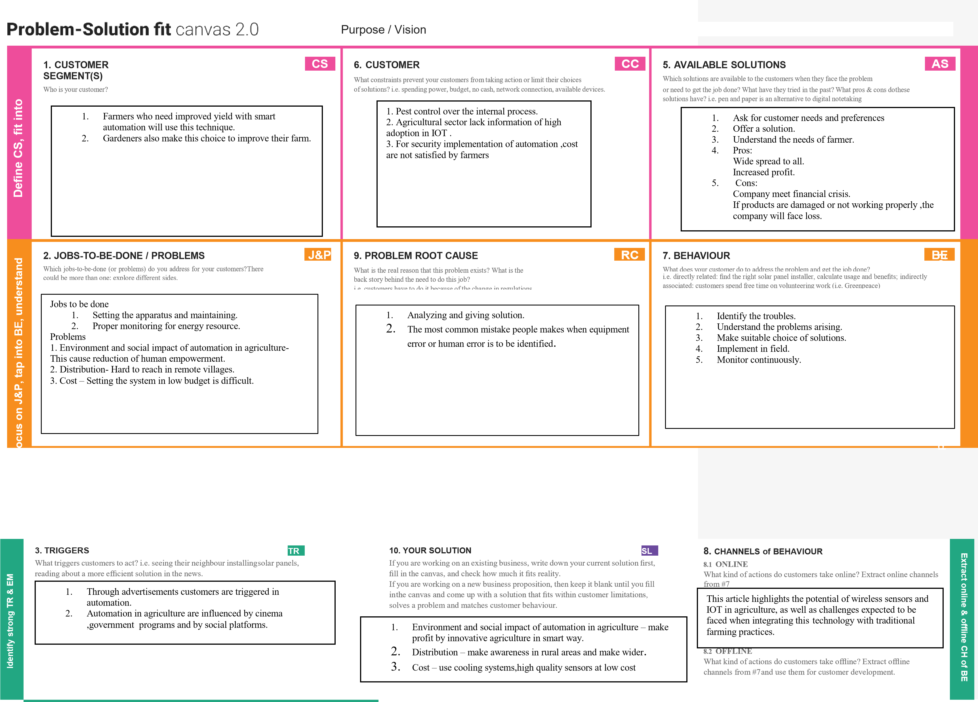

Problem

-

Solution

it

canvas

is

licensed

under

a

Creative

Commons

Attribution

-

NonCommercial

-

NoDerivatives

4.0

license

Created

by

Daria

Nepriakhina

/

Amaltama.com

**4.**

**EMOTIONS:**

**BEFORE**

**/**

**AFTER**

**EM**

How

do

customers

feel

when

they

face

a

problem

or

a

job

and

afterwards?

i.e.

lost,

insecure

>

confident,

in

control

-

use

it

in

your

communication

strategy

&

design.



Before

1.

Crops were severely affected by extreme heat, heavy rainfall,animal grazing

and other factors.

After

1.

By this method,plants are protected from

all factors that affect plants.



1.

This project will provide protection from

animals through sound system.

2.

Kills insects through automatic spray system.

3.

We protect

crops from excessive heat through

bogie system.

4.

Crop yield can be increased by monitoring

crop growth.