SNAPSHOTS OF ASSIGNMENT 2:

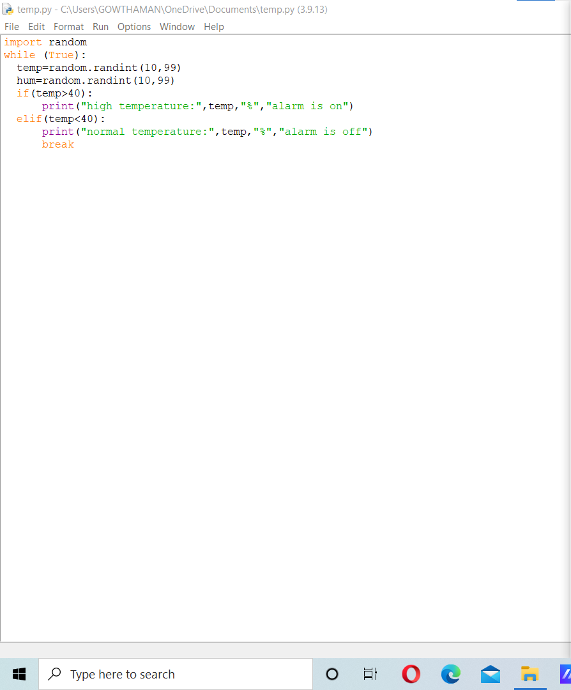

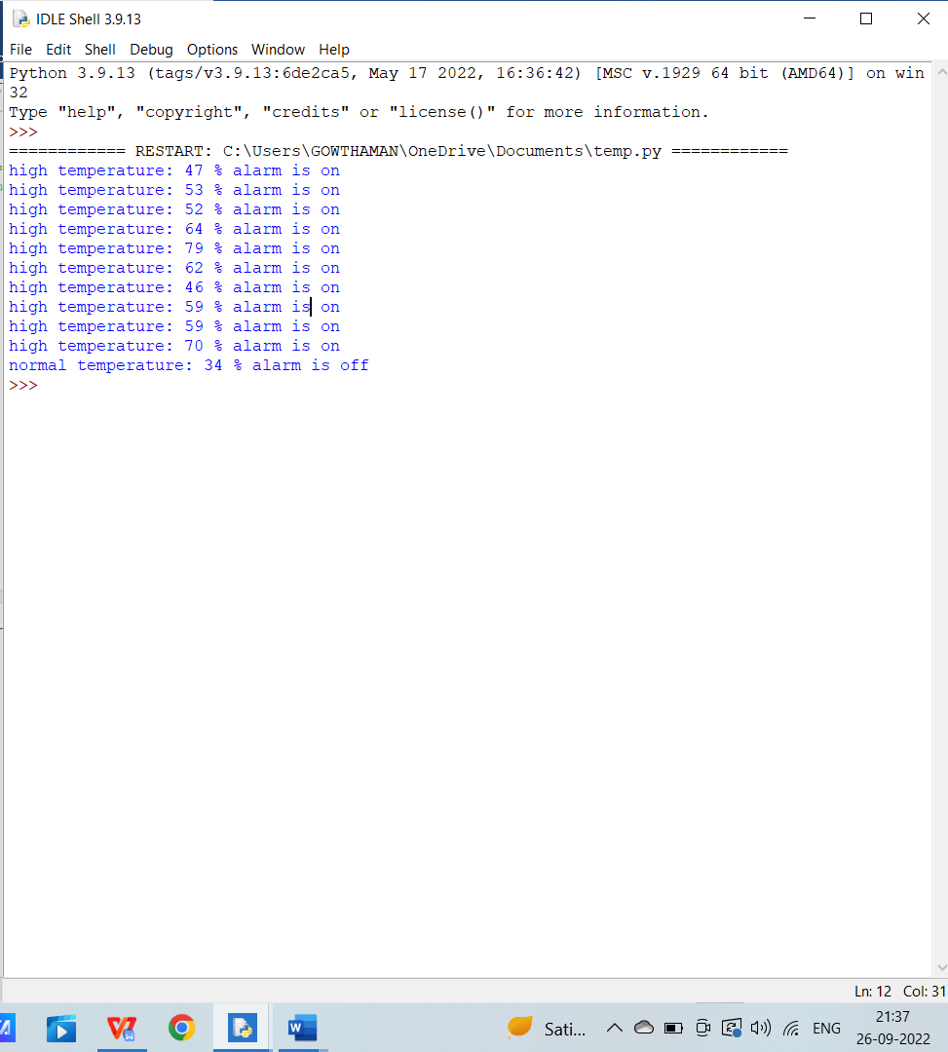

SUBMITTED BY:

MADHUMITHA.G