PROJECT REPORT ON

# Detecting Parkinson’s Disease Using Machine Learning

## Submitted By:

## SATHISH K : 2127190501117

## SATHYAVARTHAN:2127190501119

## THARUN JOSEPH : 2127190501140

## NAGA YADHIEESH K :2127190501701

**Under the Guidance of:**  DR N REVATHI **Department of**

### COMPUTER SCIENCE

**SRI VENKETESWARA COLLEGE OF ENGINEERING**

CHENNAI – 600025

November 2022

**TABLE OF CONTEXT**

#### INTRODUCTION

* 1. Project Overview
  2. Purpose

#### LITERATURE SURVEY

* 1. Existing problem
  2. References
  3. Problem Statement Definition

#### IDEATION & PROPOSED SOLUTION

* 1. Empathy Map Canvas
  2. Ideation & Brainstorming
  3. Proposed Solution
  4. Problem Solution fit

#### REQUIREMENT ANALYSIS

* 1. Functional requirement
  2. Non-Functional requirement

#### PROJECT DESIGN

* 1. Data Flow Diagrams
  2. Solution & Technical Architecture
  3. User Stories

#### PROJECT PLANNING AND SCHEDULING

* 1. Sprint Planning & Estimation
  2. Sprint Delivery Schedule
  3. Reports from JIRA

#### CODING & SOLUTIONING

* 1. Feature 1
  2. Feature 2
  3. Database Schema

#### TESTING

* 1. Test Cases
  2. User Acceptance Testing

#### RESULTS

* 1. Performance Metrics

#### ADVANTAGES & DISADVANTAGES

1. **CONCLUSION**

#### FUTURE SCOPE

1. **APPENDIX**

Source Code

GitHub & Project Demo Link

### INTRODUCTION

#### PROJECT OVERVIEW

Parkinson's disease (PD) is known to be one of the most common neurodegenerative diseases among older people aged more than 65. One of the most common effects that are easily noticeable among the PD patients and used most commonly in the early stage of diagnosis is finding the difference in handwriting and sketching abilities. However, the major drawback of these kinds of diagnoses needs proper interpretation of sketching and handwriting. Some of the common features present inside the sketches could be considered as the potential indicators to differentiate different group of subjects that includes healthy subjects and PD subjects and those tasks can be used to perform the reliability analysis in the real-time. In recent Days the wisest decision for detecting something in real-time is to make the system automatic so that we can perform the same operation with less time as well as in a more precise way. In this respect machine learning techniques are more effective an shown enough potential to be used in real-life situations.

So, we made an attempt has been made to develop an automated system that trained with the features extracted from the different sketches performed by the healthy group of patients as well as PD patients to assess the severity of the PD disease among different stages as well as between the healthy groups of patients. The investigation performed in this study to differentiate the healthy subjects from PD subjects based on the spiral sketches by extracting features from the images sketched by the healthy subjects and PD subjects.

Our goal is to quantify the visual appearance (using HOG method) of these drawings and then train a machine learning model to classify them. In this project, we are using, Histogram of Oriented Gradients (HOG) image descriptor along with a Random Forest classifier to automatically detect Parkinson’s disease in hand-drawn images of spirals and waves.

#### PURPOSE

Parkinson’s disease is a brain disorder that causes unintended or uncontrollable movements, such as shaking, stiffness, and difficulty with balance and coordination. Symptoms usually begin gradually and worsen over time. As the disease progresses, people may have difficulty walking and talking. They may also have mental and behavioural changes, sleep problems, depression, memory difficulties, and fatigue.

More than 10 million people are living with Parkinson’s Disease worldwide, according to the Parkinson’s Foundation. While Parkinson’s cannot be cured, early detection along with proper medication can significantly improve symptoms and quality of life. Detecting PD is difficult due to the delicate nature of the initial symptoms, which means that the early symptoms will go unnoticed by the person suffering from this disease. There are numerous significant burdens on patients as well as the health care systems due to there are lots of delays in the diagnosis of the Parkinson’s disease. One of the indications of Parkinson’s is tremors and rigidity in the muscles, making it difficult to draw smooth spirals and waves. It is possible to detect Parkinson’s disease using the drawings alone instead of measuring the speed and pressure of the pen on paper.

Therefore, we planned to design a system which analyzes Spiral drawing patterns and wave drawing patterns in patients suffering from Parkinson’s disease and healthy subjects. The system developed in the study leverages Histogram of Oriented Gradients (HOG)image descriptor for analyzing the drawing patters of both spiral and wave sketches respectively. Further, the prediction probabilities are trained on a random forest classifier based on ensemble voting to provide a weighted prediction from both the spiral and wave sketch.

### LITERATURE SURVEY

#### EXISTING PROBLEM

In existing system, Convolutional Neural Networks (CNN) is used to detect the Parkinson’s disease. The 3D brain images contain a huge amount of information that leads to complex CNN architectures. When these architectures become too complex, classification performances often degrades because the limitations of the training algorithm and overfitting.

It leads to the average accuracy of detecting Parkinson's disease. Thus, existing system is not effective in early detection of Parkinson’s disease and accurate medicinal diagnosis to the affected people.

#### REFERENCES

1. Zham, P., Arjunan, S.P., Raghav, S. and Kumar, D.K., 2017. Efficacy of guided spiral drawing in the classification of Parkinson's disease. IEEE journal of biomedical and health informatics, 22(5), pp.1648-1652.
2. Kotsavasiloglou, C., Kostikis, N., Hristu-Varsakelis, D. and Arnaoutoglou, M., 2017. Machine learning-based classification of simple drawing movements in Parkinson's disease. Biomedical Signal Processing and Control, 31, pp.174-180.
3. Memedi, M., Sadikov, A., Groznik, V., Žabkar, J., Možina, M., Bergquist, F., Johansson, A., Haubenberger, D. and Nyholm, D., 2015. Automatic spiral analysis for objective assessment of motor symptoms in Parkinson’s disease. Sensors, 15(9), pp.23727-23744.
4. Aich, S., Sain, M., Park, J., Choi, K.W. and Kim, H.C., 2017, November. A mixed classification approach for the prediction of Parkinson's disease.

#### PROBLEM STATEMENT DEFINITION

More than 10 million people are living with Parkinson’s Disease worldwide, according to the Parkinson’s Foundation. While Parkinson’s cannot be cured, early detection along with proper medication can significantly improve symptoms and quality of life. Parkinson Disease is a brain neurological disorder. It leads to shaking of the body, hands and provides stiffness to the body. Some of the movement disorders symptoms such as rigidity, instability in posture, tremor, and bradykinesia are usually observed on the PD patients at different stages. No proper cure or treatment is available yet at the advanced stage. One of the most common effects that are easily noticeable among the PD patients and used most commonly in the early stage of diagnosis is finding the difference in handwriting and sketching abilities.

Treatment is possible only when done at the early or onset of the disease. These will not only reduce the cost of the disease but will also possibly save a life. Parkinson’s disease is the 14th leading cause of death in the United States, according to the Center for Disease Control, and more people currently live with it than those with multiple sclerosis, muscular dystrophy, and ALS combined. Though we can’t cure it, identifying it in soon can improve the lifespan.

### IDEATION & PROPOSED SOLUTION

#### EMPATHY MAP CANVAS

An empathy map is a simple, easy-to-digest visual that captures knowledge about a user’s behaviors and attitudes. It is a useful tool to help teams better understand their users. Creating an effective solution requires understanding the true problem and the person who is experiencing it. Creating the empathy map helps participants consider things from the user’s perspective along with his or her goals.

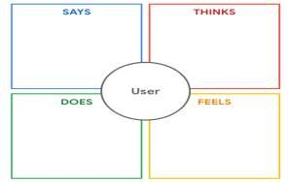

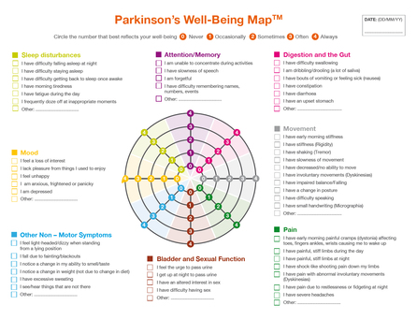

#### IDEATION & BRAINSTORMING

Ideation and Brainstorming are writing down ideas that comes to mind that addresses your problem statement.

The key rules of Brainstorming are:

* Defer Judgement
* Encourage Wild Ideas
* Build on the Ideas of Others
* Stay Focused on the Topic
* One Conversation at a Time
* Be visual
* Go for Quantity

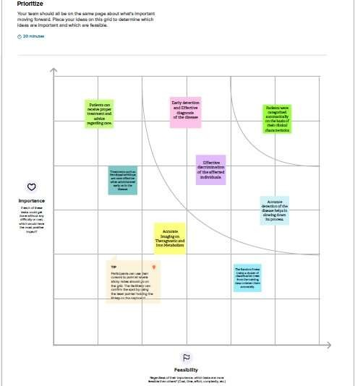

#### PROPOSED SOLUTION

Having a Solid grasp of the problem after doing a thorough investigation, a practical solution needs to be proposed or several approaches needs to be suggested for proper understanding and the rectification of issues. The ones that solve all these is a Proposed Solution.

|  |  |  |  |
| --- | --- | --- | --- |
| **S. No.** | **Parameter** | **Description** | |
| 1. | Problem Statement (Problem tobe solved) | More than 10 million people are living with Parkinson’sDisease worldwide, according to the Parkinson’s Foundation. While Parkinson’s cannot be cured, early detection along with proper medication can significantly improve symptoms and  quality of life. | |
| 2. | Idea / Solution description | this project, we are using, Histogram of OrientedGradients (HOG) image descriptor along with a Random Forest classifier to automatically detect Parkinson’s disease in hand-drawn images of spiralsand waves. | |
| 3. | Novelty / Uniqueness | HOG descriptors are powerful to detect images with occlusions, pose and illumination changes because they are extracted in a regular grid. For the regions ofthe image, it generates histograms using the magnitude and orientations of the gradient. HOG can be used to detect small-scaled images with less computational power, which means you can run HOGwithout having a powerful GPU. Hence, the accuracy is highly reliable. | |
| 4. | Social Impact / Customer Satisfaction | Parkinson’s disease is the 14th leading cause of deathin the United States, according to the Center for Disease Control, and more people currently live with it than those with multiple sclerosis, muscular dystrophy, and ALS combined. Though we can’t cure it, identifying it in soon can improve the lifespan. | |
| 5. | Business Model (Revenue Model) | Early detection along with proper medication can significantly improve symptoms and quality of life. Our model can be used by hospitals to detect in early stages, which can be profit for  them. | |
| 6. | Scalability of the Solution | scalability in our project is achieved by combining Statistics, ML, and Data Mining into flexible, scalable, and often nonparametric techniques. the projection is done at image- level and therefore the computational cost is linear in the number of views, in our model every view is approximated at feature level as a linear combination of the pre-computed views. As a result, once the views have been computed, the cost of computing new views is almostnegligible. This allows | |
| the model to be evaluated on | many more viewpoints. |

#### PROBLEM SOLUTION FIT

The Problem Solution Fit simply means that you have found a problem with your customer and that the solution you have realized for it actually solves the customer’s problem. It helps entrepreneurs, marketers and corporate innovators identify the behavioral patterns and recognize what would work and why.

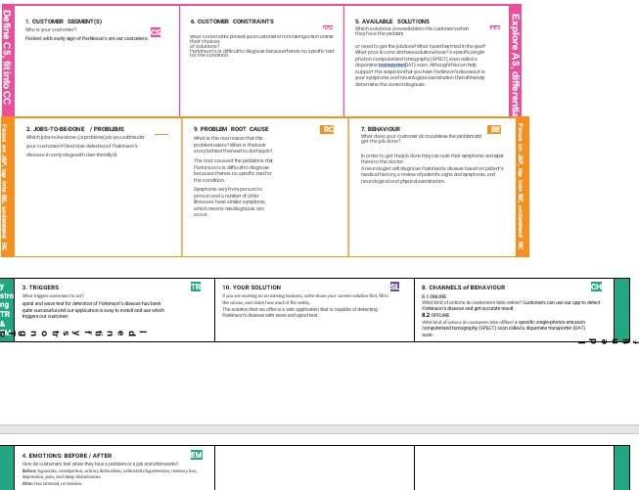

### REQUIREMENT ANALYSIS

#### FUNCTIONAL REQUIREMENT

Functional Requirement define what a product must do, what its features and functions are. They, are Product features or functions that developers must implement to enable users to accomplish their tasks. Generally, functional requirements describe system behavior under specific conditions. Example: The system sends a confirmation email when a new user account is created.

|  |  |  |
| --- | --- | --- |
| **FR**  **No.** | **Functional Requirement (Epic)** | **Sub Requirement (Story / Sub-Task)** |
| FR-1 | **Home Page** | New users have to Register.  Registered user will Login to access the account. |
| FR-2 | **User Registration** | Registration – Through Email |
| FR-3 | **User Confirmation** | Confirmation via Email with OTP |
| FR-4 | **Login Page** | User can login through their Username and password |
| FR-5 | **Test Inputs** | The user inputs the symptoms into the Machine Learningmodel. |
| FR-6 | **Result** | Accurately, get the result as positive or negative with percentage affected in a person by the Parkinson’s Disease. |

#### NON-FUNCTIONAL REQUIREMENT

Nonfunctional Requirements, not related to the system functionality, rather define how the system should perform.

|  |  |  |
| --- | --- | --- |
| **FR**  **No.** | **Non-Functional Requirement** | **Description** |
| NFR-1 | **Usability** | The users who have signed up for the web application will have access to all the resources present in that website (for e.g., tips to overcome the disease at an early stage). |
| NFR-2 | **Security** | User information is protected for authenticated users. |
| NFR-3 | **Reliability** | Since only authorized users have access to the contents of the page, the web application is reliable and authorized. |
| NFR-4 | **Performance** | The web application makes use of HOG for image classification to quantify the image hence it gives accurate results. |
| NFR-5 | **Availability** | The web application can be accessed 24/7 from anywhere when connected to the internet. |
| NFR-6 | **Scalability** | The trained ML model can provide accurate results whenever the size of the dataset and the number of users is extended. |

### PROJECT DESIGN

#### DATA FLOW DIAGRAMS

A Data Flow Diagram is a traditional visual representation of the information flows within a system. A neat and clear data flow diagram can depict the right amount of the system requirements graphically. It shows how data enters and leaves the system, what changes the information, and where data is stored.

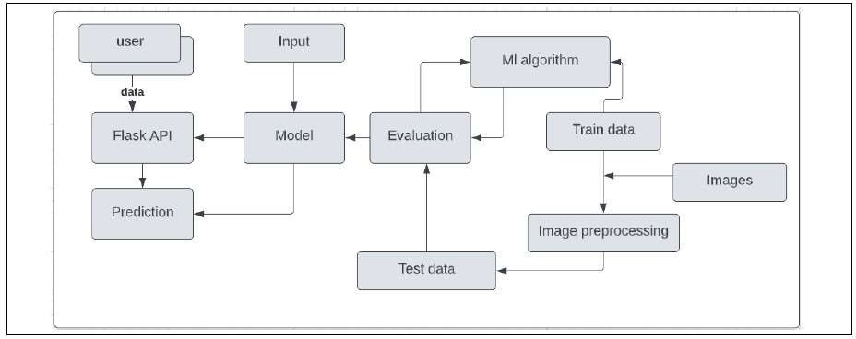

#### SOLUTION & TECHNICAL ARCHITECTURE SOLUTION ARCHITECTURE

Solution Architecture is a complex process – with many sub processes – that bridges the gap between business problems and the technology solutions.

#### SOLUTION

By using machine learning techniques, the problem can be solved with minimal error rate. The system developed in the study leverages Histogram of Oriented Gradients (HOG)image descriptor for analyzing the drawing patters of both spiral and wave sketches respectively. Further, the prediction probabilities are trained on a random forest classifier based on ensemble voting to provide a weighted prediction from both the spiral and wave sketch.

.

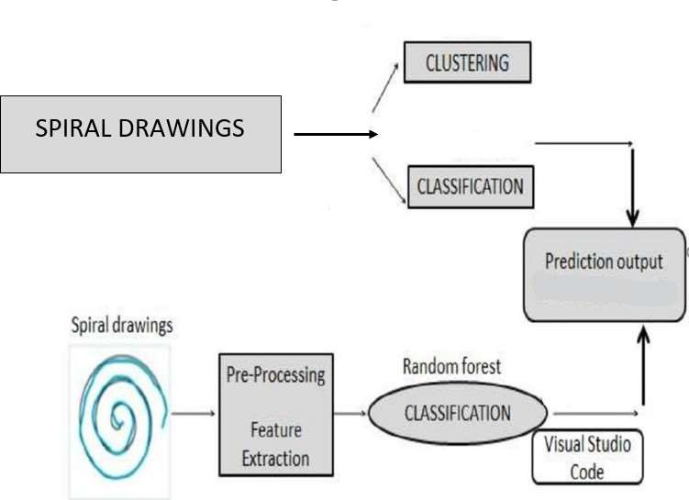

#### TECHNICAL ARCHITECTURE

The Technical Architecture involves the development of a technical blueprint with regard to the arrangement, interaction and interdependence of all elements so that the system-relevant requirements are met.

The Deliverable shall include the architectural diagram as below and the information as per the table1 & table 2

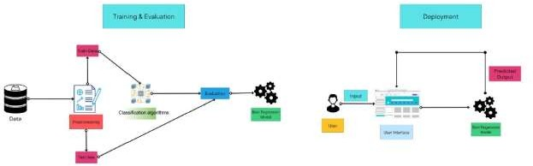

#### Table-1: Component & Technologies

|  |  |  |  |
| --- | --- | --- | --- |
| S. No: | Component | Description | Technology |
| 1. | User Interface | How user interacts with application example: Web UI, Mobile App,  Chatbot etc. | Flask API |
| 2. | Application Logic-1 | Load the dataset | Jpeg Images |
| 3. | Application Logic-2 | Classification | Random Forest  Classifier |
| 4. | Application Logic-3 | Evaluation | Python |
| 5. | Machine Learning  Model | Purpose of Machine  Learning Model | Object Recognition  Model |

* 1. **USER STORIES**

A user story is the smallest unit of work. It is not a feature, but an end goal that the user has when using the software. The user story will convey what the user wants to achieve and states into a simple, non-technical way.

|  |  |  |  |  |  |  |
| --- | --- | --- | --- | --- | --- | --- |
| **User Type** | **Functional Requirement**  **(Epic)** | **User Story**  **Number** | **User Story / Task** | **Acceptance criteria** | **Priority** | **Release** |
| User | Uploading the dada | USN-1 | As a user, I have the input data by using which I need to detect the Parkinson’s  disease | I can access my account / dashboard | High | Sprint- 1 |
|  |  | USN-2 | As a user, I will upload the data in the Flask API | I can upload by uploading or submit  button | High | Sprint- 2 |
|  |  | USN-3 | As a user, I can get the  prediction done by ML algorithm as the output | I can see the result in the Flask API interface | High | Sprint- 3 |

### PROJECT PLANNING & SCHEDULING

#### SPRINT PLANNING & ESTIMATION

|  |  |  |  |  |  |  |
| --- | --- | --- | --- | --- | --- | --- |
| **Sprint** | **Functional Requirement (Epic)** | **User Story Number** | **User Story / Task** | **Story Points** | **Priority** | **Team Members** |
| Sprint-1 | Upload Images | USN-1 | As a user, I can upload the | 2 | High | 1.SATHISH |
|  |  |  | images in the website in |  |  | 2.SATHYA |
|  |  |  | order to obtain the |  |  | 3.THARUN |
|  |  |  | prediction result of |  |  | 4.NAGA |
|  |  |  | Parkinson’sdisease |  |  |  |

|  |  |  |  |  |  |  |
| --- | --- | --- | --- | --- | --- | --- |
| Sprint-4 | Test Vital Page | USN-2 | As a user, I will get the prediction result and accuracy on the test vital page. | 3 | High | 1.SATHISH  2.SATHYA 3.THARUN 4.NAGA |

|  |  |  |  |  |  |  |
| --- | --- | --- | --- | --- | --- | --- |
| **Sprint** | **Functional Requirement**  **(Epic)** | **User Story Number** | **User Story / Task** | **Story Points** | **Priority** | **Team Members** |
| Sprint-2 | Dashboard | USN-3 | Dashboard displays the symptoms, causes and medications for the Parkinson disease | 2 | Low | 1.SATHISH 2.SATHYA 3.THARUN 4.NAGA |
| Sprint-1 | Data Collection | USN-4 | As an Administrator, I need to collect data (images of spirals and waves drawn by healthy people and Parkinson’s | 2 | High | 1.SATHISH 2.SATHYA 3.THARUN 4.NAGA |

|  |  |  |  |  |  |  |
| --- | --- | --- | --- | --- | --- | --- |
|  |  |  | patients). |  |  |  |

|  |  |  |  |  |  |  |
| --- | --- | --- | --- | --- | --- | --- |
| Sprint-1 | Data Pre- Processing | USN-5 | As an Administrator, I should cleanmy data and prepare it for model building by doing pre-processing activities such as resizing, visualizing the dataset and converting from RGB to grayscale | 2 | High | 1.SATHISH 2.SATHYA 3.THARUN 4.NAGA |
| Sprint-2 | Model Building | USN-6 | As an Administrator, I need to buildthe model using Random Forest Classifier for spiral images and Convolutional Neural Networks (CNN) for wave images | 3 | High | 1.SATHISH 2.SATHYA 3.THARUN 4.NAGA |
| **Sprint** | **Functional Requirement**  **(Epic)** | **User Story Number** | **User Story / Task** | **Story Points** | **Priority** | **Team Members** |
| Sprint-3 | Deployment of Model | USN-7 | As an Administrator, I need to deploy the Machine Learning model that was built. | 2 | Medium | 1.SATHISH 2.SATHYA 3.THARUN 4.NAGA |

|  |  |  |  |  |  |  |
| --- | --- | --- | --- | --- | --- | --- |
| Sprint-3 | Building Frontend of the application | USN-8 | As an Administrator, I need to build the website for the application using HTML, CSS etc. | 2 | High | 1.SATHISH 2.SATHYA 3.THARUN 4.NAGA |

|  |  |  |  |  |  |  |
| --- | --- | --- | --- | --- | --- | --- |
| Sprint-4 | Connecting the ML model, Frontend and Backend | USN-9 | As an Administrator, I can integrate the deployed model and web application using python flask server. | 3 | High | 1.SATHISH 2.SATHYA 3.THARUN 4.NAGA |

**Project Tracker, Velocity & Burndown Chart**

|  |  |  |  |  |  |  |
| --- | --- | --- | --- | --- | --- | --- |
| **Sprint** | **Total Story Points** | **Duration** | **Sprint Start Date** | **Sprint End Date (Planned)** | **Story Points Completed (as on**  **Planned End**  **Date)** | **Sprint Release Date (Actual)** |
| Sprint- 1 | 20 | 6 Days | 24 Oct 2022 | 29 Oct 2022 | 20 | 29 Oct 2022 |
| Sprint- 2 | 20 | 6 Days | 31 Oct 2022 | 05 Nov 2022 | 20 | 05 Nov 2022 |
| Sprint- 3 | 20 | 6 Days | 07 Nov 2022 | 12 Nov 2022 | 20 | 12 Nov 2022 |
| Sprint- 4 | 20 | 6 Days | 14 Nov 2022 | 19 Nov 2022 | 20 | 14 Nov 2022 |

#### Velocity:

For example, imagine we have a 10-day sprint duration, and the velocity of the team is 20 (points per sprint). Let’s calculate theteam’s average velocity (AV) per iteration unit (story points per day)



In our project, we have a 6-days sprint duration, and the velocity of the team is 20 (points per sprint). Let’s calculate the team’s average velocity (AV) per iteration unit (story points per day)

#### AV = Sprint Duration = 20 = 3.3 (approx.) Velocity 6

**Burndown Chart:**

A burn down chart is a graphical representation of work left to do versus time. It is often used in agile [software development](https://www.visual-paradigm.com/scrum/what-is-agile-software-development/) methodologies such as [Scrum.](https://www.visual-paradigm.com/scrum/scrum-in-3-minutes/) However, burn down charts can be applied to any project containing measurable progress over time.

A burndown chart is almost a “must” have tool for a Scrum Team for the following main reasons:

* Monitoring the project scope creep
* Keeping the team running on schedule
* Comparing the planned work against the team progression

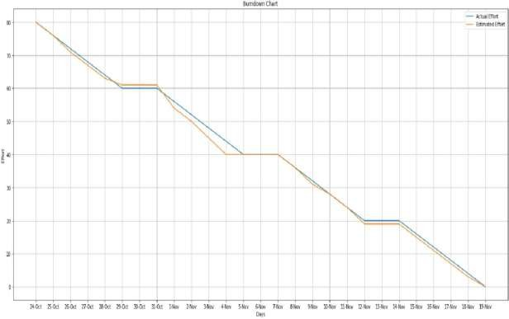

#### SPRINT DELIVERY SCHEDULE

|  |  |  |
| --- | --- | --- |
| **TITLE** | **DESCRIPTION** | **DATE** |
| **DEATION PHASE** | | |
| **Literature Survey & Information Gathering** | Literature survey on the selected project & gathering information by referring the, technical papers, research publications etc. | 18 SEPTEMBER 2022 |
| **Prepare Empathy Map** | Prepare Empathy Map Canvas to capture the user Pains & Gains, Prepare list of problem statements. | 18 SEPTEMBER 2022 |
| **Problem Statement** | List of problem in the project. | 18 SEPTEMBER 2022 |
| **Brainstorm And Idea Prioritization** | List the by organizing the brainstorming session and prioritize the top 3 ideas based on the feasibility & importance. | 18 SEPTEMBER 2022 |
| **PROJECT DESIGN PHASE-I** | | |
| **Proposed Solution** | Prepare the proposed solution document, which  includes the novelty, feasibility of idea, business model, social impact, scalability of solution, etc. | 21 SEPTEMBER 2022 |
| **Problem Solution Fit** | Prepare problem - solution fit document. | 21 SEPTEMBER 2022 |

|  |  |  |
| --- | --- | --- |
| **Solution Architecture** | Prepare solution architecture document. | 24 SEPTEMBER 2022 |
| **PROJECT DESIGN PHASE-II** | | |
| **Customer Journey** | Prepare the customer journey maps to understand the  user interactions & experiences with the application (entry to exit). | 18 OCTOBER 2022 |
| **Functional Requirement** | Prepare the functional requirement document. | 18 OCTOBER 2022 |
| **Data Flow Diagrams** | Draw the data flow diagrams and submit for review. | 18 OCTOBER 2022 |

|  |  |  |
| --- | --- | --- |
| **Technology Architecture** | Prepare the technology architecture diagram. | 18 OCTOBER 2022 |
| **PROJECT PLANNING PHASE** | | |
| **Prepare Project Planning & Sprint Delivery Plan** | Prepare the Product Backlog, Sprint Planning, Stories, and Story points. | 26 OCTOBER 2022 |
| **Prepare Milestone & Activity List** | Prepare the milestones &activity list of the project. | 26 OCTOBER 2022 |
| **PROJECT DEVELOPMENT PHASE** | | |
| **Project Development - Delivery of Sprint-1, 2, 3 &**  **4** | Develop & submit the developed code by testing it. | 13 NOVEMBER 2022 |

**DATA COLLECTION**

|  |  |  |
| --- | --- | --- |
| **Create train and test folders** | To prepare the training and testing dataset and upload it into the folders. | 29 OCTOBER2022 |

**QUANTIFYING IMAGES**

|  |  |  |
| --- | --- | --- |
| **Import feature library and configure it** | Import the feature library from SK image | 02 NOVEMBER2022 |
| **Apply feature library**  **Functionality to test and train set** | Apply it to the model | 05 NOVEMBER 2022 |

[**MODEL BUILDING**](https://careereducation.smartinternz.com/Student/guided_project_workspace/50403#collapse3)

|  |  |  |
| --- | --- | --- |
| **Import the required model building libraries** | To import the necessary libraries and packages to build the model | 02 NOVEMBER 2022 |
| **Initialize the model** | Initializing the model | 02 NOVEMBER 2022 |
| **Add the COLOR_BGR2GRAY** | To add the COLOR_BGR2GRAY | 02 NOVEMBER 2022 |
| **Add the Label Encoder** | Adding the Label Encoder | 02 NOVEMBER 2022 |
| **Compile the model** | To compile the model | 10 NOVEMBER 2022 |
| **Fit and save the model** | Save the model | 10 NOVEMBER 2022 |

[**TEST THE MODEL**](https://careereducation.smartinternz.com/Student/guided_project_workspace/50403#collapse4)

|  |  |  |
| --- | --- | --- |
| **Import the packages and load the**  **saved model** | Load the saved model and testing it | 10 NOVEMBER 2022 |
| **Load the Test image, quantify it**  **and predict** | Prediction and testing the images | 10 NOVEMBER 2022 |

[**APPLICATION BUILDING**](https://careereducation.smartinternz.com/Student/guided_project_workspace/50403#collapse5)

|  |  |  |
| --- | --- | --- |
| **Build A flask application** | To build the flask application | 06 NOVEMBER 2022 |
| **Build A flask application** | To build the flask application | 06 NOVEMBER 2022 |
| **Building the flask application-part**  **3** | To build the flask application | 06 NOVEMBER 2022 |
| **Build the HTML page** | Building the html page for frontend | 06 NOVEMBER 2022 |
| **Output** | To get the output | 11 NOVEMBER 2022 |

[**TRAIN THE MODEL ON IBM**](https://careereducation.smartinternz.com/Student/guided_project_workspace/50403#collapse6)

|  |  |  |
| --- | --- | --- |
| **Train image Classification model** | To develop the code and push it into the git hub | 11 NOVEMBER 2022 |
| **Register for IBM cloud** | To register for the IBM cloud | 26 OCTOBER 2022 |

* 1. **REPORTS FROM JIRA**

### Coverage Report

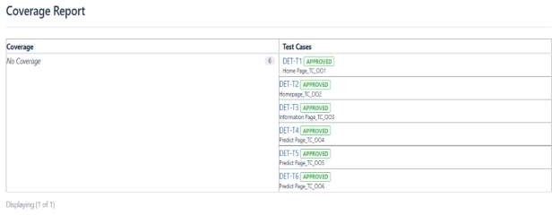

1. **Traceability matrix**

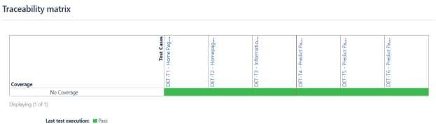

### Traceability Report

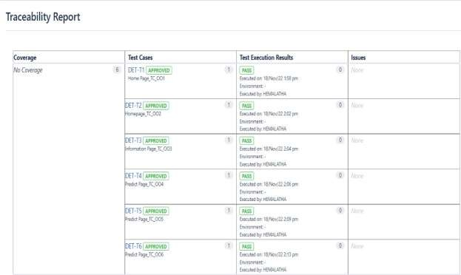

1. 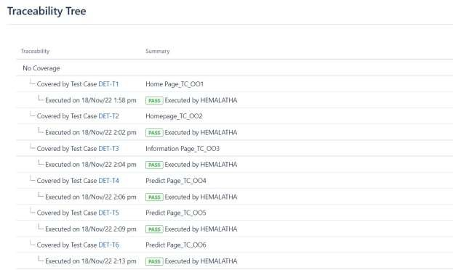**Traceability Tree**

### CODING & SOLUTIONING

#### FEATURE 1

Our model has good accuracy rate. Which helps the doctors to recommend treatment such as levodopa/carbidopa are more effective when administered early on in the disease. Non-pharmacologic treatments, such as increased exercise, are also easier to perform in the early stages of PD and may help slow down disease progression.

In our model we used the **Random Forest Classifier** that is impressive in Versatility and great with dimensionality. The quick prediction/Training speed and parallelizable. Random Forest Classifier also handles the unbalanced data.

#### FEATURE 2

The system developed in the study leverages **Histogram of Oriented Gradients (HOG)** image descriptor for analyzing the drawing patterns of both spiral and wave sketches respectively.

It shows invariance to geometric and photometric changes and is used for extracting essential features and shapes of a particular object within an image such as sketches and patterns. HOG can be used to detect small-scaled images with less computational power.

### TESTING

#### TEST CASES

* + - Verify if the user is able to see the Homepage when they click on the link
    - Verify the UL elements in Homepage

1. Home icon
2. Information icon
3. Predict icon
   * + Verify if the Information and the predict icons functions properly
     + Verify if the user is able to view the upload file option and its function
     + Verify if the user is able to choose the file from the local file system and click on predict to find the predicted result
     + Verify if the user is able to select the invalid file formats

#### USER ACCEPTANCE TESTING

In UAT design phase, test engineers are preparing UAT testcases as per the business requirements. AT test coverage should be with Alpha and beta testing. After having complete idea about business requirements and have a discussion with BA or Product Owner one can proceed with UAT Test case design/mapping to UAT test suite.

Approach: Alpha Testing and Beta Testing

* + - UAT Test scenarios & Testcases prepared based on business needs in both functional and non-functional aspects
    - UAT Testcases can be set of existing testcases and maintained as a separate UAT Test suite.
    - UAT Test scenarios & cases once designed should be reviewed by BA or Product Owner.
    - UAT Testcases target is customer environment based in-terms of Test data and Servers.

#### Defect Analysis

This report shows the number of resolved or closed bugs at each severity level, and how they were resolved

|  |  |  |  |  |  |
| --- | --- | --- | --- | --- | --- |
| **Resolution** | **Severity 1** | **Severity 2** | **Severity 3** | **Severity 4** | **Subtotal** |
| By Design | 12 | 3 | 1 | 2 | 18 |
| Duplicate | 0 | 2 | 1 | 0 | 3 |
| External | 3 | 4 | 1 | 0 | 8 |
| Fixed | 10 | 2 | 5 | 14 | 31 |
| Not Reproduced | 0 | 1 | 1 | 0 | 2 |
| Skipped | 1 | 0 | 1 | 1 | 3 |
| Won't Fix | 0 | 7 | 2 | 1 | 10 |
| Totals | 26 | 19 | 12 | 18 | 75 |

#### Test Case Analysis

This report shows the number of test cases that have passed, failed, and untested

|  |  |  |  |  |
| --- | --- | --- | --- | --- |
| **Section** | **Total Cases** | **Not Tested** | **Fail** | **Pass** |
| Print Engine | 5 | 0 | 0 | 5 |
| Client Application | 34 | 0 | 0 | 34 |
| Security | 4 | 0 | 0 | 4 |
| Outsource Shipping | 2 | 0 | 0 | 2 |
| Exception Reporting | 7 | 0 | 0 | 7 |
| Final Report Output | 3 | 0 | 0 | 3 |
| Version Control | 2 | 0 | 0 | 2 |

#### PERFORMANCE TESTING

Project team shall fill the following information in model performance testing template.

|  |  |  |  |
| --- | --- | --- | --- |
| **S.**  **No.** | **Parameter** | **Values** | **Screenshot** |
| 1. | Metrics | **Classification Model:**  Confusion Matrix -  Accuracy Score-  Classification Report – |  |
| 2. | Tune the Model | Hyperparameter Tuning -  Validation Method - |  |

### RESULTS

#### PERFORMANCE METRICS

The following images can be studied to understand the performance of our system.

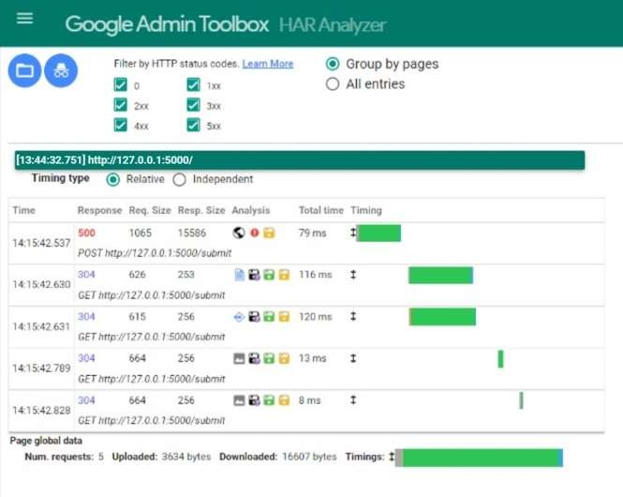

### ADVANTAGES AND DISADVANTAGES

#### ADVANTAGES

* + - Friendly UI
    - Accuracy level is more than 80%
    - More efficient as it involves the techniques in Machine Learning
    - Accurately detecting Parkinson’s disease at an early stage is certainly indispensable for slowing down its progress and providing patients the possibility of accessing to disease-modifying therapy.
    - Yields high potential for more systematic clinical decision-making system.

#### DISADVANTAGES

* + - The main limitation of random forest is that a large number of trees can make the algorithm too slow and ineffective for real-time predictions.
    - In general, these algorithms are very fast to train, but quite slow to create predictions once they are trained.
    - Random forest is less interpretable than a single decision tree.

### CONCLUSION

we all know the fact that two of the most common Parkinson’s symptoms include tremors and muscle rigidity which directly impact the visual appearance of a hand- drawn spiral and wave.

The variation in visual appearance will enable us to train a machine-learning algorithm to automatically detect Parkinson’s disease. we have utilized the random forest algorithm. We also have utilized the Histogram of Oriented Gradients image descriptor to quantify each of the input images. After extracting features from the input images, we trained a Random Forest classifier with 100 total decision trees in the forest, obtaining more than 83.33% accuracy on the spiral dataset that we provided. The Random Forest trained on the spiral dataset obtained 73.33% sensitivity, meaning that the model was capable of predicting a true positive (i.e., “Yes, the patient has Parkinson’s") nearly 73.33% of the time. Hence this model will be very useful for the early detection of Parkinson's disease and it can be easily used as it has a user-friendly interface. Though Parkinson’s cannot be cured, early detection along with proper medication can significantly improve symptoms and quality of life.

In conclusion, the model that we built using a Random Forest classifier gives us a good evaluation and accuracy score. So, it can be trusted for the early detection of Parkinson's disease and it can be utilized by people very easily.

### FUTURE SCOPE

In the future we will use different types of attributes for the classification of patients and also identify the different stages of Parkinson's disease.

Enrichment of machine learning algorithms with additional sensor data (i.e., accelerometry, gyrometry, spirography) may enhance the precision of the algorithm. More recent versions of iMotor have incorporated some of these capabilities, and additional studies are currently ongoing.

### APPENDIX

**SOURCE CODE**

### Model Building

from sklearn.ensemble import RandomForestClassifier from sklearn.preprocessing import LabelEncoder

from sklearn.metrics import confusion_matrix from skimage import feature

from imutils import build_montages from imutils import paths

import numpy as np import cv2

import os

#QUANTIFY THE IMAGES

def quantify_image(image):

features = feature.hog(image, orientations=9, pixels_per_cell=(10, 10),

cells_per_block=(2, 2), transform_sqrt=True, block_norm="L1") return features

trainingpath=r"C:/Users/Administrator/Downloads/spiral/spiral/training" testingpath=r"C:/Users/Administrator/Downloads/spiral/spiral/training"

## Loading Train Data and Test Data def load_split(path):

imagePaths = list(paths.list_images(path)) data = []

labels = []

for imagePath in imagePaths:

label = imagePath.split(os.path.sep)[-2] image = cv2.imread(imagePath)

image = cv2.cvtColor(image, cv2.COLOR_BGR2GRAY) image = cv2.resize(image, (200, 200))

image=cv2.threshold(image,0,255,cv2.THRESH_BINARY_INV | cv2.THRESH_OTSU)[1]

features = quantify_image(image) data.append(features) labels.append(label)

return (np.array(data), np.array(labels))

### Load the train and test data print("[INFO] loading data...")

(X_train, y_train) = load_split(trainingpath) (X_test, y_test) = load_split(testingpath)

## Label Encoding le = LabelEncoder()

y_train = le.fit_transform(y_train) y_test = le.transform(y_test) print(X_train.shape,y_train.shape)

# Model Building print("[INFO] training model")

model = RandomForestClassifier(n_estimators=100) model.fit(X_train, y_train)

### Model Testing

## Testing The Model

testingpath=list(paths.list_images(testingpath)) idxs=np.arange(0,len(testingpath)) idxs=np.random.choice(idxs,size=(25,),replace=False) images=[]

label_1=[] for i in idxs:

image=cv2.imread(testingpath[i]) output=image.copy()

# load the input image,convert to grayscale and resize

output=cv2.resize(output,(128,128)) image=cv2.cvtColor(image,cv2.COLOR_BGR2GRAY) image=cv2.resize(image,(200,200)) image=cv2.threshold(image,0,255,cv2.THRESH_BINARY_INV | cv2.THRESH_OTSU)[1]

# quantify the image and make predictions based on the extracted feature using last trained random forest

features=quantify_image(image) preds=model.predict([features]) label=le.inverse_transform(preds)[0] # the set of output images

if label=="healthy": color=(0,255,0) else: color=(0,0,255)

label_1.append(label)

cv2.putText(output,label,(3,20),cv2.FONT_HERSHEY_SIMPLEX,0.5,color,2) images.append(output)

#creating a montage montage=build_montages(images,(128,128),(5,5))[0]

### Model Evaluation

## Model Evaluation

predictions = model.predict(X_test)

cm = confusion_matrix(y_test, predictions).flatten() print(cm)

(tn, fp, fn, tp) = cm

accuracy = (tp + tn) / float(cm.sum()) print(accuracy)

### Classification Report

from sklearn.metrics import classification_report print(classification_report(y_test, predictions))

# HTML Files

### index.html

<!DOCTYPE html>

<html lang="en" dir="ltr">

<head>

<meta charset="utf-8">

<meta name="viewport" content="width=device-width, initial-scale=1.0">

<title>Home | Detection Of Parkinson's Disease </title>

<link rel="stylesheet" href="style.css">

<link rel="stylesheet" href="https://cdnjs.cloudflare.com/ajax/libs/font- awesome/5.14.0/css/all.min.css">

</head>

<body>

<style> body

{

background-image: url("image.jpg"); background-color: #cccccc;

}

</style>

<header>

<a href="#" class="brand"></a>

<div class="menu-btn"></div>

<div class="navigation">

<div class="navigation-items">

<a href="#"></a>

<a href="#"></a>

<a href="index.html">Home</a>

<a href="info.html">Info</a>

<a href="prediction.html">Predict</a>

</div>

</div>

</header>

<section class="home">

<div class="content active">

<h1>Parkinson's<br><span>Disease</span></h1>

<p>More than 10 million people are living with Parkinson’s Disease

worldwide, according to the Parkinson’s Foundation. While Parkinson’s cannot be cured, early detection along with proper medication can significantly improve symptoms and quality of life. The researchers found

that the drawing speed was slower and the pen pressure is lower among Parkinson’s patients. One of the indications of Parkinson’s is tremors and rigidity in the muscles, making it difficult to draw smooth spirals and waves. It is possible to detect Parkinson’s disease using the drawings alone instead of measuring the speed and pressure of the pen on paper. </p>

</div>

<div class="media-icons">

</div>

</section>

<script type="text/javascript">

//Javacript for responsive navigation menu

const menuBtn = document.querySelector(".menu-btn"); const navigation = document.querySelector(".navigation"); menuBtn.addEventListener("click", () => { menuBtn.classList.toggle("active"); navigation.classList.toggle("active");

});

//Javacript for video slider navigation

const btns = document.querySelectorAll(".nav-btn"); const slides = document.querySelectorAll(".video-slide"); const contents = document.querySelectorAll(".content"); var sliderNav = function(manual){

btns.forEach((btn) => { btn.classList.remove("active");

});

slides.forEach((slide) => { slide.classList.remove("active");

});

contents.forEach((content) => { content.classList.remove("active");

});

btns[manual].classList.add("active"); slides[manual].classList.add("active");

contents[manual].classList.add("active");

}

btns.forEach((btn, i) => { btn.addEventListener("click", () => { sliderNav(i);

});

});

</script>

</body>

</html>

### info.html

<!DOCTYPE html>

<html lang="en" dir="ltr">

<head>

<meta charset="utf-8">

<meta name="viewport" content="width=device-width, initial-scale=1.0">

<title>Info | Detection Of Parkinson's Disease </title>

<link rel="stylesheet" href="style.css">

<link rel="stylesheet" href="https://cdnjs.cloudflare.com/ajax/libs/font- awesome/5.14.0/css/all.min.css">

</head>

<body>

<header>

<a href="#" class="brand"></a>

<div class="menu-btn"></div>

<div class="navigation">

<div class="navigation-items">

<a href="#"></a>

<a href="#"></a>

<a href="index.html">Home</a>

<a href="info.html">Info</a>

<a href="prediction.html">Predict</a>

</div>

</div>

</header>

<div class="content active">

<div class="section">

<div class="container">

<div class="content-section">

<div class="title">

<h1>About Parkinson’s</h1>

</div>

<div class="content">

<h3>Parkinson's disease is a progressive disorder that affects the nervous system</h3>

<p>Parkinson’s disease is a brain disorder that causes unintended or uncontrollable movements, such as shaking, stiffness, and difficulty with balance and coordination.

Symptoms usually begin gradually and worsen over time. As the disease progresses, people may have difficulty walking and talking. They may also have mental and behavioral changes, sleep problems, depression, memory difficulties, and fatigue. </p>

<h3>Symptoms of Parkinson’s disease</h3>

<ul>

<li>Tremor in hands, arms, legs, jaw, or head</li>

<li>Muscle stiffness, where muscle remains contracted for a long time</li>

<li>Slowness of movement</li>

</ul>

<h3>Diagnosis of Parkinson’s disease</h3>

<p>There are currently no blood or laboratory tests to diagnose non-

genetic cases of Parkinson’s. Doctors usually diagnose the disease by taking a person’s medical history and performing a neurological examination. If symptoms improve after starting to take medication, it’s another indicator that the person has Parkinson’s.</p>

<div class="button"></div>

</div>

</div>

<div class="social">

</div>

</div>

<div class="image-section">

<img src="park.webp">

</div>

</div>

</div>

</body>

</html>

### prediction.html

<!DOCTYPE html>

<html lang="en" dir="ltr">

<head>

<meta charset="utf-8">

<meta name="viewport" content="width=device-width, initial-scale=1.0">

<title>Pediction | Detection Of Parkinson's Disease </title>

<link rel="stylesheet" href="style.css">

<link rel="stylesheet" href="https://cdnjs.cloudflare.com/ajax/libs/font- awesome/5.14.0/css/all.min.css">

<style>

.button { border: none; color: white;

padding: 16px 32px; text-align: center;

text-decoration: none; display: inline-block; font-size: 16px; margin: 4px 2px;

transition-duration: 0.4s; cursor: pointer;

}

.button1 {

background-color: white; color: black;

border: 2px solid #4CAF50;

}

.button1:hover { background-color: #4CAF50; color: white;

}

.button2 {

background-color: white; color: black;

border: 2px solid #008CBA;

}

.button2:hover { background-color: #008CBA; color: white;

}

.image-section{ float:none; width:100%;

}

.image-section img{ width: 100%; height: auto; display: block; margin:auto;

}

.boxed {

border: 1px solid green ;

width: 400px; height: 400px;

background-position: right; background-size: cover;

}

</style>

</head>

<body>

<header>

<a href="#" class="brand"></a>

<div class="menu-btn"></div><div class="navigation">

<div class="navigation-items">

<a href="#"></a>

<a href="#"></a>

<a href="index.html">Home</a>

<a href="info.html">Info</a>

<a href="prediction.html">Predict</a>

</div>

</div>

</header>

<div class="content active">

<div class="section">

<div class="container">

<div class="content-section">

<div class="title">

</div>

<div class="content">

<input type="file" id="image-input" accept="image/jpeg, image/png, image/jpg">

<div id="display-image"></div>

<script src="script.js"></script>

<button class="button button2" onclick="myFunction()">Predict</button>

<h2 id="demo"></h2>

<div class="button"></div>

</div>

</div>

<div class="social">

</div>

</div>

<div class="image-section">

<br>

<br>

<br>

<br>

<br>

<br>

<br>

<h2 id="demo1"></h2>

</div>

</div>

</div>

<script>

function myFunction() {

document.getElementById("demo").innerHTML = "This Person is Healthy"; document.getElementById("demo1").innerHTML = "Accuracy of the model: 83%";

}

</script>

</body>

</html>

# CSS Files

### style.css

@import url('https://fonts.googleapis.com/css2?family=Poppins:wght@200;300;400; 500;600;700;800;900&display=swap');

*{ margin: 0;

padding: 0;

box-sizing: border-box;

font-family: "Poppins", sans-serif;

}

header{

z-index: 999; position: absolute; top: 0;

left: 0;

width: 100%; display: flex;

justify-content: space-between; align-items: center;

padding: 15px 200px; transition: 0.5s ease;

}

header .brand{ color: #fff;

font-size: 1.5em; font-weight: 700;

text-transform: uppercase; text-decoration: none;

}

header .navigation{

position: relative;

}

header .navigation .navigation-items a{ position: relative;

color: #fff; font-size: 1em;

font-weight: 500;

text-decoration: none; margin-left: 30px; transition: 0.3s ease;

}

header .navigation .navigation-items a:before{ content: '';

position: absolute; background: #fff; width: 0;

height: 3px; bottom: 0;

left: 0;

transition: 0.3s ease;

}

header .navigation .navigation-items a:hover:before{ width: 100%;

}

section{

padding: 100px 200px;

}

.home{

position: relative; width: 100%;

min-height: 100vh; display: flex;

justify-content: center;

flex-direction: column;

background-image: url("image2.jpg"); height: 100%;

background-position: center; background-repeat: no-repeat; background-size: cover; background-color: #cccccc; opacity: 0.9;

}

.container{ width: 80%; display: block; margin:auto;

padding-top: 100px;; background-color: #2696E9; opacity: 0.9;

}

.content-section{ float: left;

width: 55%;

}

.image-section{ float: right; width: 40%;

}

.image-section img{ width: 100%; height: auto;

}

.content-section .title{

text-transform: uppercase; font-size: 28px;

}

.content-section .content h3{ margin-top: 20px; color:#2696E9;

font-size: 21px;

}

.content-section .content p{ margin-top: 10px;

font-family: "Times New Roman", Times, serif; font-size: 18px;

line-height: 1.5;

}

.content-section .content .button{ margin-top: 30px;

}

.content-section .content .button a{ background-color: #3d3d3d; padding:12px 40px;

text-decoration: none; color:#fff;

font-size: 25px; letter-spacing: 1.5px;

}

.content-section .content .button a:hover{ background-color: #a52a2a;

color:#fff;

}

.content-section .social{ margin: 40px 40px;

}

.content-section .social i{ color:#a52a2a;

font-size: 30px; padding:0px 10px;

}

.content-section .social i:hover{ color:#3d3d3d;

}

@media screen and (max-width: 768px){

.container{ width: 80%; display: block; margin:auto;

padding-top:50px;

}

.content-section{ float:none; width:100%; display: block; margin:auto;

}

.image-section{ float:none; width:100%;

}

.image-section img{ width: 100%; height: auto; display: block; margin:auto;

}

.content-section .title{ text-align: center; font-size: 19px;

}

.content-section .content .button{ text-align: center;

}

.content-section .content .button a{ padding:9px 30px;

}

.content-section .social{ text-align: center;

}

}

.home:before{ z-index: 777; content: '';

position: absolute;

background: rgba(3, 96, 251, 0.3);

width: 100%;

height: 100%;

top: 0;

left: 0;

}

.home .content{ z-index: 888; color: #fff; width: 70%;

margin-top: 50px; display: none;

}

.home .content.active{ display: block;

}

.home .content h1{ font-size: 4em; font-weight: 900;

text-transform: uppercase; letter-spacing: 5px;

line-height: 75px; margin-bottom: 40px;

}

.home .content h1 span{ font-size: 1.2em;

font-weight: 600;

}

.home .content p{ margin-bottom: 65px;

}

.home .content a{ background: #fff; padding: 15px 35px; color: #1680AC; font-size: 1.1em; font-weight: 500;

text-decoration: none; border-radius: 2px;

}

.home .media-icons{ z-index: 888; position: absolute; right: 30px;

display: flex;

flex-direction: column; transition: 0.5s ease;

}

.home .media-icons a{ color: #fff;

font-size: 1.6em; transition: 0.3s ease;

}

.home .media-icons a:not(:last-child){

margin-bottom: 20px;

}

.home .media-icons a:hover{ transform: scale(1.3);

}

.home video{ z-index: 000;

position: absolute; top: 0;

left: 0;

width: 100%;

height: 100%; object-fit: cover;

}

.slider-navigation{ z-index: 888; position: relative; display: flex;

justify-content: center; align-items: center;

transform: translateY(80px); margin-bottom: 12px;

}

.slider-navigation .nav-btn{ width: 12px;

height: 12px; background: #fff; border-radius: 50%; cursor: pointer;

box-shadow: 0 0 2px rgba(255, 255, 255, 0.5); transition: 0.3s ease;

}

.slider-navigation .nav-btn.active{

background: #2696E9;

}

.slider-navigation .nav-btn:not(:last-child){ margin-right: 20px;

}

.slider-navigation .nav-btn:hover{ transform: scale(1.2);

}

.video-slide{ position: absolute; width: 100%;

clip-path: circle(0% at 0 50%);

}

.video-slide.active{

clip-path: circle(150% at 0 50%); transition: 2s ease;

transition-property: clip-path;

}

#display-image{ width: 400px; height: 400px;

border: 1px solid black; background-position: center; background-size: cover;

}

@media (max-width: 1040px){ header{

padding: 12px 20px;

}

section{

padding: 100px 20px;

}

.home .media-icons{

right: 15px;

}

header .navigation{ display: none;

}

header .navigation.active{ position: fixed;

width: 100%; height: 100vh; top: 0;

left: 0; display: flex;

justify-content: center; align-items: center;

background: rgba(1, 1, 1, 0.5);

}

header .navigation .navigation-items a{ color: #222;

font-size: 1.2em; margin: 20px;

}

header .navigation .navigation-items a:before{ background: #222;

height: 5px;

}

header .navigation.active .navigation-items{ background: #fff;

width: 600px;

max-width: 600px; margin: 20px; padding: 40px; display: flex;

flex-direction: column;

align-items: center; border-radius: 5px;

box-shadow: 0 5px 25px rgb(1 1 1 / 20%);

}

.menu-btn{

background: url(menu.png)no-repeat; background-size: 30px;

background-position: center; width: 40px;

height: 40px; cursor: pointer;

transition: 0.3s ease;

}

.menu-btn.active{

-index: 999;

background: url(close.png)no-repeat; background-size: 25px;

background-position: center; transition: 0.3s ease;

}

}

@media (max-width: 560px){

.home .content h1{ font-size: 3em;

line-height: 60px;

}

}

# JAVASCRIPT Files

### script.js

const image_input = document.querySelector("#image-input"); var uploaded_image = ""; image_input.addEventListener("change", function() {

const reader = new FileReader(); reader.addEventListener("load", () => { uploaded_image = reader.result;

document.querySelector("#display-image").style.backgroundImage =

`url(${uploaded_image})`;

});

reader.readAsDataURL(this.files[0]);

});

# OUTPUT

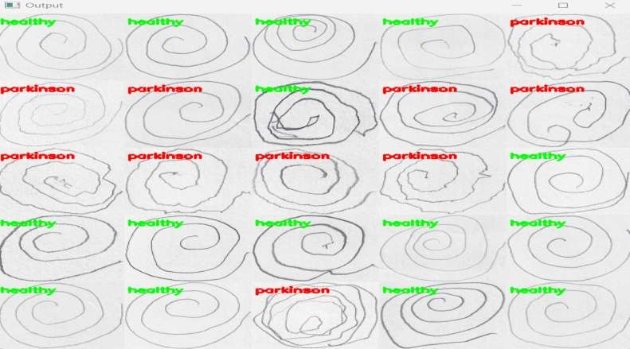

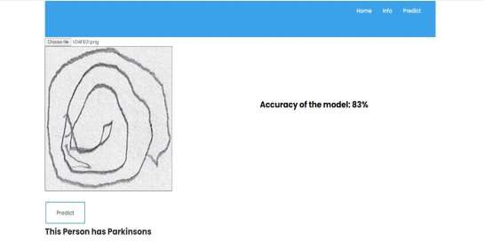

**13.2 GitHub Repository Link**

## GitHub Repository link:

https://github.com/IBM-EPBL/IBM-Project-21036-1659770603

## Project Demo:

## <https://github.com/IBM-EPBL/IBM-Project-21036-> 1659770603/blob/main/Final_Deliverables/Demo.mp4