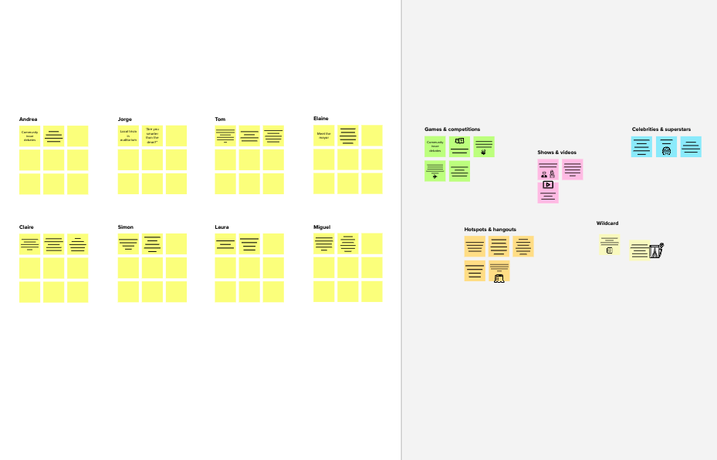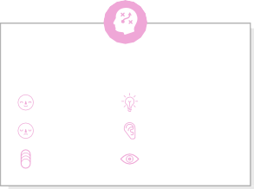

# Brainstorm

**Before you collaborate**

A little bit of preparation goes a long way with this session. Here’s what you need to do to get going.

**10 minutes**

**1**

**Define your problem statement**

What problem are you trying to solve? Frame your problem as a How Might We statement. This will be the focus of your brainstorm.

**5 minutes**

**2**

**Brainstorm**

Write down any ideas that come to mind that address your problem statement.

**10 minutes**

**3**

Indicating case counts to the users

It shows the symptoms and remedies of the viral disease

reconstructing medical

data

**MONISHADHITH K T**

**BARATH KANNAN K**

**Group ideas**

Take turns sharing your ideas while clustering similar or related notes as you go. In the last 10 minutes, give each cluster a sentence-like label. If a cluster is bigger than six sticky notes, try and see if you and break it up into smaller sub-groups.

**20 minutes**

**4**

**Prioritize**

Your team should all be on the same page about what's important moving forward. Place your ideas on this grid to determine which ideas are important and which are feasible.

**20 minutes**

**After you collaborate**

You can export the mural as an image or pdf to share with members of your company who might find it helpful.

**Quick add-ons**

# & idea prioritization

Tracking user by using geo- fence algorithm

Creating 24/ 7 service provider

Acquiring geo-location details of users

Tracking client by using geo- fence algorithm

**PROBLEM**

This application is intended to provide information about containment zones in a particular region by alerting people, through continuous monitoring of an individual's location. Key benefits of the application are monitoring people's activity and alerting them of their safety movements.

|  |  |
| --- | --- |
| Collecting | Alerting user |
| affected | while |
| person | entering |
| location | contaminated |
| details | zone |

Use this template in your own brainstorming sessions so your team can unleash their imagination and start shaping concepts even if you're not sitting in the same room.

Collecting & storing information on cloud

Collecting virus data's

1. **Team gathering**

Define who should participate in the session and send an invite. Share relevant information or pre-work ahead.

1. **Set the goal**

Think about the problem you'll be focusing on solving in the brainstorming session.

1. **Learn how to use the facilitation tools**

Use the Facilitation Superpowers to run a happy and

creating virus data warehouse

Reconstructing medical

data

Collecting Epidemiological data

Giving tips for mental fitness

LOCATION

DATA COLLECTION

Connecting hospitals to get case data

Alerting user while entering contaminated zone

1. **Share the mural**

**Share a view link** to the mural with stakeholders to keep them in the loop about the outcomes of the session.

1. **Export the mural**

Export a copy of the mural as a PNG or PDF to attach to emails, include in slides, or save in your drive.

**10 minutes** to prepare

Collecting & storing information on cloud

In order to collect all hospitals data's connection should be established

Collecting affected person location details

Creating algorithm for Data Scrambling

Monitoring geo location of user

**1 hour** to collaborate

**2-8 people** recommended

productive session.

[**Open article**](https://support.mural.co/en/articles/2113740-facilitation-superpowers)

**Key rules of brainstorming**

Suggesting nearby hospital location

Suggesting the prevention measures

To run an smooth and productive session

Getting zonal information on cases got entry

Creating algorithm for Data Scrambling

Suggesting

Using different color grading to mark zones

Collecting Epidemiological data

Tracking safe route for transport

Creating User friendly API

Tracking safe route for transport

**Keep moving forward**

**Strategy blueprint**

Define the components of a new idea or strategy.

[**Open the template**](https://app.mural.co/template/e95f612a-f72a-4772-bc48-545aaa04e0c9/984865a6-0a96-4472-a48d-47639307b3ca)

**Customer experience journey map**

Understand customer needs, motivations, and

Stay in topic. Defer judgment.

DATA USAGE

Indicating symptoms & Way to contact after affected

In order to collect all hospitals data's connection should be established

location services get shutdown when users at home

Creating User friendly API

Tracking user by using geo- fence algorithm

Encourage wild ideas. Listen to others.

**Importance**

Fetching data from cloud

Monitoring user’s day to day activity

Analyzing the virus spreading & harmful to people

Maintaining the user database on cloud

Acquiring geo-location details of users

Fetching data from cloud

If each of these

Monitoring

safety plug before or after affected

Showing alerting zone

Providing online services for

obstacles for an experience.

[**Open the template**](https://app.mural.co/template/b7114010-3a67-4d63-a51d-6f2cedc9633f/c1b465ab-57af-4624-8faf-ebb312edc0eb)

Go for volume. If possible, be visual.

**AKASH L**

**MAHESWARAN C**

Giving Tips when user on isolation zones

Getting zonal information on cases got entry

Suggesting safety plug before or after affected

Using different color grading to mark zones

Providing awareness through

idea illustration

Creating trace test treat model

Tracking safe route for transport

Alerting user while entering contaminated zone

Showing alerting zone analysis by Data visualization

Monitoring geo location of user

Collecting Epidemiological data

Maintaining the user database on cloud

Health monitoring

creating virus data warehouse

|  |  |
| --- | --- |
| Providing awareness through  idea illustration | Indicating symptoms & Way to contact after |
|  | affected |

tasks could get

done without any

difficulty or cost, which would have the most positive impact?

ALERTS

SPECIAL FEATURES

Suggesting the prevention measures

Suggesting nearby hospital location

Proceeding with Thermal screening through smart band

Showing alerting zone analysis by Data visualization

user’s day to day activity

Thermal screening through smart band

Thermal screening through smart band

Giving Tips when user on isolation zones

Creating algorithm for Data Scrambling

Creating User friendly API

location services get shutdown when users at home

Monitoring users day to day activity

Analysing the virus spreading & harmful to people

Providing online services for consulting

|  |  |  |
| --- | --- | --- |
| Indicating | Giving tips | It shows the symptoms and |
| case count to the user | for mental fitness | remedies of the viral disease |

Providing awareness through idea illustration

creating virus data warehouse

Creating 24/ 7 service provider

analysis by Data visualization

Maintaining the user database on cloud

Creating 24/ 7 service provider

Health monitoring

Providing online services for consulting

Suggesting safety plug before or after affected

consulting

Suggesting nearby hospital location

**Strengths, weaknesses, opportunities & threats**

Identify strengths, weaknesses, opportunities, and threats (SWOT) to develop a plan.

|  |  |
| --- | --- |
|  |  |
|  |  |

[**Open the template**](https://app.mural.co/template/6a062671-89ee-4b76-9409-2603d8b098be/ca270343-1d54-4952-9d8c-fbc303ffd0f2)

[**Share template feedback**](https://muralco.typeform.com/to/CiqaHVat?typeform-source=app.mural.co)

[**Share template feedback**](https://muralco.typeform.com/to/CiqaHVat?typeform-source=app.mural.co)

**Need some inspiration?**

See a finished version of this template to kickstart your work.

**Feasibility**

Regardless of their importance, which tasks are more feasible than others? (Cost, time, effort, complexity, etc.)

[**Open example**](https://app.mural.co/template/e5a93b7b-49f2-48c9-afd7-a635d860eba6/93f1b98d-b2d2-4695-8e85-7e9c0d2fd9b9)