**Project Design Phase-II**

**Data Flow Diagram & User Stories**

|  |  |
| --- | --- |
| Date | 26 October 2022 |
| Team ID | PNT2022TMID17997 |
| Project Name | University Admit Eligibility Predictor |
| Maximum Marks | 4 Marks |

**Data Flow Diagrams:**

A Data Flow Diagram (DFD) is a traditional visual representation of the information flows within a system. A neat and clear DFD can depict the right amount of the system requirement graphically. It shows how data enters and leaves the system, what changes the information, and where data is stored.

**DFD LEVEL 0:**

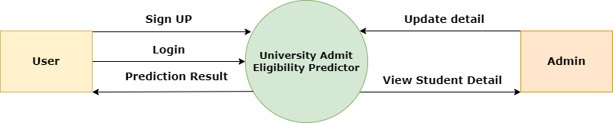

**User Stories**

|  |  |  |  |  |  |  |
| --- | --- | --- | --- | --- | --- | --- |
| **User Type** | **Functional Requirement (Epic)** | **User Story Number** | **User Story / Task** | **Acceptance criteria** | **Priority** | **Release** |
| **USER** | Sign Up | USN - 1 | As a user, I can sign up as a member using my mail id. | I can access my account. | High | Sprint - 1 |
|  | Login | USN - 2 | As a user, I can login into my account using user id and password. | I can access my account. | High | Sprint - 2 |
|  | Dashboard | USN - 4 | As a user, I can search for universities of my liking. | I can view the detail of the university of my choice. | High | Sprint -3 |
|  | Prediction | USN - 3 | As a user, I can view my prediction output. | I can view the prediction result of the university of my choice. | High | Sprint - 3 |