**PREREQUISITES**

**TEAM ID – PNT2022TMID02383**

**IBM CLOUD SERVICES**

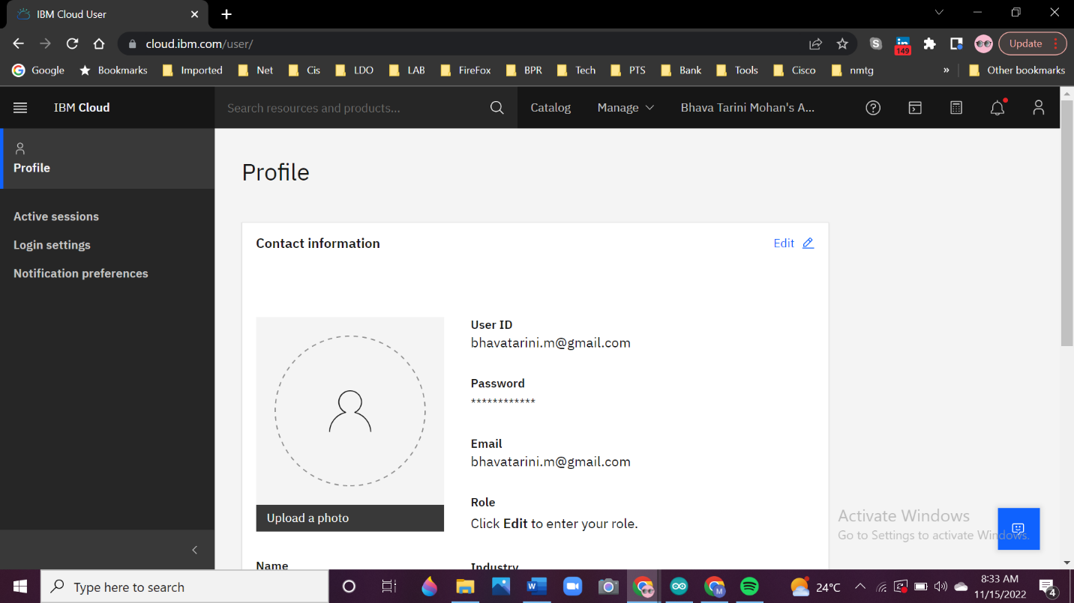

**SOFTWARE**

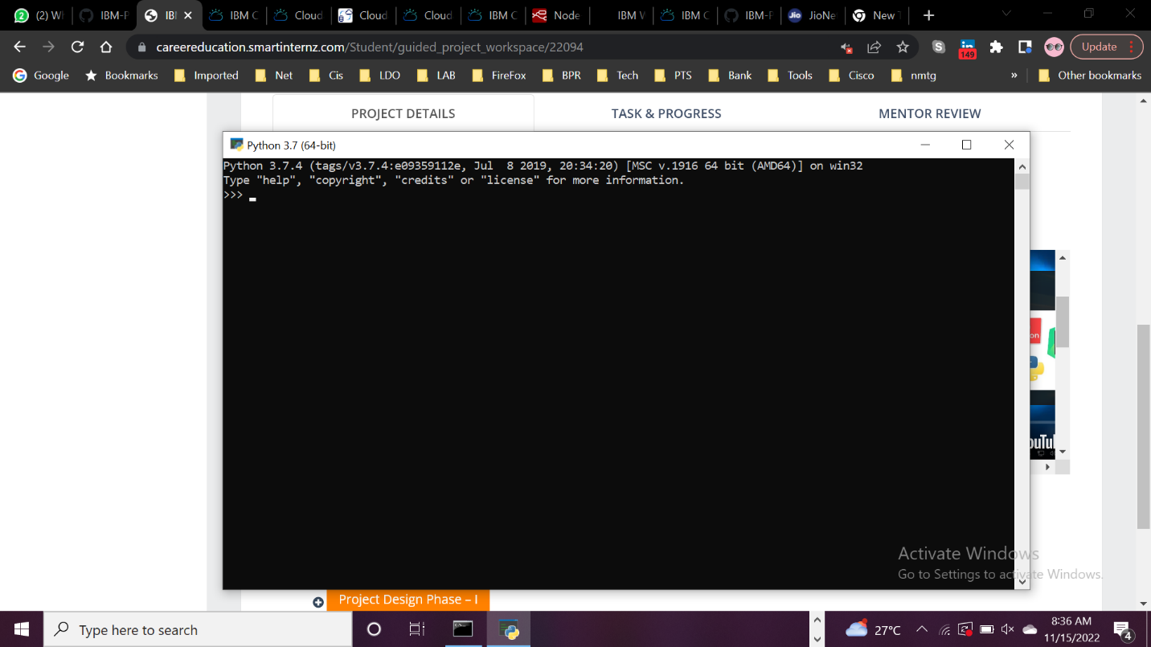

**ACCOUNT CLARIFAI**

