**VELAMMAL COLLEGE OF ENGINEERING AND TECHNOLOGY**

**DEPARTMENT OF COMPUTER SCIENCE AND ENGINEERING**

**PROFESSIONAL READINESS PROGRAM FOR INNOVATION, EMPLOYABILITY AND ENTREPRENEURSHIP**

**NALAIYA THIRAN**

**(Project Objectives, Prerequisites & Prior Knowledge, Project Structure, Project Flow)**

**Team ID :** PNT2022TMID22999

**Team Leader :** Harshini T

**Team Member :** Paarkavi Priya S

**Team Member :** Kharshitha Bhuvani E

**Team Member :** Divya Sri N

**Mentor :** Dr. R. Vijayalakshmi

### Topic : Fertilizers Recommendation System For Disease Prediction

**Project Objectives:**

Agriculture is the most important sector in today’s life. Most plants are affected by a wide variety of bacterial and fungal diseases. Diseases on plants placed a major constraint on production and a major threat to food security. Hence, early and accurate identification of plant diseases is essential to ensure high quantity and best quality. In recent years, the number of diseases on plants and the degree of harm caused has increased due to the variation in pathogen varieties, changes in cultivation methods, and inadequate plant protection techniques.

An automated system is introduced to identify different diseases on plants by checking the symptoms shown on the leaves of the plant. Deep learning techniques are used to identify the diseases and suggest the precautions that can be taken for those diseases.

**Prerequisites and Prior Knowledge:**

* Neural Network
* Natural Language Processing
* Cloudant DB
* Watson Assistant
* Artificial Intelligence
* Python
* HTML & CSS

**Project Structure:**

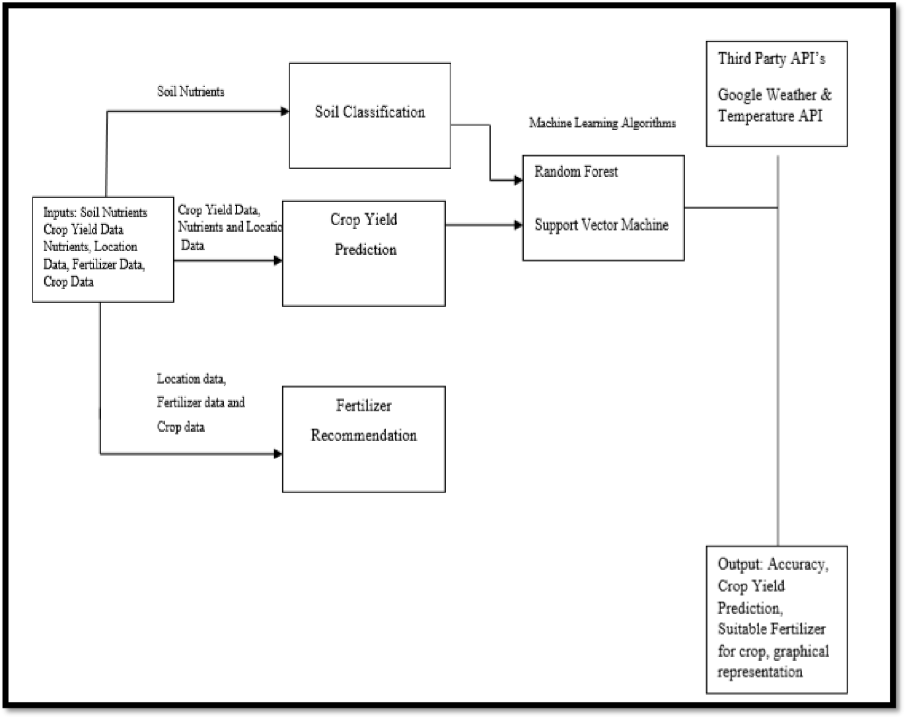

**Project Flow:**

