Assignment -1
Python Programming

Assignment Date | 19 September 2022
Student Name | Ms.Madhumitha.M
Student Roll Number | 113219071016
Maximum Marks | 2 Marks

Question-1:
Split this string.

Solution:
s = "Hi there Sam!"
print(s.split())
#----------------------------------------#
#----------------------------------------#

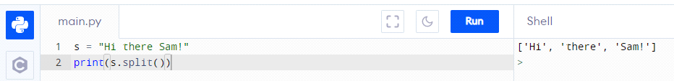

Question-2:
Use .format() to print the following string.
Output should be: The diameter of Earth is 12742 kilometers.

Solution:
planet = "Earth"
diameter = 12742
print("The diameter of {} is {} kilometers.".format(planet,diameter))
#----------------------------------------#
#----------------------------------------#

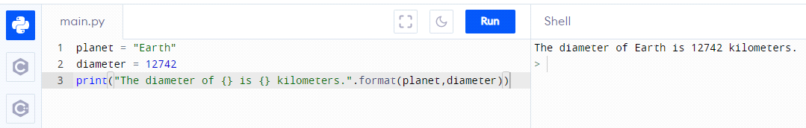

Question-3:
In this nest dictionary grab the word "hello"

Solution:
d = {'k1':[1,2,3,{'tricky':['oh','man','inception',{'target':[1,2,3,'hello']}]}]}
d['k1'][3]['tricky'][3]['target'][3]
#----------------------------------------#
#----------------------------------------#

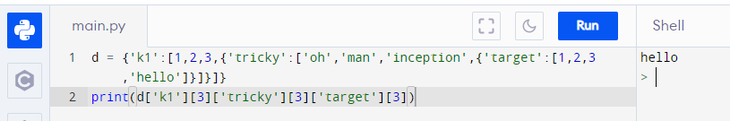

Question-4.1:
Create an array of 10 zeros?

Solution:
import numpy as np
x=np.zeros(10)
print(x)
#----------------------------------------#
#----------------------------------------#

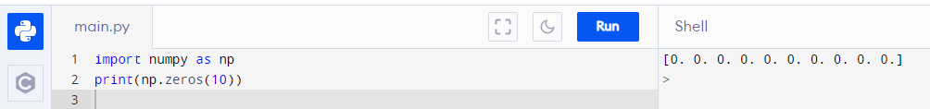

Question-4.2:
Create an array of 10 fives?

Solution:
import numpy as np
x=np.ones(10)*5
print(x)
#----------------------------------------#
#----------------------------------------#

Question-5:
Create an array of all the even integers from 20 to 35

Solution:
import numpy as np
x=np.arange(20,36,2)
print(x)
#----------------------------------------#
#----------------------------------------#

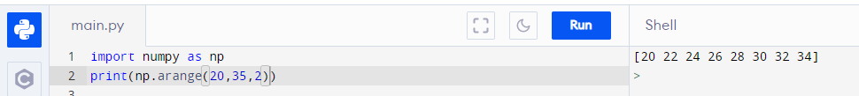

Question-6:
Create a 3x3 matrix with values ranging from 0 to 8

Solution:
import numpy as np
x=np.arange(0,9).reshape(3,3)
print(x)
#----------------------------------------#
#----------------------------------------#

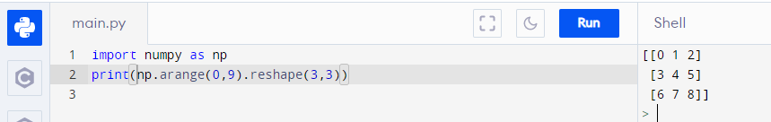

Question-7:
Concatinate a and b
a = np.array([1, 2, 3]), b = np.array([4, 5, 6])

Solution:
a=np.array([1,2,3])
b=np.array([4,5,6])
c=np.concatenate((a,b))
print(c)
#----------------------------------------#
#----------------------------------------#

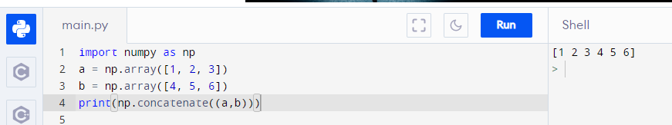

Question-8:
Pandas
Create a dataframe with 3 rows and 2 columns

Solution:
import pandas as pd
d={'a':[1,2,3],
'b':[4,5,6]}
y=pd.DataFrame(d)
print(y)
#----------------------------------------#
#----------------------------------------#

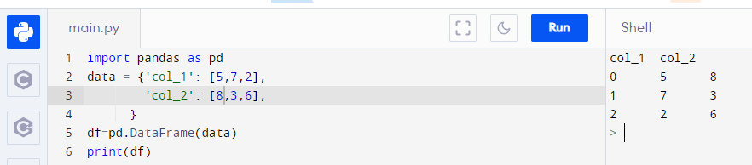

Question-9:
Generate the series of dates from 1st Jan, 2023 to 10th Feb, 2023

Solution:
import pandas as pd
x=pd.date_range(start='1-1-2023',
end='2-10-2023')
for val in x:
print(val)
#----------------------------------------#
#----------------------------------------#

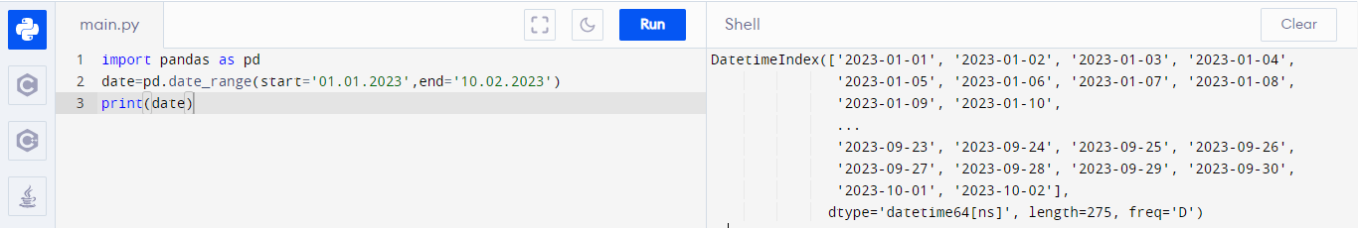

Question-10:
Create 2D list to DataFrame
lists = [[1, 'aaa', 22], [2, 'bbb', 25], [3, 'ccc', 24]]

Solution:
lists = [[1, 'aaa', 22], [2, 'bbb', 25], [3, 'ccc', 24]]

x=pd.DataFrame(lists)
print(x)
#----------------------------------------#
#----------------------------------------#

