**REAL TIME COMMUNICATION SYSTEM POWERED BY AI FOR SPECIALLY ABLED PERSONS**

**SUBMITTED BY:**

**AMISHA KUMARI.A (113219041010)**

**BACHELOR OF ENGINEERING**

**ELECTRONICS AND COMMUNICATION**

**ASSIGNMENT-02**

**DATA VISUALIZATION AND PRE PROCESSING**

|  |  |
| --- | --- |
| **Assignment Date** | 22 September 2022 |
| **Student Name** | Amisha kumari.A |
| **Student Roll Number** | 113219041010 |
| **Maximum Marks** | 2 Marks |

1. Download the dataset: Dataset Dataset downloaded in csv form.
2. Load the dataset.

import pandas as pd

df = pd.read_csv("/content/drive/MyDrive/IBM Assignments/Churn_Modellin g.csv")



1. Perform Below Visualizations.

* Univariate Analysis

sns.displot(df['Age'])

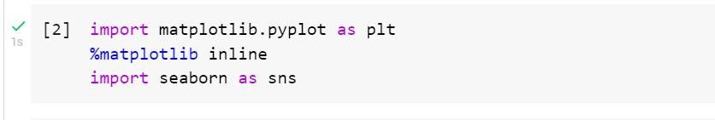

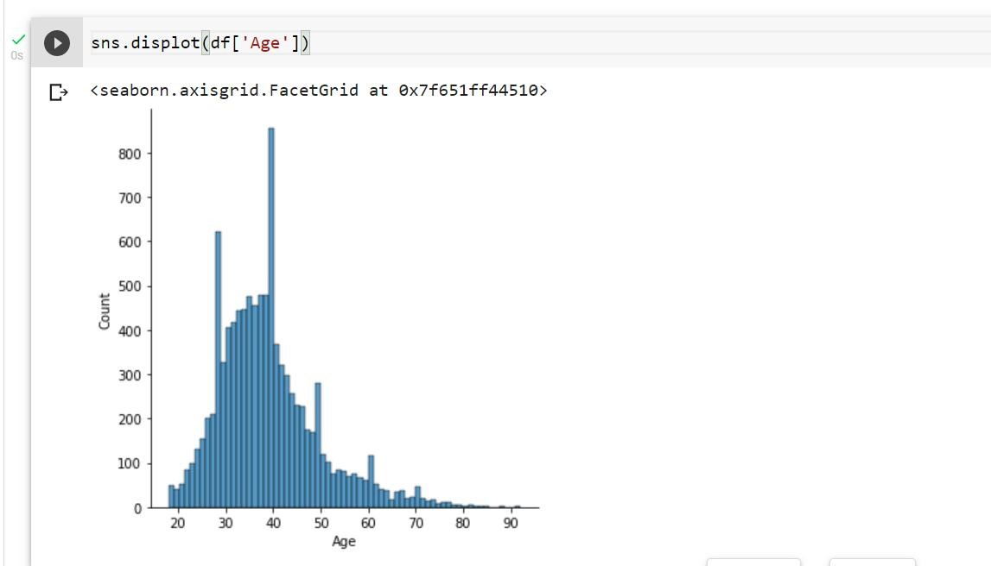

* Bi - Variate Analysis sns.boxplot(df['CustomerId'],df['Gender'])

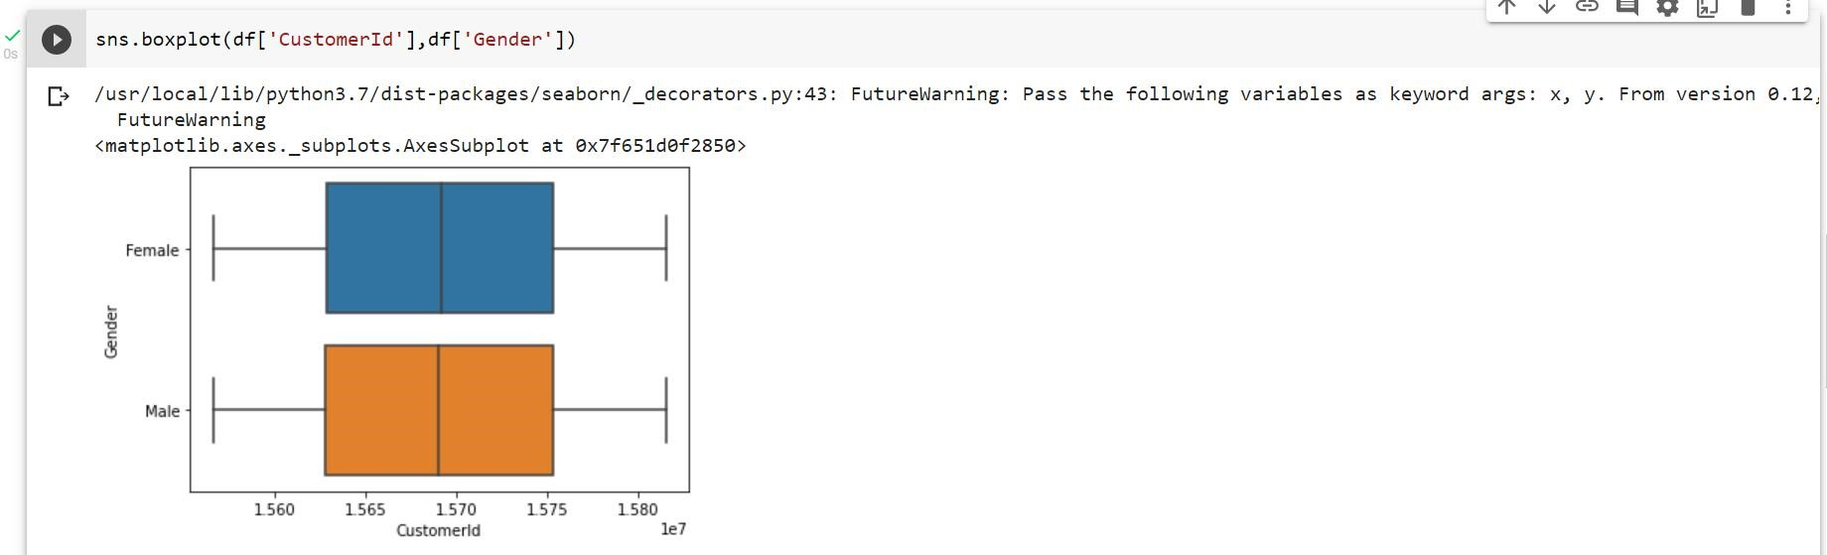

* Multi - Variate Analysis

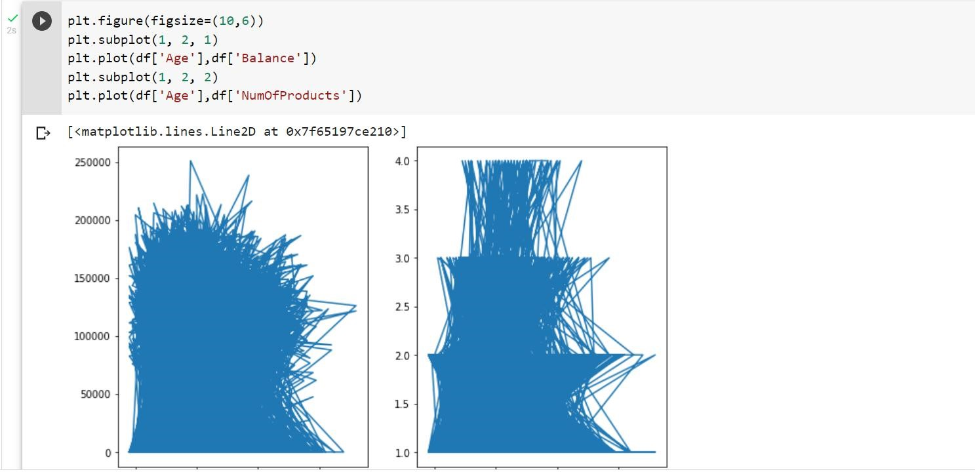

1. Perform descriptive statistics on the dataset.

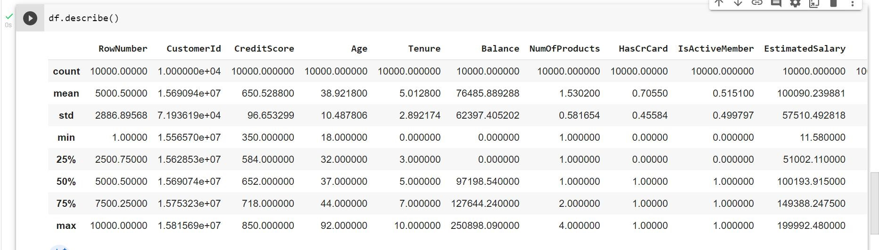

Mean:

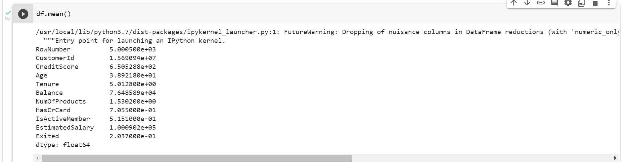

1. Handle the Missing values.

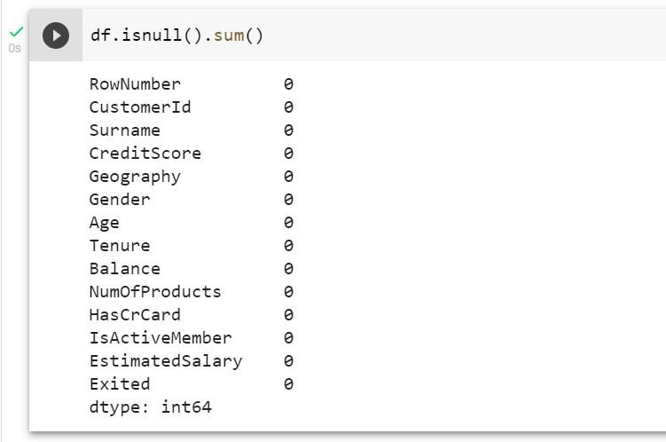

1. Find the outliers and replace the outliers

Finding Outliers:

Using Boxplot

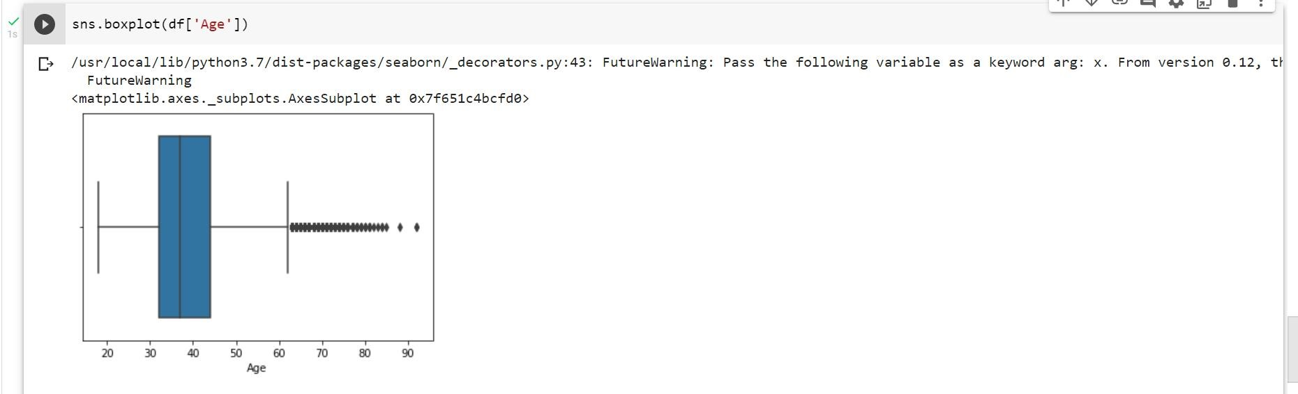

Using method

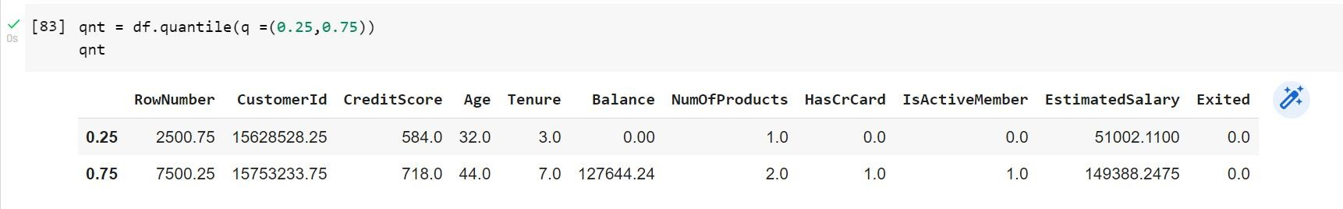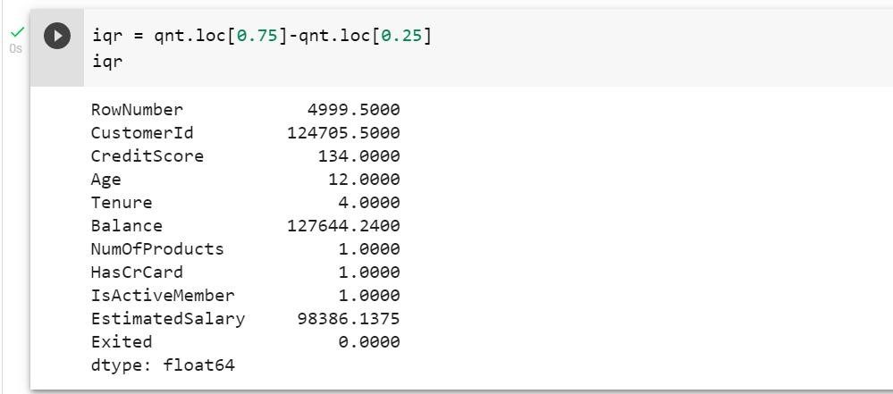

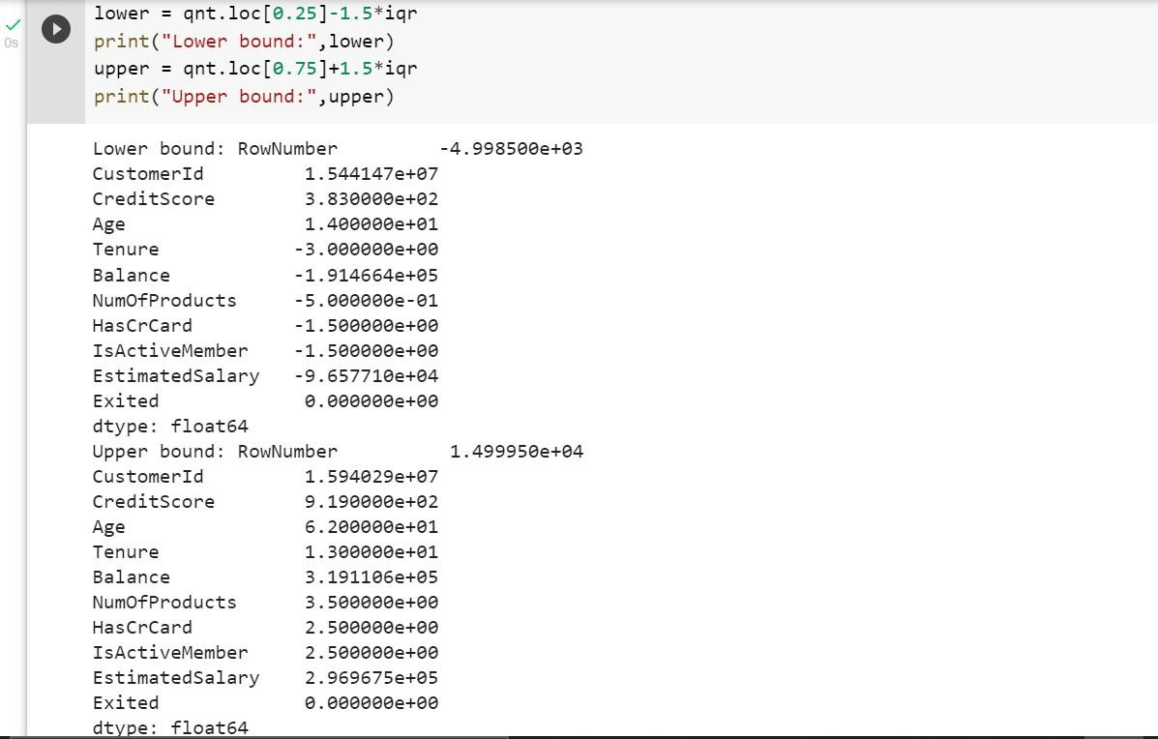

Replacing Outliers:

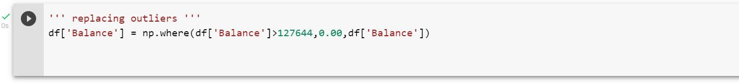

1. Check for Categorical columns and perform encoding.

Categorical columns: Geography,Gender

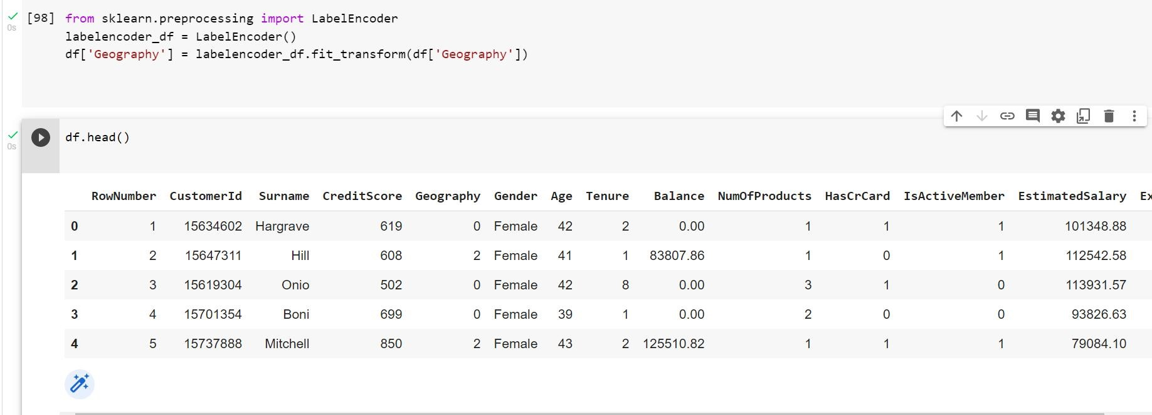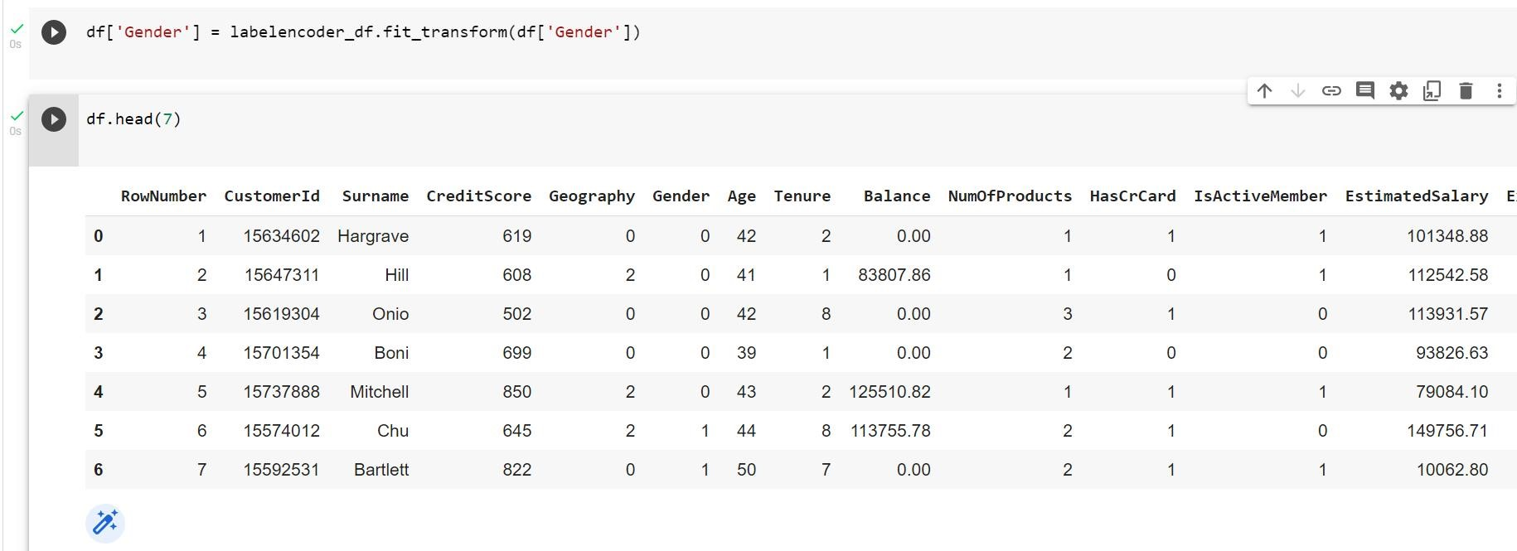

1. Split the data into dependent and independent variables.

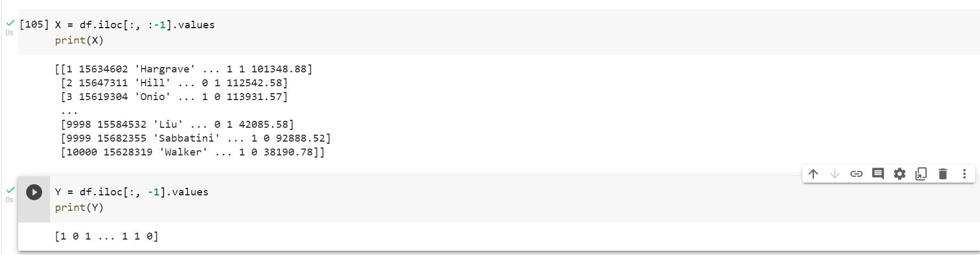

1. Scale the independent variables

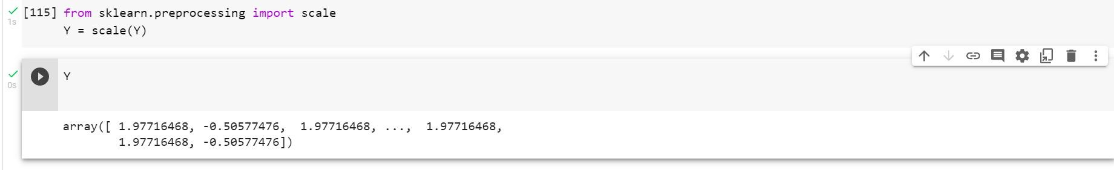

1. Split the data into training and testing

